Homepage Error – Empty Button – A button is empty or has no value text.

Where the error appears on the site (top-right corner in Search Box)
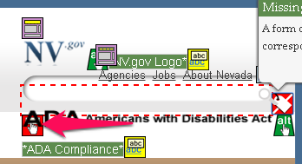
Code that generates the error:
Recommended Solution: add the labels highlighted in yellow below to the template
<div id="header_search">
<asp:Panel runat="server" ID="pnlSearch" DefaultButton="btnSearch">
<asp:Label id="searchLabel" AssociatedControlId="txtsearch" Text="Search Box" runat="server" />
<asp:TextBox ID="txtsearch" CssClass="header_nv_search_box" title="Search" placeholder="Search" runat="server" ClientIDMode="Static">
</asp:TextBox></asp:label>
<asp:Button ID="btnSearch" runat="server" Text="Search Button" CssClass="header_nv_search_button" /></asp:Panel>
</div>
Location: Layouts/Master/nevada.master

