Summary of issues/recommendations of attached test results sent to Brett (using JAWs):

Assumption that we are ONLY responsible for agencies that are using our CMS environment that are using our Ektron templates. Sites like NDOW, Courts, and Insurance are not included as well as other sites that users have done themselves or had outside vendors build & support.

Need to identify document types to make it easier for disability
  - Review Smart forms to see if they can be modified to:
    - Require users to add document type
Estimated completion time: TBD – requires template changes

Need to make sure TABLES within CMS have been built to ADA specifications (add link)
  - Once they are, Tables work perfectly
  - Need to ensure all users have updated their TABLES to be ADA compliant
  - See procedures
Estimated completion time: TBD – Requires template & code changes

Need to test a GOOGLE doc or On-Line form & see if they have the same issues as Form Stack
  - Decide NOT to allow these on-line forms in our environment if they are NOT ADA compliant
    - Risk if we do
    - Are we responsible for compliance if agencies select to use these options - mandated by Legislature to be on-line
  - Find a solution – TBD

Governor’s Proclamations - Huge issue
  - The Governor’s proclamations are graphics. All JAWS reads is the Alternate text that is added
  - Need to talk with Mari & suggest the following
    - Create a new Template that is similar to the Governor’s Press Releases so we can build the proclamation in a page, not a graphic
    - Can attach the current graphic to the page if someone wants to print it
  - Resolution – Discuss with Mari and get an approval – then need to create template & code behind

Need to learn more about ADOBE and how to OCR documents for readability
  - Ensure that changing LANGUAGE ONLY function makes it readable
  - Ensure it gives JAWS the extra prompts that Brett mentioned in 12/14 , 2:49pm memo
  - Adobe FormsCentral retired its form builder on July 28, 2015. Appears Form Stack is the best replacement and it claims to be 508 Compliant, however, when we tested their product using WAVE, we were getting the same errors on the Form Stack documents/online forms we tested
  - NEED to do additional testing

Need to evaluate Social Media (Twitter, FLICKR, Facebook)
  - Just want him to tell us if HE CAN VIEW them with JAWS
  - WAVE identifies the Twitter Feed as an iFrame.
  - NEED to do additional testing

Need to evaluate ALL Embedded IFRAMES (Twitter, Google Docs, APPS)
  - We are trying to test IFRAME visibility
- The content of an inline frame is read as if it were part of the page that contains it. The content of the iframe must be accessible. A title attribute value for the iframe will generally be read by a screen reader when the iframe is encountered. Ensure that the content within the iframe is accessible. Optionally, a title attribute value can be added to provide a brief, advisory description of the iframe.
    - WEBAIM techniques for Creating Accessible Frames and iFrames

Testing criteria #1: Tables, Documents (word, PDF), page contrast, YouTube Video, FLICKR
- Any issues with reading the table (with 4 columns, 8 rows) that contains 4 word docs, 7 PDFs
- Any contrast issues on the page – Only individuals who have low vision issues are normally affected by contrast issues.
- Can documents be opened and read? If not,
  - Which documents had an issue?
  - What was the Issue(s)
- Can the YouTube video be viewed? JAWS found no issues with the testing videos. However for those who rely on closed captioning only one of the 4 videos would be accessible.
- Can the FLICKR photo be viewed?
- Does either the YouTube or FLICKR present unique challenges? Not for JAWS

Any comments, recommendations

HR Resources Test Page
Test page/Link:
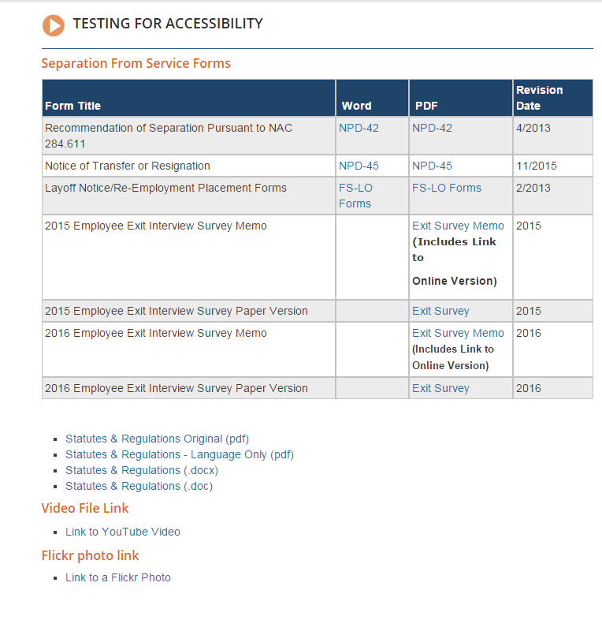

JAWS Evaluation:
- 1/7 1:02pm -Page was great. Even navigated the Exit Survey & it worked perfectly
- Table was already ADA compliant & that worked
- Flickr – The photo opened and identified the photo of Governor Sandoval and it also provided JAWS options to share, like or download.
- YouTube – would be helpful if we could display a pause button so users could stop the audio to hear JAWS as it was difficult to hear JAWS over the videos. It didn’t completely walk on JAWS but did make it more difficult. Recommend making the pause, play, forward, back buttons so they are identifiable by JAWS.
  - Played, but sound quality was very bad (might have been his speakers or microphone on camera because when he used headphones he could hear it properly & everything worked properly – poor quality sound was due to the use of a microphone without a speaker.

Possible Resolution:
- NEED to test Social Media (FLICKR, YouTube, TWITTER, Facebook)
- text script (text equivalent) required for all audio & video files
- Some YouTube videos are Closed Captioned which makes them accessible to more individuals. You will see (CC) in the description if a YouTube video is compliant (see below). On video page we added a closed captioned video for testing purposes.
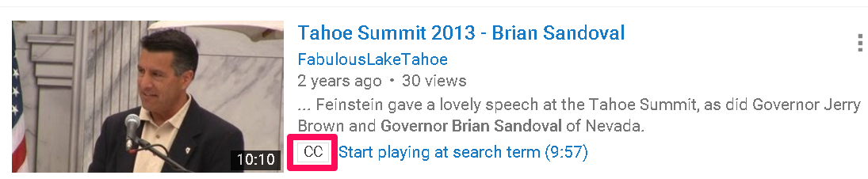
- NEEED to make sure Users make their Tables ADA compliant

Testing criteria #2: Governor’s proclamations
- that are an images, then is PDF, then added to website
- Single proclamation that is a PDF of an Image of the Proclamation
  - Can you read the proclamation?
  - Is the alternate text descriptive enough to provide a meaningful grasp of the content?
  - Does JAWS identify any issues?

Governor’s Proclamations
Test page/Link:
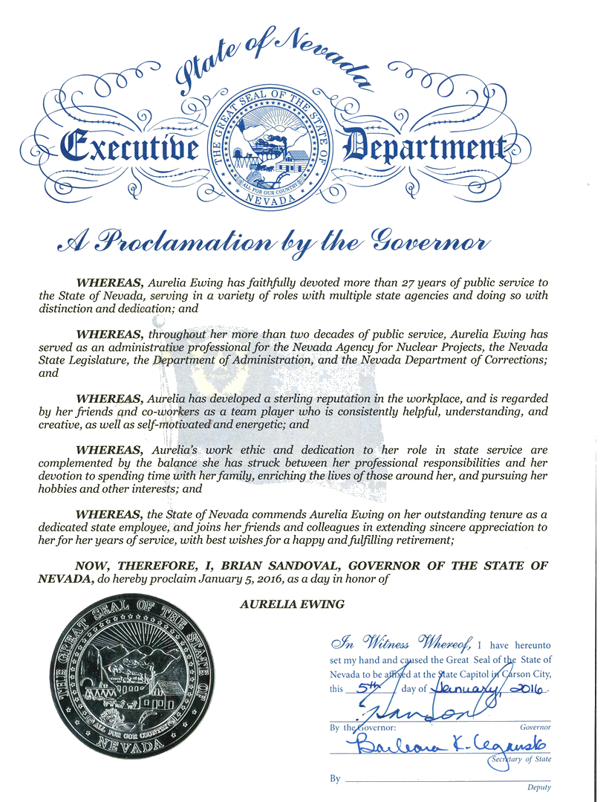

JAWS Evaluation:
- JAWS could only recognize the alternate text (title) so it was not all that meaningful.

Possible Resolution:
- Put text of proclamation in a ‘long description field’ (NOT best solution)
- Do not use graphic/image for Proclamations (Best solution)
  - Create template to enter content like with a Press Release
  - Attach PDF of graphic, if needed

Testing criteria #3: Various types of links (Word, PDF)
- Page contains two paragraphs, 6 links at bottom
  - Link 1 – excel document
    - Can you open the document
    - Can you traverse it?
  - Links 3, 5, 6 – link to PDF
    - Can you open the documents?
    - Can you traverse them?

Links
Test page/Link:
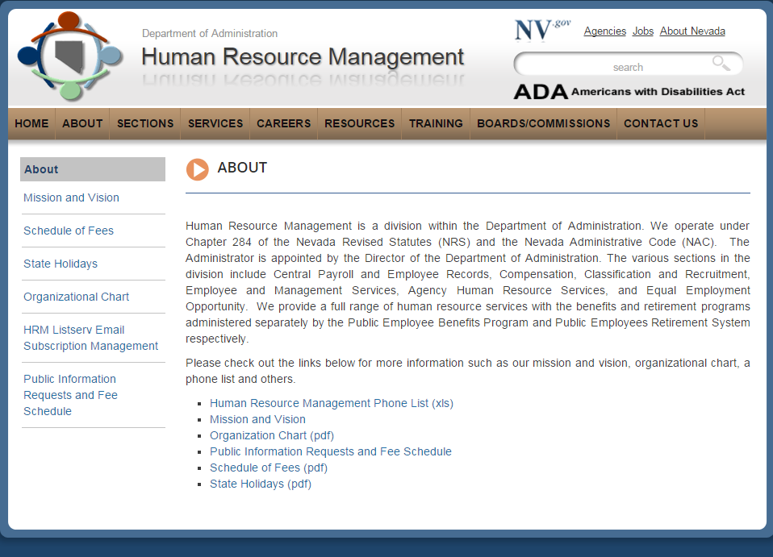

JAWS Evaluation:
- Everything opened fine
- PDF documents – In some places in the document the text reads as if there are no spaces. For instance, it reads like this, “himynameisbrettsilver IworkforthestateofNevada. it is helpful when the language is set to “English” in the file advanced properties.
- Human Resource Management Phone list (xls)
  - Needs to add AREA Codes
- Word documents – seemed to open fine, but appeared to omit some information where the pdf left nothing out.
- Organization Chart (pdf)
  - # on top are meaningless
  - In order for this to be read alternative text would need to be set for each box (image).

Possible Resolution:
- Area codes should always be included
- Decide if Organization charts in this format should be included

Testing criteria #4: Multiple section headings on a web page – should we identify type of documents
  - Page contains 7 section headings, each containing a paragraph and a link (ignore if they go to hmtl pages)
  - Does the page present any contrast issues?
    - If yes, what are the issues?
  - Would it be helpful for JAWS if each link was identified (PDF, WORD, EXCEL, etc?)

Multiple Sections with Links
Test page/Link:
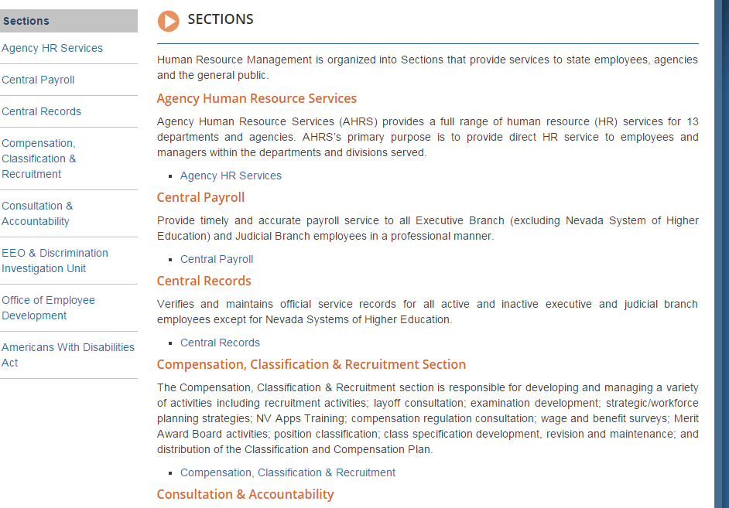
JAWS Evaluation:
- Yes, identifying the type of document will be helpful

Possible Resolution:
- Add type to document – Review Smart forms & determine if we can make some changes to the add the type & make it required

Testing criteria #5: Meetings template, documents (Agendas, Minutes, Attachments) & Audio files
- Meeting Page, lists 7 meeting dates, each followed by an agenda
  - Agenda
  - Supporting Materials
  - Minutes
- Last 3 meetings include an Audio file
  - Were you able to access & listen to the audio files?

Meetings
Test page/Link:
On the Deferred Compensation website it lists 7 meeting dates, each followed by an agenda, supporting materials, and minutes. In addition the last three meeting dates include an audio file. Does JAWS identify any issues on the page and in particular were you able to access the listen to the audio files? 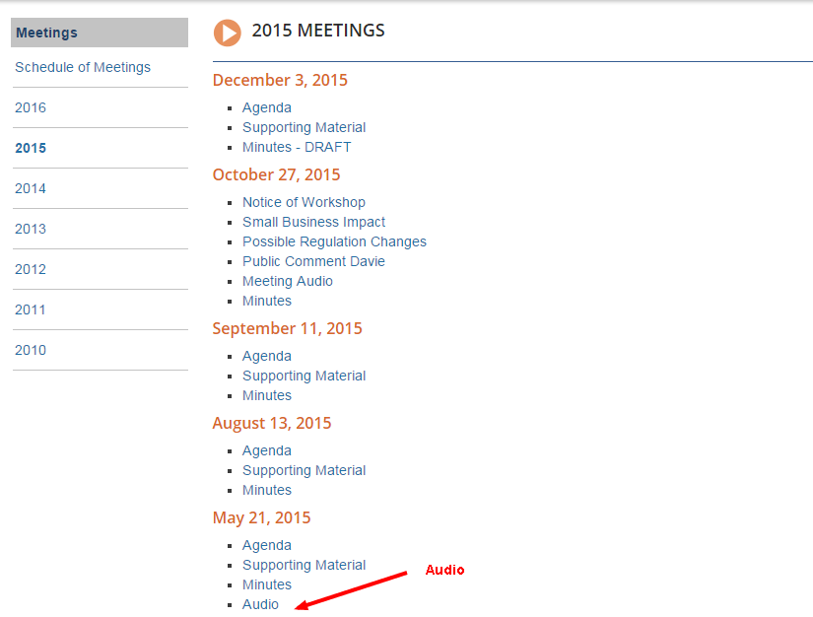

JAWS Evaluation:
- The agendas, minutes all readable by JAWS
- Multiple meetings on a page worked ok

Audio files were OK
Possible Resolution:
- text script (text equivalent) required for all audio & video files

Testing criteria #6: Online Form test (Form Stack forms using IFRAME to embed into webpage
- On-Line form test
  - Can you open & complete a couple of the on-line forms? (do not need to submit)
    - Each form has a lot of fields & most are quite lengthy
      - Is this form easy to navigate?
  - Is the alternate text descriptive enough to provide a meaningful grasp of the content?
  - Does this on-line forms present any problems for compliance?
- Suggestions

Online forms
Test page/Link: On-line forms using FormStack tool - this page contains links to FormStack Forms. 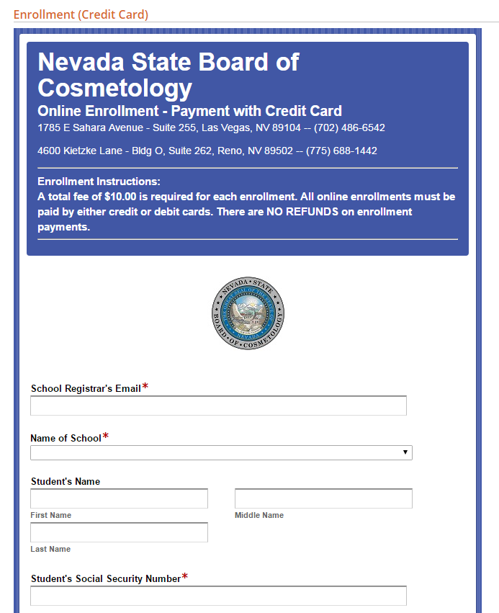

JAWS Evaluation:
- Forms are quite lengthy
- Does NOT identify the field type prior to entering your cursor into the field
- Submit form says, “Rightwards arrow button” instead of submit

Possible Resolution:
- Work with user to see if these can be fixed as Form Stack is not a tool we recommend. User just went out on their own to find it. Formstack claims to be the only third-party online form builder that Section 508 certified. Specific Formstack Information on Accessibility.
- If forms cannot be fixed, recommend NOT ALLOWING this type of form/tool in our environment

Testing criteria #7: Interactive Google Maps (embedded)
- Contact information located at top of page with two additional sections each containing information
  - Can you read the information (office hours, address, phone, fax)
  - Can you read the Interactive Google map to the designated locations?
- If you cannot read the map, is there anything you recommend that can replace the existing ones?
Test page/Link:
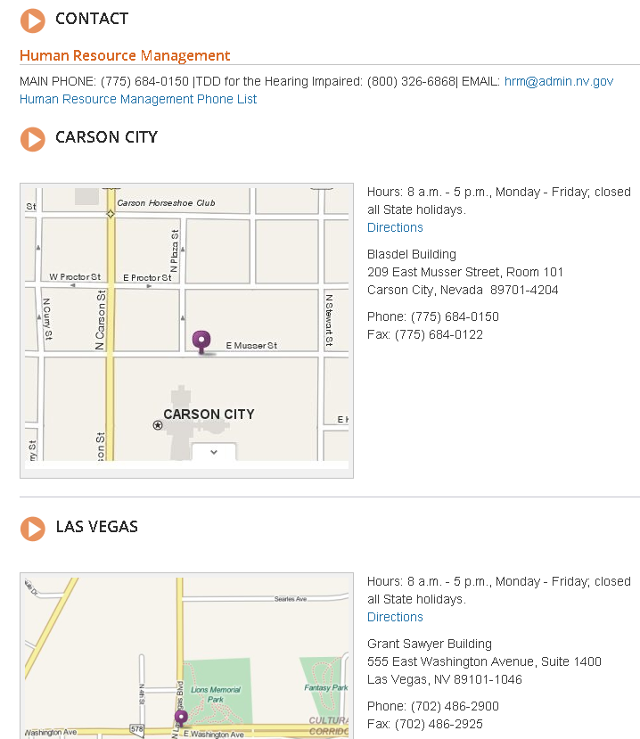

JAWS Evaluation:
- Does not drive – so test was invalid

Possible Resolution:
- Ask BRETT if he can at least see the map (see #9 for additional testing requests)

Testing criteria #8: Video Test
- Were you able to open and listen to the video file?
Test page/Link:
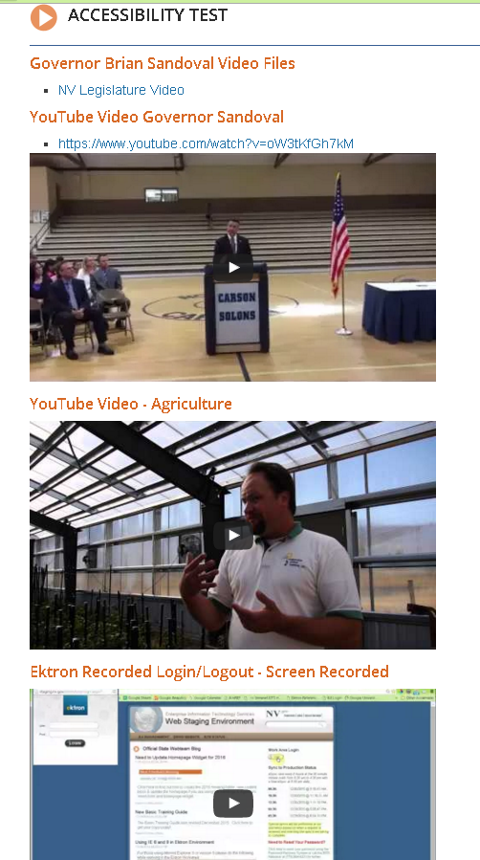

JAWS Evaluation:
- Bad test -- add new videos or links to valid one
- JAWS had no issues with any of these videos. Though anyone relying on closed captioning would find only one of these videos accessible.

Possible Resolution:
- Make closed captioning available on all videos/webinars

Testing criteria #9: Embedded content (IFRAMES) –
- test to ensure they can be seen & manipulated w/JAWS
- #7-Embedded map – Can he see the map
- #1-FLICKR – can he see the photos in FLICKR? (I am guessing he can interpret the name of the photo-if they do not give it a description, then he will just see a #)
- #6 Form stack On-Line embedded forms
  - Contact Cosmetology & ask them if they can add descriptions – if yes, then have them add & retest
- #9 Google Docs – See if those embedded forms work
- #8 Retest Video – after you fix page or direct him to a new one

Embedded iframes
Test page/Link:
- #7-Google maps
- #1-FLICKR
- #6-Formstack
- #9-Google Docs (Survey) (LINDA-update alt text 1st)
- #8-Video -

JAWS Evaluation:
- #7-Google maps
- #1-FLICKR
- #6-Formstack
- #9-Google Docs
- #8-Video

Possible Resolution:

PREVIOUS TESTING:

4/21/15 NCL homepage
- Carousel had alternate text on graphics but they were P1, P2, which is meaningless

12/14/15: Statutes & Regulation link is directed to a PDF
- Cannot read the entire document (Possibly not OCRed properly)
- Adobe WILL NORMALLY let JAWS know how many pages the document contains
  - Askif he wanted to infer reading order
  - Ask which pages of the document he wanted to read, etc.
  - THIS DOCUMENT DID NOT DO THIS

- Summary of issues/recommendations of test results:
- Assumption that we are ONLY responsible for agencies that are using our CMS environment that are using our Ektron templates. Sites like NDOW, Courts, Insurance are not included as well as other sites that users have done themselves or had outside vendors build & support.
- Need to identify document types to make it easier for disability
  - Review Smart forms to see if they can be modified to:
    - Require users to add document type
Estimated completion time: TBD
- Need to make sure TABLES within CMS have been built to ADA specifications (add link)
  - Once they are, Tables work perfectly
  - Need to ensure all users have updated their TABLES to be ADA compliant
  - See procedures
Estimated completion time: TBD
- Need to test a GOOGLE doc or On-Line form & see if they have the same issues as Form Stack
  - Decide NOT to allow these on-line forms in our environment if they are NOT ADA compliant
    - Risk if we do
    - Are we responsible for compliance if agencies select to use these options - mandated by Legislature to be on-line
  - Find a solution
- Need to learn more about ADOBE and how to OCR documents for readability
  - Ensure that changing LANGUAGE ONLY makes it readable
  - Ensure it gives JAWS the extra prompts that Brett mentioned in 12/14 , 2:49pm memo
  - Adobe FormsCentral retired its form builder on July 28, 2015. Appears Form Stack is the best replacement and it claims to be 508 Compliant, however, we are getting WAVE errors on a few of the Form Stack documents we tested
- Need to evaluate Social Media (Twitter, FLICKR, Facebook)
  - FLICKR -Just want him to tell us if HE CAN VIEW them with JAWS
JAWS reads out alternative text
  - WAVE identifies the Twitter Feed as an iFrame.
- Need to evaluate ALL Embedded IFRAMES (Twitter, Google Docs, APPS)
  - We are trying to test IFRAME visibility
- The content of an inline frame is read as if it were part of the page that contains it. The content of the iframe must be accessible. A title attribute value for the iframe will generally be read by a screen reader when the iframe is encountered. Ensure that the content within the iframe is accessible. Optionally, a title attribute value can be added to provide a brief, advisory description of the iframe.
    - WEBAIM techniques for Creating Accessible Frames and iFrames
    - JAWS was able to read the queries on Full List Data as well as the Google Form at ____________________ with no issues, Though the column header for Status should read License Status as it was a bit unclear.

