- Testing criteria #1: Tables, Documents (word, PDF), page contrast, YouTube Video, FLICKR
- Any issues with reading the table (with 4 columns, 8 rows) that contains 4 word docs, 7 PDFs
- Any contrast issues on the page – Only individuals who have low vision issues are normally affected by contrast issues.
- Can documents be opened and read? If not,
  - Which documents had an issue?
  - What was the Issue(s)
- Can the YouTube video be viewed? JAWS found no issues with the videos on. However for those who rely on closed captioning only one of the 4 videos would be accessible.
- Can the FLICKR photo be viewed?
- Does either the YouTube or FLICKR present unique challenges? Not for JAWS
- Any comments, recommendations
Test page/Link:
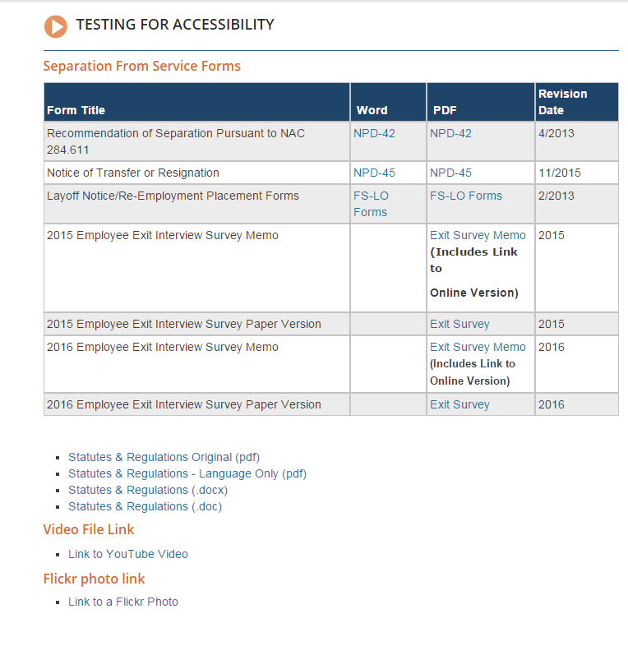
JAWS Evaluation:
- 1/7 1:02pm -Page was great. Even navigated the Exit Survey & it worked perfectly
- Table was already ADA compliant & that worked
- Flickr – The photo opened and identified the photo of Governor Sandoval and it also provided JAWS options to share, like or download.
- YouTube – would be helpful if we could display a pause button so users could stop the audio to hear JAWS as it was difficult to hear JAWS over the videos. It didn’t completely walk on JAWS but did make it more difficult. Recommend making the pause, play, forward, back buttons so they are identifiable by JAWS.
  - Played, but sound quality was very bad (might have been his speakers or microphone on camera because when he used headphones he could hear it properly & everything worked properly – poor quality sound was due to the use of a microphone without a speaker.
Possible Resolution:
- NEED to test Social Media (FLICKR, YouTube, TWITTER, Facebook)
- text script (text equivalent) required for all audio & video files
- Some YouTube videos are Closed Captioned which makes them accessible to more individuals. You will see (CC) in the description if a YouTube video is compliant (see below). On video page we added a closed captioned video for testing purposes.
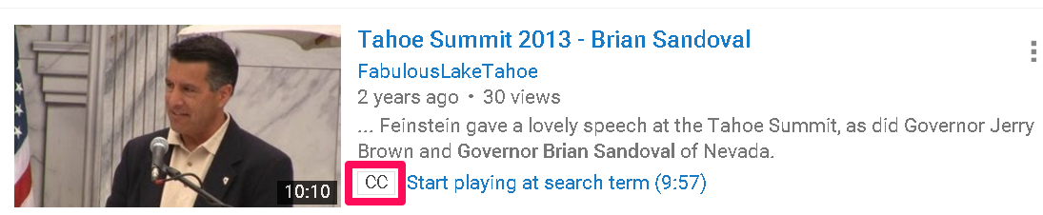
- NEED to make sure Users make their Tables ADA compliant

Procedure on creating Accessible Tables

