Testing criteria #2: Governor’s proclamations that are an images, then is PDF, then added to website
- Single proclamation that is a PDF of an Image of the Proclamation
  - Can you read the proclamation?
  - Is the alternate text descriptive enough to provide a meaningful grasp of the content?
  - Does JAWS identify any issues?
Test page/Link:
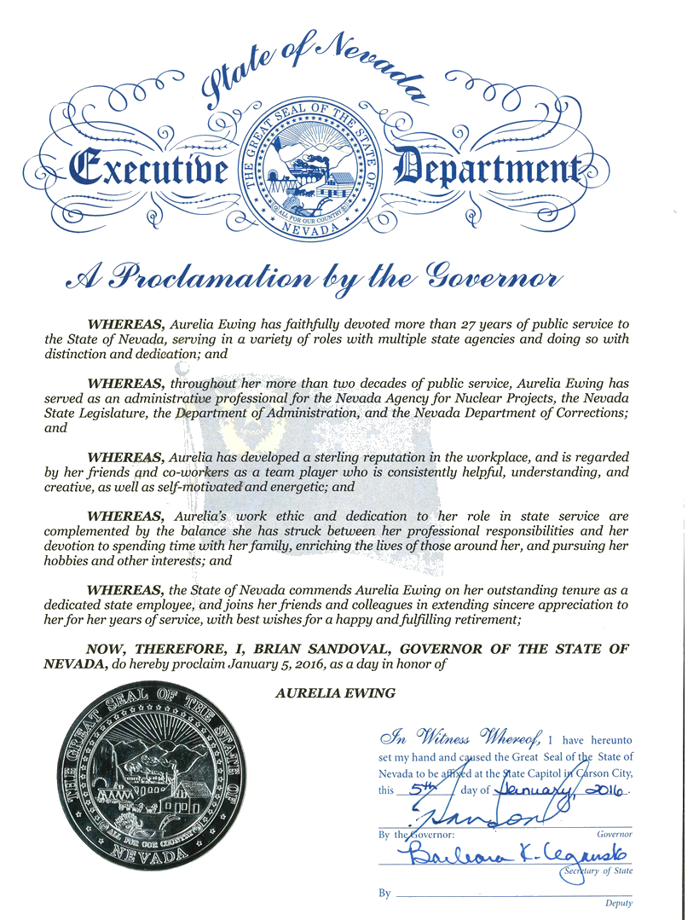
JAWS Evaluation:
- JAWS could only recognize the alternate text (title)
Possible Resolution:
- Put text of proclamation in a ‘long description field’ (NOT best solution)
- Do not use graphic/image for Proclamations (Best solution)
  - Create template to enter content like with a Press Release
  - Attach PDF of current proclamation graphic, if needed
