Testing criteria #3: Various types of links (Word, PDF)
- Page contains two paragraphs, 6 links at bottom
  - Link 1 – excel document
    - Can you open the document
    - Can you traverse it?
  - Links 3, 5, 6 – link to PDF
    - Can you open the documents?
    - Can you traverse them?
Test page/Link:
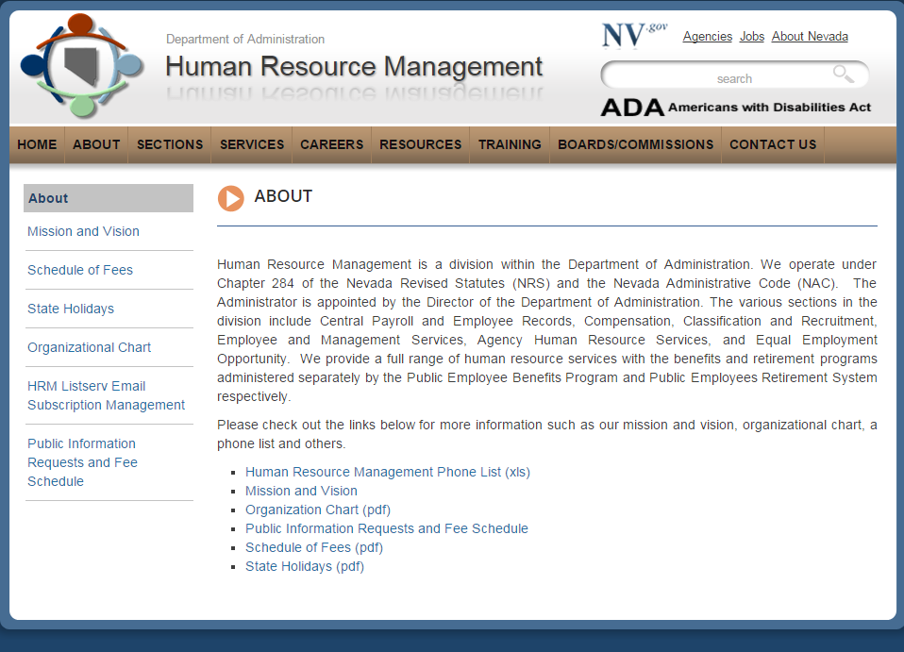
JAWS Evaluation:
- Everything opened fine
- Human Resource Management Phone list (xls)
  - Needs to add AREA Codes
- Organization Chart (pdf)
  - # on top are meaningless
  - In some places in the document the text reads as if there are no spaces. For instance, it reads like this, “himynameisbrettsilver IworkforthestateofNevada.
Possible Resolution:
- Area codes should always be included
Decide if Organization charts in this format should be included

