Testing criteria #5: Multiple section headings on a web page – should we identify type of documents
  - Page contains 7 section headings, each containing a paragraph and a link (ignore if they go to hmtl pages)
  - Does the page present any contrast issues?
    - If yes, what are the issues?
  - Would it be helpful for JAWS if each link was identified (PDF, WORD, EXCEL, etc?)
Test page/Link:
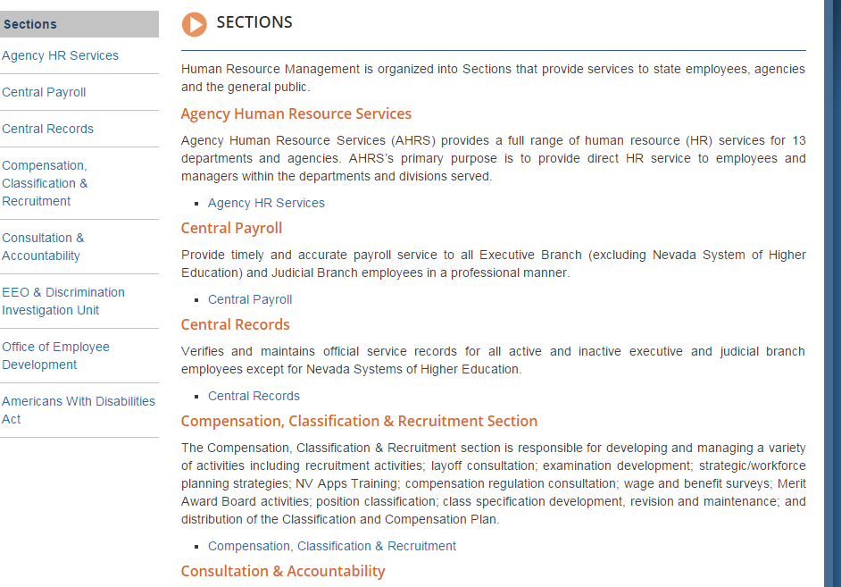
JAWS Evaluation:
- Yes, identifying the type of document will be helpful
Possible Resolution:
- Add type to document – Review Smart forms & determine if we can make some changes to the add the type & make it required

