Testing criteria #6: Meetings template, documents (Agendas, Minutes, Attachments) & Audio files
- Meeting Page, lists 7 meeting dates, each followed by an agenda
  - Agenda
  - Supporting Materials
  - Minutes
- Last 3 meetings include an Audio file
  - Were you able to access & listen to the audio files?
Test page/Link:
The test page lists 7 meeting dates, each followed by an agenda, supporting materials, and minutes. In addition the last three meeting dates include an audio file. Does JAWS identify any issues on the page and in particular were you able to access the listen to the audio files? 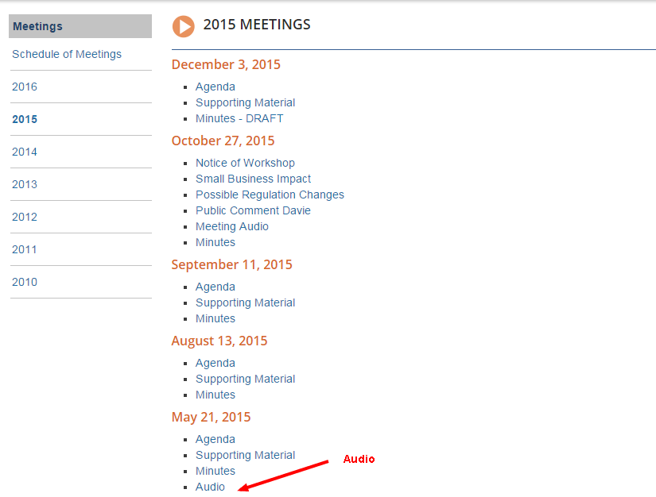
JAWS Evaluation:
- The agendas, minutes all readable by JAWS
- Multiple meetings on a page worked ok
- Audio files were OK

Possible Resolution:
transcript (text equivalent) required for all audio & video files

