Testing criteria #7: Interactive Google Maps (embedded)
- Contact information located at top of page with two additional sections each containing information
  - Can you read the information (office hours, address, phone, fax)
  - Can you read the Interactive Google map to the designated locations?
- If you cannot read the map, is there anything you recommend that can replace the existing ones?
Test page/Link:
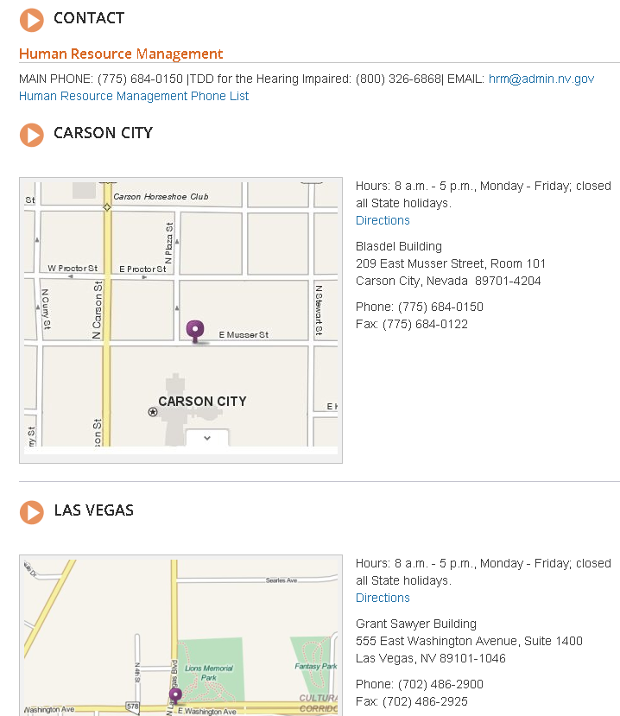
JAWS Evaluation:
- Does not drive – so test was invalid

Possible Resolution:
Ask BRETT if he can at least see the map (see #9 for additional testing requests)

