- Testing criteria #8: Video Test
- Were you able to open and listen to the video file?
Test page/Link:
On http://it.nv.gov/Sections/Application_Development/Web/Test/VideoTest-Accessibility/

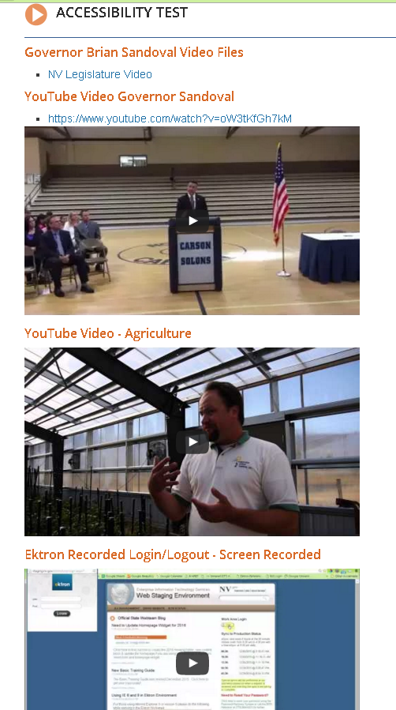
JAWS Evaluation:
- Bad test -- add new videos or links to valid one
- Ready for new test

Possible Resolution:

