Homepage Error – Link contains no text
Where the error appears on the site (top-left corner where logo or state seal is located):
Code that generates the error:
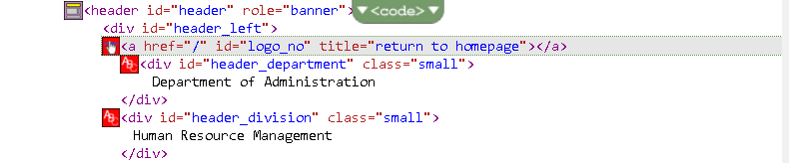
Recommended Solution:
None at this time.

