Homepage Error: Missing Form Label

a form label does not have a corresponding label
Where the error appears on the site (top-right corner in Search Box)
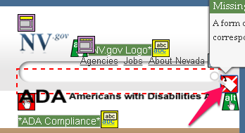
Code that generates the error:
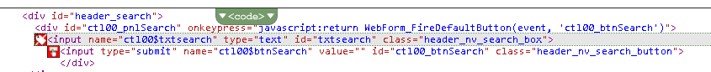
Recommended Solution: add the labels highlighted in yellow below to the template
<div id="header_search"><asp:Panel runat="server" ID="pnlSearch" DefaultButton="btnSearch"><asp:TextBox ID="txtsearch" CssClass="header_nv_search_box" title="Search" placeholder="Search" runat="server" ClientIDMode="Static"> </asp:TextBox><asp:Button ID="btnSearch" runat="server" Text="" CssClass="header_nv_search_button" /></asp:Panel></div>
Template Changed: Layouts/Master/nevada.master

