Homepage Error – Linked image missing alternative Text

Where the error appears on the site (initiative box photo)

Code that generates the error:
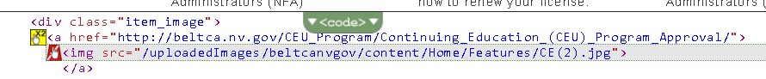
Recommended Solution: add the labels highlighted in yellow below to the template
<div class="initiative_item_title">
<div class="title_small"><xsl:copy-of select="./title_top"/></div>
<div class="title_large"><a href="{./url}" ><xsl:value-of select="title_bottom"/></a></div>
</div>
<div class="item_image"><a href="{./url}"><img src="{./image}" title="{./title_top}" alt="{./title_top}"/></a></div>
<div class="item_text"><xsl:value-of select="description"/></div>

Location: XMLFiles/initiative_boxes.xslt & XMLFiles/initiative_boxes_home.xslt

