Homepage Error – Spacer Images missing alternative Text

an image without alternative text results in an empty link.

Where the error appears on the site (bottom right-corner - Translation)
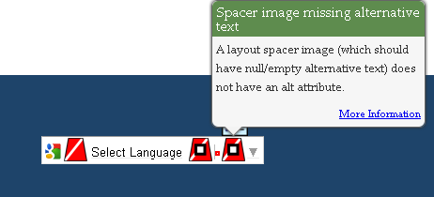
Code that generates the error:
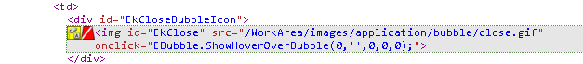
Recommended Solution: Ektron provided the script to be added to the template at /Workarea/java/ajax.js – however it does not resolve the problem.
Added the code below after line 93 – to resolve the close.gif image not having alternative text (fixed 2 locations).
<script>
document.getElementById("EkClose").title = "Alternative Text";
</script>
Location: /Workarea/java/ajax.js

