Homepage Error – Missing alternative text - image alternative text is not present..
Where the error appears on the site (bottom-right in Translation section):
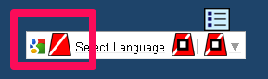
Code that generates the error:
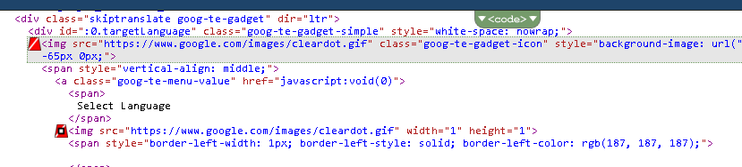
Recommended Solution:
/workarea/java/ajax.js - added the code below after line 93 – to resolve the close.gif image not having alternative text (2 locations).
<script>
document.getElementById("EkClose").title = "Alternative Text";
</script>

