Homepage Error – Missing alternative text - image alternative text is not present..
Where the error appears on the site (bottom-right in Translation section):
Code that generates the error:
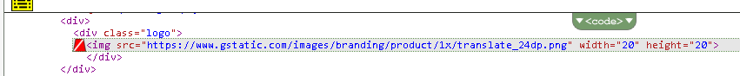
Recommended Solution:
None at this time.

