State of Nevada

American Disability (ADA) Remediation Efforts

Updates – February 13 – to Present  
Website: [http://ada.nv.gov](http://ada.nv.gov/)

Department of Administration – Division of Information Technology (EITS)  
EITS Enterprise Web Team - Linda M DeSantis, Manager  
February 13, 2018

Table of Contents

December 2017 to present 3

Our Goal: 3

First ADA Partner Meeting: 3

December 1, 2017 3

Our ADA Partners: 3

ADA Partner Meeting with Co-Chairs– December 2017: 3

December 20, 2017 3

ADA Partner Meetings & Enhancements – January 2017: 4

January 9, 2018 4

January 11, 2018 4

ADA Remediation Snapshot 4

State of Nevada CMS Website Accessibility Tracking Log 5

State of Nevada Remediation Efforts 5

State of Nevada Remediation Efforts: 6

Assistive Technology (AT) Consumers 7

January 18, 2018 9

ADA Partner Meetings & Enhancements – January 2017 (continued): 10

January 26, 2018 10

ADA Partner Meetings & Enhancements – January 2017 (continued): 11

Website and Digital Media Accommodations 13

Physical Accommodations 14

ADA Partner Meetings & Enhancements – February 2017: 15

February 1, 2018 15

February 11, 2018 15

February 12, 2018 15

Moodle ADA Training Class (Section 1) 16

Moodle ADA Training Class (Section 2): 17

Moodle ADA Training Class (Section 3): 18

Moodle ADA Training Class (Section 4): 19

Moodle ADA Training Class (Section 5): 20

Moodle ADA Training Class (Section 6): 21

Moodle Training Class Resources: 22

ADA Partner Meetings & Enhancements – February 2018 (continued): 23

February 16, 2018 23

February 17, 2018 23

February 18, 2018 – ADA Status: 23

February 20, 2018 23

February 21, 2018 24

February 22, 2018 24

February 25, 2018 – 25

March 6, 2018 25

March 6, 2018 – ADA Status: 25

March 7, 2018 26

March 7, 2018 26

ADA Chronological History Summary 2001 - 2016 27

Future Goals: 27

ADA Remediation Efforts

December 2017 to present

## Our Goal:

Our goal is to make all of the State of Nevada websites meet Section 508 and WCAG 2.0 requirements and provide proven ADA training, outreach and support to State of Nevada websites to meet the ADA compliance laws.

## First ADA Partner Meeting:

December 1, 2017**,** we had our first [State of Nevada ADA meeting](http://ada.nv.gov/Partners/Meetings/). State of Nevada [partners](http://ada.nv.gov/Partners/Partners__State_of_Nevada/) included Shannon Rahming, CIO, Division of Enterprise IT Services; David Haws, Deputy Administrator (EIS), Suzie Block, Chief IT Manager, Agency IT Services (EITS); EITS Web Team, and representatives from the Governor’s Office, Attorney General’s Office, Department of Human Resources, Department of Education and Division of Library and Archives.

Thomas Kearns from the Office of Disabilities Services, and Assistive Technology Consumers (AT Consumers) were also present. During this meeting Thomas Kearns was named a Co-chair (AT Consumers) along with Linda DeSantis (State of Nevada).   
  
The Division of Information Technology Services, Enterprise Web team is excited to have this great opportunity to work with numerous agencies throughout the State of Nevada; with Thomas Kearns from the Office of Disabilities Services at Truckee Meadows Community College, and the Assistive Technology consumers that have volunteered to work with us to test our websites and validate that they are ADA complaint to everyone.

## Our ADA Partners:

Our ADA Partners consist of individuals who are working to make State of Nevada websites and digital media Section 508 and WCAG 2.0 compliant and to provide ADA physical accommodations. For a complete list of all members, please click on the links for each group.

* [State of Nevada Partners](http://ada.nv.gov/Partners/Partners__State_of_Nevada/)
  + Linda M DeSantis – Co-chair
* [State of Nevada – Equal Employment Opportunity Office](http://ada.nv.gov/Partners/Partners_EEO/) (EEO)
  + Amy Taylor – EEO Administrator
* [Office of Disability Services](http://ada.nv.gov/Partners/Partners_TMCC/) – Truckee Meadows Community College (TMCC)
  + Thomas Kearns – Co-Chair
* [Assistive Technology Consumers](http://ada.nv.gov/Partners/Partners_TMCC/) (AT Consumers)
  + Mona Coker – Co-Chair

## ADA Partner Meeting with Co-Chairs– December 2017:

December 20, 2017, the co-chairs Linda DeSantis (State of Nevada) and Thomas Kearns (Office of Disabilities Services TMCC) met to discuss strategies and to develop a plan to move this effort forward. Items discussed included previous efforts and where they failed, lessons learned, and what the main goals we could work on first. Thomas also gave us questions we could ask vendors if we are [purchasing software or having your websites built from vendors to ensure their products are ADA complaint](http://ada.staging.nv.gov/Compliance/Resources/).

# ADA Partner Meetings & Enhancements – January 2017:

January 9, 2018**,** our newly hired Public Intern started to work with the EITS web team to assist in our ADA Efforts (20 hours, 24 minutes a week)

1. We asked the Intern to follow the instructions in our [Training for ADA Documentation Remediation documentation](http://ada.nv.gov/uploadedFiles/ada,nvgov/content/Home/Features/PDF-ADA-RemediationTraining.pdf) (pdf) and provide us with feedback. This document is going to be one of the tools we want to give our Agency users and wanted to make sure it clear, easy to follow, and had enough information for users to accomplish the remediation of *documents (see Things Users Can do to start making their websites ADA compliant (below)* 
   1. This document covers “What is Web Accessibility?”
   2. ADA webinar the EITS team built to get users familiar with ADA
   3. How to obtain a library card so they have access to Lynda.com training for Free
   4. This document walks users through the remediation of Microsoft Documents (Word, PPT, Excel, PDF)
2. Our intern was able to navigate through the training, and succeeded in making several Word, Excel and PDF documents compliant

This information is located on the homepage of our State of Nevada American Disability (ADA) Remediation Efforts website under [THINGS USERS CAN DO to start making their websites ADA Compliant](http://ada.nv.gov/uploadedFiles/ada,nvgov/content/Home/Features/PDF-ADA-RemediationTraining.pdf), along with other information to help users when they begin to remediate their websites.

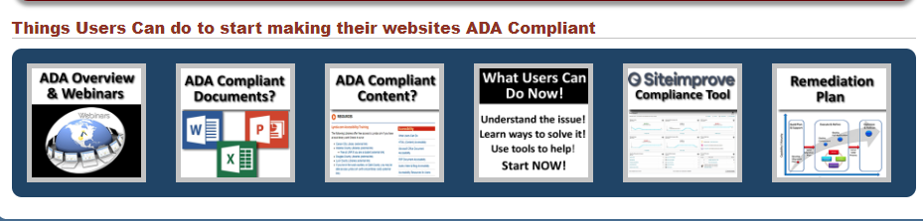

January 11, 2018the web staff made some modifications to the [ADA website](http://ada.nv.gov).

ADA Remediation Snapshot

This snapshot is a quick summary of the State of Nevada CMS Website Accessibility Tracking Log of the Total # of Websites in our CMS, # of sites being remediated, # of sites that are ADA Compliant, and # of Sites that need to be remediated.

***Note: the State of Nevada is striving for all content to meet the standard A & AA compliance, however, we are trying to meet AAA complaint, whenever possible***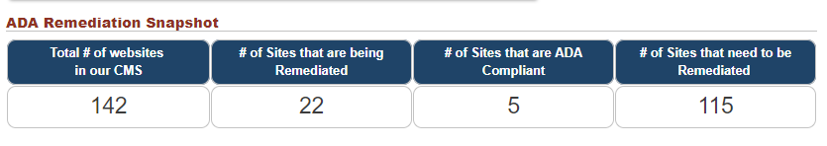

# State of Nevada CMS Website Accessibility Tracking Log

This report contains a [list of all websites that reside in the State CMS, and the website status](http://ada.nv.gov/uploadedFiles/ada,nvgov/content/Home/Features/CMS-AccessibilityTrackingLog.pdf):

1. Website Remediation **Not Started**
2. Website Remediation **In Progress**
3. **Website is ADA Compliant**

Other statuses that **are not being tracked** (sites that were renamed or moved away from our CMS or never went to production):

1. **Website turned OFF**
2. **Website has been Redirected**
3. **Intranet site**

# State of Nevada Remediation Efforts

By clicking on the link below, it will take you to our Remediation Efforts page (see below)****

[What is an ADA Compliant Website](http://ada.nv.gov/Remediation/ConformanceSeverityExplanations/)? A brief overview of ADA compliance, Section 508 and WCAG 2.0, and conformance levels (A, AA, AAA)

[Siteimprove Site Accessibility Status/Progress Reports](http://ada.nv.gov/Remediation/ProgressRpts/) Site improve evaluation reports used to update compliance status  
  
On our Remediation Efforts page, we are tracking multiple types of websites.

1. Websites that are monitored by our Siteimprove tool
   1. Department of Education websites
   2. Official State of Nevada Website
2. Prototype and new sites that are not in production yet
3. Websites that monitored by our Siteimprove tool
4. Department of Administration websites
5. Boards & Commissions

EITS Remediation Efforts to Date

1. Remediation Efforts (History)

Compliant training, Lessons Learned & What Users can do information

[Complete list of State of Nevada Website Accessibility Tracking log](http://ada.nv.gov/uploadedFiles/ada,nvgov/content/Home/Features/CMS-AccessibilityTrackingLog.pdf)

# State of Nevada Remediation Efforts:

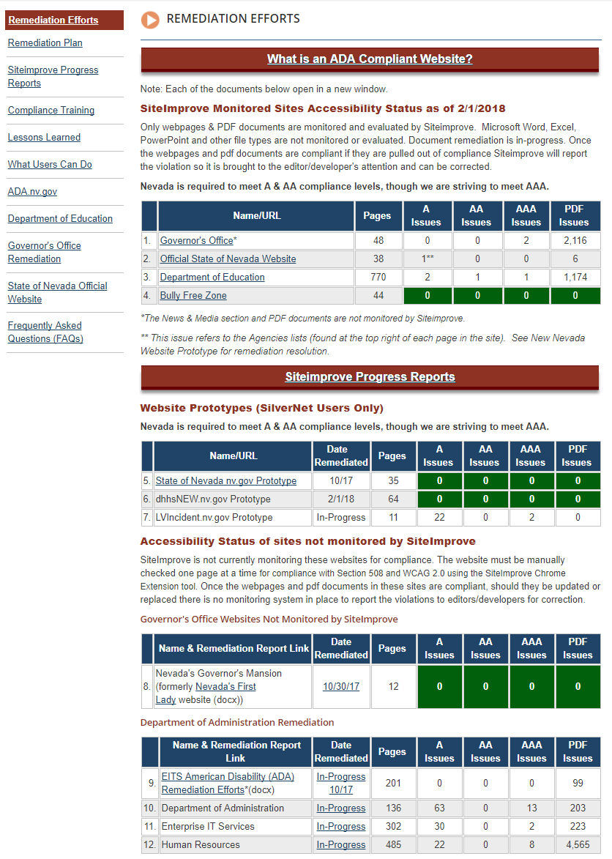

URL of Remediation Efforts: <http://ada.nv.gov/Remediation/Efforts/>

# Assistive Technology (AT) Consumers

Welcome to the Assistive Technology (AT) Consumers and special thanks to all of you who have graciously volunteered to work with the State of Nevada to assist in making the State’s website ADA compliant. Your efforts are greatly appreciated. This section has been built for the AT Consumer’s convenience while helping us test.

1. We have also added a new [AT Consumer section](http://ada.nv.gov/ATConsumers/AT_Consumers/) for your convenience. It is here that we will be posting new forms, new testing needs, and we have also built a new [ADA Evaluation Form for AT Consumers](http://ada.nv.gov/Remediation/2018/ADA_Complaint_Form-WebsiteDigitalMedia/) users to make it easier to evaluate any testing you perform for the State of Nevada.
2. After the testing of the complaint forms, the next most important area that we would like to have tested is our [Smart Form Configurations (Templates)](http://ada.nv.gov/Remediation/2018/AT-Consumer-Testing/). These templates have been created in one of the Department of Education’s websites as that site is being monitored by Siteimprove and it makes it easier for us to make it compliant and keep it compliant. All of these templates are used in 95% of the websites within the State of Nevada’s Content Management System (CMS).   
     
   Once these templates are tested and certified, we will be able to do outreach to all of the other agencies that have websites in the State CMS and train them how to make their current websites compliant.

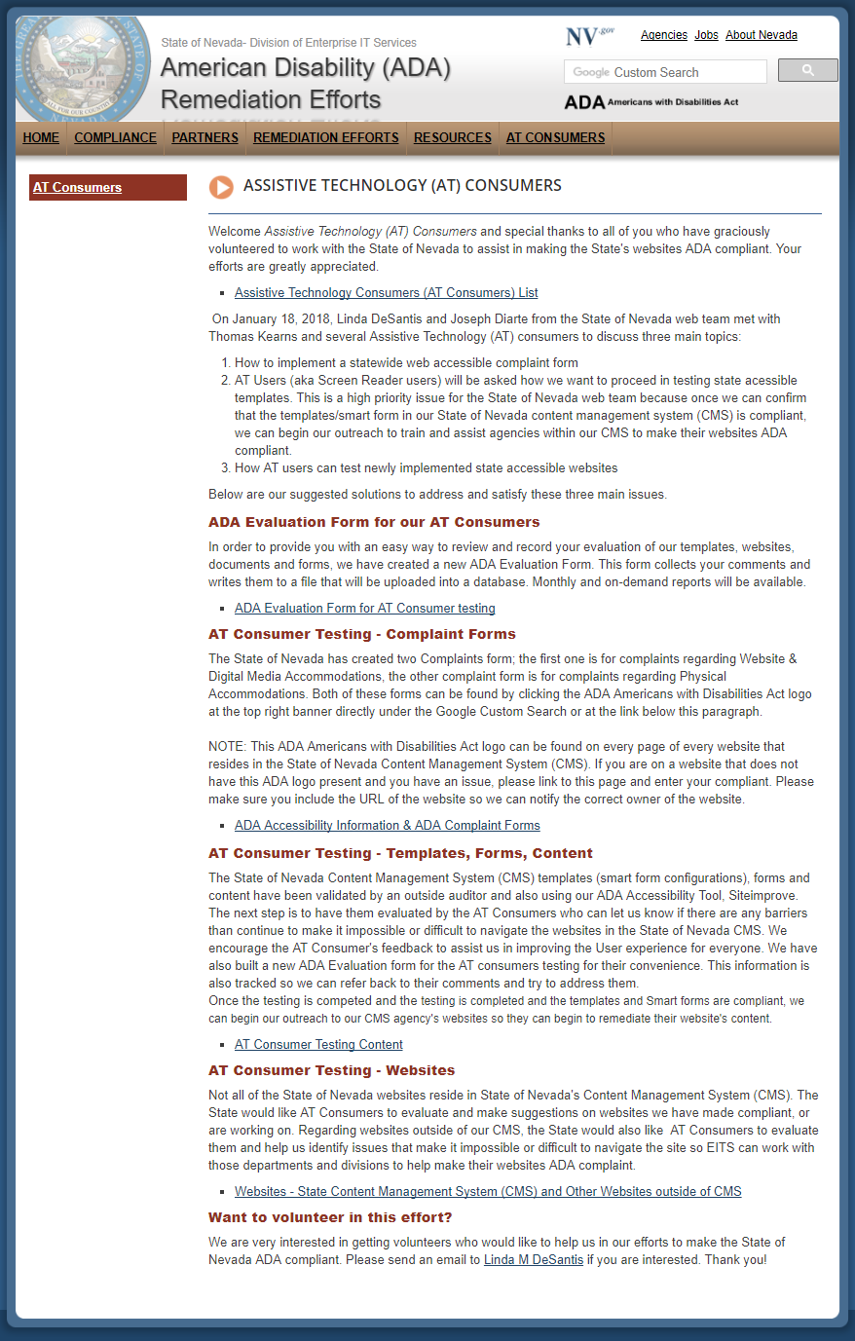URL of Assistive Technology (AT) Consumers page: <http://ada.nv.gov/ATConsumers/AT_Consumers/>

January 18, 2018, Linda DeSantis and Joseph Diarte from the State of Nevada web team met with Thomas Kearns and several Assistive Technology (AT) consumers to discuss three main topics:

1. How to implement a statewide web accessible complaint form
2. AT Users (aka Screen Reader users) will be asked how we want to proceed in testing state accessible templates. This is a high priority issue for the State of Nevada web team because once we can confirm that the templates/smart form in our State of Nevada content management system (CMS) are compliant, we can begin our outreach to train and assist agencies within our CMS to make their websites ADA compliant.
3. How AT users can test newly implemented state accessible websites
4. Below are our suggested solutions to address and satisfy these three main issues.
5. Partner Meeting Agenda and Meeting Minutes can be found on the [ADA Partner Meetings](http://ada.staging.nv.gov/Partners/Meetings/).

# ADA Partner Meetings & Enhancements – January 2017 (continued):

January 26, 2018, EITS team came up with the following solutions to satisfy the requests from January 18 meeting:

1. The [Accessibility Information page](http://ada.nv.gov/Home/Features/Accessibility_Information/) (see below) has been updated to accommodate the following changes. One of the major changes is that we moved the Complaint form links to the top of the page and separated the complaints into two separate forms as we felt they were looking for different information.  
   1. The first complaint form is for registering a complaint regarding [Website and Digital Media Accommodation](http://ada.nv.gov/Remediation/2018/ADA_Complaint_Form-WebsiteDigitalMedia/)
   2. The second complaint form is to register a complaint regarding [Physical Accommodations](http://ada.nv.gov/Remediation/2018/ADA_Complaint_Form-WebsiteDigitalMedia/)
2. You can find this updated Accessibility Information page by going to the [State of Nevada American Disability (ADA) Remediation Efforts website](http://ada.nv.gov/).  
   Once you are there, please click on the ADA Americans with Disability Act logo [Title: ADA logo - Description: Americans with Disabilities Act (ADA) Accessibiity Information](http://ada.nv.gov/Home/Features/Accessibility_Information/)in the upper right hand banner located under the Google Custom Search.

***NOTE: This ADA Americans with Disability Act logo is in the same place on every page of every website that is located in the State of Nevada Content Management System (CMS). Currently other websites that have been built outside of the State of Nevada’s CMS do not have this logo, so please come to the State of Nevada American Disability (ADA) Remediation Efforts website and register your complaint there. Efforts to request that all State of Nevada websites have this logo on their site is upcoming.***

1. Once the submit button is clicked on either complaint form, the information collected in these forms will be written to the Google Drive (a secure cloud). It will then send an email to the following:
   1. Website & Digital Media Accommodation Complaint Form *- Email sent to EITS web team & response back to person who filled out the form thanking them for taking the time to fill out the form*
   2. Physical Accommodation Complaint Form - *Email to Amy Taylor & Tammy Smith & response back to person who filled out the form thanking them for taking the time to fill out the form*

By using this process, it will allow us to collect information in a format that we can reviewed and tracked. Our process for handling these complaints are as follows:

**Step 1**: Identify the website that the complaint is about and:

* + 1. Forward the complaint to the appropriate department, division, board for resolution
       1. Let the complaintant know who their complaint has been forwarded to as they will
    2. If department, division, board does not have an ADA logo
       1. We will request they add a copy of ours on their website so when someone needs to make a complaint, it will be emailed to the EITS and EEO staff for distribution
    3. Offer to familiarize the State of Nevada department, division or board the State of Nevada ADA information and suggest how they might be able to resolve the issue
       1. Send them to the [State of Nevada (ADA) Remediation Efforts website](http://ada.nv.gov) so they can view   
          “Things Users can do to start making their websites ADA Compliant
       2. Go to [State of Nevada (ADA) Remediation Efforts website, Resources](http://ada.nv.gov/Compliance/Resources/) to find tools, training opportunities, accessibility checkers and other helpful information
       3. Share our ADA Accessibility Training Checklist

# ADA Partner Meetings & Enhancements – January 2017 (continued):

* + 1. Track progress of complaint
    2. Generate a monthly report of:
       1. Number of complaints received
       2. What type of Complaint was it?
          1. Website and Digital Media
          2. Physical Accommodations
       3. Who was the complaint forwarded to
       4. Status of the complaint

**Step 3**: Provide monthly reports to management, and add statistical information on the [ADA Remediation Efforts website](http://ada.nv.gov).

[Updated Accessibility Information Page](http://ada.nv.gov/Home/Features/Accessibility_Information/)   
[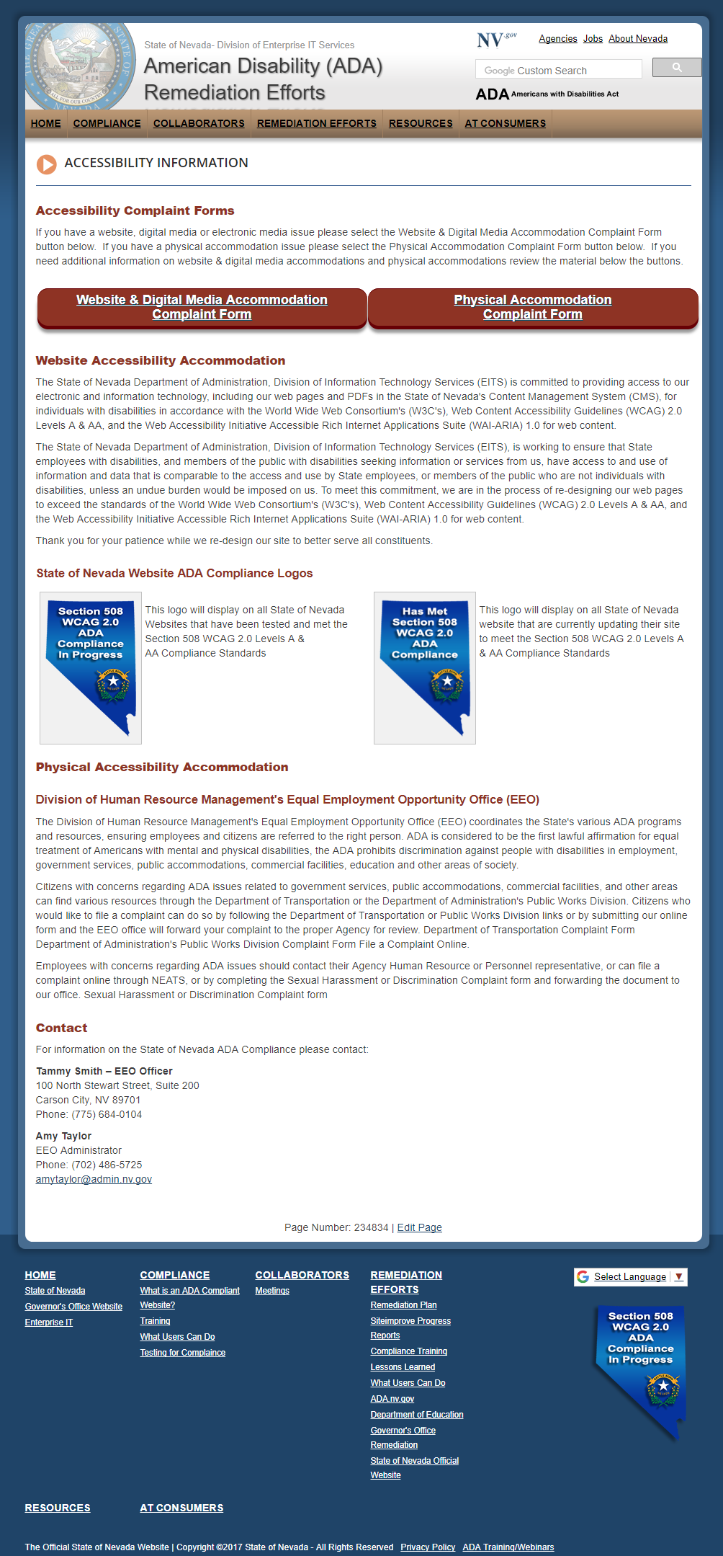](http://ada.nv.gov/Home/Features/Accessibility_Information/)  
URL of Accessibility Information page: <http://ada.nv.gov/Home/Features/Accessibility_Information/>

## Website and Digital Media Accommodations

The State of Nevada Department of Administration, Division of Information Technology Services (EITS) is committed to providing access to our electronic and information technology, including our web pages and PDFs in the State of Nevada's Content Management System (CMS), for individuals with disabilities in accordance with the Section 508 and World Wide Web Consortium's (W3C's), Web Content Accessibility Guidelines (WCAG) 2.0 Levels A, AA & AAA whenever possible, and the Web Accessibility Initiative Accessible Rich Internet Applications Suite (WAI-ARIA) 1.0 for web content.

The State of Nevada Department of Administration, Division of Information Technology Services (EITS), is working to ensure that State employees with disabilities, and members of the public with disabilities seeking information or services from us, have access to and use of information and data that is comparable to the access and use by State employees, or members of the public who are not individuals with disabilities, unless an undue burden would be imposed on us. To meet this commitment, we are in the process of re-designing our web pages to exceed the standards of the World Wide Web Consortium's (W3C's), Web Content Accessibility Guidelines (WCAG) 2.0 Levels A, AA & AAA whenever possible, and the Web Accessibility Initiative Accessible Rich Internet Applications Suite (WAI-ARIA) 1.0 for web content.

Thank you for your patience while we re-design our site to better serve all constituents.

The State of Nevada's Content Management System (CMS) is Ektron. Currently that CMS supports 142+ websites. Our goal is to make all websites and digital media in our CMS ADA Section 508 WCAG 2.0 compliant.

This is a huge undertaking for the web group, especially because we are using free ADA evaluation tools, WAVE and Siteimprove. Both free tools evaluate ONLY one page at a time. The tool flags errors on the page based on WCAG 2.0 Section 508 standards; categorizes by level of error; and gives recommendations on how to resolve the error. The webmaster needs to understand what must be done to resolve this issue.

The limitations of the ADA WAVE and SiteImprove tool, and the number of websites that we need to make compliant, is the reason we need to collaborate with other departments, divisions, boards and user groups in Nevada. Numerous recommendations and/or fixes made by the tool require a knowledge of that Agency’s business rules.

[Website & Digital Media Accommodation Complaint Form](http://ada.nv.gov/Remediation/2018/ADA_Complaint_Form-WebsiteDigitalMedia/)

## Physical Accommodations

Division of Human Resource Management's Equal Employment Opportunity Office (EEO)

The Division of Human Resource Management's Equal Employment Opportunity Office (EEO) coordinates the State's various ADA programs and resources, ensuring employees and citizens are referred to the right person. ADA is considered to be the first lawful affirmation for equal treatment of Americans with mental and physical disabilities, the ADA prohibits discrimination against people with disabilities in employment, government services, public accommodations, commercial facilities, education and other areas of society.

Citizens with concerns regarding ADA issues related to government services, public accommodations, commercial facilities, and other areas can find various resources through the Department of Transportation or the Department of Administration's Public Works Division. Citizens who would like to file a complaint can do so by following the Department of Transportation or Public Works Division links or by submitting our online form and the EEO office will forward your complaint to the proper Agency for review. Department of Transportation Complaint Form Department of Administration's Public Works Division Complaint Form File a Complaint Online.

Employees with concerns regarding ADA issues should contact their Agency Human Resource or Personnel representative, or can file a complaint online through NEATS, or by completing the Sexual Harassment or Discrimination Complaint form and forwarding the document to our office. Sexual Harassment or Discrimination Complaint form.

Contact

For information on the State of Nevada ADA Compliance for Physical Accommodations, please contact:

Tammy Smith – EEO Officer  
100 North Stewart Street, Suite 200  
Carson City, NV 89701  
Phone: (775) 684-0104

Amy Taylor  
EEO Administrator  
Phone: (702) 486-5725  
amytaylor@admin.nv.gov

[Physical Accommodation Complaint Form](http://ada.nv.gov/Remediation/2018/ADA_Complaint_Form-GoogleDrive/)

## ADA Partner Meetings & Enhancements – February 2017:

February 1, 2018 **meeting with Equal Employment Opportunity (EEO) group lead by Amy Taylor**

1. Had the opportunity to meet with the EEO officers in the State of Nevada
   1. There were numerous EEO officers that were from departments that had their websites outside of the State of Nevada CMS
   2. Directed everyone to the [State of Nevada American Disability (ADA) Remediation Efforts website](http://ada.nv.gov)
2. Presented EEO Officers with an overview of the ADA Remediation Efforts we have been taking since December 1, 2017.
   1. Gave everyone a handout of the State of Nevada’s efforts
      1. Located on [State of Nevada American Disability (ADA) Remediation Efforts website](http://ada.nv.gov), under [Partner Meetings](http://ada.staging.nv.gov/Partners/Meetings/)

February 11, 2018 – ***ADA Compliant 2018 Proclamations, 2016 and 2017 Emergency Orders went into production 2/11/2018.***An email from the Governor’s office stating that the non-complaint Proclamations, Executive Orders and Emergency orders can be replaced by the ADA compliant documents.   
  
Originally Proclamations, Executive Orders & Emergency Orders were posted as a graphical image and were not accessible to disabled users. Disabled users typically only find the title of the proclamation accessible to them and cannot read each paragraph as non-disabled users can. The goal of Accessibility is providing the same experience to all.

1. [Governor’s Website original issues and remediation testing](http://ada.nv.gov/Users/Gov/GovernorsOffice/" \o "Governor's Website Orginal Issues & remediation efforts)
2. [ADA Compliant Press Releases, Proclamations, Executive Orders and Emergency Orders](http://ada.nv.gov/Users/Gov/GovernorsOffice/" \o "Governor's Website Orginal Issues & remediation efforts)

February 12, 2018 – ADA Content Management Training Class in Nevada eLearn (Moodle)

Build a training class in Moodle eLearn for State of Nevada CMS users on ADA:

1. EITS Web team has put together the following training Class syllabus to be added to the Nevada eLearn (Moodle)
   1. First time on-line training for the State of Nevada CMS users, and then future refresher courses
   2. Mandatory:
      1. Everyone using the State of Nevada CMS is required to take this
      2. New Employees (part of onboarding process)
2. Training class will in user training (UT) the 3rd week of February
3. All class sessions will be an overview & several quick ways to accomplish what you are trying to do
   1. Additional documentation

# Moodle ADA Training Class (Section 1)

1. **Section 1 – Overview of ADA**
2. Outline/Preview for the State of Nevada Content Management System (CMS) users:
   1. This is an overview course covering multiple
   2. ADA Resources
      1. ADA webinars – <http://ada.nv.gov/Compliance/Training/>
      2. Link to EITS Web Team’s Chronological list of our Remediation Efforts
   3. Quiz – one to three questions

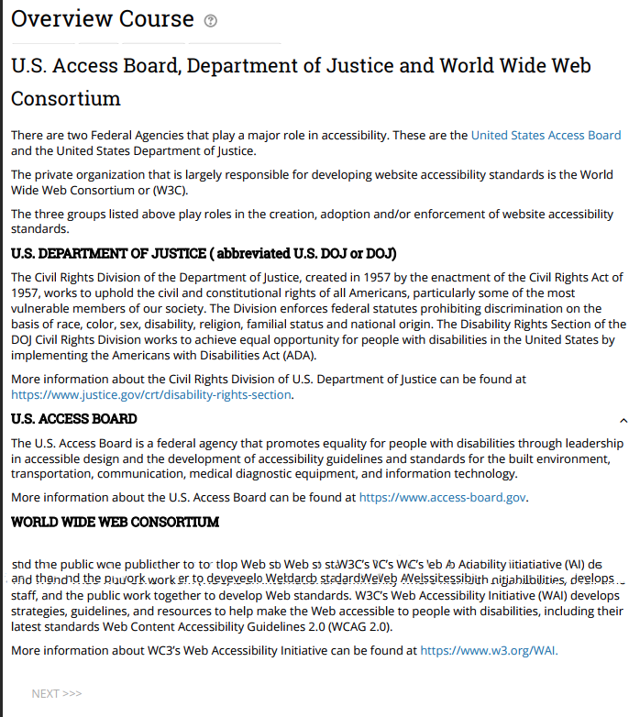

# Moodle ADA Training Class (Section 2):

1. **Section 2 –** “**Remove/delete it, or you have to remediate it!”**
   1. Recommend users review the content & one previous year’s data
   2. Recommend they only keep current & one previous year of data
      1. Websites are NOT Storage areas – Don’t use it to archive your information
   3. Quiz – one to three questions

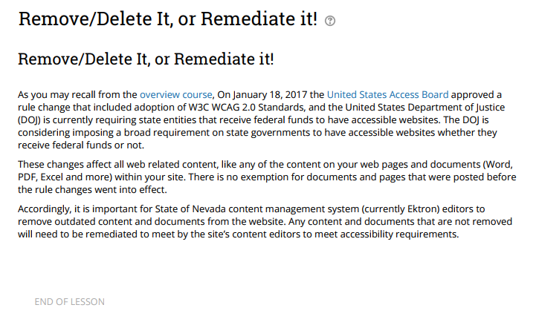

# Moodle ADA Training Class (Section 3):

1. **Section 3 – Siteimprove browser extension tool**
   1. What is it?
   2. Why we need to do it?
   3. How Siteimprove can help them identify ADA errors
   4. How Siteimprove will suggest possible solutions to correct their ADA errors
   5. What is required of them to start using the tool
   6. Resources (O/S class) – (See Stat CMS Evaluaion – Webpages, Smart forms – Suggested Smart Forms in CMS
   7. Quiz – One to three questions

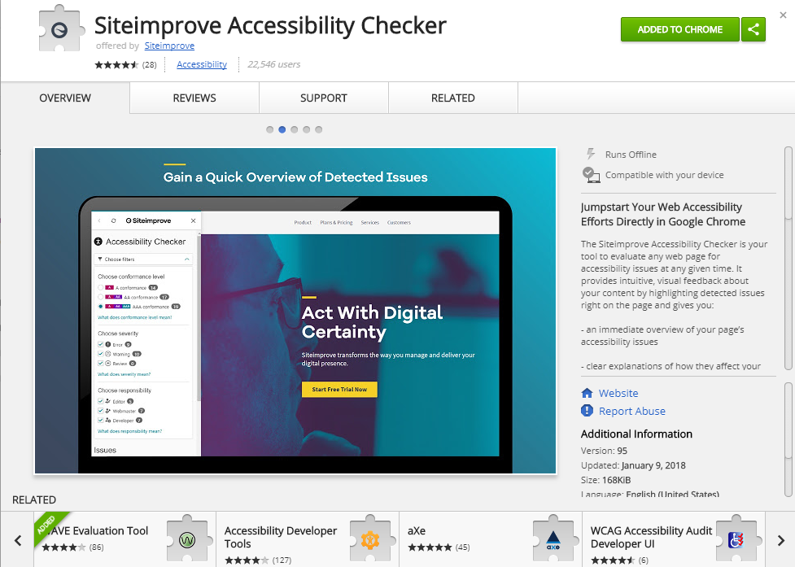

# Moodle ADA Training Class (Section 4):

1. **Section 4 – How to remediate their content**
   1. Lessons about the new ADA Smart Forms
   2. What they need to do to remediate the content
   3. Step by Step - Example of how to remediate our Smart Forms
   4. Resources
      * 1. Each new ADA Smart Form
           1. Will be available on the State of Nevada ADA website
           2. Will have detailed instructions how to remediate
   5. Quiz – one to three questions

Sample from Smart Form – ADA Page Program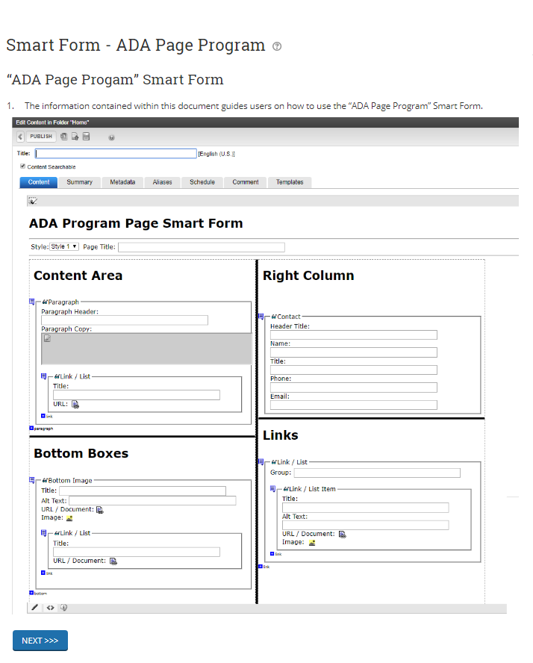

# Moodle ADA Training Class (Section 5):

**Section 5 – How to remediate Documents and PDFs**

* 1. Steps on how to remediate Word
  2. Steps on how to remediate Excel
  3. Steps on how to remediate PDFs
  4. Resources
     1. Resources (O/S classes that are available – Training for ADA Documentation Remediation if the users feel they need more detail.

Sample from Remediating Microsoft Word Documents

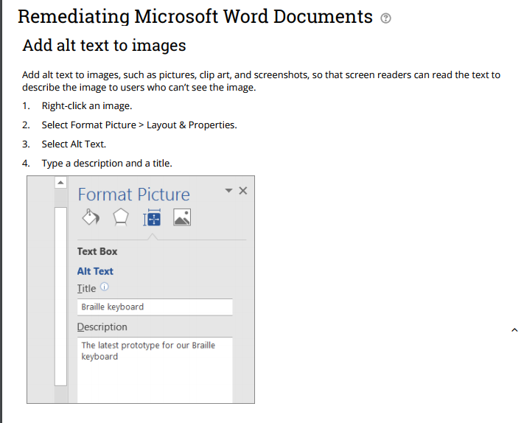

# Moodle ADA Training Class (Section 6):

1. **Section 6 – Other information included in the ADA Moodle Course**
   1. Frequently Asked Questions
   2. Tips & Suggestions
   3. Final Exam (certificate)
      1. Based on Quizzes at end of each section
   4. Feedback/Survey

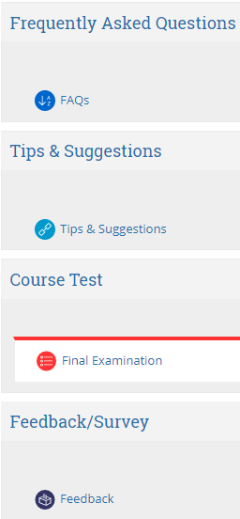

Moodle Training Class Resources:

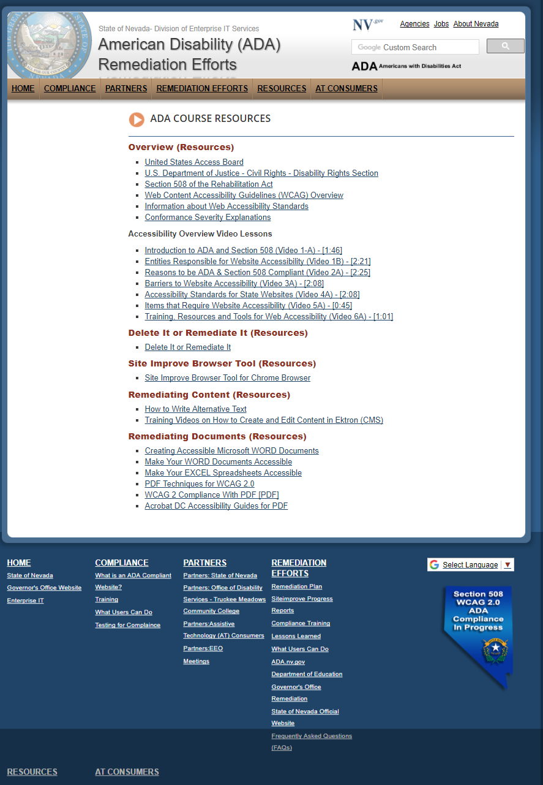

URL of [ADA Course Resources: http://ada.nv.gov/Resources/ADA-Course-Resources/](http://ada.nv.gov/Resources/ADA-Course-Resources/" \o "ADA Course Resources: http://ada.nv.gov/Resources/ADA-Course-Resources/)

*These resources have been built in the State of Nevada – Division of Enterprise IT Services ADA Disability (ADA) Remediation efforts website so users can refer these resources without having to go back into eLearning training course.*

# ADA Partner Meetings & Enhancements – February 2018 (continued):

February 16, 2018 **–** ADA class has been finished and created in ELearn. We are currently asking for CMS users to volunteer for user testing.

February 17, 2018 **–** Request from Matt Robinson, Communications Officer for DCHFP, to start the process of making all websites within the Department of Health & Human Resources ADA complaint. Websites with DHHS include:

* Department of Health & Human Services (DHHS)
* Aging and Disability Services (ADSD)
* Child & Family Services (DCFS)
* Health Care Financing & Policy (DHCFP)
* Public and Behavioral Health (DPBH)
* Welfare & Supportive Services (DWSS)

Linda provided Matt with a test website that was built several months ago to satisfy a request to redesign all of DHHS websites. This test website also has ADA templates installed. The web team will add additional training links and webinars to assist DHHS staff with this task.

We have also suggested that the DHHS transition team be part of the user testing for the new ADA remediation class in the state’s eLearn system. Matt has agreed and will work with Web team to get them started.

February 18, 2018 – ADA Status:  
***TOTAL number of websites being remediated as of 2/22 are 38; Total number of websites that are ADA Compliant are 5.***

February 20, 2018 – Linda & Robert, new Public Intern, worked with James King at Smart 21 to walk through making documents ADA compliant. Robert will continue to review and work with James to get all documents remediated. State web will assist Smart 21 to make their website ADA compliant.

February 21, 2018 **–** Robert created a ‘how to make your word document ADA complaint’ in a few easy steps. This document has been sent to James King, Derek Hawkins and Matt Robinson for user testing. It has also been added to our ADA Remediation Guide at <http://ada.nv.gov/CMS/Remediation-Guides/>. These instructions include a practice document that has all of the issues that the instructions provided are trying to remediate. Hopefully this method will give the users ‘hands-on’ experience.

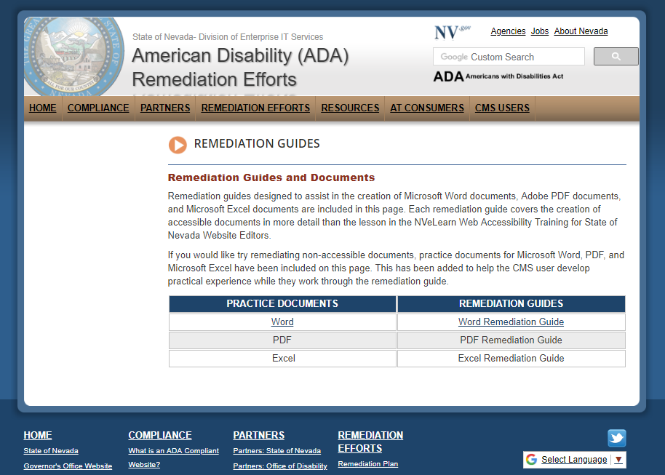  
  
  
February 21, 2018 (Meeting) - AT Consumer meeting at TMCC – Joe & Linda met Thomas Kearns and the AT consumers to continue to understand issues they face when trying to navigate websites and other digital media. It was certainly an eye opener, and once again Joe and I realized we need to continue to try to make modifications to make our websites a better user experience for them.

February 22, 2018 – Linda Desantis was asked to give a presentation to the Department of Health and Human Services Aging and Disability Services Nevada Assistive Technology Council (AT Council).

The State of Nevada’s Remediation efforts was positively received. We will be added to their next agenda to give an update on our progress.

**NOTE:** Meeting and presentation can be found at <http://ada.nv.gov/Partners/Meetings/>

February 25, 2018 – A twitter feed, Web Accessibility Nevada, was created and posted to the State of Nevada American Disability (ADA) remediation Efforts website. Follow us, <https://twitter.com/adanevada>.

March 6, 2018 - An email was sent by Linda to all ADA Partners to update them on the State of Nevada’s Remediation Status. This is the first update to everyone since our first phone conference call on December 1, 2017. Instead of sending out attachments, we directed everyone to visit [http://ada.nv.gov](http://ada.nv.gov/). The web team does bi-weekly updates on the State’s ADA status and keeps a chronological list of updates under <http://ada.nv.gov/Reporting/Reporting/>.   
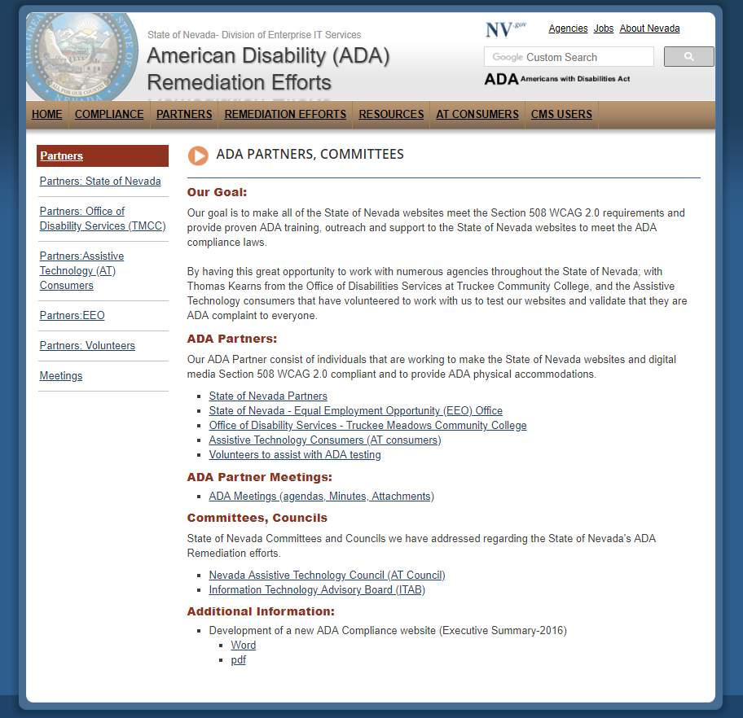

March 6, 2018 – ADA Status:  
***TOTAL number of websites being remediated as of 2/22 are 38; Total number of websites that are ADA Compliant are 5.***

March 7, 2018 – EITS Web team sent an email to all CMS user and CMS Managers opening up the new eLearn class:

**NVeLearn class**:

The State of Nevada Department of Administration, Division of Information Technology Services (EITS) is committed to providing access to our electronic and information technology, including our web pages and PDFs in the State of Nevada’s Content Management System (CMS), for individuals with disabilities in accordance with the World Wide Web Consortium’s (W3C’s), Web Content Accessibility Guidelines (WCAG) 2.0 Levels A & AA, and the Web Accessibility Initiative Accessible Rich Internet Applications Suite (WAI-ARIA) 1.0 for web content. Please visit our State of Nevada American Disability (ADA) Remediation Efforts website at [http://ada.nv.gov](http://ada.nv.gov/) for constant updates.

IMPORTANT ANNOUNCMENT:

Today, we are inviting you to take our new Web Accessibility Training in the NVeLearn environment. This training is highly recommended for our CMS content users.

**Please go to** [**http://ada.nv.gov/CMS/CMS_Users/**](http://ada.nv.gov/CMS/CMS_Users/) **for details and information on how to the course.**

The training class includes topics to help users:

* Remediate their current non-compliant web pages to ADA complaint templates
* Remediate non-complaint documents; Word, Excel, PowerPoint, PDF to ADA compliant documents in ten easy steps or less
* Find additional training resources
* Answer some Frequently Asked Questions (FAQs)

Once you finish the CMS training, you can contact [stateweb@admin.nv.gov](mailto:stateweb@admin.nv.gov) and our staff will help you add our ADA compliant templates so that you can begin to remediate your content.

**Additional Information About the Remediation Effort:**

* All reporting, status updates can be located at: <http://ada.nv.gov/Reporting/Reporting/>
* The remediation of State Content Management websites can be located at <http://ada.nv.gov/Remediation/Efforts/>
* Our ADA Partner Meetings can be found at <http://ada.nv.gov/Partners/Meetings/>  
  Please view the list of our ADA Partners at [http://ada.nv.gov/Partners/ADA_Partners/.](http://ada.nv.gov/Partners/ADA_Partners/)
* You can find a place where AT Consumers could ask for help regarding Physical Accommodations and/or Website& Digital Media Accommodations information at <http://ada.nv.gov/Home/Features/Accessibility_Information/>.

### March 7, 2018

ADA Chronological History Summary 2001 - 2016

The Division of Information Technology, Enterprise began working on ADA compliance in 2001, when Governor Guinn issued an Executive Order requiring ADA compliance as well as a consistent look and feel (branding) for all state of Nevada websites. A training website was also created that hosted instructions, templates, style guides and other tools to assist agencies in redesigning their existing content to meet the branding and ADA requirements mandated by the Governor. An ADA class were developed by the EITS web team and over sixty agency webmasters were trained in about 2 months. The classes were developed to train the agency webmasters how to update their current website and make them ADA compliant. During those classes, special individual websites were developed and given to each agency webmaster that reflected their agency’s information. These websites had all of the ADA requirement built in so they could just take those site and move their current information into them.

After the last class, agencies were given 30 days to make homepages compliant and then 90 days for the entire sites to be ADA compliant with new branding. This goal was met, unfortunately without an ADA monitoring tool in place; the sites did not stay compliant very long and the ADA compliant sites quickly became non-compliant

In 2012, EITS Web Team then purchased and managed the implementation of the State Web Content Management System (CMS). A web developer was hired, and templates and smart forms were created to help brand the State of Nevada websites. The team helped customer’s convert state websites from FrontPage to the State’s Content Management System. During that time 500+ users were trained to build and maintain their own CMS sites, which was new as previous all updates to state websites were made by the EITS Web team

Realizing the State CMS templates were not built to be Section 508 WCAG 2.0 Section 508 compliant, the web group began to focus their efforts to correct that. In September 2015, our team began to research and evaluate ADA accessibility evaluation tools and it was determined that WAVE was the best free option

We were also able to work with Brett Silver, a blind employee who worked for the State of Nevada Division of Library and Archives (NSLA), Office of Talking books. Brett uses JAWs, and he was able to assist us in testing for compliance [=](http://ada.nv.gov/LessonsLearned/adaNVgov/)

Brett continues to help our team, whenever needed. We also worked with the Division of Human Resources Management’s Equal Opportunity office (EEO) who coordinates the State’s various ADA program and resources.

A logo was added to all State CMS websites; with a link to their information regarding providing physical accommodations for persons with disabilities. This information did not cover state CMS websites, so the EITS web team’s Manager wrote a white paper suggesting the state create an ADA Website Coordination Committee to share the web group’s current effort to make the State of Nevada websites become Section 508 WCAG 2.0 Section 508 compliant. The first meeting was held February 11, 2016, and [the State of Nevada, Division of Enterprise IT Services, American Disability (ADA) Remediation Efforts website](http://ada.nv.gov) was created

To view a status of the State of Nevada ADA Remediation Efforts, please visit the [State of Nevada, Division of Enterprise IT Services, American Disability (ADA) Remediation Efforts page](http://ada.nv.gov/Remediation/Efforts/). The content on this page is updated bi-weekly and reflects he efforts made to get the State of Nevada’s websites ADA compliant. On the bottom of the same page, a chronological history of the State of Nevada’s ADA compliance efforts, also with testing results working with Brett Silver, are listed.

Future Goals:

1. Continue to work with the AT Consumers to test other selected websites and other Digital media so that they have a sample of what is compliant. That way we can use that as a standard.
2. Finalize our ADA Training Class for users that have websites in our Content Management System (CMS).
   1. Make this Training Class a required class for ALL CMS Users.

***NOTE: This ADA Training class is currently in user testing as of 2/8/17***

1. Keep reviewing our current processes and make enhancements, including expanding our outreach beyond websites.
2. Continue to do outreach to agency webmasters that have their websites in our State CMS
   1. Instruct them to take the Training class
   2. Assist them with additional suggestions, webinars, etc.
3. Work with Governor’s office to obtain an Executive Order that requires all websites in the State of Nevada, not only in the State CMS, to be ADA Compliant.
4. Continue to work with the Department of Education to ensure their success with the Office of Civil Rights (OCR).