### State of Nevada American Disability (ADA) Remediation Efforts Website: [http://ada.nv.gov](http://ada.nv.gov/) This document explains the new State of Nevada American Disability (ADA) remediation Effort website and it contents

EITS Enterprise Web Team – Linda M DeSantis, Manager  
January 29, 2018

ADA Compliance Issues  
  
ADA Chronological History Summary 2001 - 2016

The Division of Information Technology, Enterprise began working on ADA compliance in 2001, when Governor Guinn issued an Executive Order requiring ADA compliance as well as a consistent look and feel (branding) for all state of Nevada websites. A training website was also created that hosted instructions, templates, style guides and other tools to assist agencies in redesigning their existing content to meet the branding and ADA requirements mandated by the Governor. An ADA class were developed by the EITS web team and over sixty agency webmasters were trained in about 2 months. The classes were developed to train the agency webmasters how to update their current website and make them ADA compliant. During those classes, special individual websites were developed and given to each agency webmaster that reflected their agency’s information. These websites had all of the ADA requirement built in so they could just take those site and move their current information into them.   
  
After the last class, agencies were given 30 days to make homepages compliant and then 90 days for the entire sites to be ADA compliant with new branding. This goal was met, unfortunately without an ADA monitoring tool in place; the sites did not stay compliant very long and the ADA compliant sites quickly became non-compliant.   
  
In 2012, EITS Web Team then purchased and managed the implementation of the State Web Content Management System (CMS). A web developer was hired, and templates and smart forms were created to help brand the State of Nevada websites. The team helped customer’s convert state websites from FrontPage to the State’s Content Management System. During that time 500+ users were trained to build and maintain their own CMS sites, which was new as previous all updates to state websites were made by the EITS Web team.   
  
Realizing the State CMS templates were not built to be Section 508 WCAG 2.0 Section 508 compliant, the web group began to focus their efforts to correct that. In September 2015, our team began to research and evaluate ADA accessibility evaluation tools and it was determined that WAVE was the best free option.   
  
We were also able to work with Brett Silver, a blind employee who worked for the State of Nevada Division of Library and Archives (NSLA), Office of Talking books. Brett uses JAWs, and he was able to assist us in testing for compliance <http://ada.nv.gov/LessonsLearned/adaNVgov/>

Brett continues to help our team, whenever needed. We also worked with the Division of Human Resources Management’s Equal Opportunity office (EEO) who coordinates the State’s various ADA program and resources.  
  
A logo was added to all State CMS websites; with a link to their information regarding providing physical accommodations for persons with disabilities. This information did not cover state CMS websites, so the EITS web team’s Manager wrote a white paper suggesting the state create an ADA Website Coordination Committee to share the web group’s current effort to make the State of Nevada websites become Section 508 WCAG 2.0 Section 508 compliant. The first meeting was held February 11, 2016, and [the State of Nevada, Division of Enterprise IT Services, American Disability (ADA) Remediation Efforts website](http://ada.nv.gov) was created.   
  
To view a status of the State of Nevada ADA Remediation Efforts, please visit the [State of Nevada, Division of Enterprise IT Services, American Disability (ADA) Remediation Efforts page](http://ada.nv.gov/Remediation/Efforts/). The content on this page is updated bi-weekly and reflects he efforts made to get the State of Nevada’s websites ADA compliant. On the bottom of the same page, a chronological history of the State of Nevada’s ADA compliance efforts, also with testing results working with Brett Silver, are listed.

Physical Accommodations

Division of Human Resource Management's Equal Employment Opportunity Office (EEO)

The Division of Human Resource Management's Equal Employment Opportunity Office (EEO) coordinates the State's various ADA programs and resources, ensuring employees and citizens are referred to the right person. ADA is considered to be the first lawful affirmation for equal treatment of Americans with mental and physical disabilities, the ADA prohibits discrimination against people with disabilities in employment, government services, public accommodations, commercial facilities, education and other areas of society.

Citizens with concerns regarding ADA issues related to government services, public accommodations, commercial facilities, and other areas can find various resources through the Department of Transportation or the Department of Administration's Public Works Division. Citizens who would like to file a complaint can do so by following the Department of Transportation or Public Works Division links or by submitting our online form and the EEO office will forward your complaint to the proper Agency for review. Department of Transportation Complaint Form Department of Administration's Public Works Division Complaint Form File a Complaint Online.

Employees with concerns regarding ADA issues should contact their Agency Human Resource or Personnel representative, or can file a complaint online through NEATS, or by completing the Sexual Harassment or Discrimination Complaint form and forwarding the document to our office. Sexual Harassment or Discrimination Complaint form.

Contact

For information on the State of Nevada ADA Compliance please contact:

Tammy Smith – EEO Officer  
100 North Stewart Street, Suite 200  
Carson City, NV 89701  
Phone: (775) 684-0104

Amy Taylor  
EEO Administrator  
Phone: (702) 486-5725  
amytaylor@admin.nv.gov

Website and Digital Media Accommodations  
  
The State of Nevada Department of Administration, Division of Information Technology Services (EITS) is committed to providing access to our electronic and information technology, including our web pages and PDFs in the State of Nevada's Content Management System (CMS), for individuals with disabilities in accordance with the World Wide Web Consortium's (W3C's), Web Content Accessibility Guidelines (WCAG) 2.0 Levels A & AA, and the Web Accessibility Initiative Accessible Rich Internet Applications Suite (WAI-ARIA) 1.0 for web content.

The State of Nevada Department of Administration, Division of Information Technology Services (EITS), is working to ensure that State employees with disabilities, and members of the public with disabilities seeking information or services from us, have access to and use of information and data that is comparable to the access and use by State employees, or members of the public who are not individuals with disabilities, unless an undue burden would be imposed on us. To meet this commitment, we are in the process of re-designing our web pages to exceed the standards of the World Wide Web Consortium's (W3C's), Web Content Accessibility Guidelines (WCAG) 2.0 Levels A & AA, and the Web Accessibility Initiative Accessible Rich Internet Applications Suite (WAI-ARIA) 1.0 for web content.

Thank you for your patience while we re-design our site to better serve all constituents.  
  
The State of Nevada's Content Management System (CMS) is Ektron. Currently that CMS supports 142+ websites. Our goal is to make all websites and digital media in our CMS ADA Section 508 WCAG 2.0 compliant.

This is a huge undertaking for the web group, especially because we are using free ADA evaluation tools, WAVE and Siteimprove. Both free tools evaluate ONLY one page at a time. The tool flags errors on the page based on WCAG 2.0 Section 508 standards; categorizes by level of error; and gives recommendations on how to resolve the error. The webmaster needs to understand what must be done to resolve this issue.

The limitations of the ADA WAVE and SiteImprove tool, and the number of websites that we need to make compliant, is the reason we need to collaborate with other departments, divisions, boards and user groups in Nevada. Numerous recommendations and/or fixes made by the tool require a knowledge of that Agency’s business rules.

ADA Partners 2017  
 Our Goal

Our goal is to make all of the State of Nevada websites meet the Section 508 WCAG 2.0 requirements and provide proven ADA training, outreach and support to the State of Nevada websites to meet the ADA compliance laws.

In December, 2017, we had our first meeting with State of Nevada Partners, Thomas Kearns from the office of Disabilities Services, and Assistive Technology Consumers (AT Consumers). It was during this meeting Thomas Kearns was named a Co-chair along with Linda DeSantis.   
  
By having this great opportunity to work with numerous agencies throughout the State of Nevada; with Thomas Kearns from the Office of Disabilities Services at Truckee Community College, and the Assistive Technology consumers that have volunteered to work with us to test our websites and validate that they are ADA complaint to everyone.   
  
Our ADA Partners

Our ADA Partner consist of individuals that are working to make the State of Nevada websites and digital media Section 508 WCAG 2.0 compliant and to provide ADA physical accommodations. For a complete list of all members, please click on the links for each group.

* [State of Nevada Partners](http://ada.nv.gov/Partners/Partners__State_of_Nevada/)
  + Shannon Rahming – Chairman
  + Linda M DeSantis – Co-chair
* [Office of Disability Services](http://ada.nv.gov/Partners/Partners_TMCC/) – Truckee Meadows Community College (TMCC)
  + Thomas Kearns – Co-Chair
* [Assistive Technology Consumers](http://ada.nv.gov/Partners/Partners_TMCC/) (AT Consumers)
  + Mona Coker – Co-Chair

ADA Remediation Efforts 2017

ADA Partner Meetings:  
  
On December 1, 2017, we had our first ADA partners meeting. Meeting agendas, minutes and attachments canb e found on <http://ada.nv.gov/Partners/Meetings/>. This was a high-level introductory meeting that was attended by the State of Nevada, Office of Disability Services and Assistive Technology Consumers. Thomas Kearns (Office of Disability Services) and Linda DeSantis (EITS Web team Manager) we designed as Co-Chairs for this effort.   
  
On December 20, 2017, the co-chairs got together to discuss strategies and develop a plan to move this effort forward

On January 18, 2018, Linda DeSantis and Joseph Diarte from the State of Nevada web team met with Thomas Kearns and several Assistive Technology (AT) consumers to discuss three main topics:

1. How to implement a statewide web accessible complaint form
2. AT Users (aka Screen Reader users) will be asked how we want to proceed in testing state accessible templates. This is a high priority issue for the State of Nevada web team because once we can confirm that the templates/smart form in our State of Nevada content management system (CMS) is compliant, we can begin our outreach to train and assist agencies within our CMS to make their websites ADA compliant.
3. How AT users can test newly implemented state accessible websites
4. Below are our suggested solutions to address and satisfy these three main issues.

Recent Updates:  
  
On January 26, 2018, we came up with the following solutions:

1. Our Accessibility Information page has been recently updated. One of the major changes is that we moved the Complaint forms to the top of the page and separated the complaints into two separate forms as we felt they were looking for different information. The first complaint form is for registering a complaint regarding [Website and Digital Media Accommodation](http://ada.nv.gov/Remediation/2018/ADA_Complaint_Form-WebsiteDigitalMedia/) and the other complaint form is to register a complaint regarding [Physical Accommodations](http://ada.nv.gov/Remediation/2018/ADA_Complaint_Form-WebsiteDigitalMedia/).
2. You can find this updated Accessibility Information page by going to the [State of Nevada American Disability (ADA) Remediation Efforts website](http://ada.nv.gov/).    
   Once you are there, please click on the ADA Americans with Disability Act logo [Title: ADA logo - Description: Americans with Disabilities Act (ADA) Accessibiity Information](http://ada.nv.gov/Home/Features/Accessibility_Information/)in the upper right hand banner located under the Google Custom Search.   
     
   ***NOTE: This ADA Americans with Disability Act logo is in the same place on  every page of every website that is located in the State of Nevada Content Management System (CMS). Currently other websites that have been built outside of the State of Nevada’s CMS do not have this logo, so please come to the State of Nevada American Disability (ADA) Remediation Efforts website and register your complaint there. Efforts to request that all State of Nevada websites have this logo on their site is upcoming.***We have also added a new [AT Consumer section](http://ada.nv.gov/ATConsumers/AT_Consumers/) for your convenience. It is here that we will be posting new forms, new testing needs, and we have also built a new [ADA Evaluation Form for AT Consumers](http://ada.nv.gov/Remediation/2018/ADA_Complaint_Form-WebsiteDigitalMedia/) users so it will make it easier to evaluate any testing you perform for the State of Nevada.     
     
   After the testing of the complaint forms, the next most important area that we would like to have tested is our [Smart Form Configurations (Templates)](http://ada.nv.gov/Remediation/2018/AT-Consumer-Testing/). These templates have been created in one of the Department of Education’s websites as that site is being monitored by Siteimprove and it makes it easier for us to make it compliant and keep it compliant. All of these templates are used in 95% of the websites within the State of Nevada’s Content Management System (CMS).   
     
   Once these templates are tested and certified, we will be able to do outreach to all of the other agencies that have websites in the State CMS and train them how to make their current websites compliant.

New Hire

On January 9, 2018, we hired a Public Intern to work with the EITS web team to assist in our ADA Efforts

1. We asked the Intern to follow the instruction on our [Training for ADA Documentation Remediation documentation](http://ada.nv.gov/uploadedFiles/ada,nvgov/content/Home/Features/PDF-ADA-RemediationTraining.pdf) (pdf) and provide us with feedback. This document is going to be one of the tools we want to give our Agency users and wanted to make sure it clear, easy to follow, and had enough information for the users to accomplish the remediation of documents  
   1. This document covers “What is Web Accessibility”
   2. ADA webinar the EITS team built to get users familiar with ADA
   3. Obtain a library card so they have access to Lynda.com
   4. Walk them through the remediation of Microsoft Documents
2. Our intern was able to navigate through the training, and succeeding in making several Word, Excel and PDF documents compliant

This information is located on the homepage of our State of Nevada American Disability (ADA) Remediation Efforts website under [THINGS USERS CAN DO to start making their websites ADA Compliant](http://ada.nv.gov/uploadedFiles/ada,nvgov/content/Home/Features/PDF-ADA-RemediationTraining.pdf), along with other information to help users when they begin to remediate their websites.

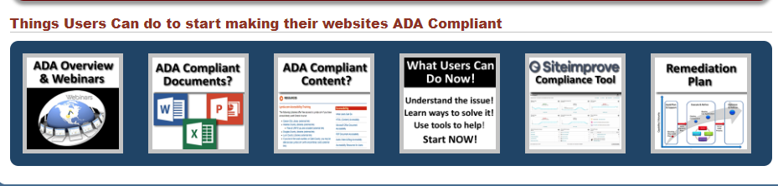

Future Goals:

1. Continue to work with the AT Consumers to test other selected websites and other Digital media so that he have a sample of what is complaint. That way we can use that as a standard.
2. Finalize our ADA Training Class for users that have websites in our Content Management System (CMS).
   1. Make this Training Class a required class for ALL CMS Users. Details to follow!
3. Keep reviewing our current processes and make enhancements, including expanding our outreach beyond websites.
4. Start to do Outreach to agency webmasters that have their websites in our State CMS
   1. Instruct them to take the Training class
   2. Assist them with additional suggestions, webinars, etc.
5. Work with Governor’s office to obtain an Executive Order that requires all websites in the State of Nevada, not only in the State CMS, to be ADA Compliant.
6. Continue to work with the Department of Education

# ADA Remediation Snapshot

This snapshot is a quick summary of the Total # of Websites in our CMS, # of sites being remediated, # of sites that are ADA Compliant, and # of Sites that need to be remediated.  
  
***Note: the State of Nevada is striving for all content to meet the standard A & AA compliance, however, we are trhing to meet AAA complaint, whenever possible.   
  
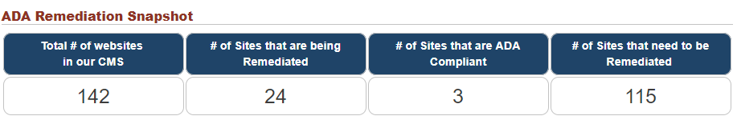***

# State of Nevada CMS Website Accessibility Tracking Log

This report contains a [list of all websites that reside in the State CMS, and the website status](http://ada.nv.gov/uploadedFiles/ada,nvgov/content/Home/Features/CMS-AccessibilityTrackingLog.pdf):

1. Not Started
2. In Progress
3. ADA Compliant

Other statuses that are not being tracked (sites that moved away from our CMS or never went to production):

1. Site turned OFF
2. Redirect
3. Intranet site

# Accessibility Information Page – Complaint forms

Every State of Nevada website that resides in the State of Nevada Content Management System (CMS) has a logo at the top right banner, directly under the Google Custom Search box.   
  
[ADA Compliance](http://ada.nv.gov/Home/Features/Accessibility_Information/)  
This logo, ADA Americans with Disabilities Act, will take you to the [Accessibility Information page](http://ada.nv.gov/Home/Features/Accessibility_Information/) shown on the next page. Departments, Divisions, Boards and other websites that were created by or link to outside vendor built sites might not have the ADA logo we use, but they should have a link for ADA accommodations and complaints.   
  
Once a user is on the [Accessibility Information page](http://ada.nv.gov/Home/Features/Accessibility_Information/), they have the option of clicking on two buttons:

1. Website & Digital Media Accommodation Complaint Form
2. Physical Accommodation Complaint Form

Both of these forms were created using Google Forms/Drive. These forms are embedded into the [State of Nevada ADA Remediation Efforts website](http://ada.nv.gov).

Once the submit button is clicked on either complaint form, the information collected in these forms will be written to the Google Drive (a secure cloud). It will then send an email to the following:

1. Website & Digital Media Accommodation Complaint Form *- Email sent to EITS web team & response back to person who filled out the form thanking them for taking the time to fill out the form*
2. Physical Accommodation Complaint Form - *Email to Amy Taylor & Tammy Smith & response back to person who filled out the form thanking them for taking the time to fill out the form*

By using this process, it will allow us to collect information in a format that we can reviewed and tracked. Our process for handling these complaints are as follows:

Step 1: Identify the website that the complaint is about and:

* + Forward the complaint to the appropriate department, division, board for resolution
    - Let the complaintive know who their complaint has been forwarded to as they will
  + If department, division, board does not have an ADA logo
    - We will request they add it on to their website
  + Offer to familiarize the State of Nevada department, division or board the State of Nevada ADA information and suggest how they might be able to resolve the issue
  + Track progress
  + Generate a monthly report
    - Number of complaints received
    - What type of Complaint was it?
      * Website and Digital Media
      * Physical Accommodations
    - Who was the complaint forwarded to
    - Status of the complaint

Step 2: Follow up with department, division, board for status of complaint resolution

Step 3: Provide monthly reports to management, and add statistics on [ADA Remediation Efforts website](http://ada.nv.gov).

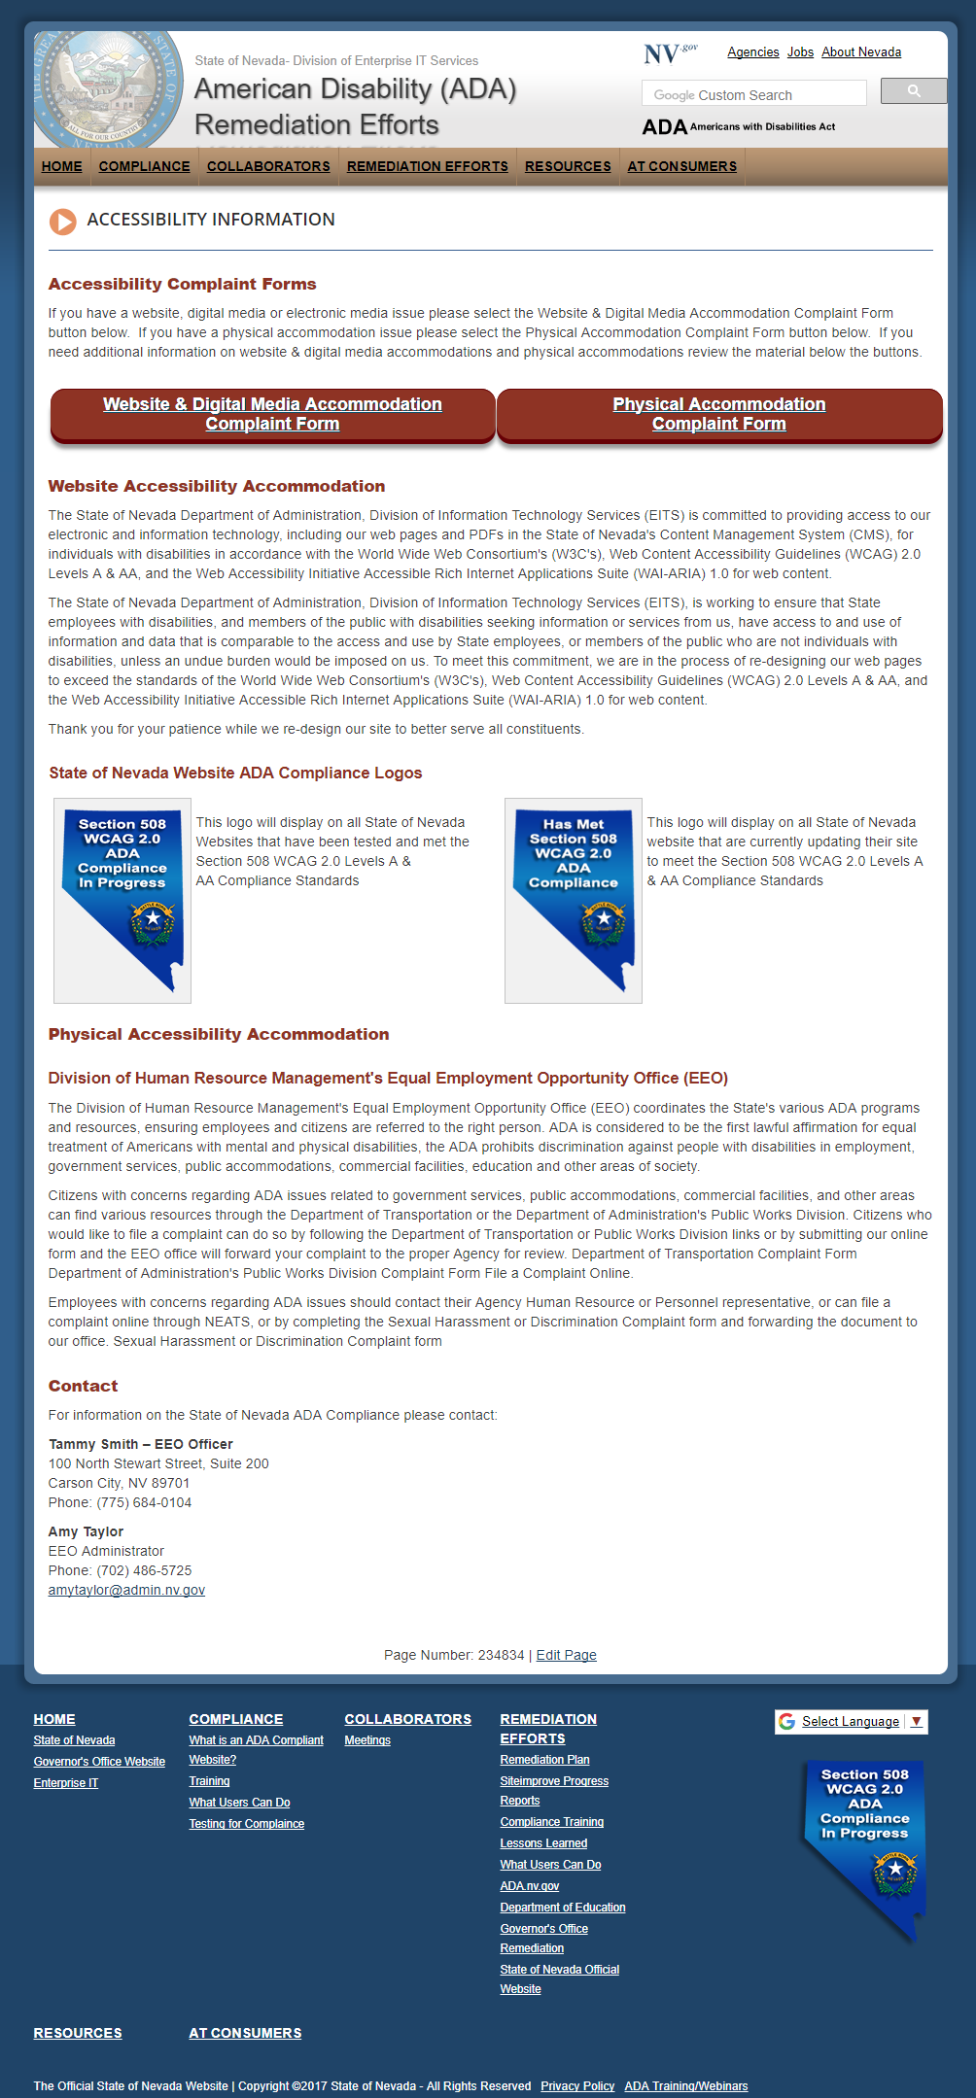

# Assistive Technology (AT) Consumers

Welcome to the Assistive Technology (AT) Consumers and special thanks to all of you who have graciously volunteered to work with the State of Nevada to assist in making the State’s website ADA compliant. Your efforts are greatly appreciated. This section has been built for the AT Consumer’s convenience while helping us test.

