Testing criteria #1: On-Line Google Form
Test page/Link:
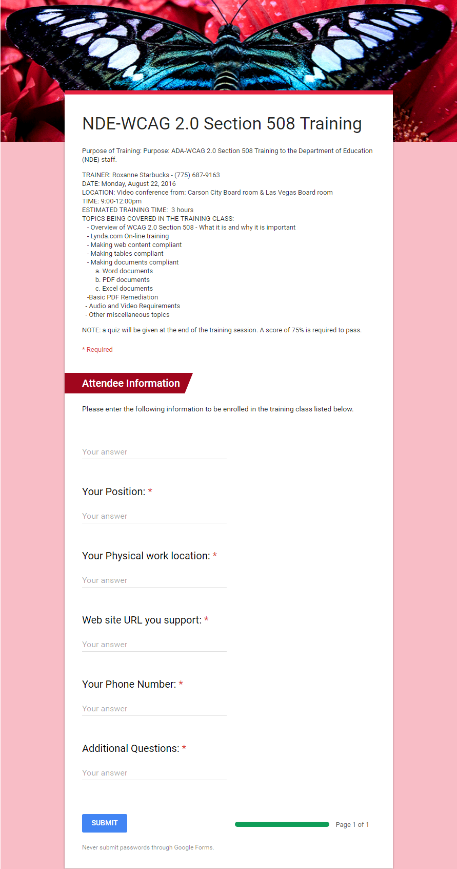
On http://www.doe.nv.gov/ADA/ADATrainingClass/ it describes the class, date, location, time, and topics being covered in the class. Requests input from Users attending class.

Test Group Evaluations:

Members of the Public with disabilities

Brett Silver Jaws Evaluation:
Brett was able to fill out the form. He did wonder why it says “your answer” below each edit box? The edit box is what your screen reading software defines as the area you put your designated information in to. For instance, it says your name, then you arrow down and there’s the edit box where you’d type your name, then below that if you arrow down you’ll see it says, “your answer.” What does that mean?

Parents
TBD

Students
TBD

Employees
TBD

Others Associated with Nevada DOE
TBD

Possible Resolution
TBD

Testing criteria #2: Skip to Content/Skip to Sitemap Links
On http://bullyfreezone.nv.gov/ we’ve added a Skip to Content link and a Skip to Footer Sitemap link at the top of every page. Every page but the homepage has navigation to the left of the content.
For the purpose of this test ignore all documents. We are only testing the html portions of the site.
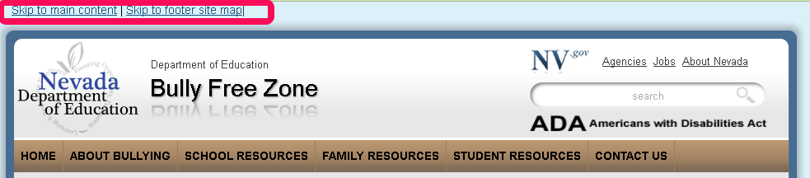

Test Group Evaluations:

Members of the Public with disabilities

Brett Silver Jaws Evaluation:
Good

Parents
TBD

Students
TBD

Employees
TBD

Others Associated with Nevada DOE
TBD

Possible Resolution
TBD

Testing criteria #3: ADA Link in banner area
On http://bullyfreezone.nv.gov/ there is an ADA link on the right side of the page in the banner directly above the navigation on the right side of the page. Is the linked page accessible to you?
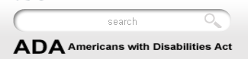

Test Group Evaluations:

Members of the Public with disabilities

Brett Silver Jaws Evaluation:
Brett had no trouble with reading this section.

Parents
TBD

Students
TBD

Employees
TBD

Others Associated with Nevada DOE
TBD

Possible Resolution
TBD

Testing criteria #4: Bully Free Zone Homepage
Test page/Link: http://bullyfreezone.nv.gov/
The homepage includes rotating images, 3 titles with 6 links to the right of the images area. Below that are two text areas that run the full width of the page below that are four more images with links to Lesson Plans, Educator Share Fair, and Students in the Spotlight & Bully Information by District.
Below that is a single line of test with four links below it that appear on every page of the site..
Lastly is the footer section of the page that is the sitemap which links to every page in the site and appears on every page.
What are your thoughts? Did you have any issues? Was it easier to traverse than the Human Resource website or other State of Nevada websites?
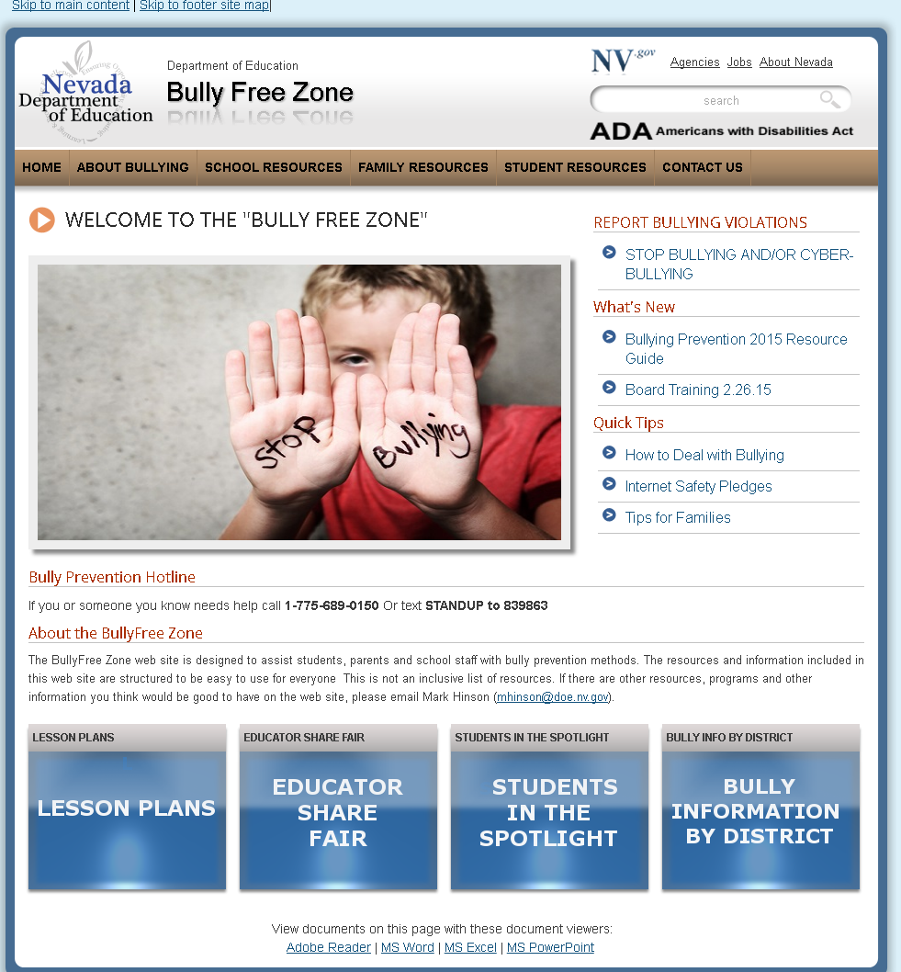

Test Group Evaluations:

Members of the Public with disabilities

Brett Silver Jaws Evaluation:
it’s very navigable, but on the part that outlines what’s on the site like family resources, social media for families, and so on those aren’t links so you may just want to put bullets in front of them so people don’t think they’re links. Some sites are doing that now where it won’t say link for something, but in reality it is a link.

Parents
TBD

Students
TBD

Employees
TBD

Others Associated with Nevada DOE
TBD

Possible Resolution
Need to understand why he does not see the links in the initiative box images.

Testing criteria #5: About Bullying
Test page/Link: http://bullyfreezone.nv.gov/About/About/
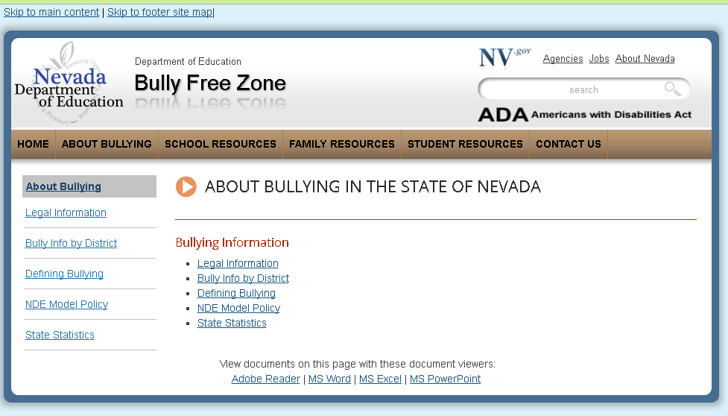
This page has a page title, a level two heading with 5 links under it to other pages within the site. They are:

Test Group Evaluations:

Members of the Public with disabilities

Brett Silver Jaws Evaluation:
Brett didn’t have any issues, and he think it’s good that alternatives are given for how they can read the different documents on the site. Meaning he likes the “View documents on this page with these document viewer”.

Parents
TBD

Students
TBD

Employees
TBD

Others Associated with Nevada DOE
TBD

Possible Resolution
Need to understand why he does not see the links in the initiative box images.

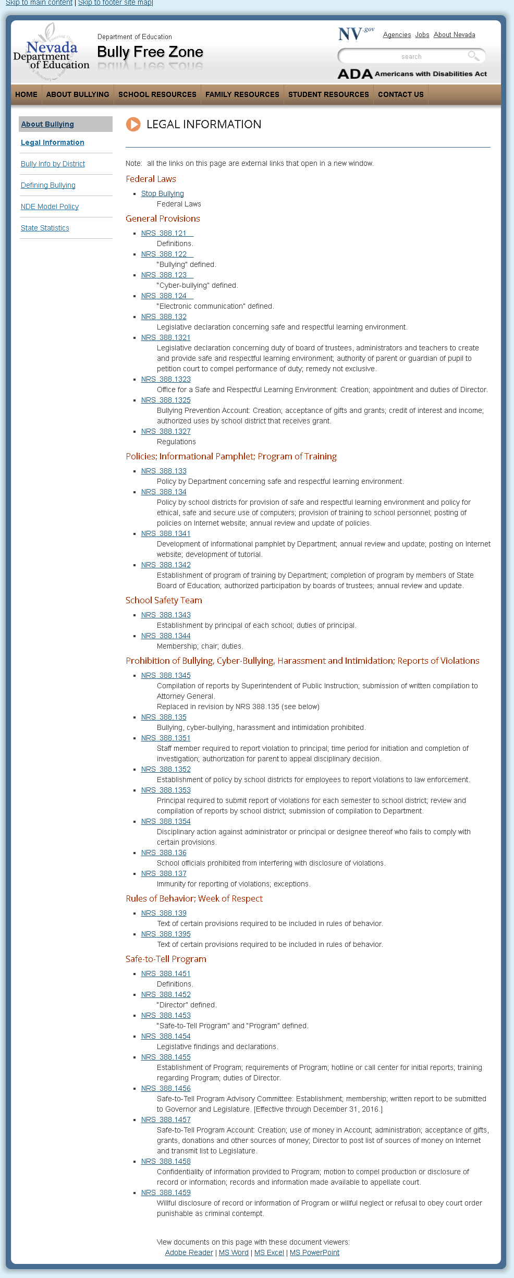
Testing criteria #6: Legal Information
Test page/Link: http://bullyfreezone. nv.gov/About/Legal/
Legal Information has 7 headings with links to Nevada Revised Statutes under each. These links open in a new window. Would you prefer they opened in the same window?

Test Group Evaluations:

Members of the Public with disabilities

Brett Silver Jaws Evaluation:
Brett could not open this page.

Parents
TBD

Students
TBD

Employees
TBD

Others Associated with Nevada DOE
TBD

Possible Resolution
Wonder if he was trying to access this page during sync when the system was trying to update the page?

Testing criteria #7: Bully info by District
Test page/Link: http://bullyfreezone.staging.nv.gov/About/School_Districts/
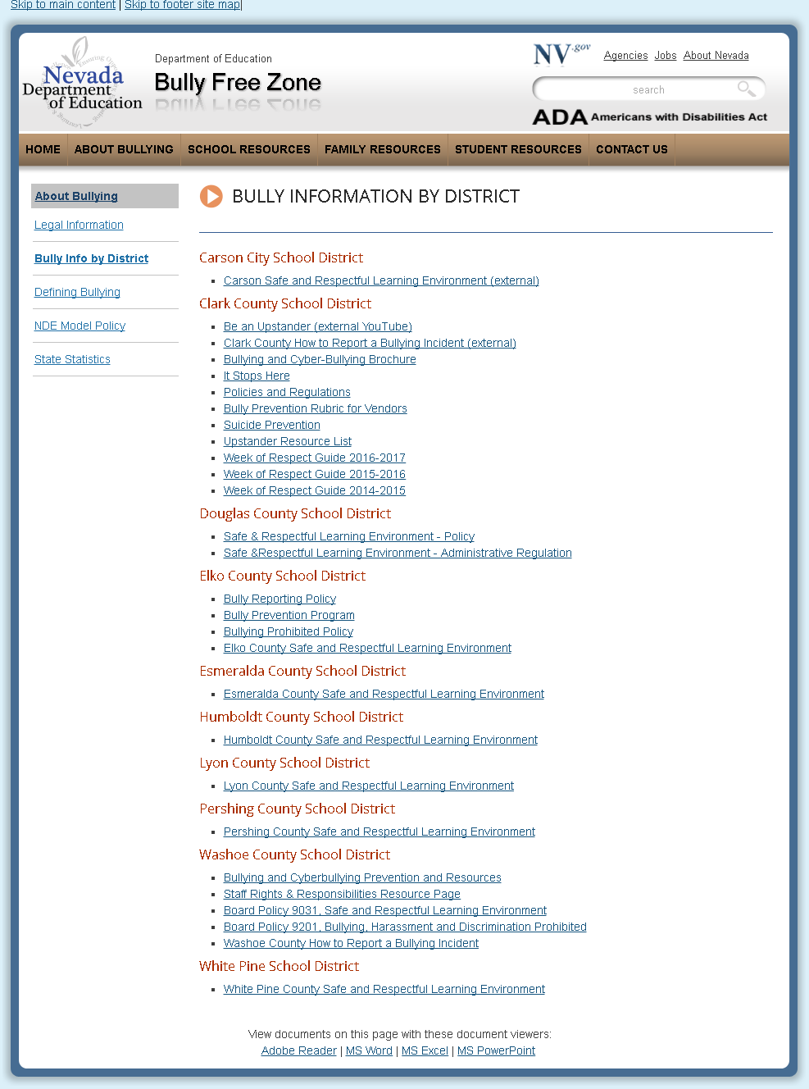
Bully Info by District has 10 headings with links under each. Some of these links are external, some are internal and some go to documents. Would you prefer each type to be identified?

Test Group Evaluations:

Members of the Public with disabilities

Brett Silver Jaws Evaluation:
Brett likes when it identifies whether it’s an external link or not so this way some people won’t think it’s part of the same web site and try to go back, and they can close the page if they know that’s what they have to do. It’s better to know if it’s a document, external link, and so on.

Parents
TBD

Students
TBD

Employees
TBD

Others Associated with Nevada DOE
TBD

Possible Resolution
TBD

Testing criteria #8: School Resources
Test page/Link: http://bullyfreezone.nv.gov/Resources/School_Resources/
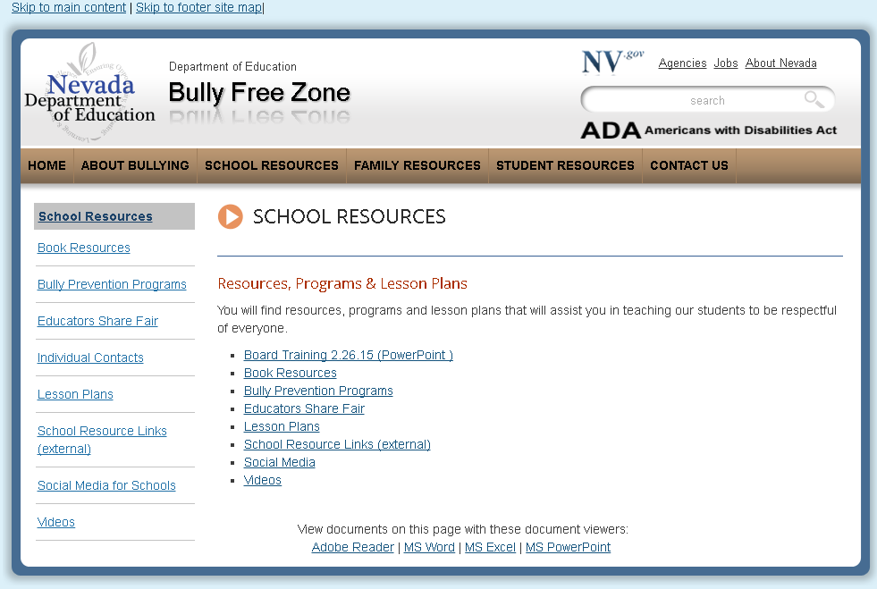
This page has a page title, a second level heading followed by a single paragraph of text with 8 links under that. The links go to various documents. You do not need to check the documents. We know they are not very accessible at this time.

Test Group Evaluations:

Members of the Public with disabilities

Brett Silver Jaws Evaluation:
Good.

Parents
TBD

Students
TBD

Employees
TBD

Others Associated with Nevada DOE
TBD

Possible Resolution
TBD

Testing criteria #9: Bully Prevention Programs
Test page/Link: http://bullyfreezone.staging.nv.gov/Resources/School/Bully_Prevention_Programs_-_new/ Book resources has a page title with six links under it, then a second level heading with two links under that. Does this present any challenges for you?
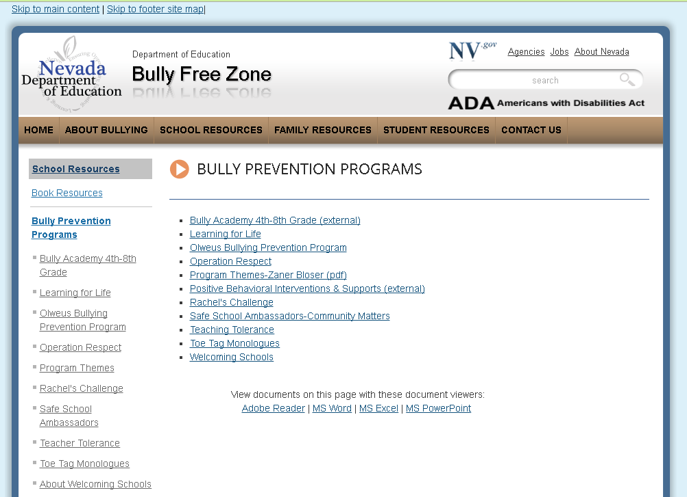

Test Group Evaluations:

Members of the Public with disabilities

Brett Silver Jaws Evaluation:
Good.

Parents
TBD

Students
TBD

Employees
TBD

Others Associated with Nevada DOE
TBD

Possible Resolution
TBD

Testing criteria #10: Individual Contacts
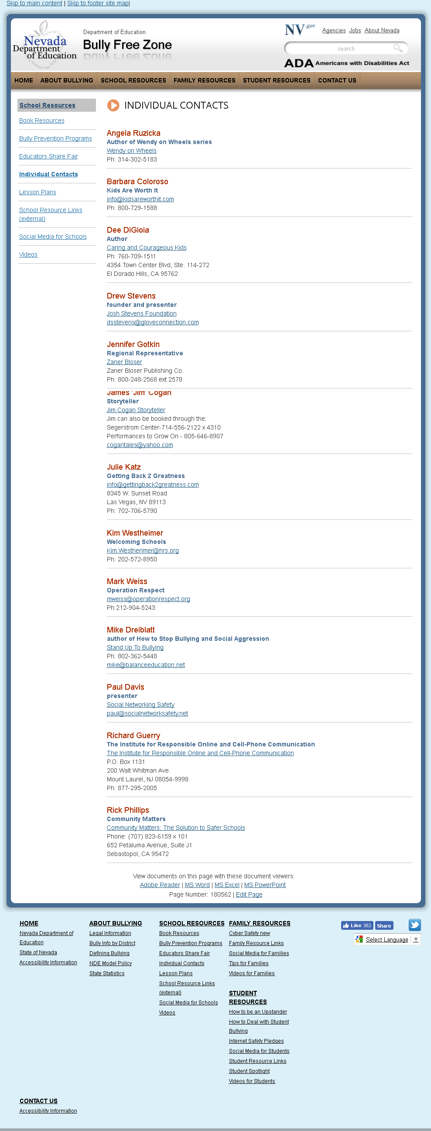
Test page/Link: http://bullyfreezone.staging.nv.gov/Resources/School/Individual_Contacts_-_new/ This page has a list of contacts. Each contact includes name, organization, program, and contact information. Some have an email address and phone while others provide additional contact information.

Test Group Evaluations:

Members of the Public with disabilities

Brett Silver Jaws Evaluation:
Brett thought this one’s laid out really well with all the contacts. It even has links to the certain author’s websites if applicable, and links to their emails too

Parents
TBD

Students
TBD

Employees
TBD

Others Associated with Nevada DOE
TBD

Possible Resolution
TBD

Testing criteria #11: Cyber Safety
Test page/Link: http://bullyfreezone.staging.nv.gov/Resources/Family/Cyber_Safety_new/ This page has a page title followed by 8 links then a level 2 heading with two links and then another level 2 heading with two more links
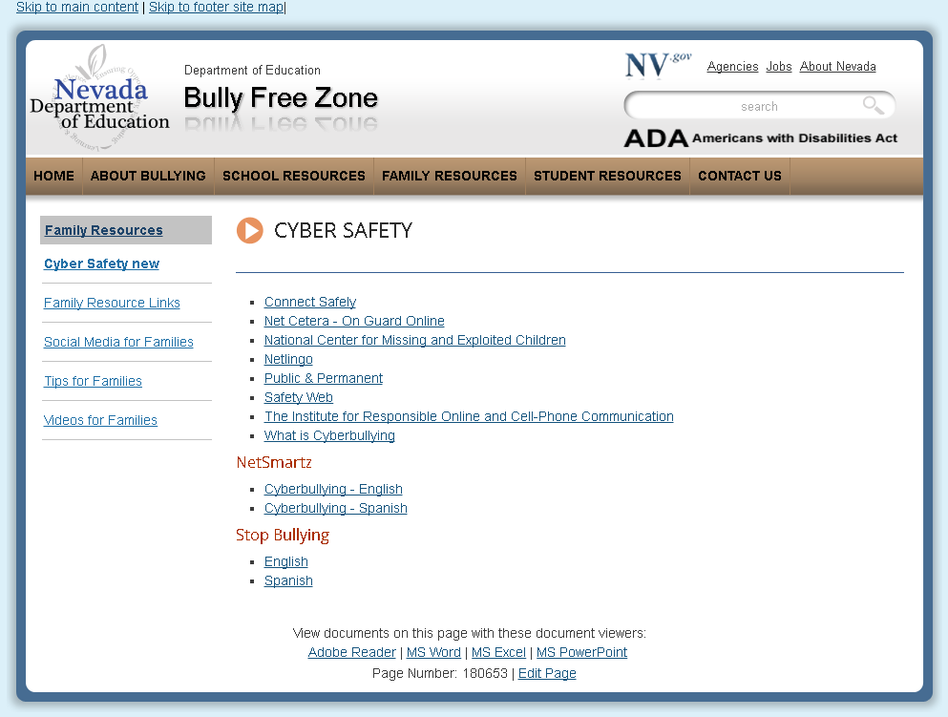

Test Group Evaluations:

Members of the Public with disabilities

Brett Silver Jaws Evaluation:
Good

Parents
TBD

Students
TBD

Employees
TBD

Others Associated with Nevada DOE
TBD

Possible Resolution
TBD

Testing criteria #12: Rest of site, Links and how they open
- Please traverse the rest of the site and identify any issues and provide any comments of the user experience that you think might assist us in making the site more accessible.
- Some of the pages in the site indicated links were external links and opened in new windows at the top of the page and other pages indicated what kind of link it was (word, pdf, etc.) on each link. Which do you prefer?
- Do you prefer windows to be opened in a new window or not?

Test Group Evaluations:

Members of the Public with disabilities

Brett Silver Jaws Evaluation:
Brett felt the rest of the site was good. He preferred when links were indicated if they were external or a document and the document type. He didn’t mind the windows opening in a new window as long as they were designated as external.

Parents
TBD

Students
TBD

Employees
TBD

Others Associated with Nevada DOE
TBD

Possible Resolution
TBD

Testing criteria #13: Online Form (embedded iFrame) Formstack Form
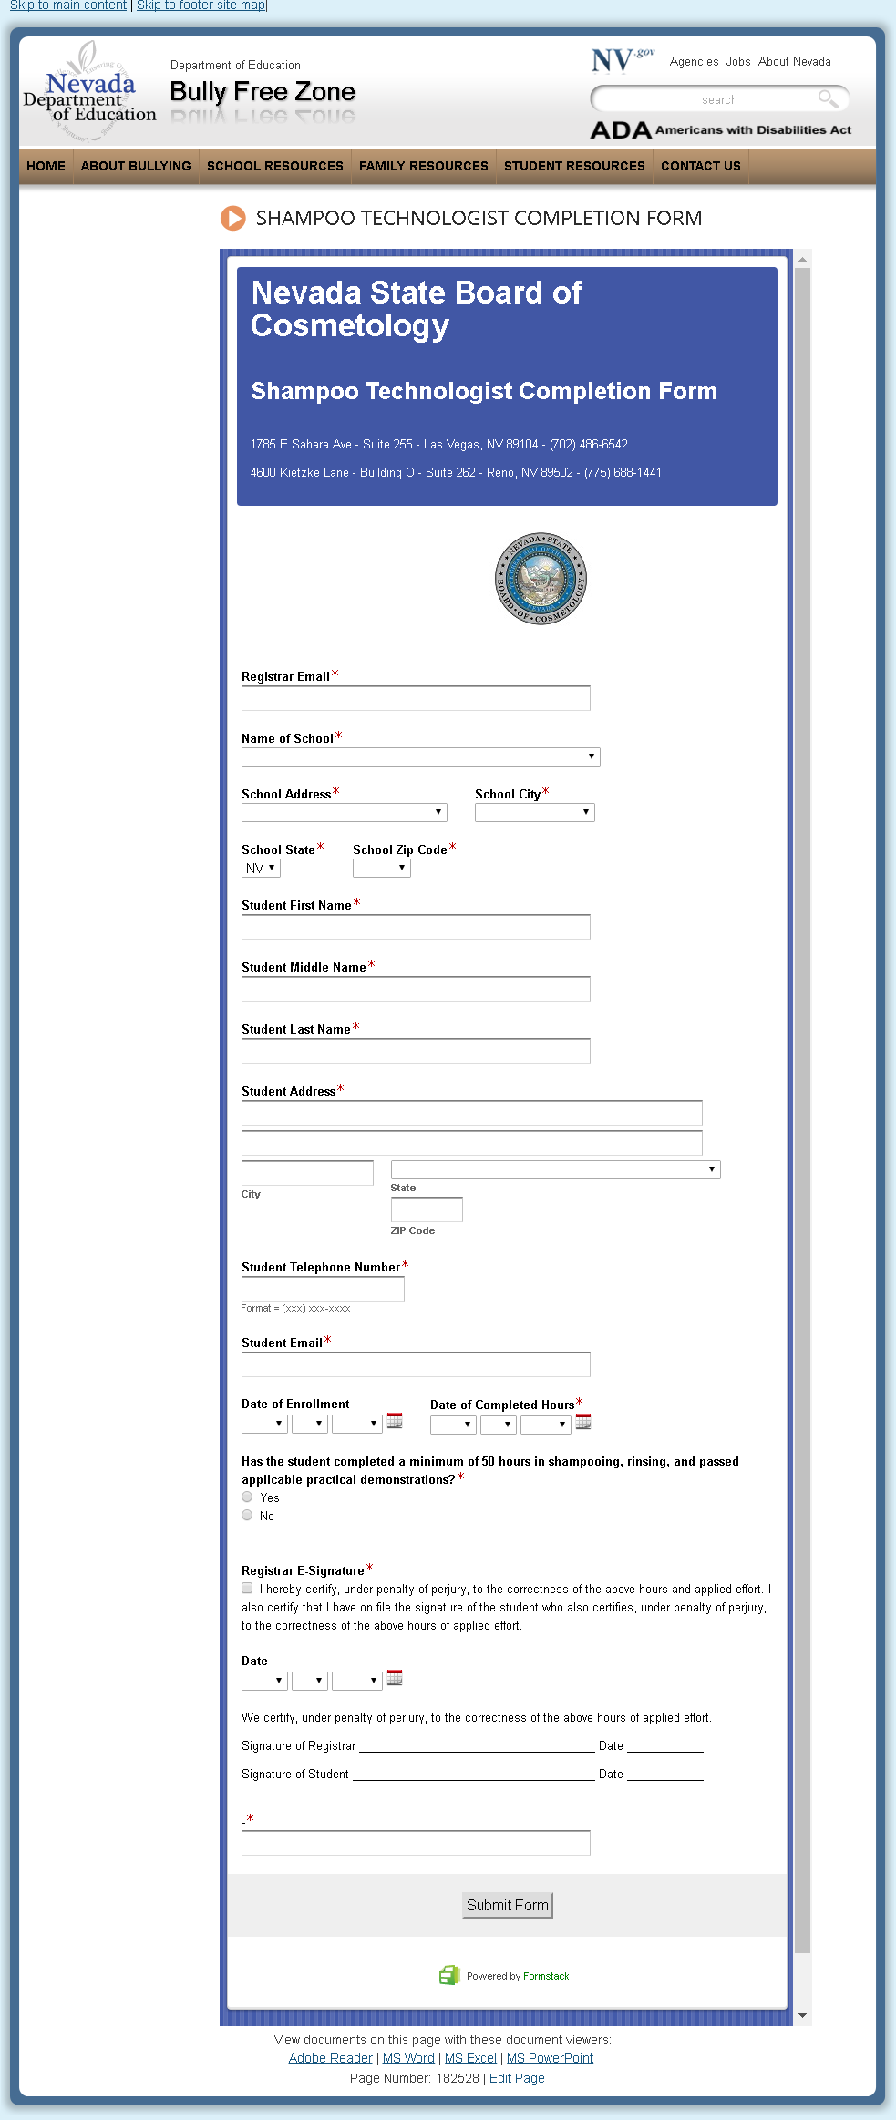
Test page/Link: http://bullyfreezone.staging.nv.gov/Resources/ShampooTechCompletionForm/ This page is a form. It contains the following fields:
- Registrar email
- Name of school
- School address
- School city
- School state
- School zip code
- Student first name
- Student middle name
- Student last name
- Student address
- Student city
- Student state
- Student zip code
- Student telephone number
- Student email
- Date of enrollment
- Date of completion hours
- Has the student completed a minimum of 50 hours in shampooing, rinsing, and passed applicable practical demonstrations
- Registrar e-signature
- Date
- Two signature lines with dates
- Black fields (not sure what this field is for)

Test Group Evaluations:

Members of the Public with disabilities

Brett Silver Jaws Evaluation:

The form’s pretty straight forward but there are a few issues. First off where the student puts in their address it should say address line 1 and address line 2 above each of the edit boxes. Also in the box where you’re supposed to put your phone number it gives a format of (xxx) xxx-xxxx. That’s pretty confusing. I had a personal situation with a site like that about a week ago. I never could figure out how they wanted me to put in my phone number. To keep it simple it should be xxx-xxxxxxx. The other thing is why is it a combo box when it asks for your city and zipcode? Those should just be edit boxes where people can type that info in. The state part can be a combo box or drop down box, but city and zip shouldn’t.

Parents
TBD

Students
TBD

Employees
TBD

Others Associated with Nevada DOE
TBD

Possible Resolution
TBD

Testing criteria #14: Microsoft Word Document
Test page/Link: Word document BullyPreventionRubricForVendors.docx (attached)

Test Group Evaluations:

Members of the Public with disabilities

Brett Silver Jaws Evaluation:

TBD

Parents
TBD

Students
TBD

Employees
TBD

Others Associated with Nevada DOE
TBD

Possible Resolution
TBD

Testing criteria #15: PDF document
Test page/Link: pdf document ElkoCSD-BullyReportingPolicy-Accessible.pdf (attached)

Test Group Evaluations:

Members of the Public with disabilities

Brett Silver Jaws Evaluation:

TBD

Parents
TBD

Students
TBD

Employees
TBD

Others Associated with Nevada DOE
TBD

Possible Resolution
TBD

Testing criteria #16: PDF document
Test page/Link: pdf document FullFlipTheScriptCurriculum-accessible.pdf (attached)

Test Group Evaluations:

Members of the Public with disabilities

Brett Silver Jaws Evaluation:

TBD

Parents
TBD

Students
TBD

Employees
TBD

Others Associated with Nevada DOE
TBD

Possible Resolution
TBD

Testing criteria #17: Excel document
Test page/Link: pdf document 2017GrantAwardees.xlsx (attached)

Jaws Evaluation:
TBD

Other Evaluations:
TBD

Possible Resolution
TBD

Testing criteria #18: PowerPoint document
Test page/Link: pdf document ADAtraining.pdf (attached)

Jaws Evaluation:
TBD

Other Evaluations:
TBD

Possible Resolution
TBD

