State of Nevada

American Disability (ADA) Remediation Efforts

Detailed Efforts – as of August 13, 2018  
Website: [http://ada.nv.gov](http://ada.nv.gov/)

Department of Administration – Division of Information Technology (EITS)  
EITS Enterprise Web Team - Linda M DeSantis, Manager  
**Updated: August 12, 2018**

Table of Contents

December 2017 to present 4

Our Goal: 4

First ADA Partner Meeting: 4

December 1, 2017 4

Our ADA Partners: 4

December 2017 - ADA Partner Meeting with Co-Chairs: 4

December 20, 2017 4

January 2017 - ADA Partner Meetings & Remediation Efforts: 5

January 9, 2018 5

January 11, 2018 5

ADA Remediation Snapshot 5

State of Nevada CMS Website Accessibility Tracking Log 6

State of Nevada Remediation Efforts 6

State of Nevada Remediation Efforts: 7

Assistive Technology (AT) Consumers: 8

January 18, 2018 10

January 2017 - ADA Partner Meetings & Remediation Efforts: 11

January 26, 2018 11

January 2017 - ADA Partner Meetings & Remediation Efforts (continued): 12

Website and Digital Media Accommodations 14

Physical Accommodations 15

February 2017- ADA Partner Meetings & Remediation Efforts: 16

February 1, 2018 16

February 11, 2018 16

February 12, 2018 16

Moodle ADA Training Class (Section 1) 17

Moodle ADA Training Class (Section 2): 18

Moodle ADA Training Class (Section 3): 19

Moodle ADA Training Class (Section 4): 20

Moodle ADA Training Class (Section 5): 21

Moodle ADA Training Class (Section 6): 22

Moodle Training Class Resources: 23

February 2018 - ADA Partner Meetings & Remediation Efforts: 24

February 16, 2018 24

February 17, 2018 24

February 18, 2018 – ADA Status: 24

February 20, 2018 24

February 21, 2018 25

February 22, 2018 25

February 25, 2018 – 26

March 2018 - ADA Partner Meeting & Remediation Efforts: 27

March 6, 2018 27

March 6, 2018 – ADA Status: 28

March 7, 2018 28

IMPORTANT ANNOUNCEMENT: 28

Additional Information About the Remediation Effort: 28

April 2018 - ADA Partner Meeting & Remediation Efforts: 29

April 16, 2018 – Met with the Nevada State Library, Archives and Public records (NSLA) 29

April 18, 2018 – Met with the Department of Public Safety (DPS) to revamp their websites 30

April 20, 2018 – “EITS Explorer” Newsletter 31

April 26, 2018 – Meeting with EITS Operations Division to help us remediate website documents 31

See August 19, 2018 – Partnership with Operations Group has been cancelled due to staffing issues 32

May 2018 - ADA Partner Meeting & Remediation Efforts: 33

May 1, 2018 – Department of Health & Human Services (DHHS) 33

May 2, 2018 – CMS user and CMS Managers who took the new NVeLearn Class on ADA 33

May 2, 2018 – ADA complaints (using new on-line complaint form) 34

NOTE 34

May 3, 2018 - Status of our ADA Website Remediation Efforts: 34

May 3, 2018 - Department of Education (DOE) & Office of Civil Rights (OCR): 35

May 10, 2018 - Seamless Docs Kickoff 35

June 2018 - ADA Partner Meeting & Remediation Efforts: 36

June 6, 2018 - Information Technology Advisory Board (ITAB) Meeting 36

June 20, 2018 – Evaluation of “ADA global updates” that were made manually by EITS staff to each website in the CMS’ Header, Footer and other global issues to make the website ADA Compliant. 36

CMS Websites - ADA Global Updates Applied manually: 36

What are the manual ADA GLOBAL changes that were applied: 37

NOTE: These errors are barriers that stop AT Consumers from accessing and/or navigating our websites 37

List of Smart Forms that are fixed with program update: 38

List of Smart Forms that need to be fixed manually by Users: 38

June 21, 2018 – EITS staff will write a program to apply ADA global updates instead of manually 39

June 30, 2018, Budget Enhancements: 39

July 2018 - ADA Partner Meeting & Remediation Efforts: 40

July 23, 2018 – Meeting with Richard Whitley-Director, Division of Health & Human Services 40

July 24, 2018 – Purchase of ADA training materials from Deque University 40

July 25, 2018 – Apply ADA Global update via program written in house by EITS 40

July 26, 2018 – Put new version of State of Nevada ADA website into Production 41

July 27, 2018 – Meeting with National Federation of the Blind (NFB) 42

July 30, 2018 – Follow up meeting with EITS CIO to brainstorm ideas regarding ADA issues 42

Considerations for remediating Documents in-house: 42

Calculations for remediating documents in-house: 42

Considerations for remediating Documents using outside vendors: 42

July 31, 2018 – New CMS Website Tracking Status report has been created 43

July 31 Statistics: 44

NOTE: Download or review on-line the 7/31/18 CMS Tracking Log - 44

August 2018 - ADA Partner Meeting & Remediation Efforts: 45

August 1, 2018 – Update to ADA Complaints - 45

Physical ADA Complaints sent to Tammy Smith: 46

August 9, 2018 – Partnership with EITS Operations Division has been cancelled 47

August 10, 2018 – NVeLearn – ADA Remediation Class on line 47

August 13, 2018 – Created twitter feed for ADA Compliance website – NevadaADA 47

ADA Chronological History Summary 2001 - 2016 48

Future Goals: 48

May 2, 2018 – ADA complaints (using new on-line complaint form) 49

ADA Remediation Efforts

December 2017 to present

## Our Goal:

Our goal is to make all of the State of Nevada websites meet Section 508 and WCAG 2.0 requirements and provide proven ADA training, outreach and support to State of Nevada websites to meet the ADA compliance laws.

## First ADA Partner Meeting:

December 1, 2017**,** we had our first [State of Nevada ADA meeting](http://ada.nv.gov/Partners/Meetings/). State of Nevada [partners](http://ada.nv.gov/Partners/Partners__State_of_Nevada/) included Shannon Rahming, CIO, Division of Enterprise IT Services; David Haws, Deputy Administrator (EIS), Suzie Block, Chief IT Manager, Agency IT Services (EITS); EITS Web Team, and representatives from the Governor’s Office, Attorney General’s Office, Department of Human Resources, Department of Education and Division of Library and Archives.

Thomas Kearns from the Office of Disabilities Services, and Assistive Technology Consumers (AT Consumers) were also present. During this meeting Thomas Kearns was named a Co-chair (AT Consumers) along with Linda DeSantis (State of Nevada).   
  
The Division of Information Technology Services, Enterprise Web team is excited to have this great opportunity to work with numerous agencies throughout the State of Nevada; with Thomas Kearns from the Office of Disabilities Services at Truckee Meadows Community College, and the Assistive Technology consumers that have volunteered to work with us to test our websites and validate that they are ADA complaint to everyone.

## Our ADA Partners:

Our ADA Partners consist of individuals who are working to make State of Nevada websites and digital media Section 508 and WCAG 2.0 compliant and to provide ADA physical accommodations. For a complete list of all members, please click on the links for each group.

* [State of Nevada Partners](http://ada.nv.gov/Partners/Partners__State_of_Nevada/)
  + Linda M DeSantis – Co-chair
* [State of Nevada – Equal Employment Opportunity Office](http://ada.nv.gov/Partners/Partners_EEO/) (EEO)
  + Amy Taylor – EEO Administrator
* [Office of Disability Services](http://ada.nv.gov/Partners/Partners_TMCC/) – Truckee Meadows Community College (TMCC)
  + Thomas Kearns – Co-Chair
* [Assistive Technology Consumers](http://ada.nv.gov/Partners/Partners_TMCC/) (AT Consumers)
  + Mona Coker – Co-Chair

## December 2017 - ADA Partner Meeting with Co-Chairs:

December 20, 2017, the co-chairs Linda DeSantis (State of Nevada) and Thomas Kearns (Office of Disabilities Services TMCC) met to discuss strategies and to develop a plan to move this effort forward. Items discussed included previous efforts and where they failed, lessons learned, and what the main goals we could work on first. Thomas also gave us questions we could ask vendors if we are [purchasing software or having your websites built from vendors to ensure their products are ADA complaint](http://ada.staging.nv.gov/Compliance/Resources/).

# January 2017 - ADA Partner Meetings & Remediation Efforts:

January 9, 2018**,** our newly hired Public Intern started to work with the EITS web team to assist in our ADA Efforts (20 hours, 24 minutes a week)

1. We asked the Intern to follow the instructions in our [Training for ADA Documentation Remediation documentation](http://ada.nv.gov/uploadedFiles/ada,nvgov/content/Home/Features/PDF-ADA-RemediationTraining.pdf) (pdf) and provide us with feedback. This document is going to be one of the tools we want to give our Agency users and wanted to make sure it clear, easy to follow, and had enough information for users to accomplish the remediation of *documents (see Things Users Can do to start making their websites ADA compliant (below)* 
   1. This document covers “What is Web Accessibility?”
   2. ADA webinar the EITS team built to get users familiar with ADA
   3. How to obtain a library card so they have access to Lynda.com training for Free
   4. This document walks users through the remediation of Microsoft Documents (Word, PPT, Excel, PDF)
2. Our intern was able to navigate through the training, and succeeded in making several Word, Excel and PDF documents compliant

This information is located on the homepage of our State of Nevada American Disability (ADA) Remediation Efforts website under [THINGS USERS CAN DO to start making their websites ADA Compliant](http://ada.nv.gov/uploadedFiles/ada,nvgov/content/Home/Features/PDF-ADA-RemediationTraining.pdf), along with other information to help users when they begin to remediate their websites.

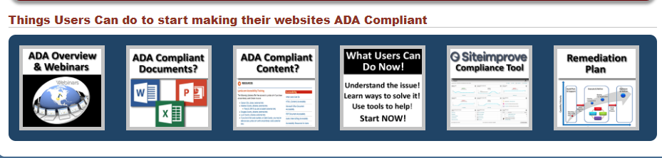

January 11, 2018the web staff made some modifications to the [ADA website](http://ada.nv.gov).

ADA Remediation Snapshot

This snapshot is a quick summary of the State of Nevada CMS Website Accessibility Tracking Log of the Total # of Websites in our CMS, # of sites being remediated, # of sites that are ADA Compliant, and # of Sites that need to be remediated.

***Note: the State of Nevada is striving for all content to meet the standard A & AA compliance, however, we are trying to meet AAA complaint, whenever possible***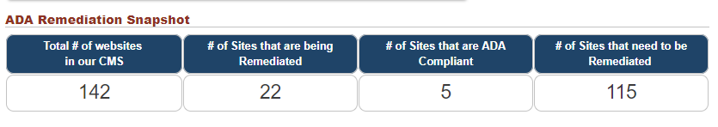

# State of Nevada CMS Website Accessibility Tracking Log

This report contains a [list of all websites that reside in the State CMS, and the website status](http://ada.nv.gov/uploadedFiles/ada,nvgov/content/Home/Features/CMS-AccessibilityTrackingLog.pdf):

1. Website Remediation **Not Started**
2. Website Remediation **In Progress**
3. **Website is ADA Compliant**

Other statuses that **are not being tracked** (sites that were renamed or moved away from our CMS or never went to production):

1. **Website turned OFF**
2. **Website has been Redirected**
3. **Intranet site**

# State of Nevada Remediation Efforts

By clicking on the link below, it will take you to our Remediation Efforts page (see below)****

[What is an ADA Compliant Website](http://ada.nv.gov/Remediation/ConformanceSeverityExplanations/)? A brief overview of ADA compliance, Section 508 and WCAG 2.0, and conformance levels (A, AA, AAA)

[Siteimprove Site Accessibility Status/Progress Reports](http://ada.nv.gov/Remediation/ProgressRpts/) Site improve evaluation reports used to update compliance status  
  
On our Remediation Efforts page, we are tracking multiple types of websites.

1. Websites that are monitored by our Siteimprove tool
   1. Department of Education websites
   2. Official State of Nevada Website
2. Prototype and new sites that are not in production yet
3. Websites that monitored by our Siteimprove tool
4. Department of Administration websites
5. Boards & Commissions

EITS Remediation Efforts to Date

1. Remediation Efforts (History)

Compliant training, Lessons Learned & What Users can do information

[Complete list of State of Nevada Website Accessibility Tracking log](http://ada.nv.gov/uploadedFiles/ada,nvgov/content/Home/Features/CMS-AccessibilityTrackingLog.pdf)

# State of Nevada Remediation Efforts:

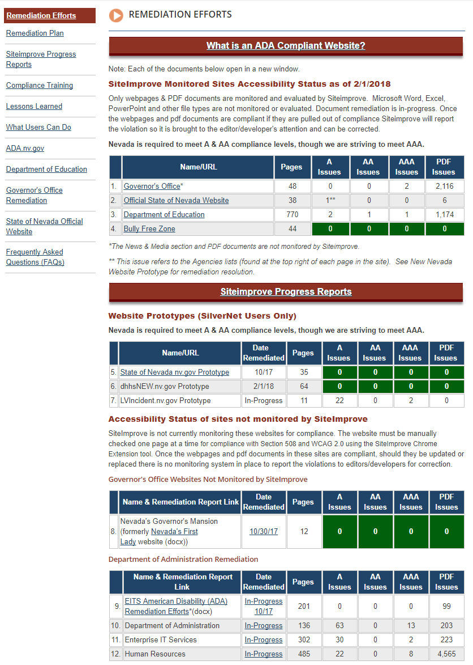

URL of Remediation Efforts: <http://ada.nv.gov/Remediation/Efforts/>

# Assistive Technology (AT) Consumers:

Welcome to the Assistive Technology (AT) Consumers and special thanks to all of you who have graciously volunteered to work with the State of Nevada to assist in making the State’s website ADA compliant. Your efforts are greatly appreciated. This section has been built for the AT Consumer’s convenience while helping us test.

1. We have also added a new [AT Consumer section](http://ada.nv.gov/ATConsumers/AT_Consumers/) for your convenience. It is here that we will be posting new forms, new testing needs, and we have also built a new [ADA Evaluation Form for AT Consumers](http://ada.nv.gov/Remediation/2018/ADA_Complaint_Form-WebsiteDigitalMedia/) users to make it easier to evaluate any testing you perform for the State of Nevada.
2. After the testing of the complaint forms, the next most important area that we would like to have tested is our [Smart Form Configurations (Templates)](http://ada.nv.gov/Remediation/2018/AT-Consumer-Testing/). These templates have been created in one of the Department of Education’s websites as that site is being monitored by Siteimprove and it makes it easier for us to make it compliant and keep it compliant. All of these templates are used in 95% of the websites within the State of Nevada’s Content Management System (CMS).   
     
   Once these templates are tested and certified, we will be able to do outreach to all of the other agencies that have websites in the State CMS and train them how to make their current websites compliant.

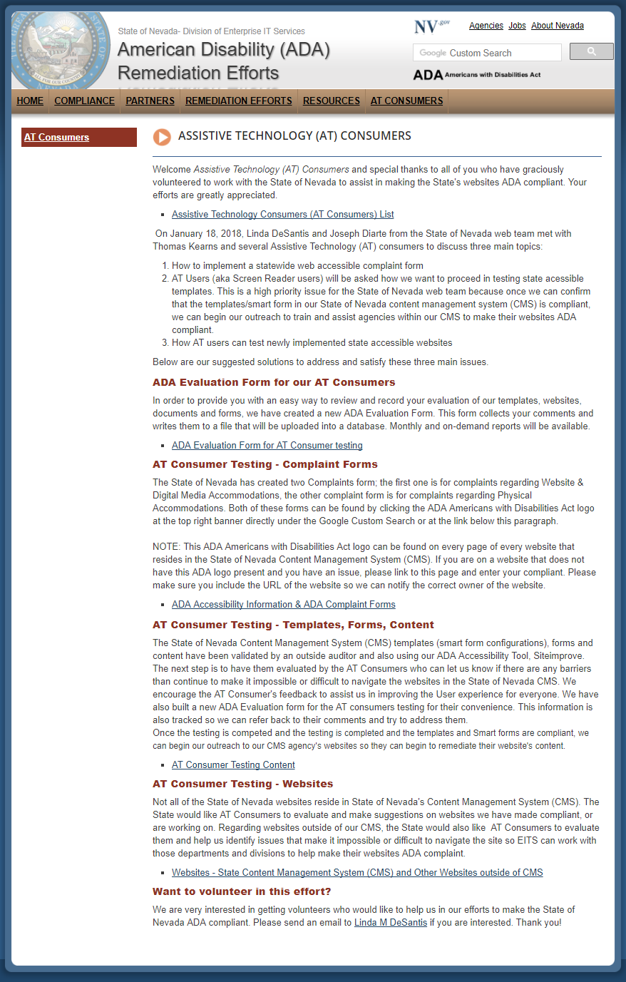URL of Assistive Technology (AT) Consumers page: <http://ada.nv.gov/ATConsumers/AT_Consumers/>

January 18, 2018, Linda DeSantis and Joseph Diarte from the State of Nevada web team met with Thomas Kearns and several Assistive Technology (AT) consumers to discuss three main topics:

1. How to implement a statewide web accessible complaint form
2. AT Users (aka Screen Reader users) will be asked how we want to proceed in testing state accessible templates. This is a high priority issue for the State of Nevada web team because once we can confirm that the templates/smart form in our State of Nevada content management system (CMS) are compliant, we can begin our outreach to train and assist agencies within our CMS to make their websites ADA compliant.
3. How AT users can test newly implemented state accessible websites
4. Below are our suggested solutions to address and satisfy these three main issues.
5. Partner Meeting Agenda and Meeting Minutes can be found on the [ADA Partner Meetings](http://ada.staging.nv.gov/Partners/Meetings/).

# January 2017 - ADA Partner Meetings & Remediation Efforts:

January 26, 2018, EITS team came up with the following solutions to satisfy the requests from January 18 meeting:

1. The [Accessibility Information page](http://ada.nv.gov/Home/Features/Accessibility_Information/) (see below) has been updated to accommodate the following changes. One of the major changes is that we moved the Complaint form links to the top of the page and separated the complaints into two separate forms as we felt they were looking for different information.  
   1. The first complaint form is for registering a complaint regarding [Website and Digital Media Accommodation](http://ada.nv.gov/Remediation/2018/ADA_Complaint_Form-WebsiteDigitalMedia/)
   2. The second complaint form is to register a complaint regarding [Physical Accommodations](http://ada.nv.gov/Remediation/2018/ADA_Complaint_Form-WebsiteDigitalMedia/)
2. You can find this updated Accessibility Information page by going to the [State of Nevada American Disability (ADA) Remediation Efforts website](http://ada.nv.gov/).  
   Once you are there, please click on the ADA Americans with Disability Act logo [Title: ADA logo - Description: Americans with Disabilities Act (ADA) Accessibiity Information](http://ada.nv.gov/Home/Features/Accessibility_Information/)in the upper right hand banner located under the Google Custom Search.

***NOTE: This ADA Americans with Disability Act logo is in the same place on every page of every website that is located in the State of Nevada Content Management System (CMS). Currently other websites that have been built outside of the State of Nevada’s CMS do not have this logo, so please come to the State of Nevada American Disability (ADA) Remediation Efforts website and register your complaint there. Efforts to request that all State of Nevada websites have this logo on their site is upcoming.***

1. Once the submit button is clicked on either complaint form, the information collected in these forms will be written to the Google Drive (a secure cloud). It will then send an email to the following:
   1. Website & Digital Media Accommodation Complaint Form - *Email sent to EITS web team & response back to person who filled out the form thanking them for taking the time to fill out the form*
   2. Physical Accommodation Complaint Form - *Email to Amy Taylor & Tammy Smith & response back to person who filled out the form thanking them for taking the time to fill out the form*

By using this process, it will allow us to collect information in a format that we can reviewed and tracked. Our process for handling these complaints are as follows:

**Step 1**: Identify the website that the complaint is about and:

* + 1. Forward the complaint to the appropriate department, division, board for resolution
       1. Let the complaintant know who their complaint has been forwarded to as they will
    2. If department, division, board does not have an ADA logo
       1. We will request they add a copy of ours on their website so when someone needs to make a complaint, it will be emailed to the EITS and EEO staff for distribution
    3. Offer to familiarize the State of Nevada department, division or board the State of Nevada ADA information and suggest how they might be able to resolve the issue
       1. Send them to the [State of Nevada (ADA) Remediation Efforts website](http://ada.nv.gov) so they can view   
          “Things Users can do to start making their websites ADA Compliant
       2. Go to [State of Nevada (ADA) Remediation Efforts website, Resources](http://ada.nv.gov/Compliance/Resources/) to find tools, training opportunities, accessibility checkers and other helpful information
       3. Share our ADA Accessibility Training Checklist

# January 2017 - ADA Partner Meetings & Remediation Efforts (continued):

* + 1. Track progress of complaint
    2. Generate a monthly report of:
       1. Number of complaints received
       2. What type of Complaint was it?
          1. Website and Digital Media
          2. Physical Accommodations
       3. Who was the complaint forwarded to
       4. Status of the complaint

**Step 3**: Provide monthly reports to management and add statistical information on the [ADA Remediation Efforts website](http://ada.nv.gov).

[Updated Accessibility Information Page](http://ada.nv.gov/Home/Features/Accessibility_Information/)   
[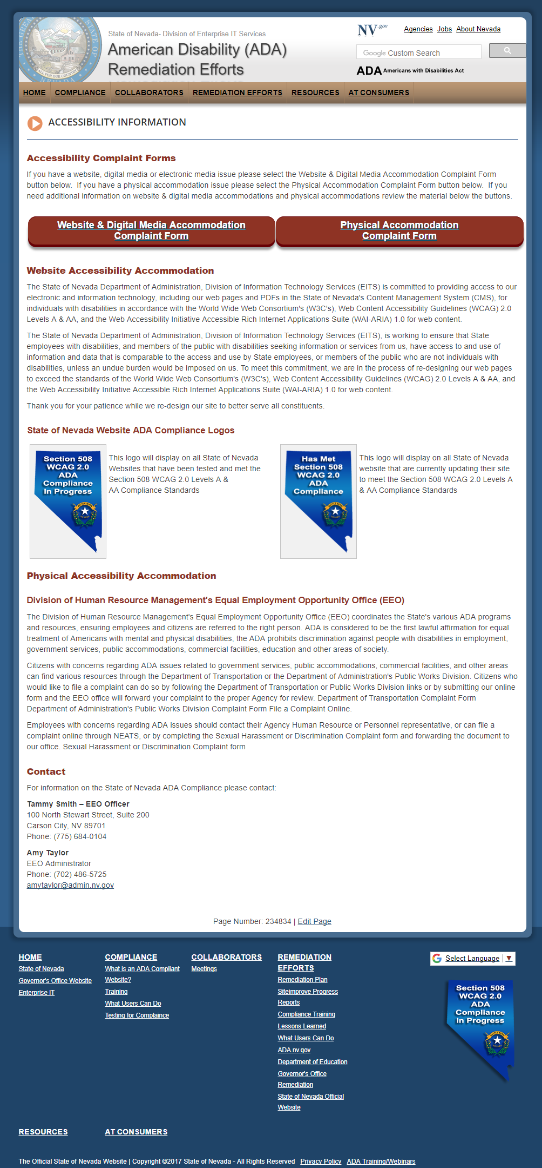](http://ada.nv.gov/Home/Features/Accessibility_Information/)  
URL of Accessibility Information page: http://ada.nv.gov/Home/Features/Accessibility_Information/

## Website and Digital Media Accommodations

The State of Nevada Department of Administration, Division of Information Technology Services (EITS) is committed to providing access to our electronic and information technology, including our web pages and PDFs in the State of Nevada's Content Management System (CMS), for individuals with disabilities in accordance with the Section 508 and World Wide Web Consortium's (W3C's), Web Content Accessibility Guidelines (WCAG) 2.0 Levels A, AA & AAA whenever possible, and the Web Accessibility Initiative Accessible Rich Internet Applications Suite (WAI-ARIA) 1.0 for web content.

The State of Nevada Department of Administration, Division of Information Technology Services (EITS), is working to ensure that State employees with disabilities, and members of the public with disabilities seeking information or services from us, have access to and use of information and data that is comparable to the access and use by State employees, or members of the public who are not individuals with disabilities, unless an undue burden would be imposed on us. To meet this commitment, we are in the process of re-designing our web pages to exceed the standards of the World Wide Web Consortium's (W3C's), Web Content Accessibility Guidelines (WCAG) 2.0 Levels A, AA & AAA whenever possible, and the Web Accessibility Initiative Accessible Rich Internet Applications Suite (WAI-ARIA) 1.0 for web content.

Thank you for your patience while we re-design our site to better serve all constituents.

The State of Nevada's Content Management System (CMS) is Ektron. Currently that CMS supports 142+ websites. Our goal is to make all websites and digital media in our CMS ADA Section 508 WCAG 2.0 compliant.

This is a huge undertaking for the web group, especially because we are using free ADA evaluation tools, WAVE and Siteimprove. Both free tools evaluate ONLY one page at a time. The tool flags errors on the page based on WCAG 2.0 Section 508 standards; categorizes by level of error; and gives recommendations on how to resolve the error. The webmaster needs to understand what must be done to resolve this issue.

The limitations of the ADA WAVE and SiteImprove tool, and the number of websites that we need to make compliant, is the reason we need to collaborate with other departments, divisions, boards and user groups in Nevada. Numerous recommendations and/or fixes made by the tool require a knowledge of that Agency’s business rules.

[Website & Digital Media Accommodation Complaint Form](http://ada.nv.gov/Remediation/2018/ADA_Complaint_Form-WebsiteDigitalMedia/)

## Physical Accommodations

Division of Human Resource Management's Equal Employment Opportunity Office (EEO)

The Division of Human Resource Management's Equal Employment Opportunity Office (EEO) coordinates the State's various ADA programs and resources, ensuring employees and citizens are referred to the right person. ADA is considered to be the first lawful affirmation for equal treatment of Americans with mental and physical disabilities, the ADA prohibits discrimination against people with disabilities in employment, government services, public accommodations, commercial facilities, education and other areas of society.

Citizens with concerns regarding ADA issues related to government services, public accommodations, commercial facilities, and other areas can find various resources through the Department of Transportation or the Department of Administration's Public Works Division. Citizens who would like to file a complaint can do so by following the Department of Transportation or Public Works Division links or by submitting our online form and the EEO office will forward your complaint to the proper Agency for review. Department of Transportation Complaint Form Department of Administration's Public Works Division Complaint Form File a Complaint Online.

Employees with concerns regarding ADA issues should contact their Agency Human Resource or Personnel representative, or can file a complaint online through NEATS, or by completing the Sexual Harassment or Discrimination Complaint form and forwarding the document to our office. Sexual Harassment or Discrimination Complaint form.

Contact

For information on the State of Nevada ADA Compliance for Physical Accommodations, please contact:

Tammy Smith – EEO Officer  
100 North Stewart Street, Suite 200  
Carson City, NV 89701  
Phone: (775) 684-0104

Amy Taylor  
EEO Administrator  
Phone: (702) 486-5725  
amytaylor@admin.nv.gov

[Physical Accommodation Complaint Form](http://ada.nv.gov/Remediation/2018/ADA_Complaint_Form-GoogleDrive/)

## February 2017- ADA Partner Meetings & Remediation Efforts:

February 1, 2018 **meeting with Equal Employment Opportunity (EEO) group lead by Amy Taylor**

1. Had the opportunity to meet with the EEO officers in the State of Nevada
   1. There were numerous EEO officers that were from departments that had their websites outside of the State of Nevada CMS
   2. Directed everyone to the [State of Nevada American Disability (ADA) Remediation Efforts website](http://ada.nv.gov)
2. Presented EEO Officers with an overview of the ADA Remediation Efforts we have been taking since December 1, 2017.
   1. Gave everyone a handout of the State of Nevada’s efforts
      1. Located on [State of Nevada American Disability (ADA) Remediation Efforts website](http://ada.nv.gov), under [Partner Meetings](http://ada.staging.nv.gov/Partners/Meetings/)

February 11, 2018 – ***ADA Compliant 2018 Proclamations, 2016 and 2017 Emergency Orders went into production 2/11/2018.***An email from the Governor’s office stating that the non-complaint Proclamations, Executive Orders and Emergency orders can be replaced by the ADA compliant documents.   
  
Originally Proclamations, Executive Orders & Emergency Orders were posted as a graphical image and were not accessible to disabled users. Disabled users typically only find the title of the proclamation accessible to them and cannot read each paragraph as non-disabled users can. The goal of Accessibility is providing the same experience to all.

1. [Governor’s Website original issues and remediation testing](http://ada.nv.gov/Users/Gov/GovernorsOffice/" \o "Governor's Website Orginal Issues & remediation efforts)
2. [ADA Compliant Press Releases, Proclamations, Executive Orders and Emergency Orders](http://ada.nv.gov/Users/Gov/GovernorsOffice/" \o "Governor's Website Orginal Issues & remediation efforts)

February 12, 2018 – ADA Content Management Training Class in Nevada eLearn (Moodle)

Build a training class in Moodle eLearn for State of Nevada CMS users on ADA:

1. EITS Web team has put together the following training Class syllabus to be added to the Nevada eLearn (Moodle)
   1. First time on-line training for the State of Nevada CMS users, and then future refresher courses
   2. Mandatory:
      1. Everyone using the State of Nevada CMS is required to take this
      2. New Employees (part of onboarding process)
2. Training class will in user training (UT) the 3rd week of February
3. All class sessions will be an overview & several quick ways to accomplish what you are trying to do
   1. Additional documentation

# Moodle ADA Training Class (Section 1)

1. **Section 1 – Overview of ADA**
2. Outline/Preview for the State of Nevada Content Management System (CMS) users:
   1. This is an overview course covering multiple
   2. ADA Resources
      1. ADA webinars – <http://ada.nv.gov/Compliance/Training/>
      2. Link to EITS Web Team’s Chronological list of our Remediation Efforts
   3. Quiz – one to three questions

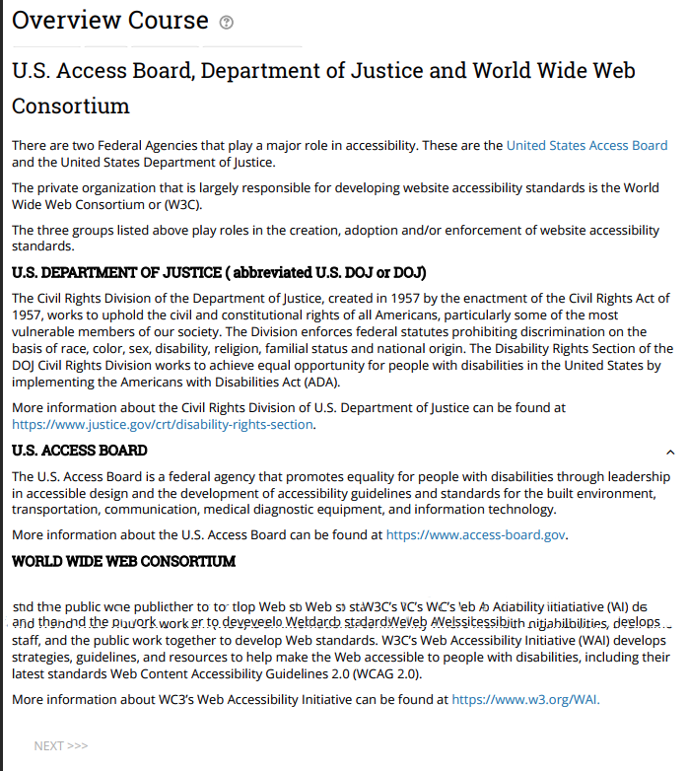

# Moodle ADA Training Class (Section 2):

1. **Section 2 –** “**Remove/delete it, or you have to remediate it!”**
   1. Recommend users review the content & one previous year’s data
   2. Recommend they only keep current & one previous year of data
      1. Websites are NOT Storage areas – Don’t use it to archive your information
   3. Quiz – one to three questions

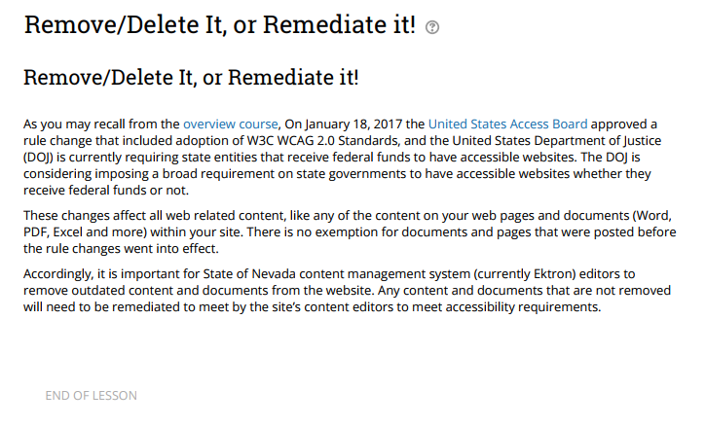

# Moodle ADA Training Class (Section 3):

1. **Section 3 – Siteimprove browser extension tool**
   1. What is it?
   2. Why we need to do it?
   3. How Siteimprove can help them identify ADA errors
   4. How Siteimprove will suggest possible solutions to correct their ADA errors
   5. What is required of them to start using the tool
   6. Resources (O/S class) – (See Stat CMS Evaluaion – Webpages, Smart forms – Suggested Smart Forms in CMS
   7. Quiz – One to three questions

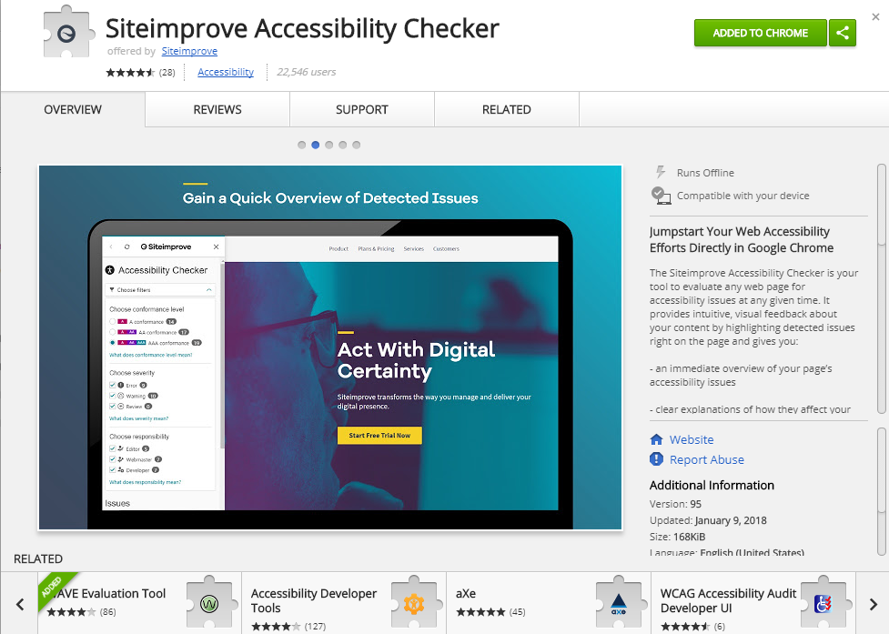

# Moodle ADA Training Class (Section 4):

1. **Section 4 – How to remediate their content**
   1. Lessons about the new ADA Smart Forms
   2. What they need to do to remediate the content
   3. Step by Step - Example of how to remediate our Smart Forms
   4. Resources
      * 1. Each new ADA Smart Form
           1. Will be available on the State of Nevada ADA website
           2. Will have detailed instructions how to remediate
   5. Quiz – one to three questions

Sample from Smart Form – ADA Page Program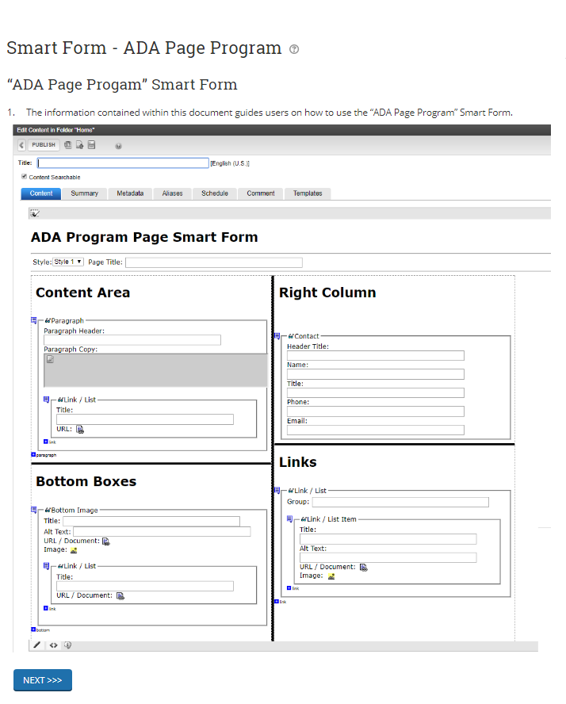

# Moodle ADA Training Class (Section 5):

**Section 5 – How to remediate Documents and PDFs**

* 1. Steps on how to remediate Word
  2. Steps on how to remediate Excel
  3. Steps on how to remediate PDFs
  4. Resources
     1. Resources (O/S classes that are available – Training for ADA Documentation Remediation if the users feel they need more detail.

Sample from Remediating Microsoft Word Documents

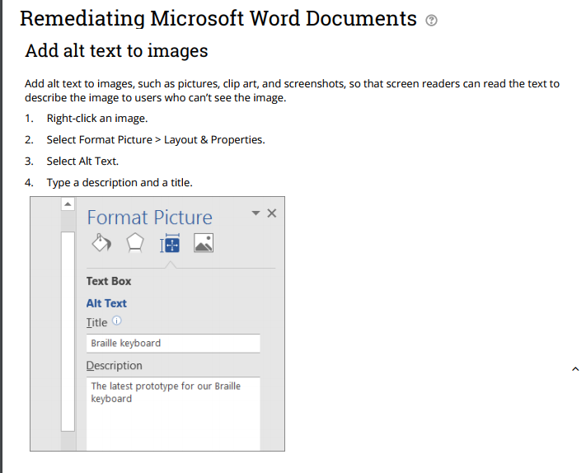

# Moodle ADA Training Class (Section 6):

1. **Section 6 – Other information included in the ADA Moodle Course**
   1. Frequently Asked Questions
   2. Tips & Suggestions
   3. Final Exam (certificate)
      1. Based on Quizzes at end of each section
   4. Feedback/Survey

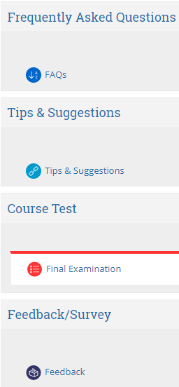

Moodle Training Class Resources:

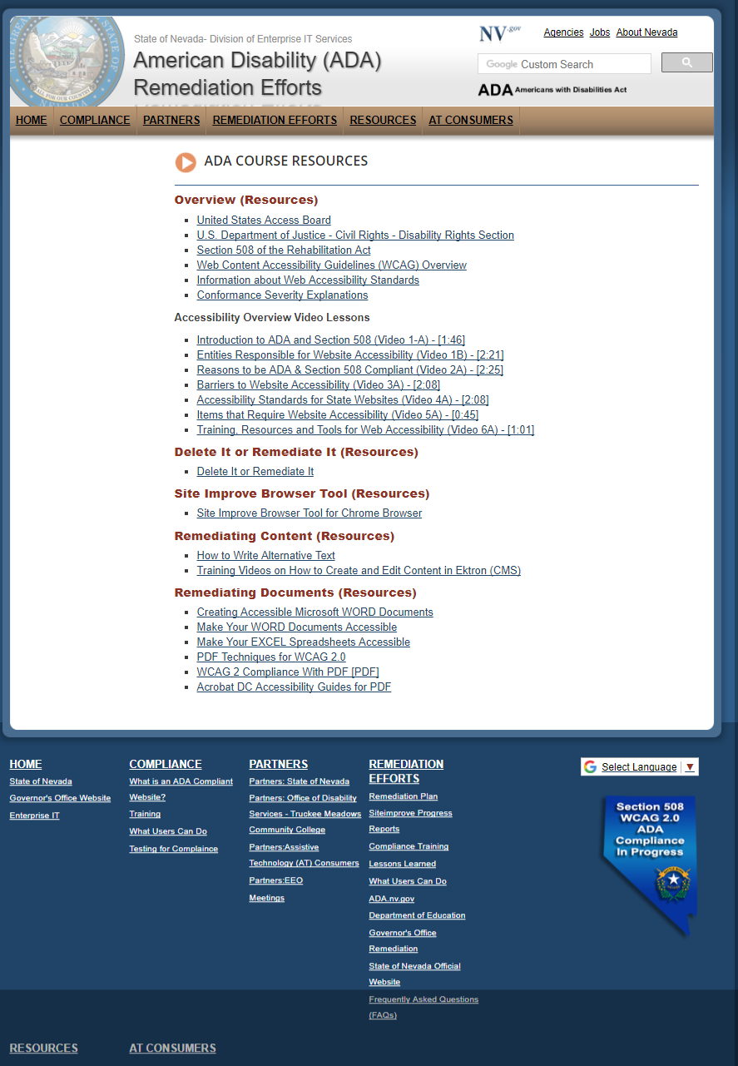

URL of [ADA Course Resources: http://ada.nv.gov/Resources/ADA-Course-Resources/](http://ada.nv.gov/Resources/ADA-Course-Resources/" \o "ADA Course Resources: http://ada.nv.gov/Resources/ADA-Course-Resources/)

*These resources have been built in the State of Nevada – Division of Enterprise IT Services ADA Disability (ADA) Remediation efforts website so users can refer these resources without having to go back into eLearning training course.*

# February 2018 - ADA Partner Meetings & Remediation Efforts:

February 16, 2018 **–** ADA class has been finished and created in NVELearn. We are currently asking for CMS users to volunteer for user testing.

February 17, 2018 **–** Request from Matt Robinson, Communications Officer for DCHFP, to start the process of making all websites within the Department of Health & Human Resources ADA complaint. Websites with DHHS include:

* Department of Health & Human Services (DHHS)
* Aging and Disability Services (ADSD)
* Child & Family Services (DCFS)
* Health Care Financing & Policy (DHCFP)
* Public and Behavioral Health (DPBH)
* Welfare & Supportive Services (DWSS)

Linda provided Matt with a test website that was built several months ago to satisfy a request to redesign all DHHS websites. This test website also has ADA templates installed. The web team will add additional training links and webinars to assist DHHS staff with this task.

We have also suggested that the DHHS transition team be part of the user testing for the new ADA remediation class in the state’s eLearn system. Matt has agreed and will work with Web team to get them started.

February 18, 2018 – ADA Status:  
***TOTAL number of websites being remediated as of 2/22 are 38; Total number of websites that are ADA Compliant are 5.***

February 20, 2018 – Linda & Robert, new Public Intern, worked with James King at Smart 21 to walk through making documents ADA compliant. Robert will continue to review and work with James to get all documents remediated. State web will assist Smart 21 to make their website ADA compliant.

February 21, 2018 **–** Robert created a ‘how to make your word document ADA complaint’ in a few easy steps. This document has been sent to James King, Derek Hawkins and Matt Robinson for user testing. It has also been added to our ADA Remediation Guide at <http://ada.nv.gov/CMS/Remediation-Guides/>. These instructions include a practice document that has all of the issues that the instructions provided are trying to remediate. Hopefully this method will give the users ‘hands-on’ experience.

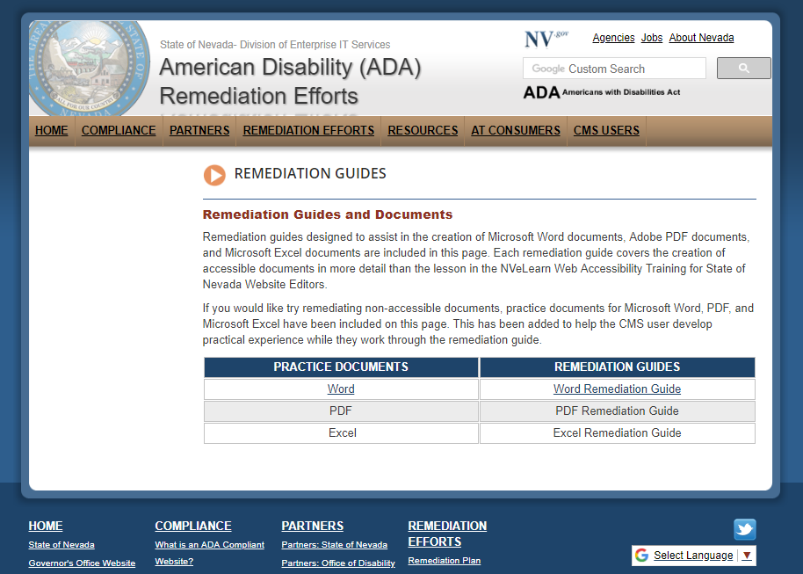  
  
  
February 21, 2018 (Meeting) - AT Consumer meeting at TMCC – Joe & Linda met Thomas Kearns and the AT consumers to continue to understand issues they face when trying to navigate websites and other digital media. It was certainly an eye opener, and once again Joe and I realized we need to continue to try to make modifications to make our websites a better user experience for them.

February 22, 2018 – Linda Desantis was asked to give a presentation to the Department of Health and Human Services Aging and Disability Services Nevada Assistive Technology Council (AT Council).

The State of Nevada’s Remediation efforts was positively received. We will be added to their next agenda to give an update on our progress.

**NOTE:** Meeting and presentation can be found at <http://ada.nv.gov/Partners/Meetings/>

February 25, 2018 – A twitter feed, Web Accessibility Nevada, was created and posted to the State of Nevada American Disability (ADA) remediation Efforts website. Follow us, <https://twitter.com/adanevada>.

March 2018 - ADA Partner Meeting & Remediation Efforts:

March 6, 2018 - An email was sent by Linda to all ADA Partners to update them on the State of Nevada’s Remediation Status. This is the first update to everyone since our first phone conference call on December 1, 2017. Instead of sending out attachments, we directed everyone to visit [http://ada.nv.gov](http://ada.nv.gov/). The web team does bi-weekly updates on the State’s ADA status and keeps a chronological list of updates under <http://ada.nv.gov/Reporting/Reporting/>.   
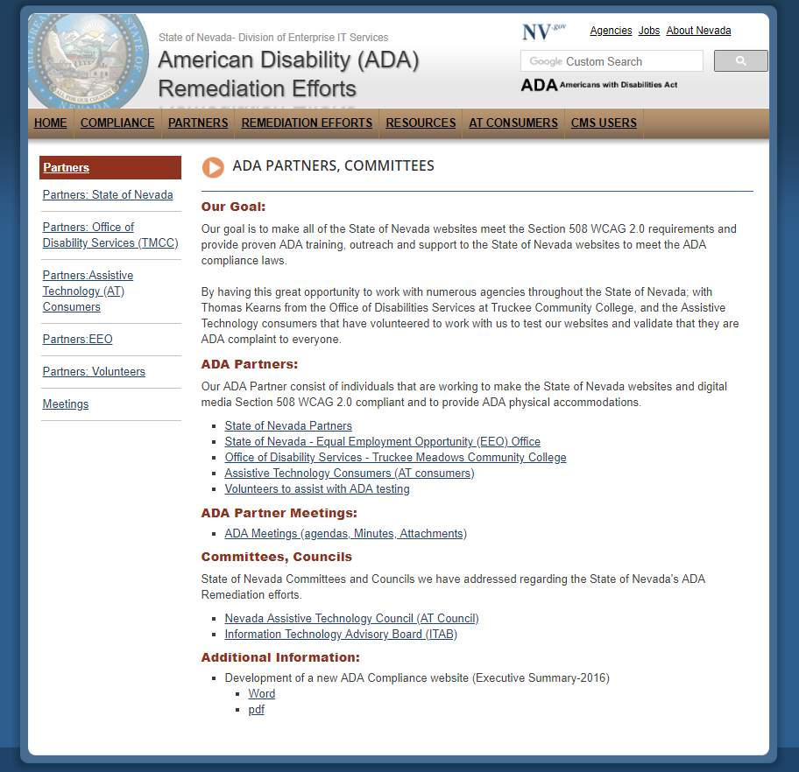

March 6, 2018 – ADA Status:  
***TOTAL number of websites being remediated as of 2/22 are 38; Total number of websites that are ADA Compliant are 5.***

March 7, 2018 – EITS Web team sent an email to all CMS user and CMS Managers opening up the new eLearn class:

**NVeLearn class**:

The State of Nevada Department of Administration, Division of Information Technology Services (EITS) is committed to providing access to our electronic and information technology, including our web pages and PDFs in the State of Nevada’s Content Management System (CMS), for individuals with disabilities in accordance with the World Wide Web Consortium’s (W3C’s), Web Content Accessibility Guidelines (WCAG) 2.0 Levels A & AA, and the Web Accessibility Initiative Accessible Rich Internet Applications Suite (WAI-ARIA) 1.0 for web content. Please visit our State of Nevada American Disability (ADA) Remediation Efforts website at [http://ada.nv.gov](http://ada.nv.gov/) for constant updates.

### IMPORTANT ANNOUNCEMENT:

Today, we are inviting you to take our new Web Accessibility Training in the NVeLearn environment. This training is highly recommended for our CMS content users.

**Please go to** [**http://ada.nv.gov/CMS/CMS_Users/**](http://ada.nv.gov/CMS/CMS_Users/) **for details and information on how to the course.**

The training class includes topics to help users:

* Remediate their current non-compliant web pages to ADA complaint templates
* Remediate non-complaint documents; Word, Excel, PowerPoint, PDF to ADA compliant documents in ten easy steps or less
* Find additional training resources
* Answer some Frequently Asked Questions (FAQs)

Once you finish the CMS training, you can contact [stateweb@admin.nv.gov](mailto:stateweb@admin.nv.gov) and our staff will help you add our ADA compliant templates so that you can begin to remediate your content.

### Additional Information About the Remediation Effort:

* All reporting, status updates can be located at: <http://ada.nv.gov/Reporting/Reporting/>
* The remediation of State Content Management websites can be located at <http://ada.nv.gov/Remediation/Efforts/>
* Our ADA Partner Meetings can be found at <http://ada.nv.gov/Partners/Meetings/>  
  Please view the list of our ADA Partners at [http://ada.nv.gov/Partners/ADA_Partners/.](http://ada.nv.gov/Partners/ADA_Partners/)
* You can find a place where AT Consumers could ask for help regarding Physical Accommodations and/or Website& Digital Media Accommodations information at <http://ada.nv.gov/Home/Features/Accessibility_Information/>.

April 2018 - ADA Partner Meeting & Remediation Efforts:

### April 16, 2018 – Met with the Nevada State Library, Archives and Public records (NSLA)

NSLA purchased a new Content Management System (CMS) called Libguides and moved away from the State CMS. The new NSLA website is a well-organized, attractive and clean website and we agreed to redirect their URL from our CMS to their new site. While we were reviewing the site, we realized the new NSLA website is not ADA Compliant. We are currently working with NSLA staff to resolve that problem.

* We are getting a quote for them to purchase Siteimprove, the ADA remediation tool we use to remediate our CMS websites
  + Working with Siteimprove to get a quote for them to purchase the software
* We are coordinating a conference call with Thomas Kearns, who is familiar with Libguides, to give them some pointers to help get their new site ADA compliant
* We are recommending their use our [Document remediation guide](http://ada.nv.gov/CMS/Remediation-Guides/-) so their can make their documents compliant

A special thanks to Thomas Kearns, Office of Disabilities Services & EITS Web team’s Diana for checking to ensure this website was ADA compliant.

NSLA website - <https://nsla.libguides.com/home>

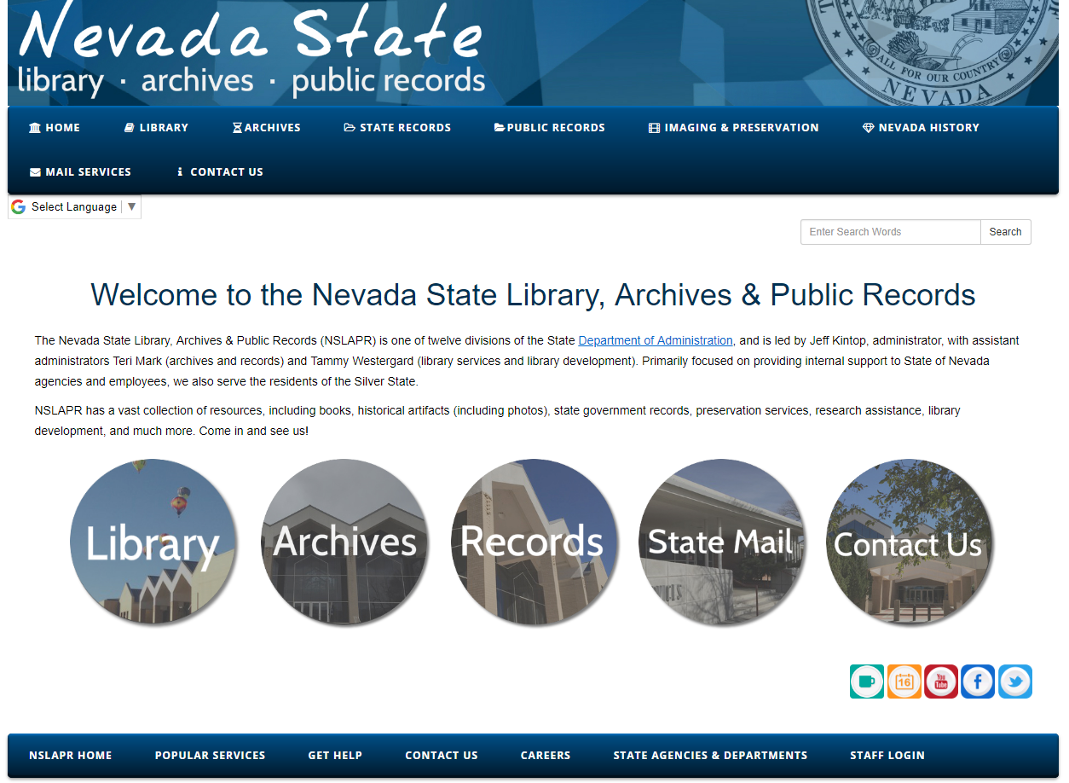

### April 18, 2018 – Met with the Department of Public Safety (DPS) to revamp their websites

The Division of Highway Patrol requested we met to discuss updating their current website to include new features. The Public Information Officer from DPS also attended.   
  
We agreed to create a new prototype for them in our current CMS that can be used by all divisions of DPS. The prototype would use our ADA compliant Smart forms, but we modified the CSS to make the look and feel look different.

DPS prototype that will be used by DPS and all divisions; 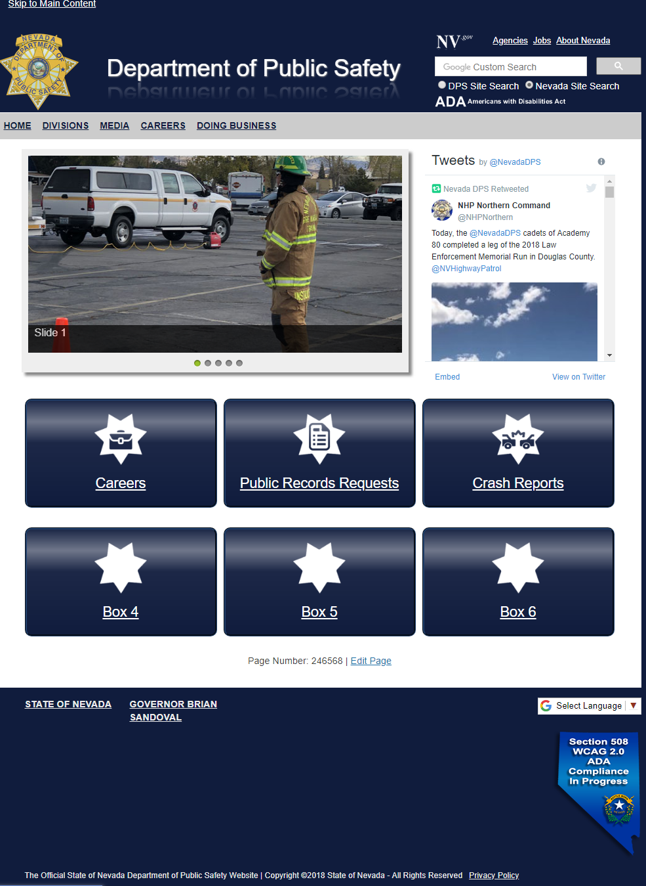

The agreement we made with DPS is that before they go live with the new prototypes, they will need to do the following:

* Take the NVeLearn class for CMS Users
* Make the new site ADA compliant *BEFORE THEY CAN MOVE the NEW WEBSITE into production.*
* The following 13 websites will be rebuilt:
  + Department of Public
  + Capitol Police
  + Criminal Justice Assistance
  + Emergency Management/Homeland Security
  + Highway Patrol
  + Human Resources (DPS)
  + Investigation Division
  + Parole & Probation
  + Professional Responsibility
  + Records, Communications and Compliance
  + State Fire marshal
  + Traffic Safety
  + Training

**Next Steps for DPS rewrites:**

* Meeting scheduled with DPS PIO on 5/16 to move project forward

April 20, 2018 – “EITS Explorer” NewsletterStarting in February 2018, Enterprise IT Services Web team is featuring a series of articles about the State of Nevada’s ADA Compliance Efforts. Links to our EITS Explorer Newsletter can be found on <http://ada.nv.gov/>, under Helpful Links, “[Nevada accessibility in the News](http://ada.nv.gov/News/News/)”

* [February 2018 – ADA Compliance Efforts](http://ada.nv.gov/uploadedFiles/ada,nvgov/content/Home/Features/2018-02_Newsletter_EITS.pdf) (Part I)
  + What is being done to bring state website into compliance?
  + First State of Nevada ADA meeting with State of Nevada Stakeholders and partners
* [April 2018 – ADA Compliance Efforts](http://ada.nv.gov/uploadedFiles/ada,nvgov/content/Home/Features/currentNewsletter.PDF) (Part II)
  + Nevada’s ADA Partners
  + How to remediate documents in Ten Easy Steps

### April 26, 2018 – Meeting with EITS Operations Division to help us remediate website documents

The EITS web team and the EITS Operations staff (8 people) are collaborating. The operations staff can have free time during their workday and they are willing to help us remediate non-complaint documents. Our intern, Robert Shrader, has created a [Document Remediation Guide](http://ada.nv.gov/CMS/Remediation-Guides/-) to train our users how to remediate their documents. By working with the Operations staff, we will be able to put a dent in the number of PDFs that the websites in our CMS has, and they will also be helping us get the process clean so when we do the outreach to our users, it will be a proven solution.

This remediation Guide has written instructions on how to remediate Word, PDF, Excel and PowerPoint and includes a practice document for each that the users can download and use when they follow the instructions. We are currently creating Remediation Guide webinars to give users an option of paper or captioned YouTube webinars. These webinars should be available mid-May.   
  
The first training class given to the operation staff was on April 26. We started with the remediation of WORD documents and after the class, three additional documents were sent to the Ops team to to practice.  
  
Robert will continue to meet with the Op staff weekly and help review their progress and ensure they are feeling comfortable and are remediating the documents correctly.   
  
The documents we are using giving to the Ops group are documents from current CMS websites that the EITS web team updates. The content pages for all the sites have already been made compliant, but the documents were not. Once these documents have been remediated & verified, they will be uploaded to the CMS websites.

Documentation Remediation Guides:   
**[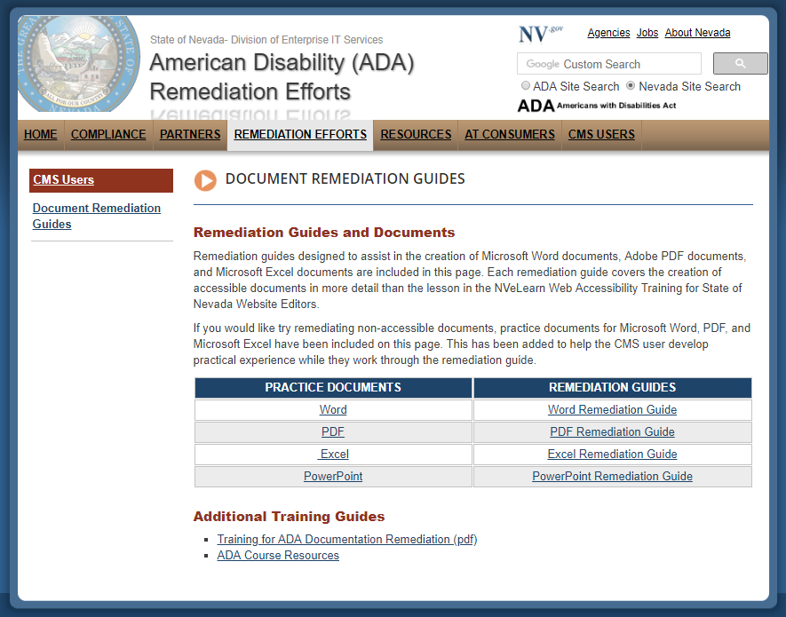](http://ada.nv.gov/CMS/CMS_Users/)**Issues encountered**:** Most of our documents are PDFs, and after researching and working with Thomas Kearns, it appears the ONLY tool that will help remediate PDFs is Adobe Acrobat. The problem is a lot of the agencies do not have Adobe Acrobat and because it is an expensive tool, they might not be able to purchase it. We are currently looking at alternatives:

* Find a tool to convert the PDF back to Word if they do not have the word document
  + Then, remediate the word document
  + Create a PDF that is compliant
* Exploring other options

### See August 19, 2018 – Partnership with Operations Group has been cancelled due to staffing issues

May 2018 - ADA Partner Meeting & Remediation Efforts:

### May 1, 2018 – Department of Health & Human Services (DHHS)

The websites involved:

* Department of Health & Human Services
* Aging & Disability Services (ADSD)
* Child & Family Services (DCFS)
* Health Care Financing & Policy (DHCFP)
* Public & Behavioral Health (DPBH)
* Welfare and Supportive Services (DWSS)

Their staff is currently reviewing their existing websites to determine what can be cleaned up in preparation of building a new ADA website. Attached is an example of the report we send our users to help them identify all the content pages within their CMS websites.

* Staff is also taking NVeLEARN ADA class
* Staff is reviewing Documentation Remediation guide
  + We also suggest the users clean up their sites first, and work on getting their documents complaint

May 2, 2018 – CMS user and CMS Managers who took the new NVeLearn Class on ADA:   
As of 5/2, the following 24 CMS users have taken our CMS users class:

* Christina Cole – Division of Human Resources
* Athena Cox – Silver State Health Insurance Exchange
* Gideon David - Purchasing
* Michelle Dufrisne – EITS HR Help Desk
* Diana Estey (EITS Web Team staff)
* Perry Faigin – Business & Industry - Housing Division
* Derek Hawkins (EITS Web Team class creator)
* Theodore Hendricks – Business & Industry
* Stephanie Klapstein – Department of Taxation
* Catherine Krause – Attorney General’s Office
* Denise Madera – Public and Behavioral Health (DPBH)
* Heather Mitchell – Health Care Financing & Policy
* Sean Nichols – Environmental Protection
* Nathan Orme - Public and Behavioral Health (DPBH)
* Kelley Railey – Division of Mortgage Lending
* Erik Ringle – Environmental Protection
* Michael Shannon – Division of Human Resources
* Amalia Sifuentes – EITS HR Help Desk
* Susan Slack - Division of Mortgage Lending
* Glen Smith – Division of Child and Family Services
* Millicent Thomas – Aging and Disability Services Division
* Alicia Whipple – Judicial Branch
* Elizabeth Williams – Library & Archives & Public Records
* Jun Yuan – Department of Veteran Services

Only 10 people took the survey to review the class. Reviews of the class ranged from Poor to Excellent. Currently the survey does not ask for the user’s name, so we have not been able to reach out to the users and find out what they liked and disliked about the survey. We are currently modifying the survey to resolve that.  
  
In the meantime, we are working on sending out a follow up survey that gets more specific information, so we can modify the class to be more effective for our users.   
  
**Next steps:** Our staff is going to reach out to all the users who have taken the class & begin to work with them on getting their websites compliant. That involves:

* Adding the new ADA smart forms to their site (EITS Web team)
* Applying CSS and JavaScript files to the site (EITS Web team)
* Converting the properties of the old smart form to the new ADA properties (EITS Web team)
* Walk the users through how to make the new ADA page compliant based on knowledge gained from the NVeLearn class and the Siteimprove Accessibility Chrome Extension tool

### May 2, 2018 – [ADA complaints](http://ada.nv.gov/Home/Features/Accessibility_Information/) (using new on-line complaint form)

To date, we have had four complaints regarding Physical accommodations. These complaints have been forwarded to Tammy Smith, EEO office for resolution.

* Tammy has reviewed the complaints and has forwarded them to the appropriate person

To date, we had two complaints regarding Website & Digital Media. These complaints are handled by the EITS web team.

* One of the complaints was not a complaint, but a person volunteering to assist us in our effort.
* The second complaint was against the State of Nevada Treasurer.
  + Treasurer’s website is linking to a bank that the AT consumer could not navigate
    - EITS staff talked with the Nevada Disability Advocacy & Law Center Rights Attorney who spoke on behalf of the person who filed the complaint to gather the specific details of the complaint.
    - EITS staff verified the accessibility issue and then talked with the web coordinator at Nevada Treasurer
    - Together they came up with a solution on how to fix the issue that the vendor can apply. This resolution was identified on 5/2, and explicit instructions were sent by EITS to the Treasurer’s coordinator for forwarding to their vendor for resolution
* Next Step:
  + EITS will verify fixes have been made
  + EITS and/or Treasurer coordinator will contact the person who filed the complaint to ensure they can get what they need

NOTE: Even though there are two separate complaint forms, EITS staff continues to monitor ALL complaints and ensure they are getting to the correct person for resolution. A recent modification was made to the process to send an automatic ‘notification email’ to the EITS Staff whenever a complaint has been filed.   
**(see August 23, 2018 for update)**

### May 3, 2018 - Status of our ADA Website Remediation Efforts:

* Total # of websites in our CMS: **142**
* Total # of sites that are currently being remediated**: 38**
* Total # of Sites that are ADA compliant**: 7**
* Total # of Sites that need to be remediated**: 99**

### May 3, 2018 - Department of Education (DOE) & Office of Civil Rights (OCR):

The Department of Education was cited for non-compliance websites in May 2016. At that time, EITS coordinated the purchase of Siteimprove software to help them begin their remediation process. Education has several main websites and several other websites that are not in our CMS. DOE is following the OCR reporting schedule, and they are making significant progress. When DOE was originally sited, they had about 765 pages and over 5,000 PDFs to remediate. The first thing they did was review the 5,000 PDFs and eliminate anything that was old and not needed. That left them around 4,000 PDFs to remediate. They also set up training classes to teach the 100 + content owners how to remediate their documents.

* Final signed document from OCR
* [Nevada Department of Education Remediation efforts](http://ada.nv.gov/Users/DOE/2017/Education/)

In March, OCR reached out to DOE to relax their schedule and DOE “DECLINED”. They felt that they have made a lot of progress and DOE wanted to continue to make the Department of Education’s websites A, AA, AAA compliant.

* Department of Education website has four A issues, and 812 PDFs that still need to be remediated
* Bully Free Zone website is A, AA, AA compliant and so are all their PDFs.

Congratulations and Kudos for all their efforts and their decision to decline the relaxed schedule that OCR offered.

May 10, 2018 - Seamless Docs Kickoff  
Seamless Docs will allow us to transform manual processes to paperless.   The platform provides workflows, electronic signatures, on-line payment capabilities, and will help users create ADA compliant documents and on-line forms.  Seamless Docs will also satisfy Senate Bill 236 which requires state agencies to make all forms available electronically.  These forms will allow for online completion and secure submission.  All forms can become downloadable to meet any specific requirements.  All online forms that are completed and submitted are archived with the information from the form stored in a searchable database.   I wanted to update you on where we are at with our efforts in the project and provide an overview of the Seamless Docs environment.  
  
Pilot program: One of the first forms that will be used in our pilot is to combine the two ADA complaint forms into one  
  
May 15, 2018 – Seamless Docs Testing/Evaluation of Software  
EITS testing has identified ADA compliance issues. Pilot has been held up while EITS works with Seamless to identify and resolve ADA issues with their tools

### 

June 2018 - ADA Partner Meeting & Remediation Efforts:

June 6, 2018 - Information Technology Advisory Board (ITAB) Meeting   
The Information Technology Advisory Board is created by statute NRS 242.122 and NRS 242.124 for the purposes of:

1. Advising EITS on variety of issues relating to information technology, including strategic planning and the budget appropriate to support the EITS mission of performing information services for state agencies.
2. Reviewing goals and objectives, including the review of planning for the information technology of each state agency.

ITAB members include legislators, representatives of large user of EITS services, information technology specialists from cities and counties, private sector representatives of the information technology industry, and members of the Executive Branch. Thomas Kearns from the Office of Disabilities Services at Truckee Meadows Community College gave public comment on 2/14/18 regarding ADA and the way it affects people with disabilities. Mr. Kearns’ testimony resulting in an invitation to Linda DeSantis, EITS Enterprise Web team to address the committee on June 6, 2018. Presentation can be found on the State of [Nevada American Disability (ADA) Remediation Efforts](http://ada.nv.gov/Efforts/Report__Efforts/).

#### A request was made after meeting by Richard Whitley-Director, Division of Health & Human services (DHHS), to meet and discuss what DHHS could do to make their DHHS websites ADA compliant.

June 20, 2018 – Evaluation of “ADA global updates” that were made manually by EITS staff to each website in the CMS’ Header, Footer and other global issues to make the website ADA Compliant.   
Based on our evaluation, it took an EITS staff member one year of time (working 4 hours a day) to apply the changes manually to 21 websites.    
**TOTAL TIME TAKEN**: **49.5 hours per website** * 21 websites = **1039.5 hours worked  
CALCULATED time to complete other 111 websites that are not done: 5495.5 hours**

### CMS Websites - ADA Global Updates Applied manually:

|  |  |
| --- | --- |
| Completed website | # pages affected |
| Governor’s Office | 1,007 |
| Smart 21 | 41 |
| Bully Free Zone - Education | 31 |
| NV.gov-State of Nevada website | 38 |
| First Lady (Governor’s mansion) |  |
| Admin.nv.gov | 136 |
| Barber | 16 |
| Oriental Medicine | 24 |
| Beltca – Home Care Health | 22 |
| NSBLA | 31 |
| Massage Therapy | 33 |
| NVBDO | 31 |
| CRPTR – Court Reporters | 40 |
| PTBoard | 36 |
| Socwork |  |
| Alcohol | 63 |
| Podiatry | 30 |
| Athletic Trainers | 37 |
| Pardons | 50 |
| Chirobd-Chiropractic Board | 45 |
| Psyexam- Physic Exam | 64 |
| Total Webpages Remediated | 1,830 |

What are the manual ADA GLOBAL changes that were applied:   
The CMS header and footer information are on EVERY page of the website, so when we apply these changes, it clears up these errors on all pages within the site. Please note, by applying these changes, the entire website is NOT ADA compliant, however, it does resolve the following issues:

1. Header: Add a ‘Skip to main content’ link at top of each page so screen reader users can skip redundant navigation.
2. Header: Navigation issues: This means disabled users who do not use a mouse can traverse the website (including the navigation) using nothing but their keyboard. Currently, if any navigation links had drop downs, they would not be seen by the AT consumer’s devices.
3. Contrast Ratio corrections:  level AA requires a contrast ratio of at least 4.5:1 for normal text and 3:1 for large text. Level AAA requires a contrast ratio of at least 7:1 for normal text and 4.5:1 for large text.  These levels are required to aid low vision users.  
     
   The orange color #d86926 originally used throughout the Ektron websites for level 2 headings (on a white background) and as a background color (with white text) has a contrast ratio of 3.51 and does not meet AA requirements.  The color was replaced with #8f331f (burgundy/brown) on the white background that and as a background with white text and now has a contrast ratio of 7.89 and meets AAA requirements.
4. Header: Google search had many attributes that were removed with JavaScript and JavaScript was also used to add wai-aria roles and labels to attributes, add page titles to pages that did not have them, and to remove attributes from YouTube videos that violate accessibility requirements, to name just a few.
5. 22 non-compliant smart forms were programmatically updated to include the required accessibility features.  Of those only seven require users to add any additional input to the compliant version of the smart form.
6. Added an underline to all links that aren’t in the navigation because browsers underline hypertext links by default. It is possible to remove the underline using Cascading Style Sheets (CSS), but this is a bad idea most of the time. Users are accustomed to seeing links underlined. In body text, they may or may not be able to figure out which text is linked if the underline convention is not used.  
     
   Although users are accustomed to seeing links in the main content underlined, they are also accustomed to seeing tabs and main navigational features (oftentimes created as graphics rather than text) without underlining. In these cases, the linked items should be designed so it is apparent that the user can click on them to perform an action
7. Ensure that code to generate Google Statistics has been applied to every web site

NOTE: These errors are barriers that stop AT Consumers from accessing and/or navigating our websites

List of Smart Forms that are fixed with program update:   
Smart forms fixed by program:

* ADA Countdown Clock
* ADA Documents
* ADA Glossary
* ADA Image Only
* ADA Links
* ADA Page
* ADA Page FAQs
* ADA Press
* ADA Staff List
* ADA State: V3 list Serve

### List of Smart Forms that need to be fixed manually by Users:

These Smart Forms have additional fields added to allow Users to enter in the information required to make their content in these new ADA Smart forms ADA Compliant:

* ADA Carousel:
  + users need to add alternative text (Alt Text) for the image fields
* ADA Initiative Boxes:
  + users need to add alternative text (Alt Text) for the image fields
* ADA Slides:
  + users need to add alternative text (Alt Text) for the image fields
* ADA Social Media:
  + users need to add alternative text (Alt Text) for each social media image icon
* ADA State: Page Program V4:
  + users need to add alternative text (Alt Text) for the image fields
* ADA YouTube:
  + users need to add a page title if the page is used as a standalone page and is not using metadata to display this content on another page.
* ADA Meetings & Agendas:
  + users must identify each meeting document with the date of the meeting. If a meeting date has more than one meeting a unique identifier must be used to differentiate between them in addition to the date.

June 21, 2018 – EITS staff will write a program to apply ADA global updates instead of manually  
Benefits - write program vs manual updates:

* Time/Cost Saving of **5474.5-man hours** (estimated 5495.5 hours manually vs program hours-40 hours)
* Accuracy – program updates vs manual updates
* Using Subversion – all code will be saved & updated from subversion
* Reusable code – other updates to the CMS websites can be done programmatically (including search changes, new code changes, etc.)
* Estimated Completion time for program testing: **End of July 2018 - (SEE July 25, 2018 for update)**

### June 30, 2018, Budget Enhancements:

Agency IT Services has put in budget requests for 2020-2021 for the EITS Web team:

* New Content Management System (CMS)
* Purchase an enterprise version of Siteimprove for all CMS users
  + Siteimprove tool monitors our websites and identifies ADA issues to be remediated
  + Siteimprove tool validates the website against WCAG 2.0 Section 508 standards and gives recommendation how to fix the issues
  + Currently we only have five licenses. We need additional licenses to cover all 132 websites within the State of Nevada CMS
* Add Two additional staff members to the Web team area
  + ITP II, ITP IV
* Purchase ADA training for Web team staff

July 2018 - ADA Partner Meeting & Remediation Efforts:

July 23, 2018 – Meeting with Richard Whitley-Director, Division of Health & Human Services  
Discussion with Suzie Block, Linda DeSantis and DHHS group on ideas how we can move their DHHS websites into compliance.

* Discussed DHHS purchasing Siteimprove for their six division
* Discussed different ways DHHS & EITS web team could continue to collaborate
* Agreed that collaboration between DHHS & EITS is essential and will continue

July 24, 2018 – Purchase of ADA training materials from Deque University  
 Web team was able to acquire three copies of Deque’s University Full on-line curriculum for one year. These on-line classes cover accessibility knowledge in the fundamentals, web accessibility, testing techniques, document accessibility, mobile app accessibility, accessibility management. This curriculum also includes IAAP certification preparation courses. These classes have been assigned to Linda DeSantis, Diana Estey and Robert Shrader. Web team is planning to add additional classes as funding is available.

July 25, 2018 – Apply ADA Global update via program written in house by EITS *(see June 27, 2018)*  
Programmatic global updates were applied to the 100+ of the CMS websites in the State CMS. Updates were NOT made to ‘custom’ websites that reside within the State CMS.

* Execute program to apply updates to each website - <http://staging.nv.gov/tools/sites.aspx>
  + Version history (staging) - <http://staging.nv.gov/tools/history.aspx>
  + Version history (production)
* Minor issues were encountered and corrected
* Updates were reapplied again and thoroughly tested
* **Savings:** Manual **5474.5-man hours – 136.8 weeks – 2.63 years**

July 26, 2018 – Put new version of State of Nevada ADA website into Production   
A new, cleaner version of ADA.nv.gov has been put into production. The focus of this new version is to assist the users with steps and tools needed to start bringing their non-complaint websites and documents into ADA compliance.   
More detailed information is available when they click on the links under each step.   
<http://ada.nv.gov> Homepage Listed below:   
  
Homepage of http://ada.nv.gov


### July 27, 2018 – Meeting with National Federation of the Blind (NFB)

Meeting was requested by the NFB to discuss the State of Nevada ADA status. Representatives from the Nevada Federation of the Blind, the National Federation of the Blind, the Governor’s office, Department of Administration (DOA), Division of Enterprise IT Services, Legislature, and Secretary of State.

### July 30, 2018 – Follow up meeting with EITS CIO to brainstorm ideas regarding ADA issues

The following ideas were discussed:

* Get an Enterprise Siteimprove license for the ENTIRE State of Nevada, not just the State CMS
  + Get quote
* Research vendors that provide Document remediation services
  + Get quotes
* Calculated time estimates for remediating documents in house
  + Using Interns (quote 3 interns, quote 1 AT Consumer intern or Manpower AT Consumer
  + Using Other state agencies to remediate their own
    - What tools are needed?
    - What training is needed?
    - Richard Whitley – had a group th
* Calculate time estimates for remediation documents using Outside Vendors
* Set up an ADA User group, lead by EITS CIO (small group – decision makers)
  + Make policies, provide outreach, enforce compliance
* Other ways to provide outreach to the State of Nevada users

### Considerations for remediating Documents in-house:

### Small (60 Minutes) 1-25 pages per document (with tables, graphs, images)

### Medium 70 Minutes) 26-50 pages per document (with tables, graphs, images)

### Large (80 minutes) 50+ pages (tables, graphs, images)

### CONSIDERATIONS:

### • Users will get experience first hand

### • Users will have benefit of Web Team’s documentation and training documents/webinars

### • Users will take OWNERSHIP

### • Cost will be less than using outside vendors

### • Accuracy will be at 100% because of Siteimprove tool

### Calculations for remediating documents in-house:

|  |  |  |  |  |  |  |  |  |  |  |
| --- | --- | --- | --- | --- | --- | --- | --- | --- | --- | --- |
| **Minutes Per document** | **# of Documents** | **Total # Hours** | **(Total Weeks) Total # of Hrs Worked** | **(Total Weeks) Total # of Weeks** | **Total Years Using 1 Person** | **Total Years Using 3 people** | **Total Years Using 10 People** | **Total Years Using 20 people** | **Total Years Using 50 people** | **Total Years Using 100 people** |
| **80** | **71,061** | **94,748** | **20** | **4,737** | **91.10** | **30.37** | **9.11** | **4.56** | **1.82** | **0.91** |
| **80** | **71,061** | **94,748** | **35** | **2,707** | **52.06** | **17.35** | **5.21** | **2.60** | **1.04** | **0.52** |

### 

### Considerations for remediating Documents using outside vendors:

Small (60 Minutes) 1-25 pages per document (with tables, graphs, images)  
Medium 70 Minutes) 26-50 pages per document (with tables, graphs, images)  
Large (80 minutes) 50+ pages (tables, graphs, images)

**Outside Vendors:**

• VENDOR BREAK COST DOWN BY SIZE OF DOCUMENT (SMALL, MEDIUM, LARGE) , COMPLEXITY OF DOCUMENTS, VOLUME

• VENDORS WERE RESISTANCE TO GIVE ANY PRICES AS THEY TOLD US THERE ARE SO MANY COMBINATIONS THEY COULD ENCOUNTER

• Tables, graphs, images, scripts, maps, etc.), and each one adds complexity which increases cost

• WOULD NOT EVEN GIVE ME A SWAG FOR FILLABLE FORMS - SAID THEY WOULD HAVE TO PRICE THEM ON CASE BY CASE BASIS

• HAVE TO PICK A WCAG VERSION FOR ALL DOCS (THAT MEANS IF WCAG DOES UPGRADE, WE WOULD HAVE TO DO IT ALL AGAIN)

• USE MACHINE BASED TRANSCRIPTION (90% ACCURATE)

|  |  |  |  |  |  |
| --- | --- | --- | --- | --- | --- |
| Cost per Document | Total # of Documents | Total Cost | Est Docs per Month | Total Weeks | Total Years |
| Using Machine based remediation (90% accuracy) |  |  |  |  |  |
| $15.00 | 71,061 | $999,765 | 5,000 | 14.21 | 1.18 |
| $50.00 | 71,061 | $3,553,050 |  |  |  |
| $85.00 | 71,061 | $6,040,185 |  |  |  |
|  |  |  |  |  |  |
| Using Prisoners (Simple, PDF documents ONLY) |  |  |  |  |  |
| $15.00 | 71,060 | $999,765 | 1,000 | 66.65 | 5.55 |

CONSIDERATIONS:

• Web team will need to create an FTP site for all agencies, so they can upload/download docs for vendors

• Users will need to break up the document into types: Small, Medium, Large so vendors can charge appropriately

o Still run the risk of price being changed by remediators because of complexity

• Users will need to KEEP the path when they download docs, so they can upload & replace bad with Remediated documents on web

o without path, users will not be able to locate document so website will still be linking to old, non-ADA documents

• High Cost

• Only 90% accuracy (using machine)

• Users will still be responsible to check & monitor for ADA Compliance, if there are issues, they will need to work w/Vendor to fix

• USERS WILL NOT LEARN HOW TO REMEDIATE, SO THEY WILL HAVE A DIFFICULT TIME MAKING NEW OR

KEEPING REMEDIATED DOCS MAINTAINED

* Users do not take ownership

NOTE: We are still working to get quotes from vendors

July 31, 2018 – New CMS Website Tracking Status report has been created  
The remediation status has been broken into several categories to help clarify the status

* Department Summary (grant totals)
* Websites Details (Websites within a specific department or boards)
* Met Standards (websites that have met ADA Compliance)
* Department of Administrative websites Sites (DOA, Governor’s office, Public Safety)
* Partially Compliant Websites (websites that have content that are ADA compliant, but documents are NOT ADA Compliant)
* People who have taken ADA Course – List of people who have taken the NVeLearn class, which is a prerequisite for moving forward with making their CMS websites ADA compliant
* Sites maintained by EITS web team – these sites are maintained by EITS Web staff

### July 31 Statistics:

* Total # of sites in our CMS: **133 websites**
* Total # of Sites in our CMS that are ADA Compliant: **9 websites**
* Total # of PDFs for all websites: **75,609**
* Total # of PDFs that have been remediated to date: 4,528
* Total # of PDFs left to remediate: 71,061

NOTE: Download or review on-line the 7/31/18 CMS Tracking Log - <http://ada.nv.gov/Resources/DailyWebsiteUpdates/>

August 2018 - ADA Partner Meeting & Remediation Efforts:

#### August 1, 2018 – Update to ADA Complaints - <http://ada.nv.gov/ADAinfo/ReportIssues/>

We have added user complaints to the bottom of the Accessibility Complaint Form where users go to make a complaint. EITS web team reviews these complaints and then send them to the appropriate agency. The EITS web team also follows up monthly to ensure the complaints are being reviewed & hopefully resolved.   
  
**Website Accessibility Complaints Received** for website and digital media issues:   
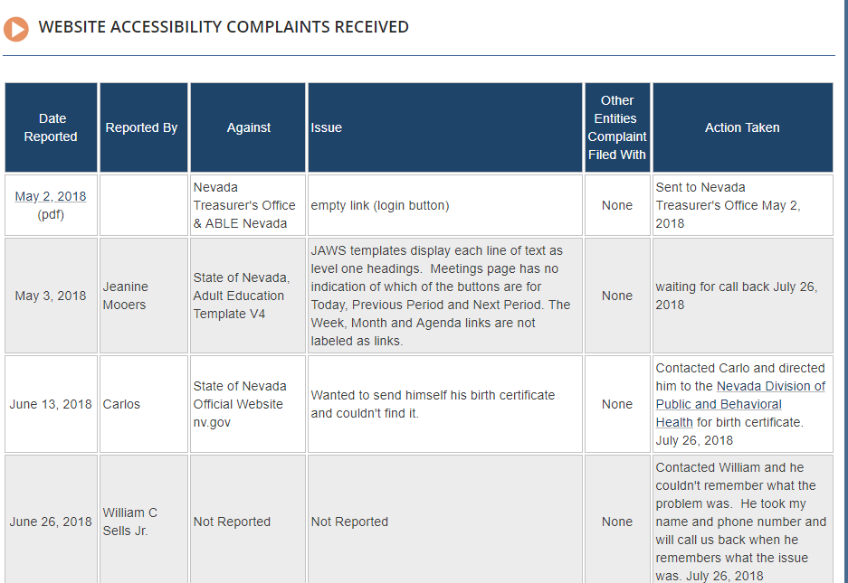  
  
  
**Physical ADA Complaints received:**The Web team forwards all Physical ADA complaints files to the following:  
 **Tammy Smith -** EEO Officer  
100 North Stewart Street, Suite 200  
Carson City, NV  89701  
Phone: (775) 684-0104  
[tammys@admin.nv.gov](mailto:tammys@admin.nv.gov)  
  
The Web team contacts Tammy monthly to get a status and see if the issue has been resolved.

Physical ADA Complaints sent to Tammy Smith:   
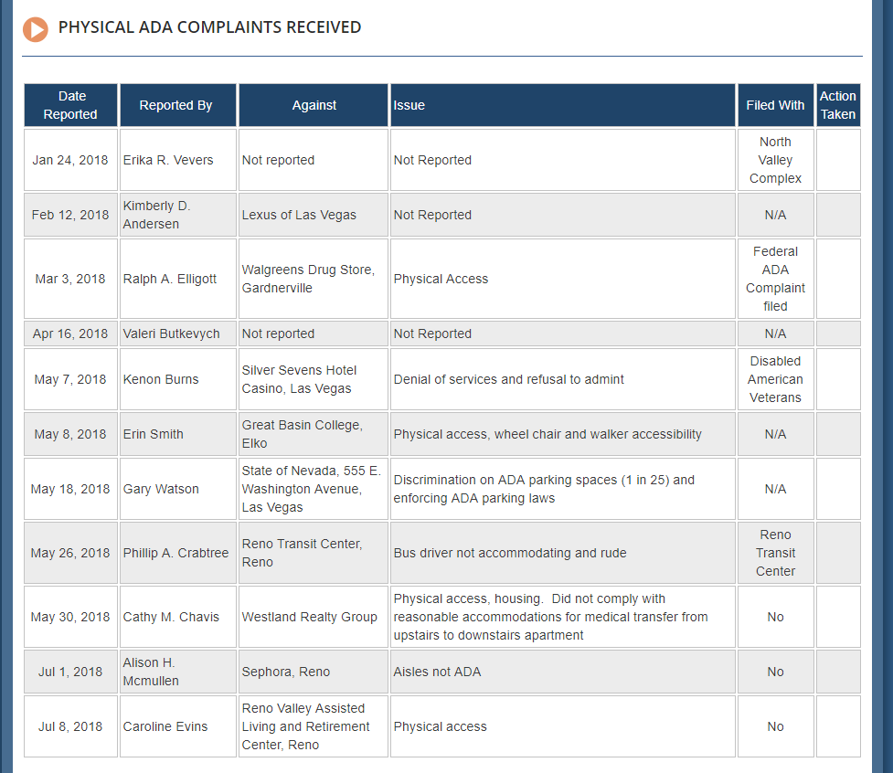

#### 

#### August 9, 2018 – Partnership with EITS Operations Division has been cancelled

Unfortunately, our partnership with the EITS Operations group has been terminated due to staffing issues. We want to thank the Operations group for all their time and efforts.   
  
Lessons learned:   
A lot of time was spent to train the operations staff, unfortunately, they had other major responsibilities that provided to leave very little time for them to dedicate to the ADA efforts. This resulted in slow turnaround. This is not a win-win for either group, so we agreed to stop the process. However, working with the staff helped the Web team sharpened their training techniques and provide a solid Remediation guide for remediating [Remediation Guides, Word, PDF, Excel, PowerPoint](http://ada.nv.gov/Resources/document_remediation/) that everyone can benefit from.

### August 10, 2018 – NVeLearn – ADA Remediation Class on line

Based on input we have been receiving from user who have taken this test, we are reevaluating it. However, we will continue to request users take this class as it does have a lot of needed information. 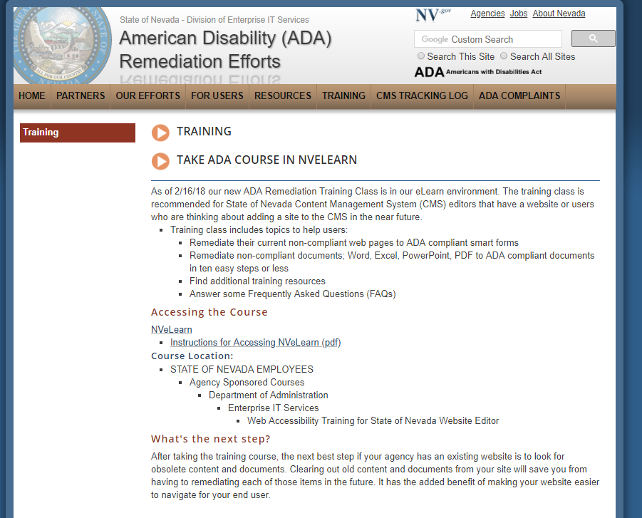

August 13, 2018 – Created twitter feed for ADA Compliance website – NevadaADA  
All members of the Web team will have access to tweet! Twitter feed will be added to the home page of the State of Nevada ADA website, <http://ada.nv.gov>

ADA Chronological History Summary 2001 - 2016

The Division of Information Technology, Enterprise began working on ADA compliance in 2001, when Governor Guinn issued an Executive Order requiring ADA compliance as well as a consistent look and feel (branding) for all state of Nevada websites. A training website was also created that hosted instructions, templates, style guides and other tools to assist agencies in redesigning their existing content to meet the branding and ADA requirements mandated by the Governor. An ADA class were developed by the EITS web team and over sixty agency webmasters were trained in about 2 months. The classes were developed to train the agency webmasters how to update their current website and make them ADA compliant. During those classes, special individual websites were developed and given to each agency webmaster that reflected their agency’s information. These websites had all of the ADA requirement built in so they could just take those site and move their current information into them.

After the last class, agencies were given 30 days to make homepages compliant and then 90 days for the entire sites to be ADA compliant with new branding. This goal was met, unfortunately without an ADA monitoring tool in place; the sites did not stay compliant very long and the ADA compliant sites quickly became non-compliant

In 2012, EITS Web Team then purchased and managed the implementation of the State Web Content Management System (CMS). A web developer was hired, and templates and smart forms were created to help brand the State of Nevada websites. The team helped customer’s convert state websites from FrontPage to the State’s Content Management System. During that time 500+ users were trained to build and maintain their own CMS sites, which was new as previous all updates to state websites were made by the EITS Web team

Realizing the State CMS templates were not built to be Section 508 WCAG 2.0 Section 508 compliant, the web group began to focus their efforts to correct that. In September 2015, our team began to research and evaluate ADA accessibility evaluation tools and it was determined that WAVE was the best free option

We were also able to work with Brett Silver, a blind employee who worked for the State of Nevada Division of Library and Archives (NSLA), Office of Talking books. Brett uses JAWs, and he was able to assist us in testing for compliance [=](http://ada.nv.gov/LessonsLearned/adaNVgov/)

Brett continues to help our team, whenever needed. We also worked with the Division of Human Resources Management’s Equal Opportunity office (EEO) who coordinates the State’s various ADA program and resources.

A logo was added to all State CMS websites; with a link to their information regarding providing physical accommodations for persons with disabilities. This information did not cover state CMS websites, so the EITS web team’s Manager wrote a white paper suggesting the state create an ADA Website Coordination Committee to share the web group’s current effort to make the State of Nevada websites become Section 508 WCAG 2.0 Section 508 compliant. The first meeting was held February 11, 2016, and [the State of Nevada, Division of Enterprise IT Services, American Disability (ADA) Remediation Efforts website](http://ada.nv.gov) was created

To view a status of the State of Nevada ADA Remediation Efforts, please visit the [State of Nevada, Division of Enterprise IT Services, American Disability (ADA) Remediation Efforts page](http://ada.nv.gov/Remediation/Efforts/). The content on this page is updated bi-weekly and reflects he efforts made to get the State of Nevada’s websites ADA compliant. On the bottom of the same page, a chronological history of the State of Nevada’s ADA compliance efforts, also with testing results working with Brett Silver, are listed.

Future Goals:

1. Continue to work with the AT Consumers to test other selected websites and other Digital media so that they have a sample of what is compliant. That way we can use that as a standard.
2. Finalize our ADA Training Class for users that have websites in our Content Management System (CMS).
   1. Make this Training Class a required class for ALL CMS Users.

***NOTE: This ADA Training class is currently in user testing as of 2/8/17***

1. Keep reviewing our current processes and make enhancements, including expanding our outreach beyond websites.
2. Continue to do outreach to agency webmasters that have their websites in our State CMS
   1. Instruct them to take the Training class
   2. Assist them with additional suggestions, webinars, etc.
3. Work with Governor’s office to obtain an Executive Order that requires all websites in the State of Nevada, not only in the State CMS, to be ADA Compliant.
4. Continue to work with the Department of Education to ensure their success with the Office of Civil Rights (OCR).

### May 2, 2018 – [ADA complaints](http://ada.nv.gov/Home/Features/Accessibility_Information/) (using new on-line complaint form)