Adobe Acrobat Pro
Inspect Documents and Delete Unnecessary Content

You must have Adobe Acrobat Pro is required to remediate pdf documents.
The first step before remediating documents is to go to this link http://ada.nv.gov/Users/CleanUpCurrentSite/ .On this page you will find the WCAG 2.0 and 508 standards for accessibility. On the bottom of this page, the link http://ada.nv.gov/Efforts/PDF_Report/ will take you to a page to look up each agencies website.
The Second step is to click on your agencies page to see exactly how many documents are currently on your website to remediate. This will give you an idea of how many documents to “Delete or Remediate”.
The Third step is to locate a simple document and start the remediation process to become familiar with how to remediate a document.
The hardest and nearly impossible documents to remediate are Redacted material, Fillable forms and Scanned documents. These forms are extremely time consuming and should be remediated last.
I have included Instructions on making most PDF documents compliant and I will create a more advanced class on how to remediate Fillable forms along with redacted material. If you have any questions about document remediation please email StateWeb StateWeb@admin.nv.gov

Contents
1
Inspect Documents and Delete Unnecessary Content 1
Select and Add Remediation Tools 4
Add Accessibility Tools 4
Document Title 5
Creating a Document Title 5
Title Continued 6
Creating a Title Cont. 6
Setting PDF to Document Title 7
Changing File Name to Document Title 7
Setting the Language 8
Setting the Language in PDF 8
Using the Action Wizard 9
Making accessible documents with this tool. 9
Using the Action Wizard Cont. 10
Accessibility Checker Options 13
Accessibility Check 13
Finding Errors on Page 14
Finding all Errors on PDF page 14
Tagging Images 15
Tagging Images 15
Alternative Text 16
Alternative Text 16
How to Fix Tables 17
Giving the table a description 17
How to Fix Tables Cont. 18
Detailed Table Summary 18
How to Fix Tables Cont. 19
Setting Header Rows 19
How to Fix Tables Cont. 20
Setting Header Rows Cont. 20
Incorrect Headings 21
Changing the Structure of headings 21
Unidentified Content 22
Removing Unidentified Content 22
How to Tag Text 23
Tagging Text 23
Assigning Headings 24
Headings 24
Hyperlinks 25
Tagging Hyperlinks 25
How to Tag Hyperlinks Cont. 26
Hyperlinks Continued 26
Adding text to Hyperlinks 27
Adding text to Unmarked Links 27
Logical Reading Order 28
Logical Reading Order 28
How to Fix the Reading Order 29
Reading Order Continued 29
Color Contrast 30
Color Contrast 30
A Compliant PDF Document 31
An example of a Compliant PDF Document. 31

Adding Tools for Remediation

Select and Add Remediation Tools
To make documents you will have to select them from the tools menu.
- Select “Tools”.
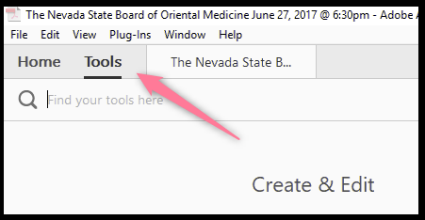

Add Accessibility Tools
The three tools that help with remediating PDF documents are:
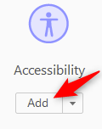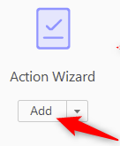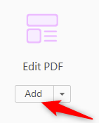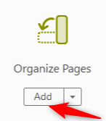
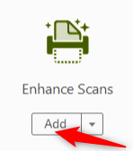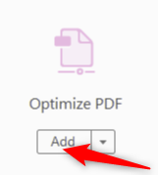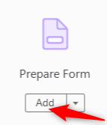

Once you have added the remediation tools they will be located on the right panel for future use.

Document Title

Creating a Document Title
The first step in creating a compliant PDF is to give your document a title instead of a file name.
- Select “File”.
- Scroll down and select “Properties”.
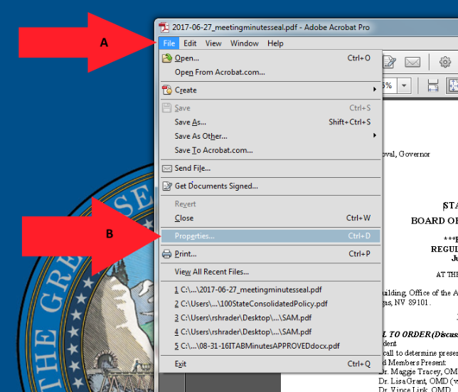

Title Continued

Creating a Title Cont.
Make sure to give the document a title. When a PDF document is saved it will be saved under a document file name and not a title.
- Select the “description” tab.
- Give a “Title” description to the document.
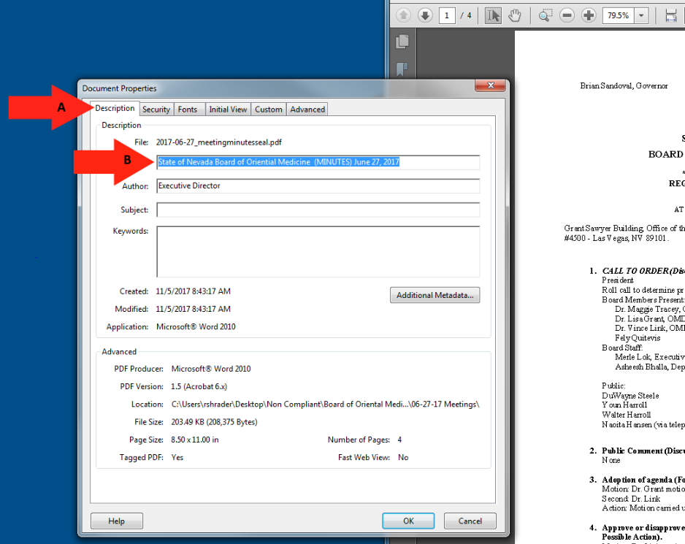

Setting PDF to Document Title

Changing File Name to Document Title
When adding a Title to you document, you must also change the Metadata from File Name to Document Title.
- Select the “Initial View” tab.
- Change the File Name to “Document Title.
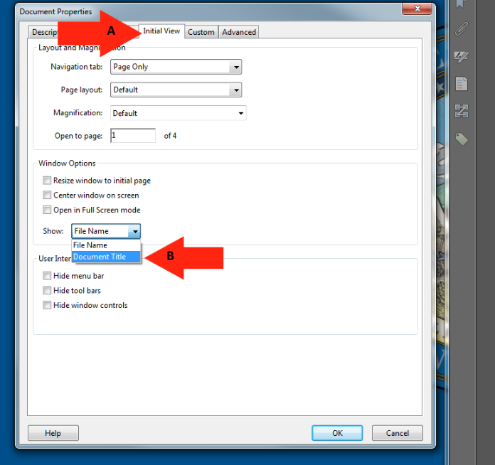

Setting the Language

Setting the Language in PDF
Screen reader technology will read the document to the user in the language set for the document. The steps to set the correct language in a PDF are:
- Select the “Advanced” tab.
- Choose the “Language” that you prefer you document to be set as.
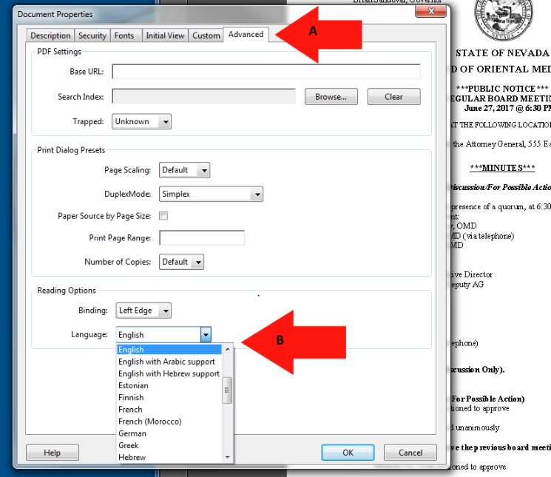

Using the Action Wizard

Making accessible documents with this tool.
The next step after giving a PDF document a title is to run the full check option to see what errors are in the document. This tool is used to give all images and tables the option to add Alt text as the scan runs.
- Select the “Action Wizard” option.
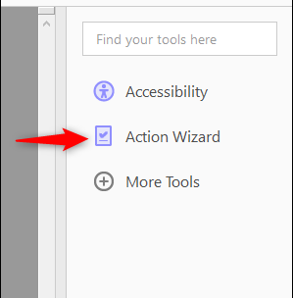
- Click on the “Make Accessible” option.
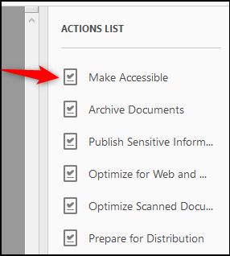

Using the Action Wizard Cont.

C. Click the “Start” option to run the accessible scan.
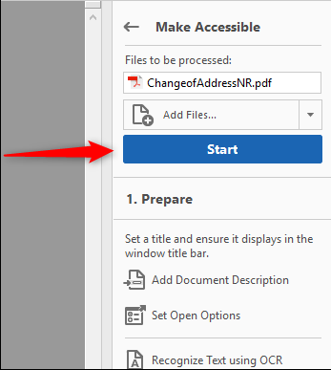

This space intentionally left blank.

Using the Action Wizard Cont.
Give the document a Title and click ok.
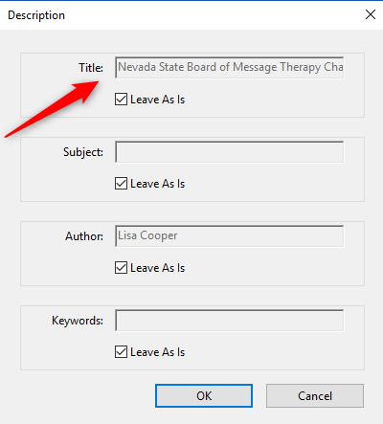

Set the language to English and click ok.
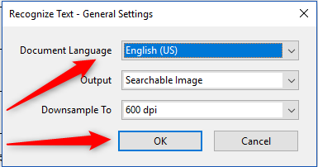

Using the Action Wizard Cont.
If this document is really a fillable form, STOP. Send to stateweb@admin.nv.gov and go to the next document. Otherwise, select No, Skip this Step.
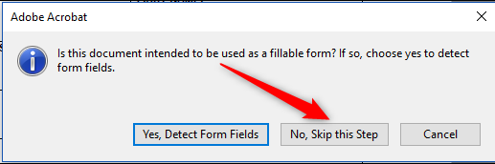
Make sure the language is set to English and click ok.
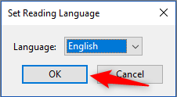
If your document has images or tables, Give them a description in each box and click save/close.
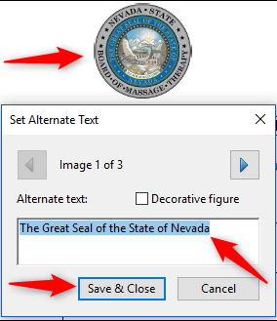

Accessibility Checker Options

Accessibility Check
To be able to scan for all errors on a PDF document, all the option boxes should be checked.
- Check all boxes to run a “Full Check”.
- Select the “Start Checking” option to run the scan.
- 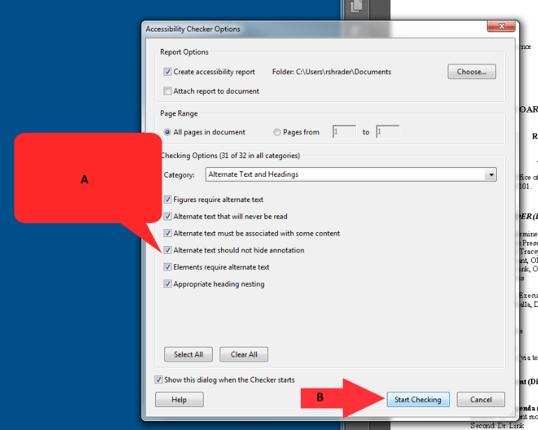

Finding Errors on Page

Finding all Errors on PDF page
Running the Accessibility checker will give results of all errors found throughout the entire document. In order to make a document compliant, all errors must be corrected.
- Select the “Element”.
- The PDF error will highlight on the page when selecting the Element.

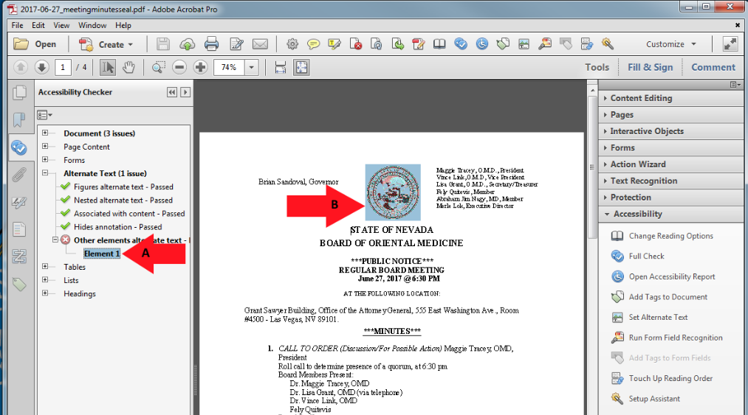

Tagging Images

Tagging Images
All Images, Tables, and Unidentified content must be tagged in a PDF document to make it compliant. Screen reader technology will read an image and the image description is what is read back to the user.
- Select “Touch Up Reading Order”.
- Using the “Touch Up” tool, Enclose the Image until it is selected.
- Tag the Image as a “Figure”.
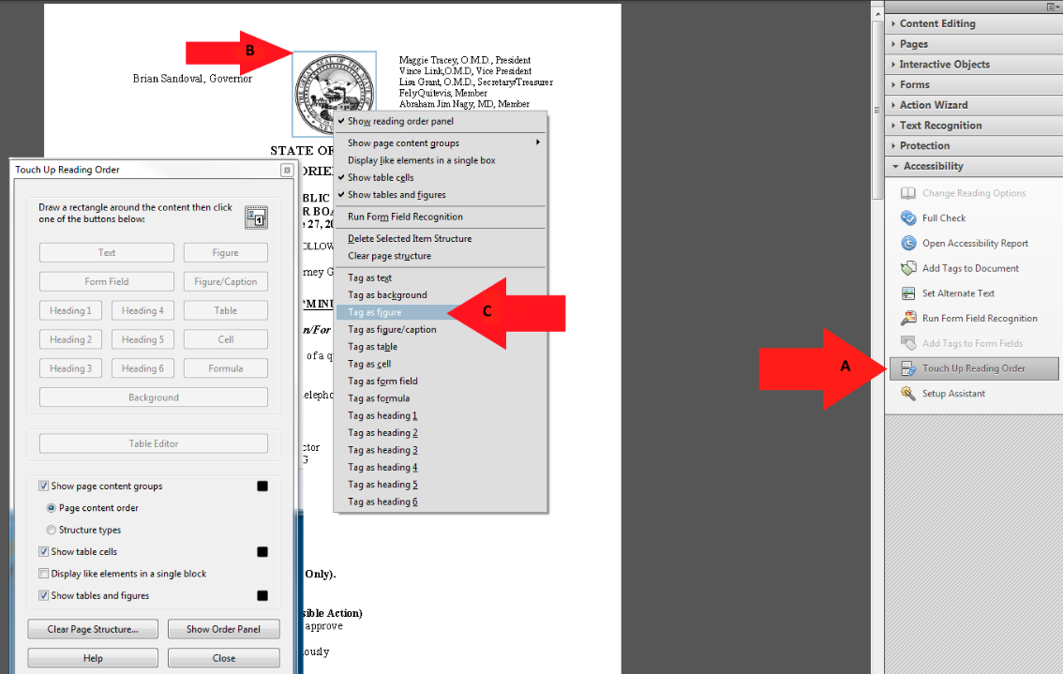

Alternative Text

Alternative Text
Alternative text should be provided with all visual content: pictures, clip art, tables, shapes, groups, charts, embedded objects, ink, and videos.
- Right-click on “Figure”
- Select “Edit Alternate Text”.
- Add a description to the “Figure”.
- Select “OK” to save changes.
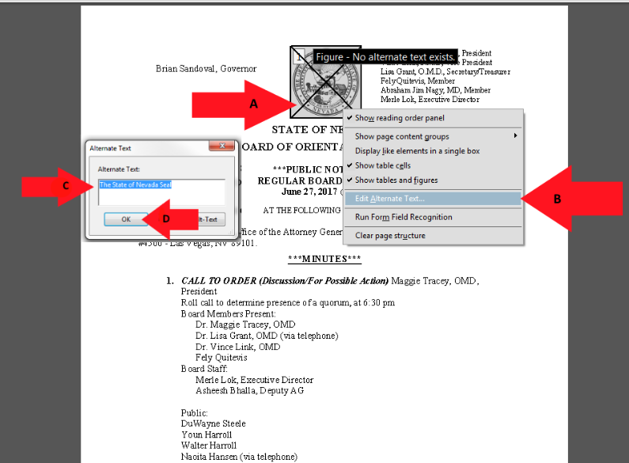

How to Fix Tables

Giving the table a description
A table must have header rows identified and the table must have a description to make them compliant.
- Right Click on the Table to open Table Menu.
- Select “Table Summary.
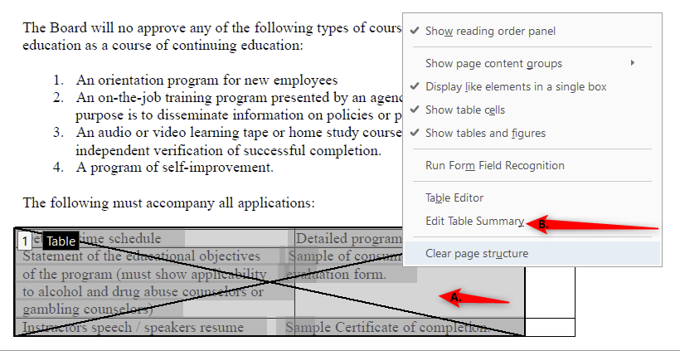
Instructions for a complex table and summary are found on the next page.
- Give the Table a “Table Description”.
- Click “Ok” to save.
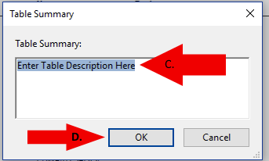

How to Fix Tables Cont.

Complex Table Detailed Summary
For users who cannot perceive a visual overview of a table, understanding a data table always means reconstructing the relationship between every element of the table and how they interact with one another. The user needs to understand how many rows or columns there are, which elements represent header information, which are simple data cells, etc.(Screen Reader technology will read out the number of rows and columns in every table) Authors are therefore advised to omit this information and do their very best to create simple data tables whenever possible (tables that only have one row or column of headers), even if this means breaking a complex data table into a number of smaller, simpler data tables. The table description should explain all the element included in the table, so a non-sighted or low vision user can understand what information table contains without being able to see the graphics or details of the table. I have included the example of a table and included a sample description below.
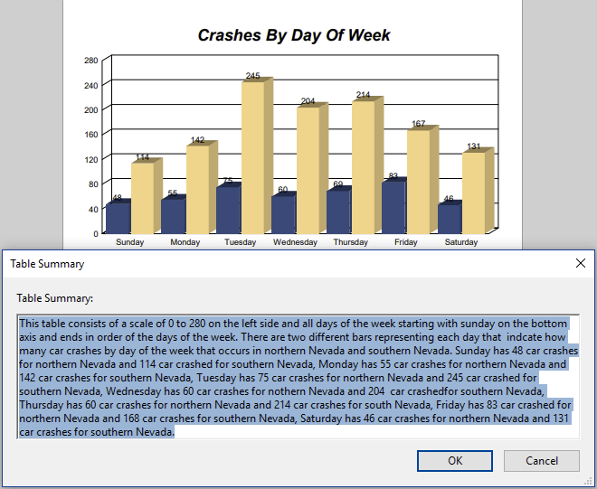

How to Fix Tables Cont.

Setting Header Rows
A table must have header rows identified to make the table compliant.
- Right click on the table and select Table Editor.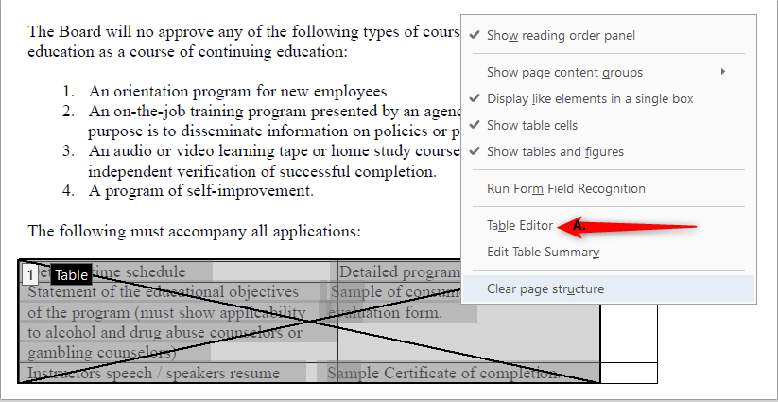

- Hold down the Shift key and click all cells that are designated to be the Table Header Cells.
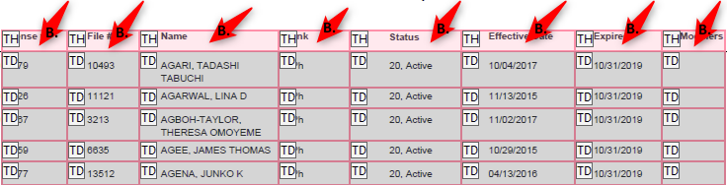

- Right click on table and select “Table Cell Properties”.
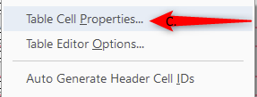

How to Fix Tables Cont.

Setting Header Rows Cont.

D. Select “Header Cells”.
E. Select “Row, Column, or Both” for header cells.
F. Click “ok” to save your changes.
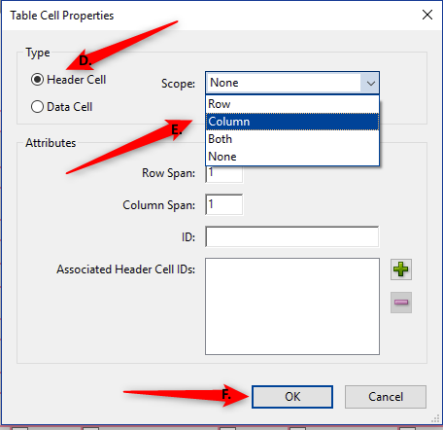

Incorrect Headings

Changing the Structure of headings
- Select the “Element”.
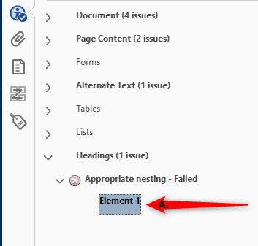
- The error will highlight on the page.
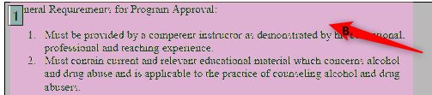

- Click on the “Tags” icon.
- Highlight the Heading tag and delete it.

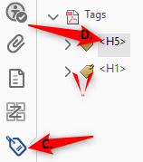

Unidentified Content

Removing Unidentified Content
The Accessibility checker will identify content in a PDF that needs to be tagged or removed from the document to become compliant. In this example the content is unidentified and needs to be removed.
- Select the “Element” to highlight the error on the page.
- Using the “Touch Up” tool, enclose the tagged content.
- Right-click and select “Delete Selected Item Structure.
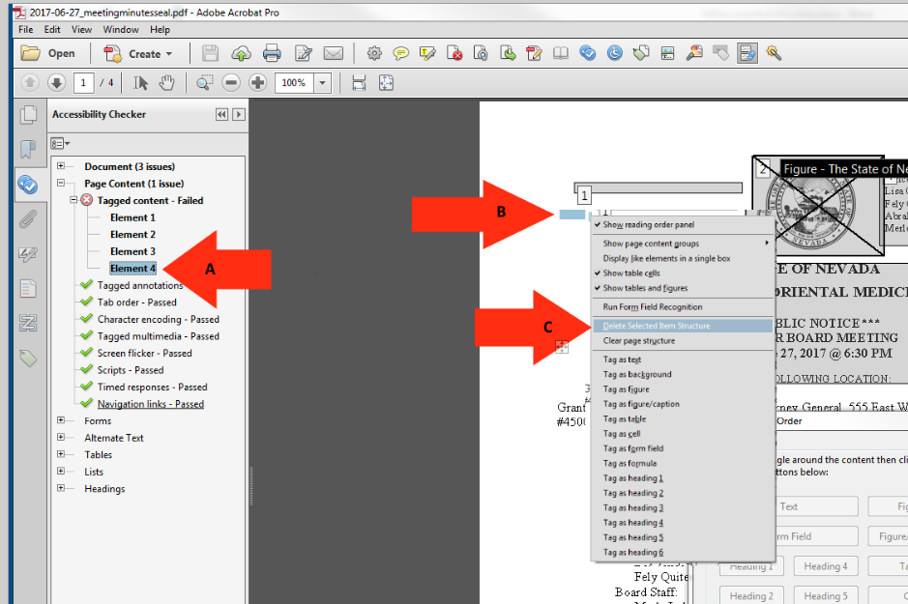

How to Tag Text

Tagging Text
In order for a screen reader to understand a document, all text on a page needs to be identified correctly to make it a better experience for the user.
- Select the “Touch Up Reading Order” tab.
- Enclose the text until it is completely highlighted.
- Choose text in the “Reading Order” panel.
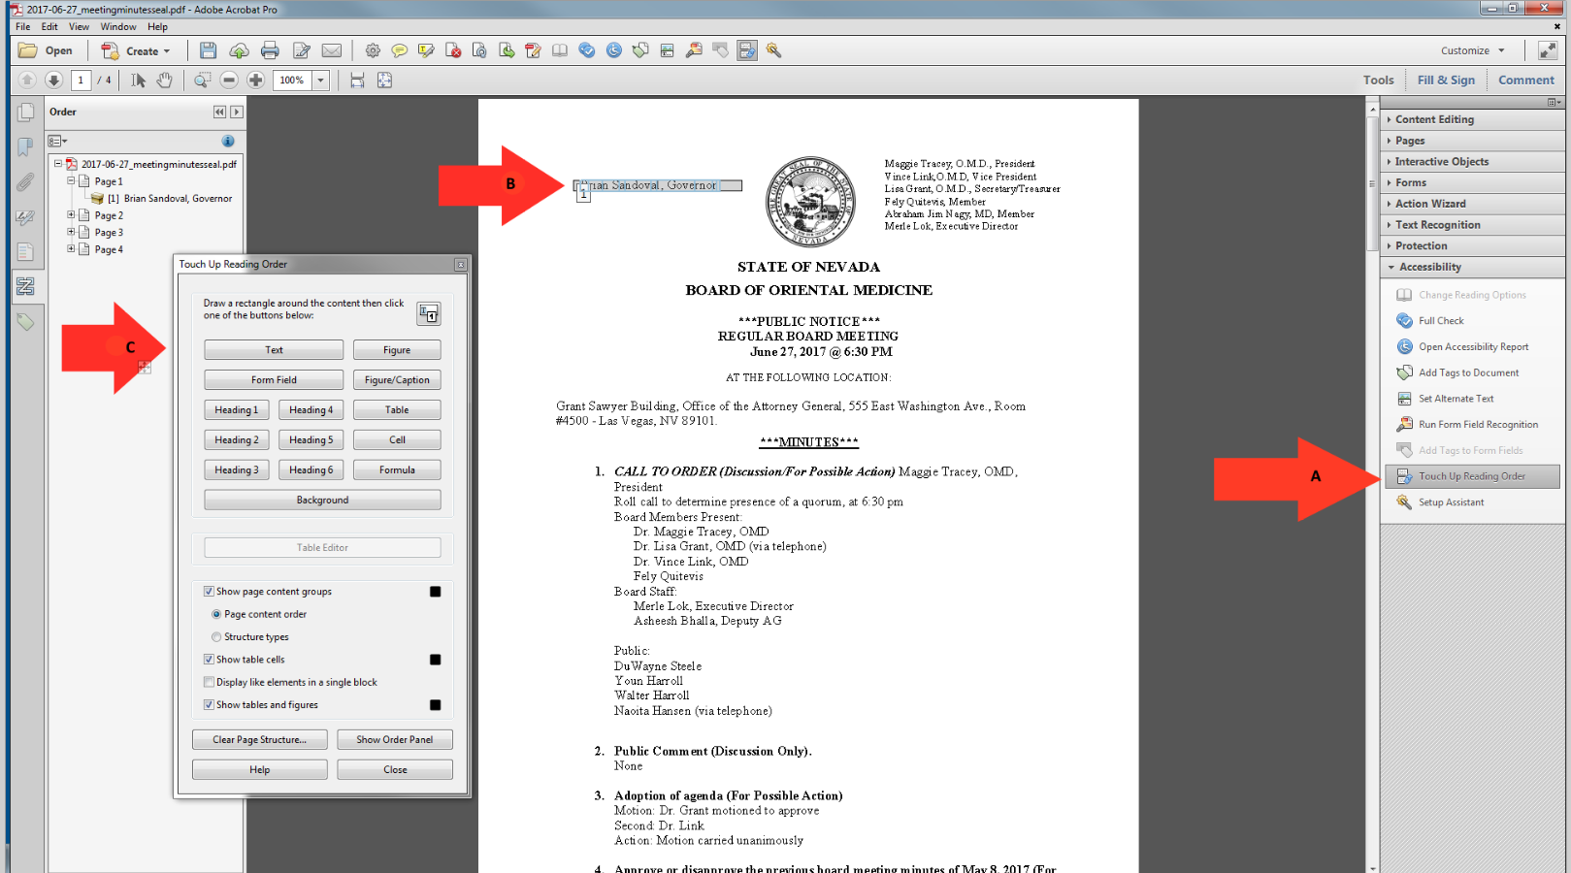

Assigning Headings

Headings
Proper headings are used in a PDF document, so a disabled user can navigate through a document with ease. It would be extremely difficult to find content in a document without headings and require them to read the entire document in order to find the piece of information that they were looking for.
- Select the “Touch Up Reading Order” tab.
- Enclose the text until it is completely highlighted.
- Choose the proper “Heading” in the touch up reading order panel.
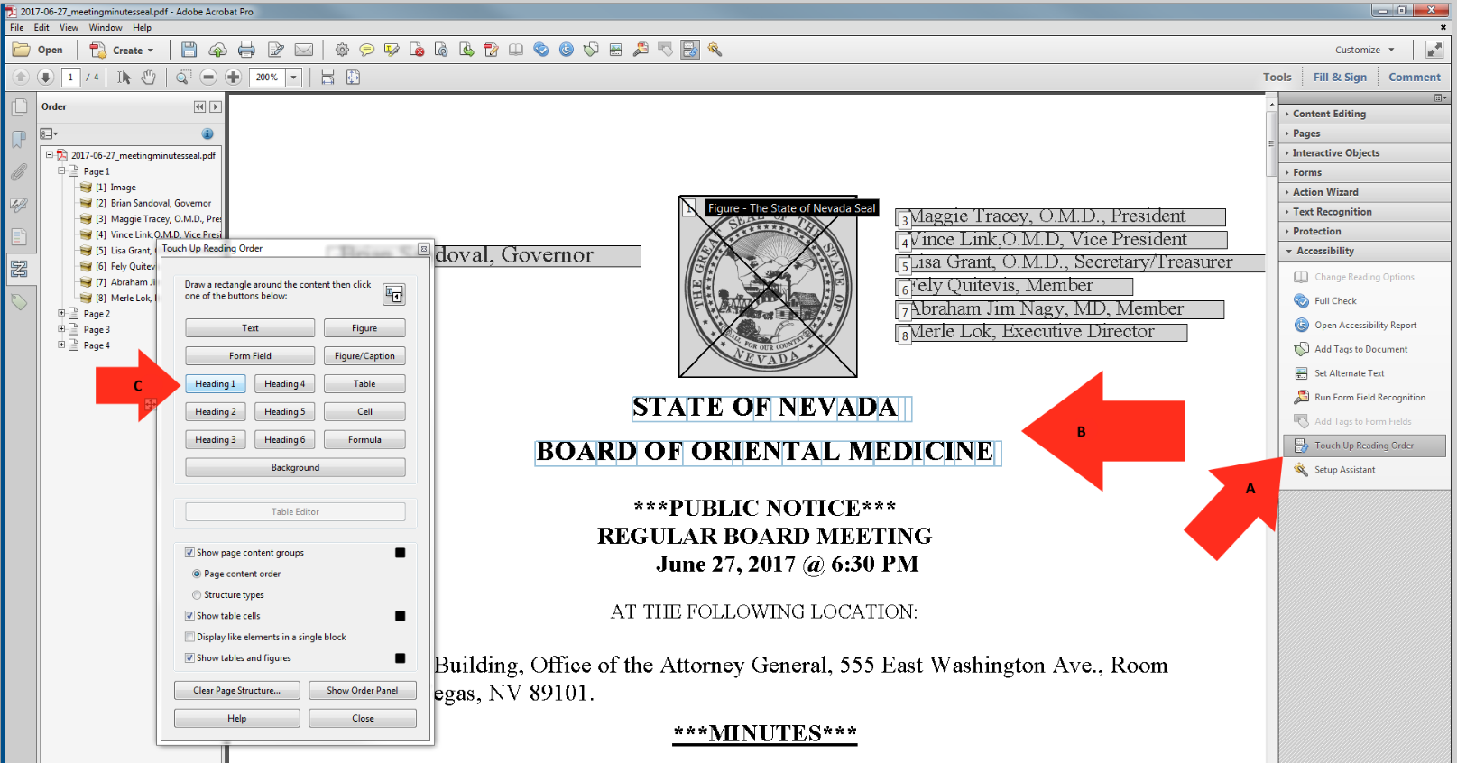

Hyperlinks

Tagging Hyperlinks
All hyperlinks in a PDF will need to be identified to make the document ADA compliant. There are multiple steps in this process.
- Select the “Element” to find the hyperlink.
- The hyperlink will highlight on the PDF document.
- Right-click on the “Element” and choose “Show in Content Panel”.
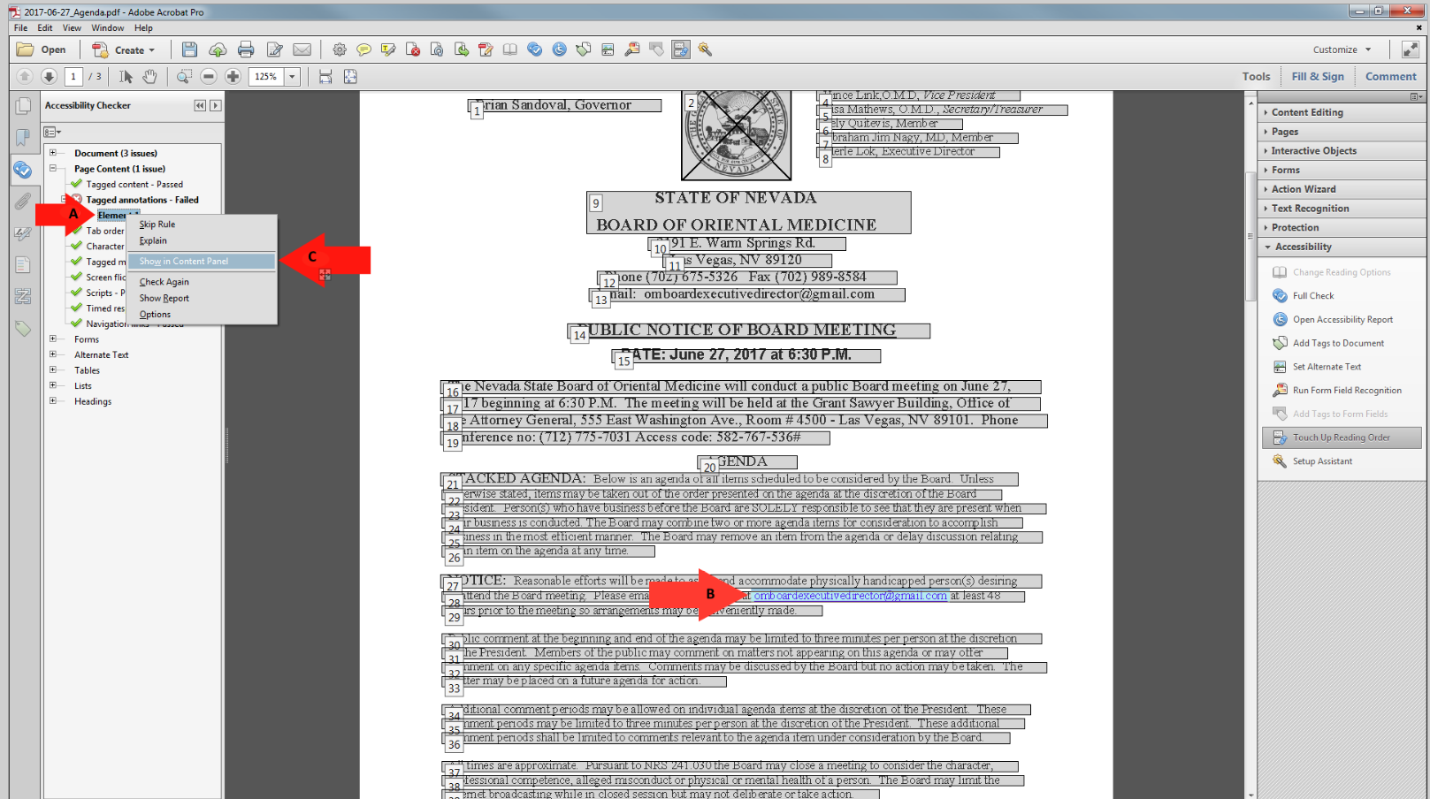

How to Tag Hyperlinks Cont.

Hyperlinks Continued
To find Unmarked Links in a PDF you have to search for them using the Find Element option.
- Right-click on “Link”.
- Select “Find” and it will open the “Find Element” search window.
- Highlight “Unmarked Links” option.
- Select “Find” to start the search.
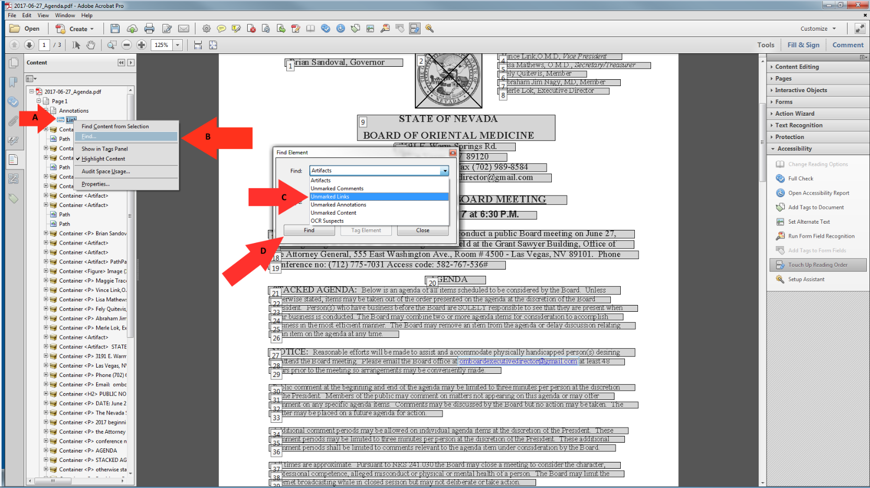

Adding text to Hyperlinks

Adding text to Unmarked Links
Adding text to hyperlinks in a PDF document will give users a better description of the link and the link will be read as the description instead of the URL.
- The location of the Hyperlink after the search has finished.
- Choose the “Tag Element” option.
- Give the Hyperlink a “Title”.
- Click “OK” to save changes.
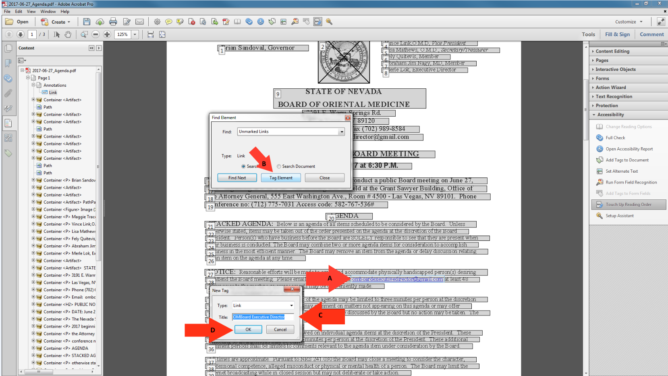

Logical Reading Order

Logical Reading Order
When reading a PDF document using screen reader technology, all text is read the same as it would be in a book. All document should be checked to have the document read in order. Once
- Select the “Order” tab.
- Start at the beginning of the document, page 1.
- This reading order is out of order.
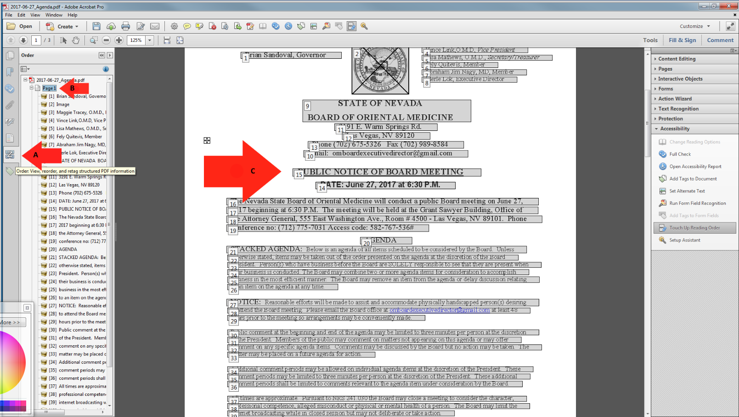

How to Fix the Reading Order

Reading Order Continued
The structure of the Reading Order can be changed during document remediation and here are the steps to fix the document and put it back into logical reading order.
- Select the text and move it up or down to put in the correct order.
- When you have moved the text, you will see the reading order in the document.
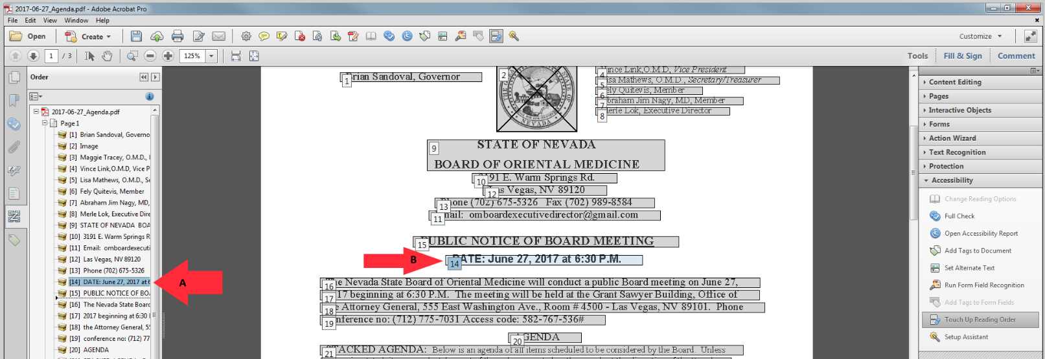

Color Contrast

Color Contrast
The color contrast will show up and can be ignored by manually passing it in the accessibility checker as this can be addressed in the source document and not in the PDF. The color of the text can only be fixed in the WORD version and not in the PDF version.
- Right-click on “Color Contrast”.
- Select “Pass” to fix the error manually. The color of the text can only be changed using the source document and is unable to be fixed in the PDF.
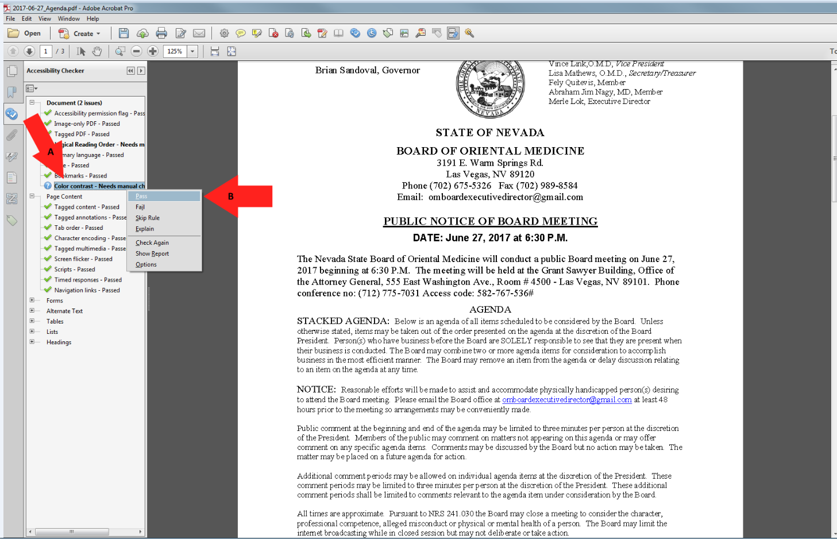

A Compliant PDF Document

An example of a Compliant PDF Document.
This is what a document should look like when all of the errors have been corrected.
- Re-run the “Full Check” option and the left pane will show the document results. There should be no errors and the entire document should have green checks in order to be compliant.
