Power Point Accessibility Issues
This tutorial has given examples of the most common errors encountered when creating a Power Point Presentation. I have enclosed a sample Power Point Presentation that is non-compliant and Instructions on how to make this document compliant. In this example the document was remediated using Power Point 2013.
How to Remediate a Power Point Presentation in 10 easy steps:

- How to Inspect your Presentation.
- How to Check for Issues.
- Alternative Text.
- Adding ALT Text to Images, Shapes, and Charts.
- Hyperlink Text.
- Adding ALT Text to a Hyperlink.
- How to set a Table Header.

Any further questions please refer to this QR code reader.

How to Inspect your Presentation

Inspecting a Document

All documents should be checked for ADA compliance and this is how to check using Microsoft Word.
- Select “File” in the top left of your document
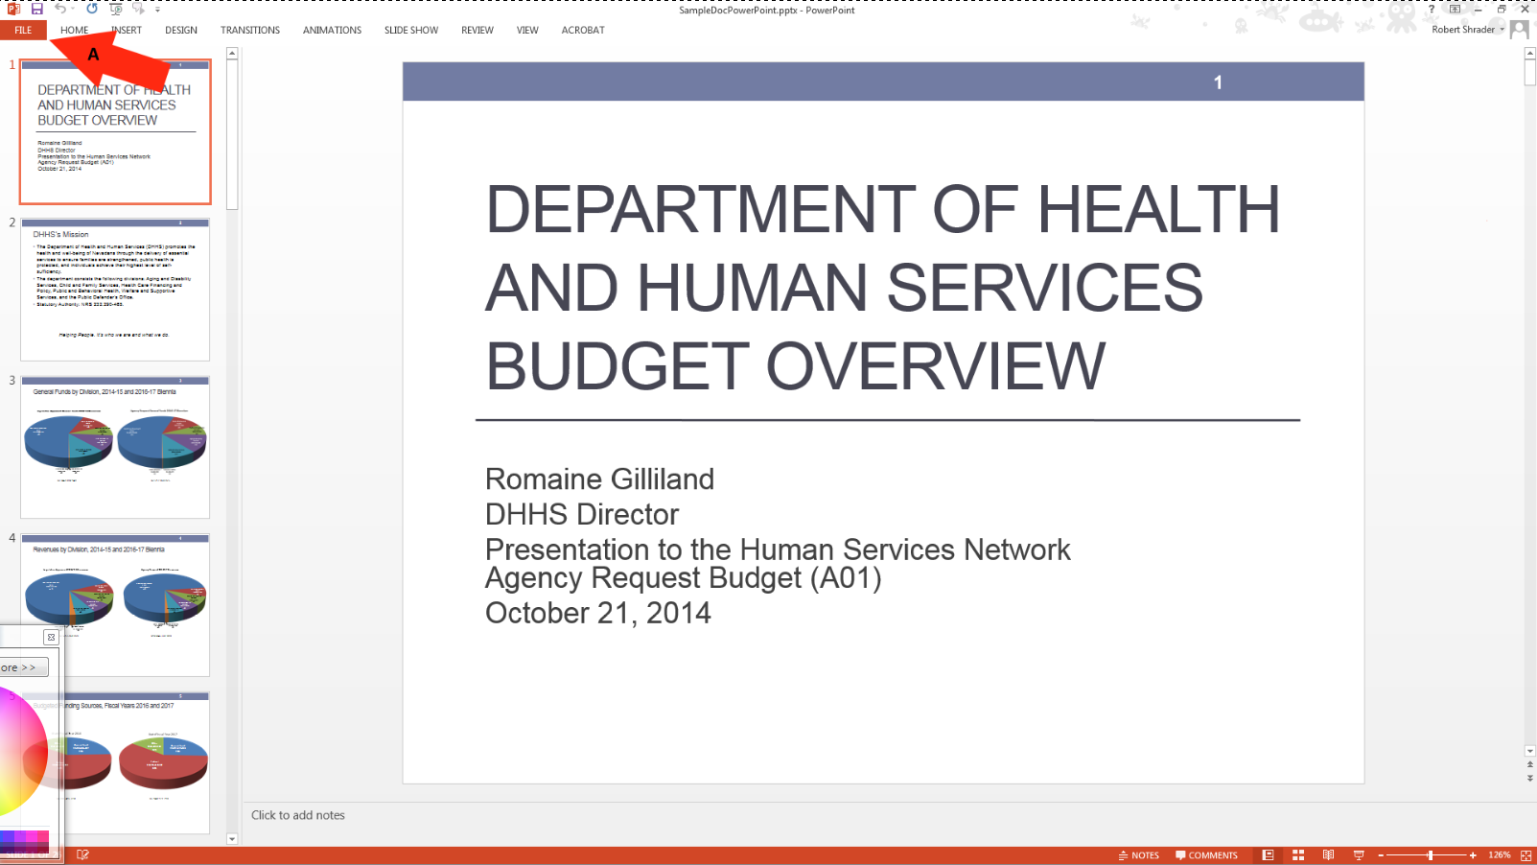

How to Check for Issues

Check for Issues
All documents can be checked for issues and the check accessibility will run a scan on documents. All errors will be listed for remediation.
- Click on check for issues.
- Select “check accessibility”.
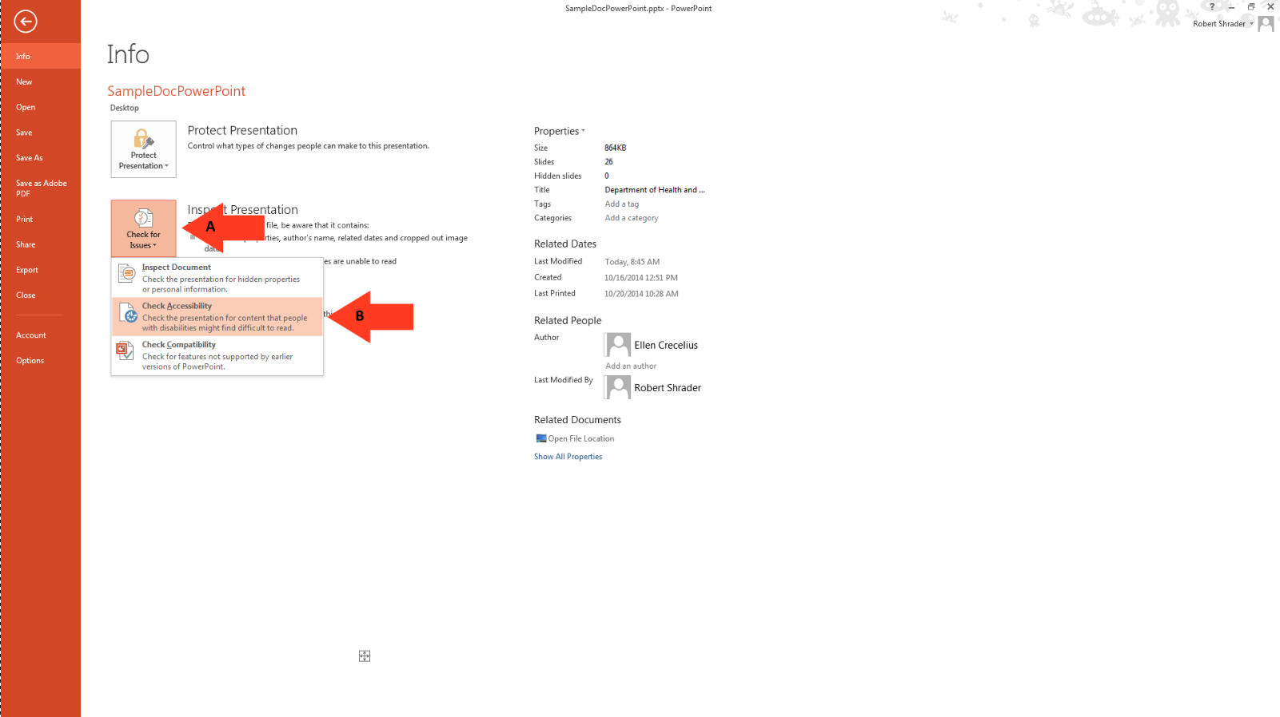

Alternative Text

Alternative Text
Alternative text should be provided with all visual content: pictures, clip art, SmartArt graphics, shapes, groups, charts, embedded objects, ink, and videos.
- Right-click on photo.
- Select “Format Picture”.

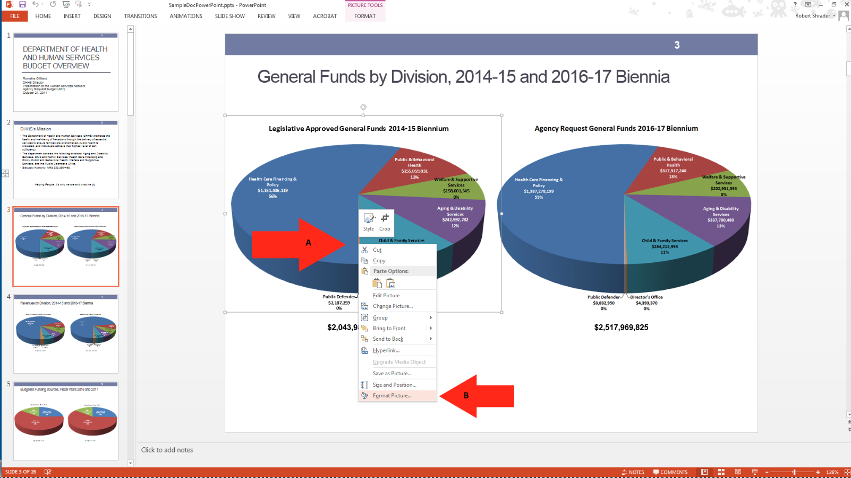

Adding ALT Text to Images, Shapes, and Charts

Adding ALT Text
Adding ALT text to each image in your document will give a description of your image and give a non-sighted user and better understanding of your document.
- Select the “layout properties”.
- Select “ALT Text”.
- Add a title to the image.
- Give a description of the image.
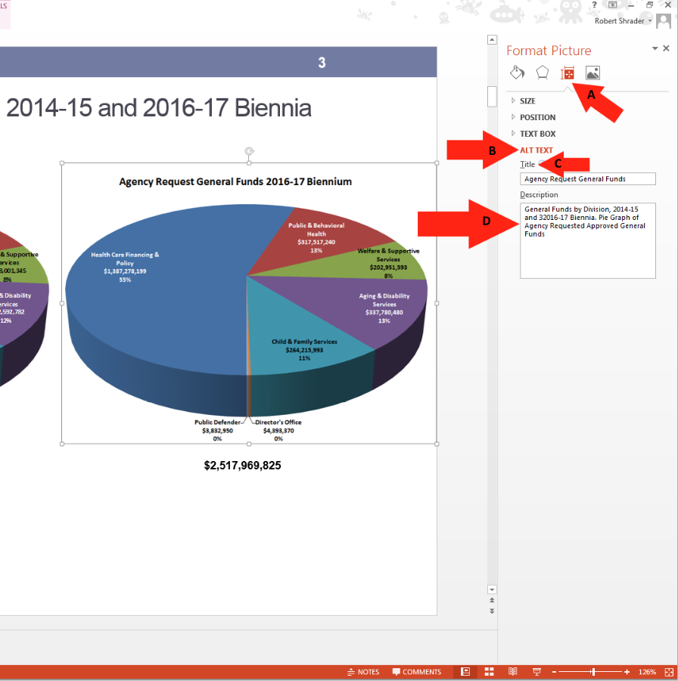

Hyperlink Text

Hyperlink Text
Those using screen readers can often use their screen readers to look through all of the links in a word document. The links should have descriptive information about the link so that the user knows where they are going.
- Right-click on “Hyperlink”.
- Select “Edit Hyperlink”.
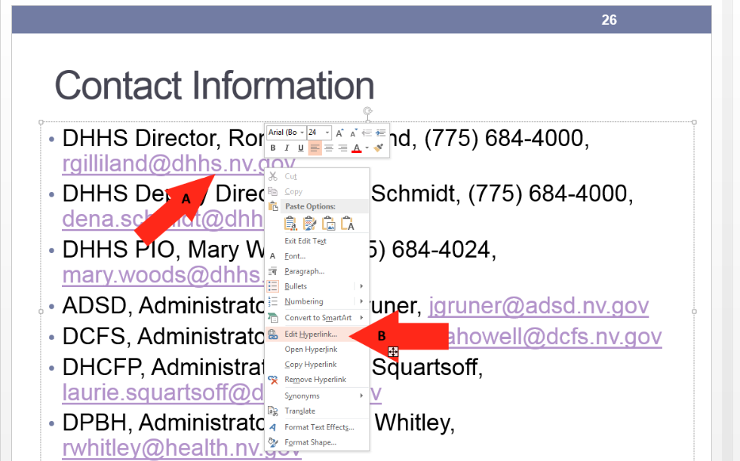

Adding ALT Text to a Hyperlink

Adding ALT Text to a Hyperlink
- Select the “screenTip” tab.
- Give the Hyperlink and description.
- Select “OK” to save changes.
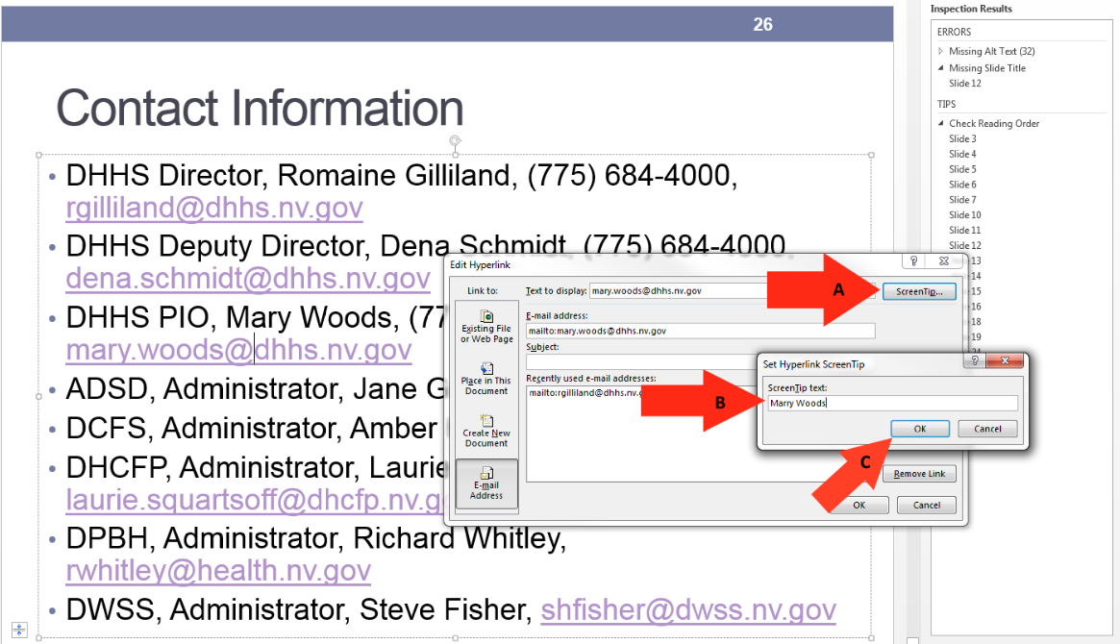

How to set a Table Header

Table Header
A Table requires a column header to identify the structure of a table for screen reader technologies.
- Identify the location of the missing table header.
- Highlight the row of cells that you designate to be the header.
- Select “Header Row”.

