Excel Accessibility Issues
This tutorial has given examples of the most common errors encountered when creating an Excel Spreadsheet. I have enclosed a sample Excel document that is non-compliant and Instructions on how to make this document compliant. In this example the document was remediated using Microsoft Excel 2013.
How to Remediate an Excel Spreadsheet 10 easy steps:

- How to Inspect an Excel Spreadsheet.
- How to Check for Issues.
- Alternative Text.
- Adding ALT Text to Images.
- How to set a Table Header.
- Hyperlink Text.
- Adding ALT Text to a Hyperlink.
- Adding ALT Text to a Table.
- Merged Cells.
- Default Sheet Names.
- A Compliant Excel Document.
Any further questions please refer to http://ada.nv.gov/CMS/Remediation-Guides/ or this QR code reader.

How to Inspect an Excel spreadsheet

Inspecting a Document

All documents should be checked for ADA compliance and this is how to check using Excel.
- Select “File” in the top left of your document
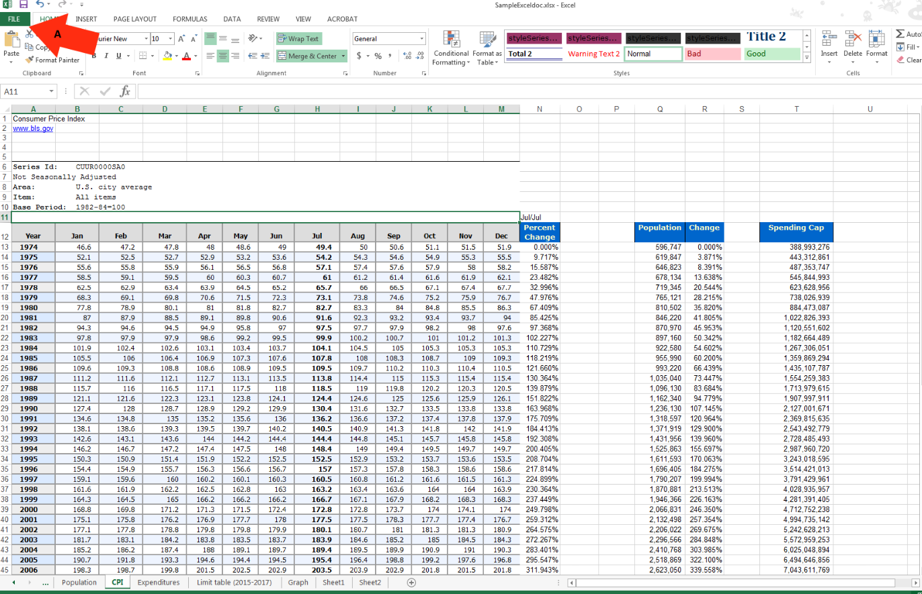

How to Check for Issues

Check for Issues
All documents can be checked for issues and the check accessibility will run a scan on documents. All errors will be listed for remediation.
- Click on check for issues.
- Select “check accessibility”.

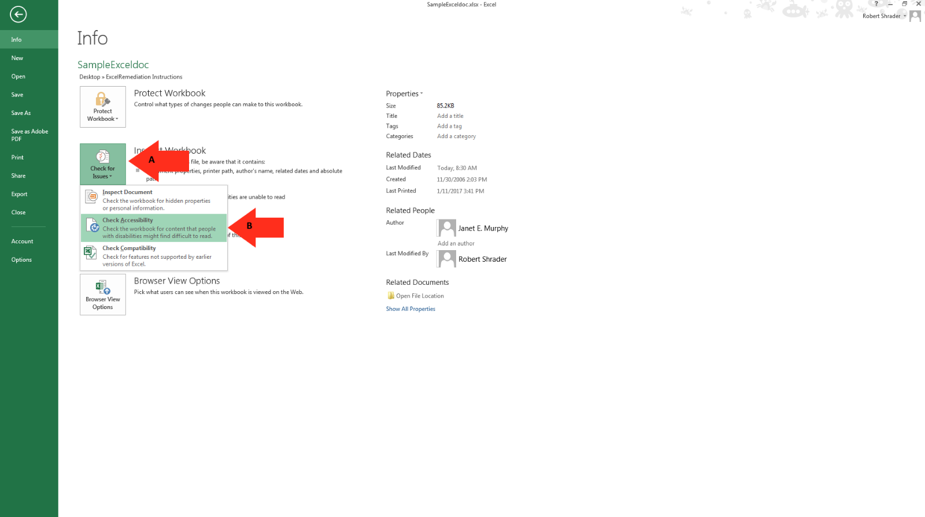

Alternative Text

Alternative Text
Alternative text should be provided with all visual content: pictures, clip art, SmartArt graphics, shapes, groups, charts, embedded objects, ink, and videos.
- Right-click on photo.
- Select “Format Picture”.
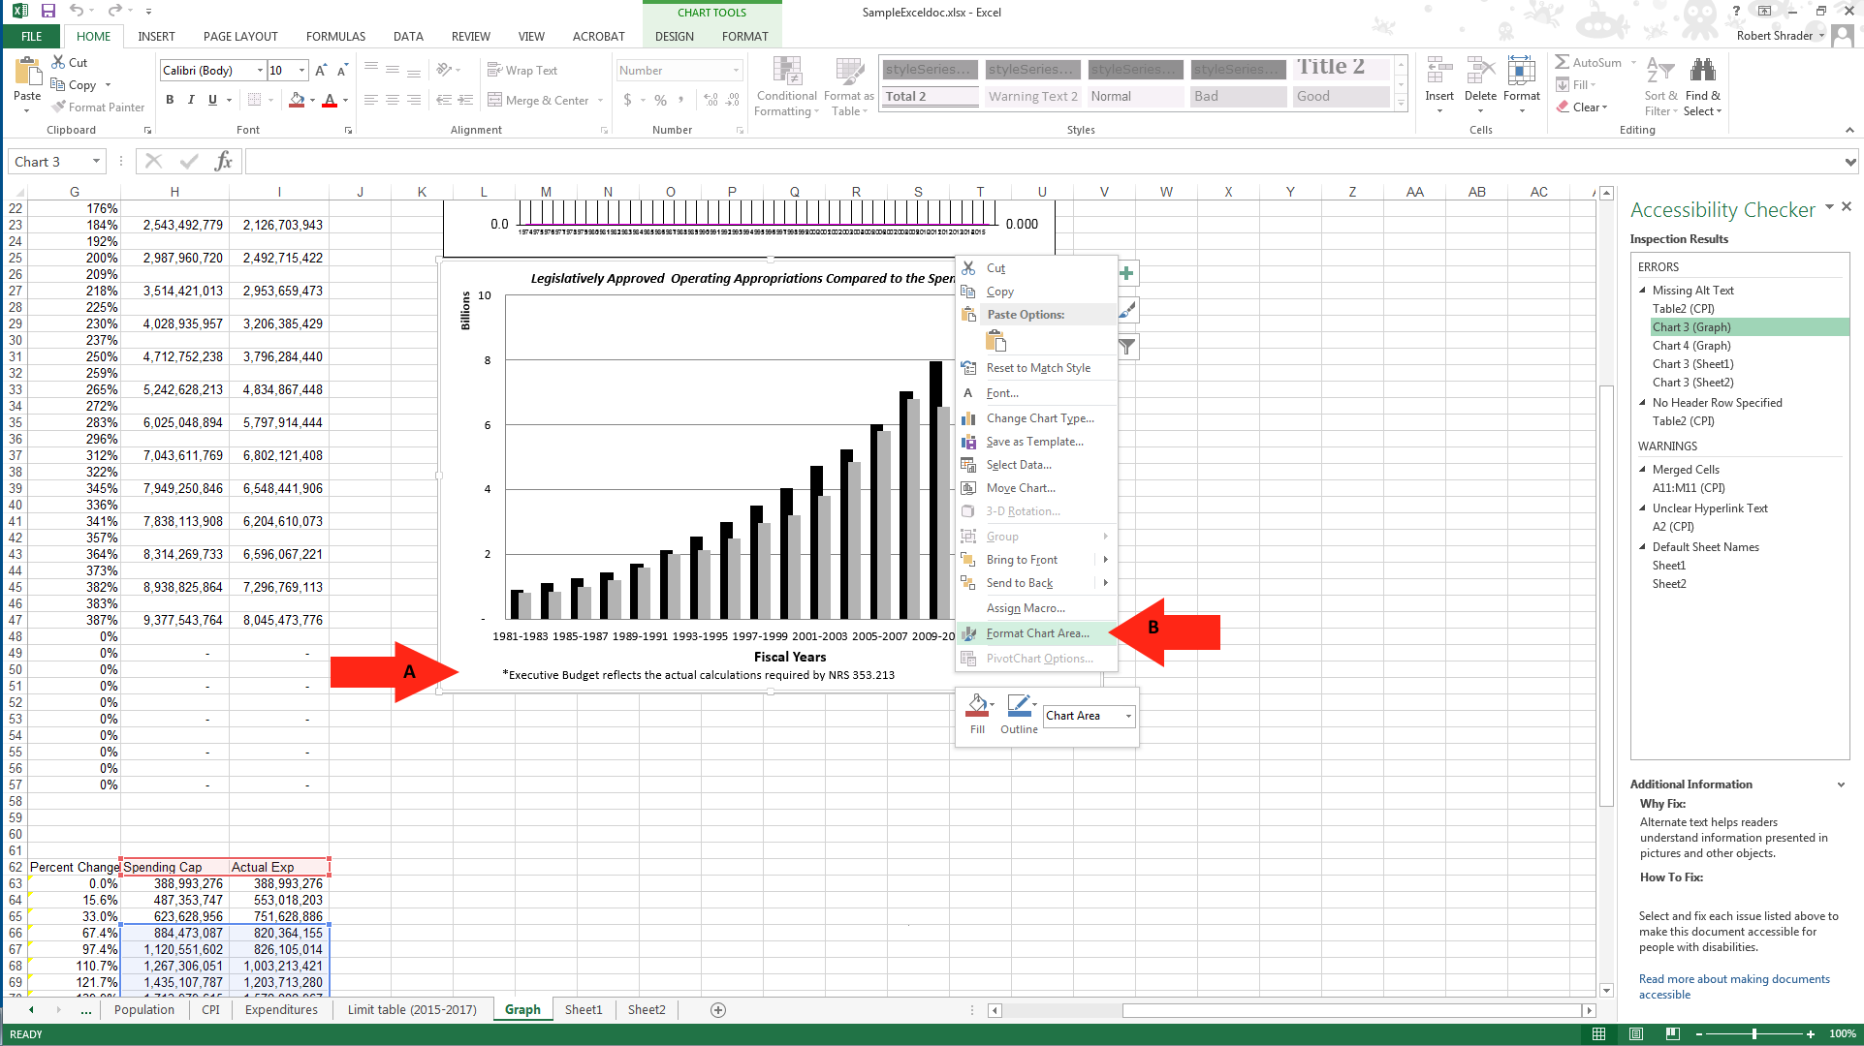

Adding ALT Text to Images

Adding ALT Text
Adding ALT text to each image in your document will give a description of your image and give a non-sighted user and better understanding of your document.
- Select the “layout properties”.
- Select “ALT Text”.
- Add a title to the image.
- Give a description of the image.
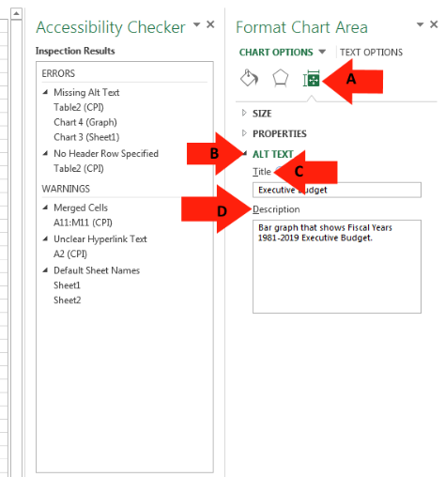

How to set a Table Header

Table Header
A Table requires a column header to identify the structure of a table for screen reader technologies.
- Highlight the row of cells that you designate to be the header.
- Select the “Design” tab.
- Select “Header Row”.
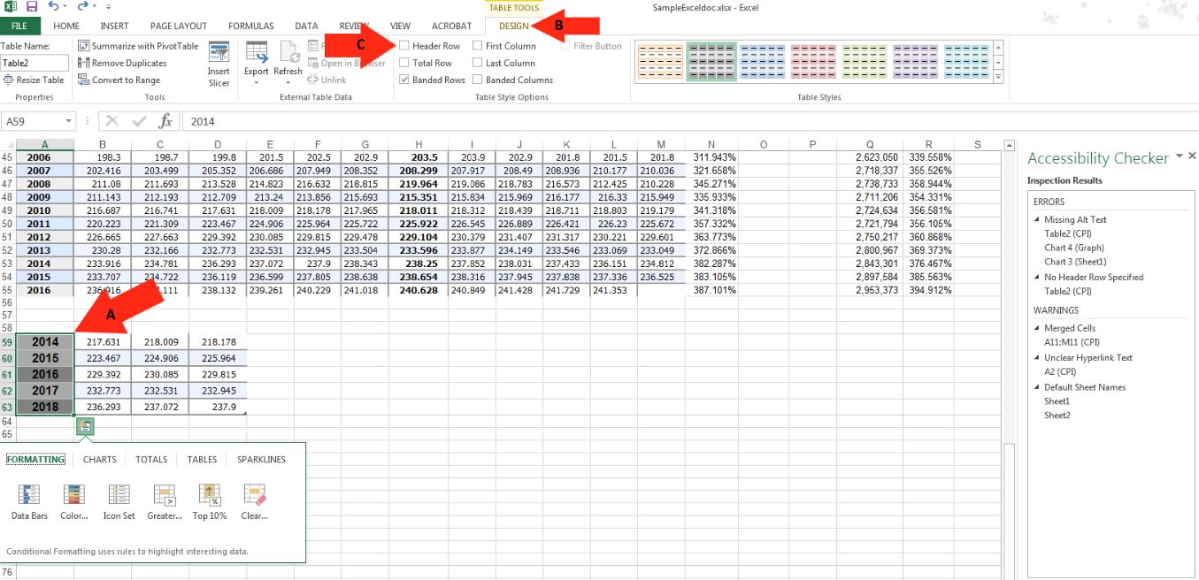

Hyperlink Text

Hyperlink Text
Those using screen readers can often use their screen readers to look through all of the links in a word document. The links should have descriptive information about the link so that the user knows where they are going.
- Right-click on “Hyperlink”.
- Select “Edit Hyperlink”.
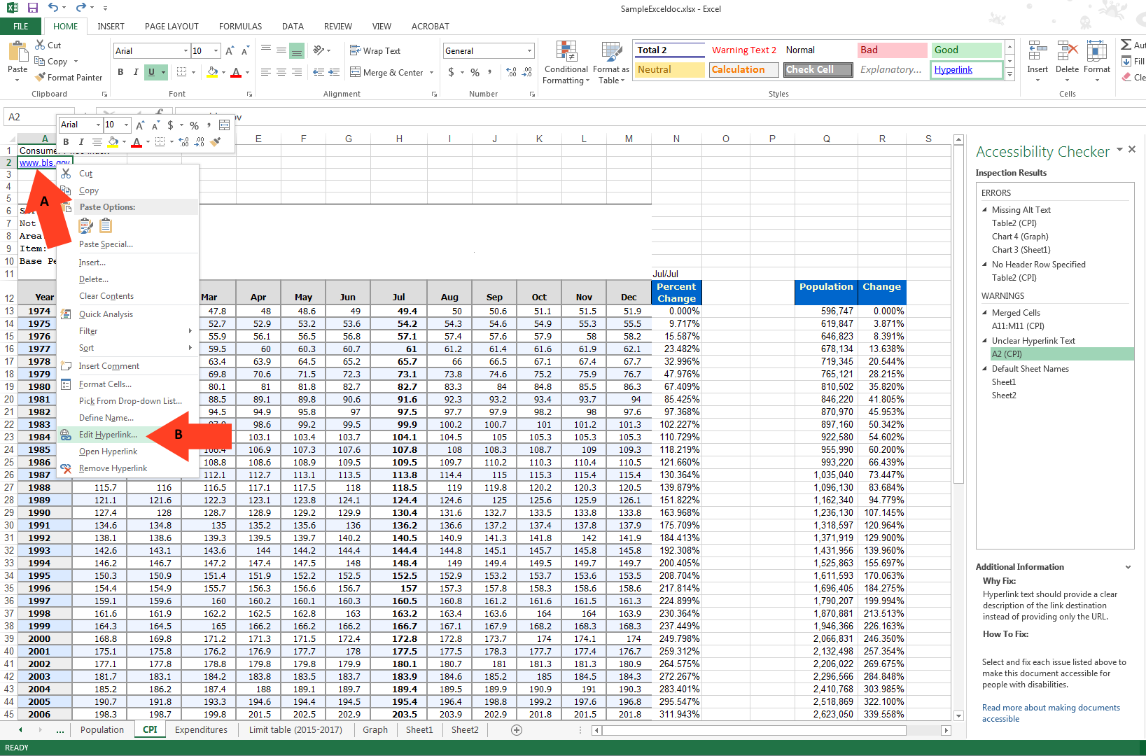

Adding ALT Text to a Hyperlink

Adding ALT Text to a Hyperlink
- Select the “ScreenTip” tab.
- Give the Hyperlink and description.
- Select “OK” to save changes.
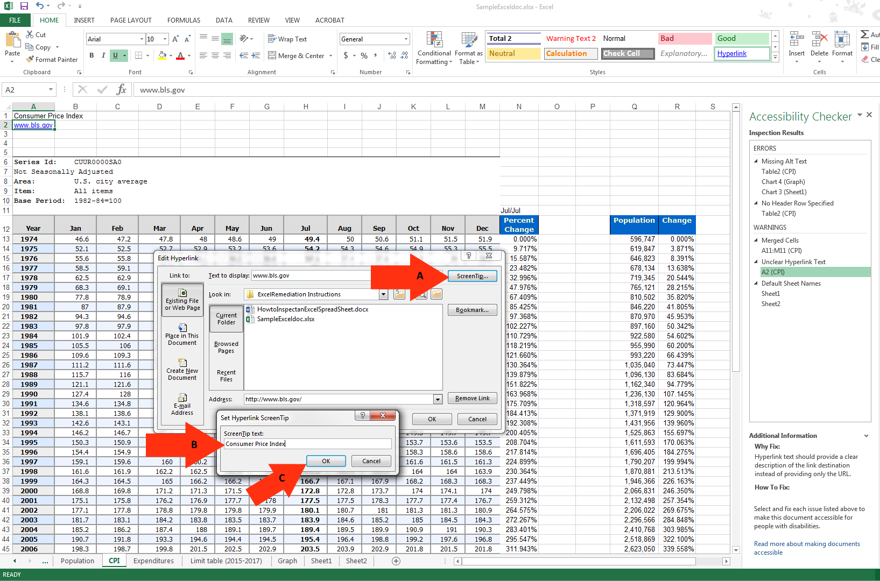

Adding ALT Text to a Table

Adding ALT Text to a Hyperlink
- Right-click on table to open table options
- Highlight the “Table”.
- Select “Alternative Text:
- Give the table a “Title”.
- Give the Table a “Description” and click “OK” to save changes.
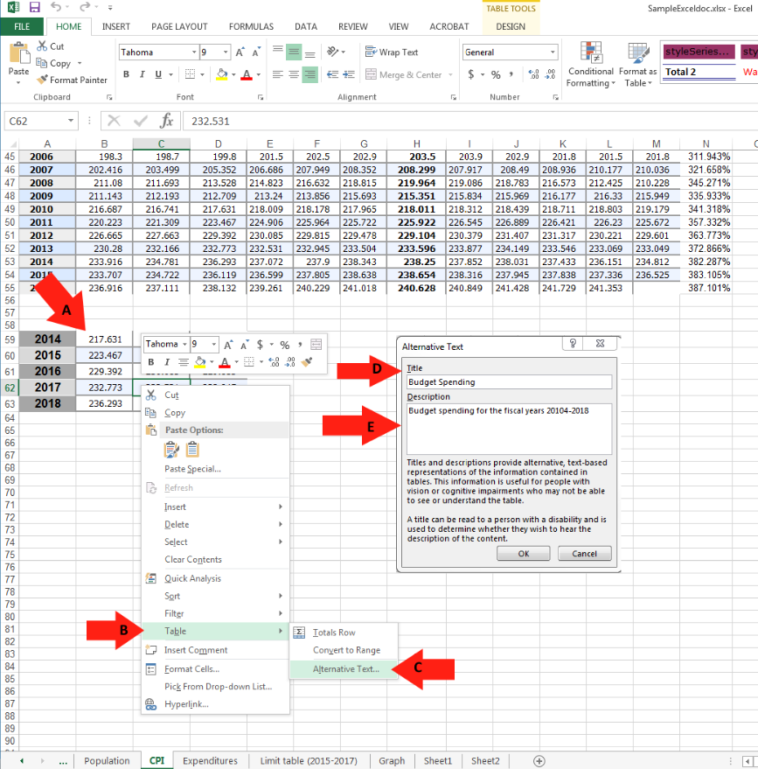

Merged Cells

How to unmerge cells
Merged cells can confuse a screen reader and make the Spread Sheet hard to follow. This is a quick guide on how to unmerge cells.
- Select the “Merged Cell” to find it on the document.
- This is the location of the “Merged cell” on the document.
- Select the ‘Merge & Center” menu.
- Select the “Unmerge cells” option.
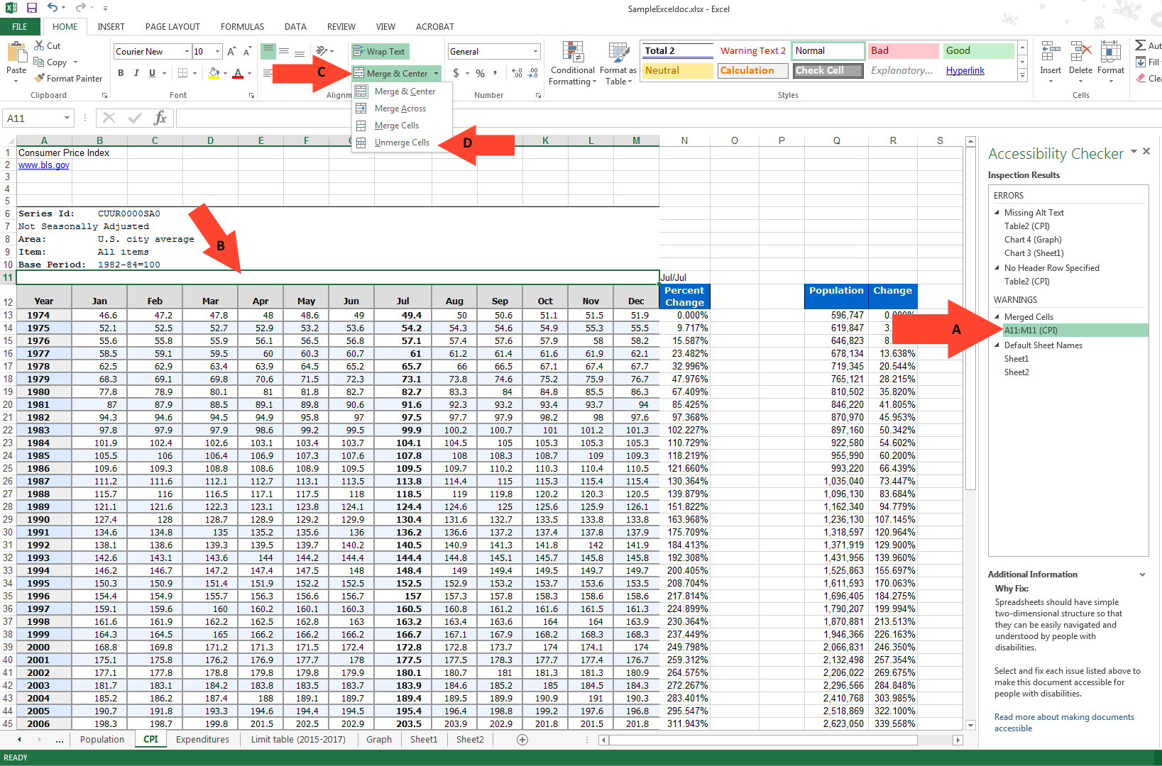

Default Sheet Names

Adding a name to sheets
In order for your document to be ADA compliant, all sheets need to be named. Sheet 1 is the default name and it needs to be renamed.
- The error on the document.
- Right-click on the sheet to bring up the sheet options.
- Select the “Rename” option and give the sheet a name.
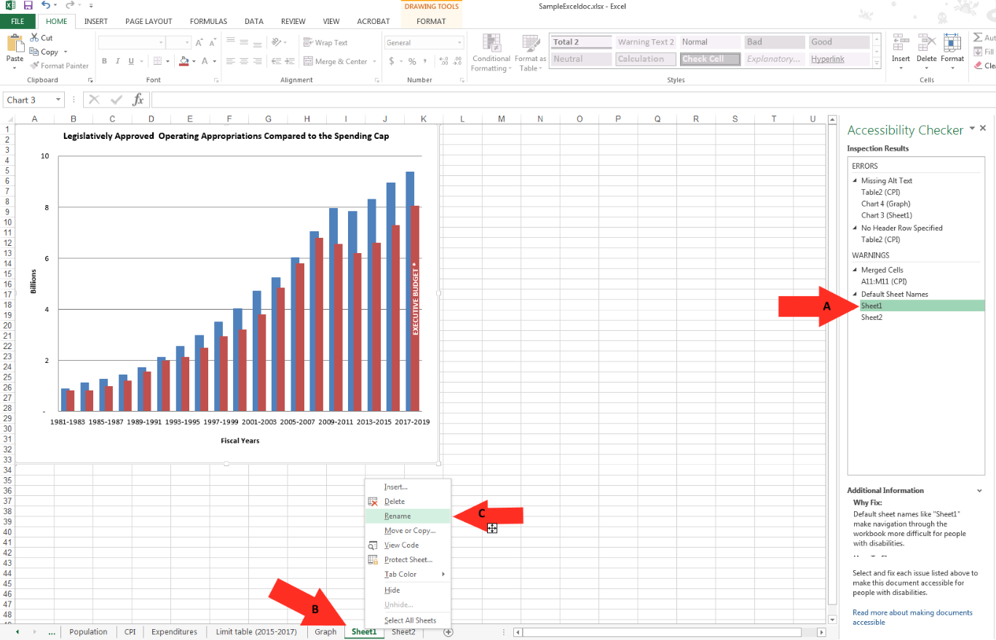

A Compliant Excel Document

An example of a Compliant Excel Document.
This is what a document should look like when all of the errors have been corrected.
- Re-run the “Check Accessibility” option and the right pane will show the document results. There should be no errors and this is what a compliant document should look like.
