Remediate a Fillable PDF

Before you can remediate a fillable PDF, review the guide on Creating a Fillable PDF. The best practice is to clear the page structure and tag the document from scratch to avoid fighting with the Logical reading order.

Clearing page structure:
- Choose the accessibility tool and then Select Reading order.
- Select Clear Page Structure to clear the document of any remediation.

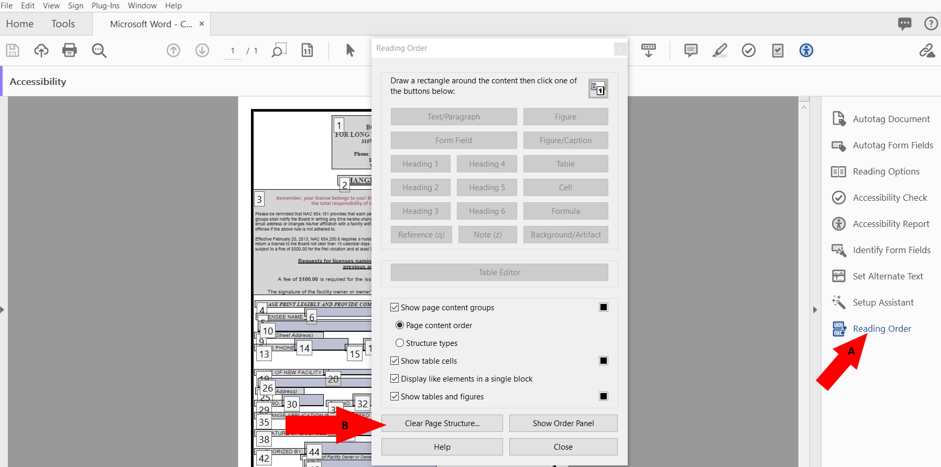

Tag text on form
- Encapsulate all text by holding down the left click of the mouse and encapsulate all the text and it will highlight on the document.
- Select the “Text/Paragraph option in the reading order to tag as text.

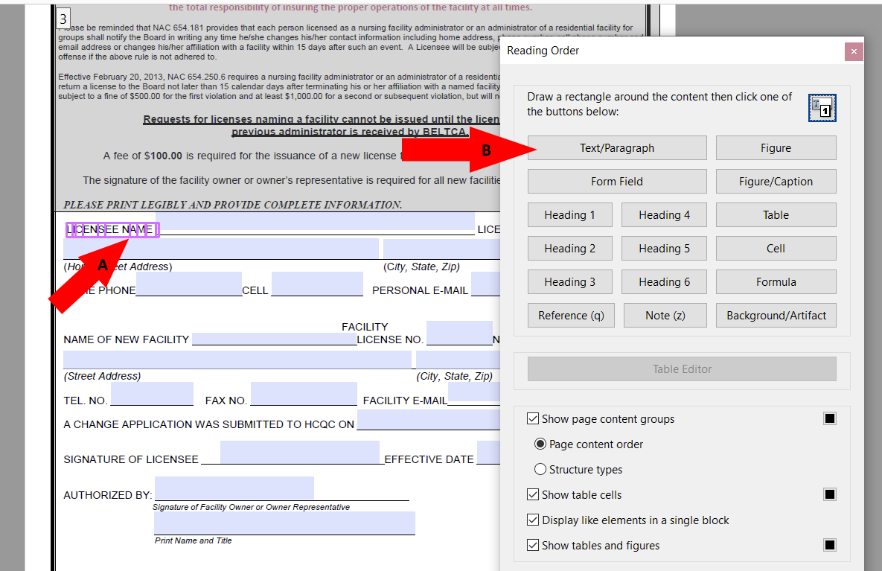

Tag input fields as “Form Fields”
- Encapsulate the entire by holding down the left click of the mouse and encapsulate the entire field and it will highlight on the document. If you encapsulated more than the field, hold down the CTRL key on the keyboard and encapsulate any extra to remove. Make sure you have a solid box around on the form field.
- Select the “Form Field” option in the reading order to tag as Form Field.

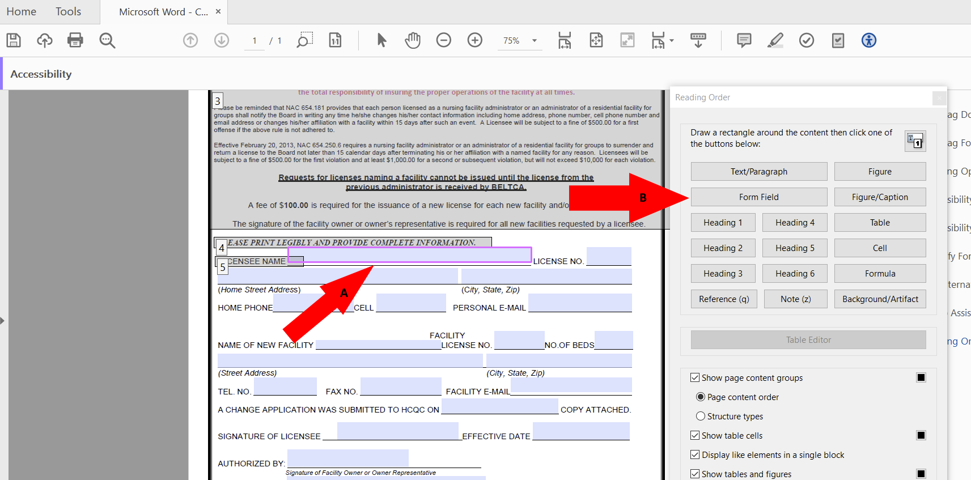

Fixing Logical Reading order
As the document is tagged as text or form fields, it will create a number for each item tagged. To keep the correct reading order structure, have the reading order view open to view the structure. The box containers are text, and the blue and white container are form fields.
- Select the “Reading order” tool to view the number sequence in the document.
- The text should be first and the form field should be second. In the example below, License No. should be number 7 and the form field should be 8.
- To rearrange the reading order, Select the container in the reading order by holding down the left click of the mouse and dragging the container up or down into the correct number position.

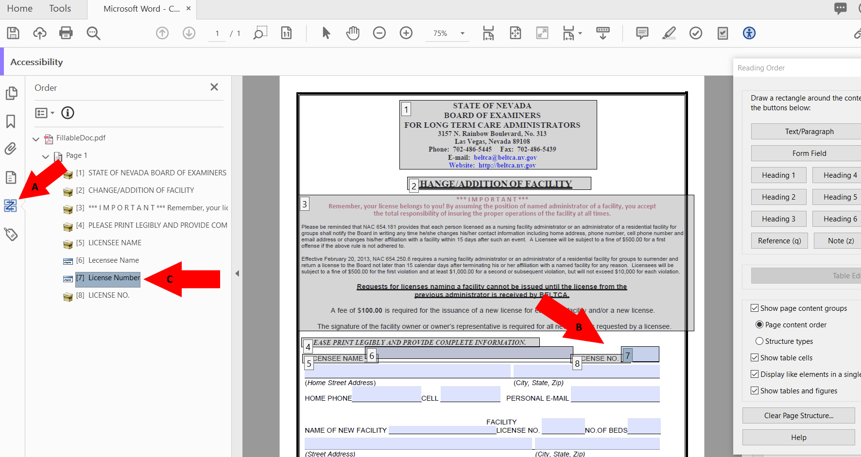

Example of correct reading order structure
The correct reading order in a fillable PDF will make it usable to assistive technology users and allow the user to tab through fields in the correct order.
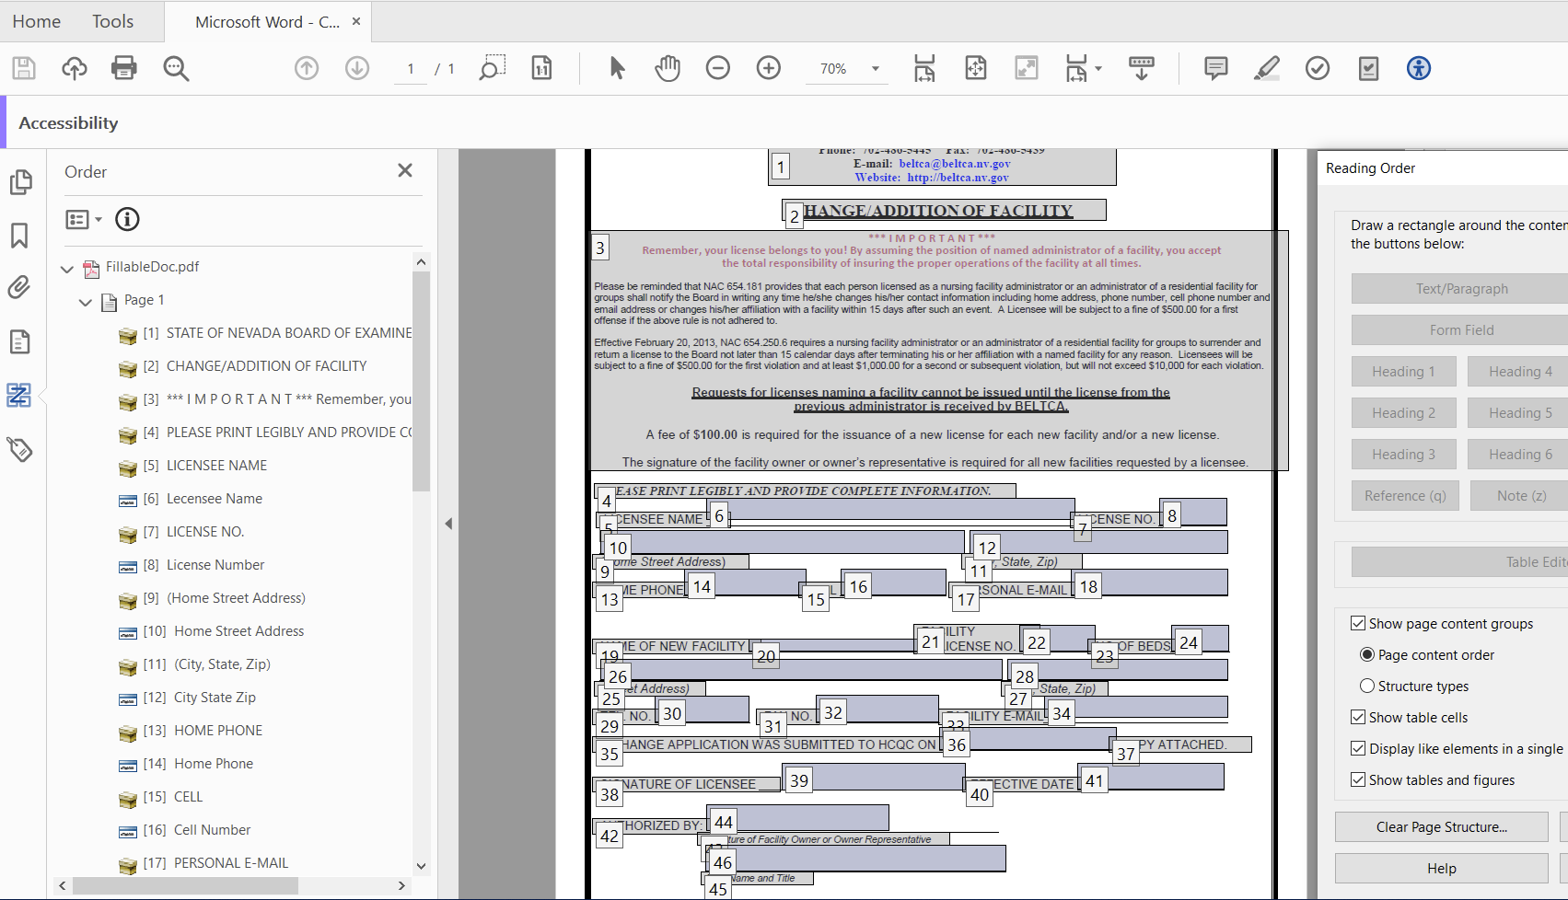

Artifact paths in the content panel
When paths are not artificated, they will be read as underscores by a screen reader. The content panel should have all container grouped together without any paths.
- Select the “Content Panel” tool to view any paths in the document.
- Highlight the paths by left clicking the mouse. To select multiple paths at one time, Select the first path, scroll to the last path, hold down the Shift key and select the last path to highlight the group of paths.
- Right click on the group of paths and select “Create Artifact”.

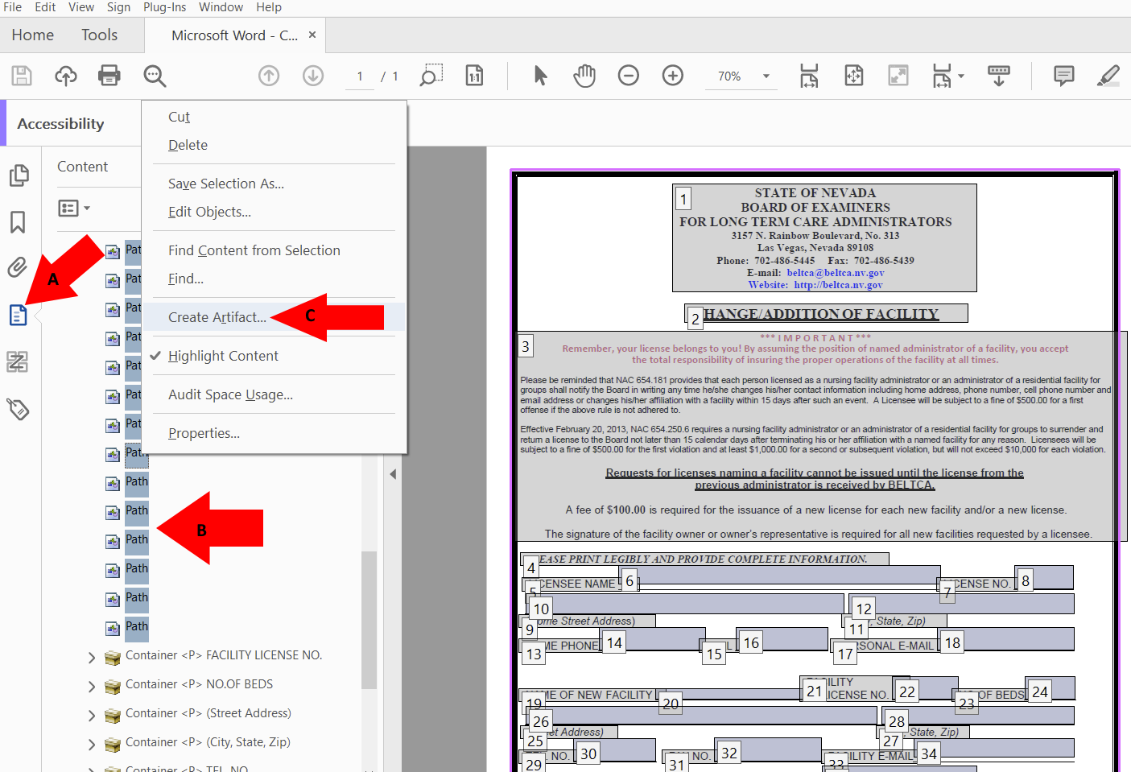
- Select “ok” to save changes.
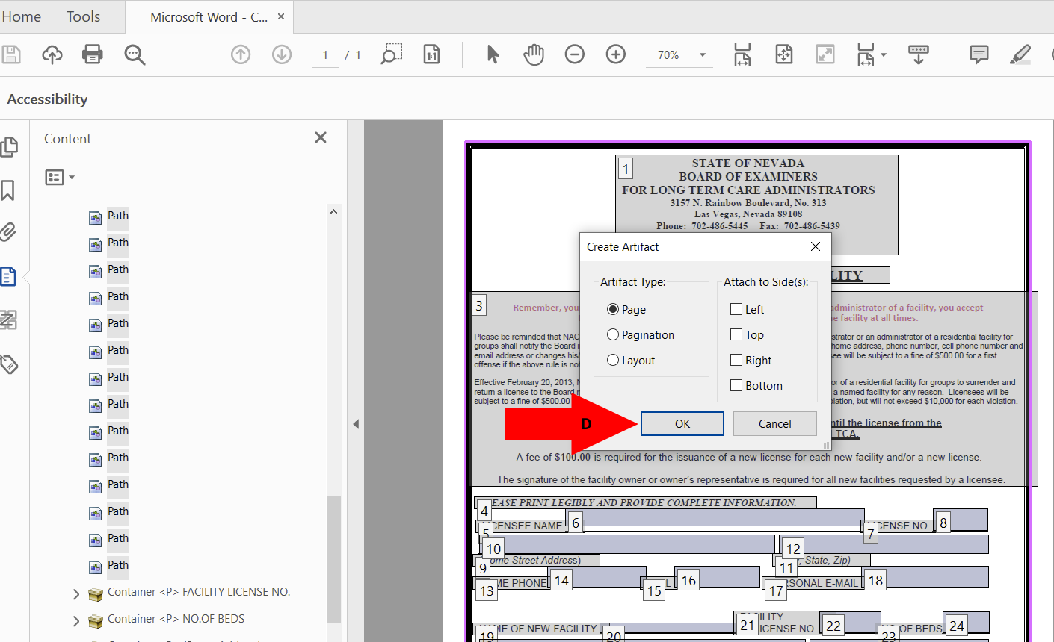

Example of correct view of content panel without paths
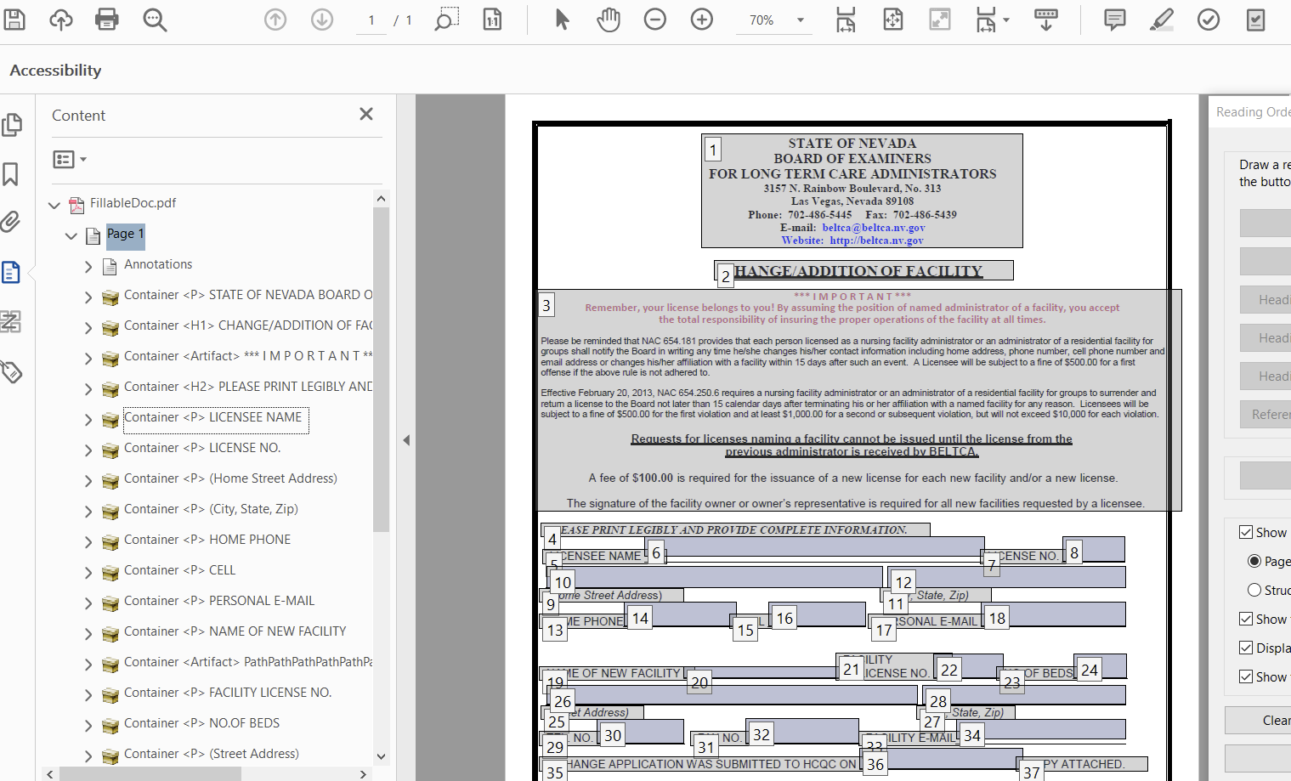

Accessibility Check for errors
The last step in remediating a fillable PDF is to check the document for errors and the image below is what an ADA compliant will look like after an accessibility check.
