Installing the Siteimprove Chrome Extension Tool
- You must have the Google Chrome browser installed on your computer.
- Visit the Chrome Web Store Siteimprove Extension to locate the tool.
(https://chrome.google.com/webstore/search/siteimprove?hl=en )
- Click the +ADD TO CHROME button to install the tool in your browser
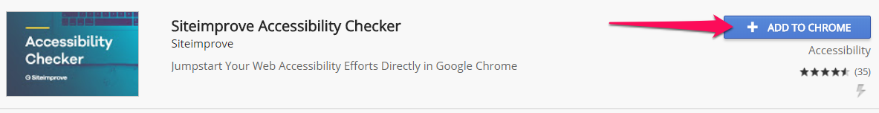

Using the Siteimprove Accessibility Checker Tool
Please note: This tool checks a single page at a time and must be manually run on every page within the site.
Prerequisite: Must understand the requirements of WCAG 2.0 and Section 508 as that is what the Tool measures sites against. In addition, an understanding of HTML, CSS and any other language(s) used in your website is most helpful.
- In Chrome, open the webpage you want to check.
- Click the Siteimprove icon in the top right side of the tool bar to run the tool.
Note: The first time you download the tool you can sign up or click Skip form. Recommend you sign up for future updates. Close this window and then click the Siteimprove icon in the toolbar.
- See the accessibility issues directly on the page. Click on each drop-down arrow next an issue to see what is causing the issue. You may see a single issue or multiple issues. All issues are identified as A, AA or AAA issues. State of Nevada websites are required to meet A and AA compliancy but we are striving for AAA compliancy.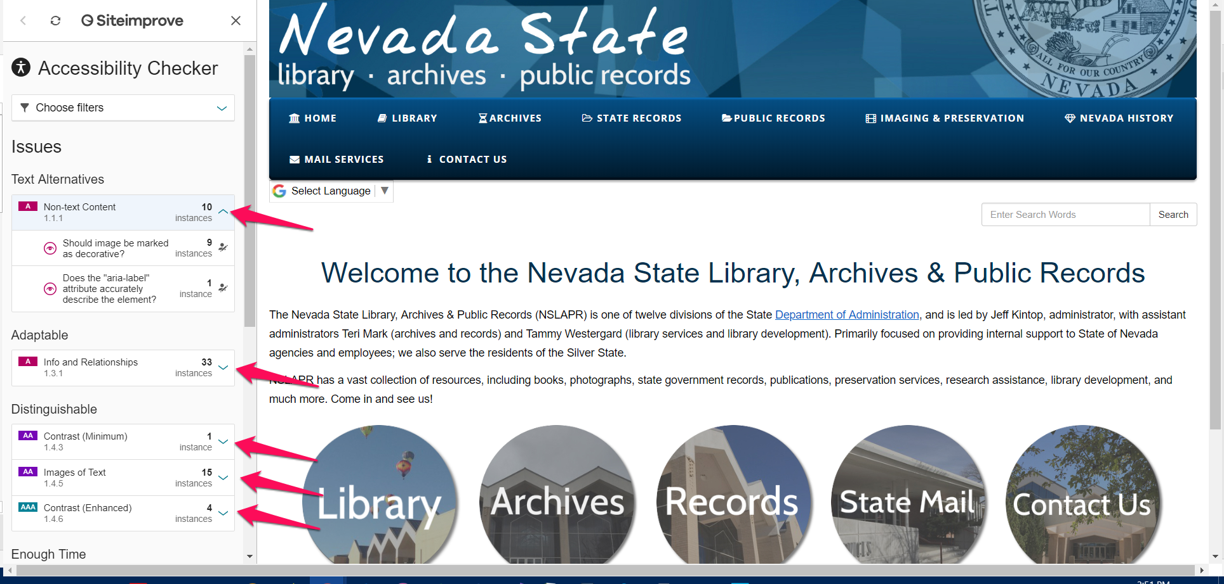
- lick on each instance for more information on what the problem is and what can be done to correct it.
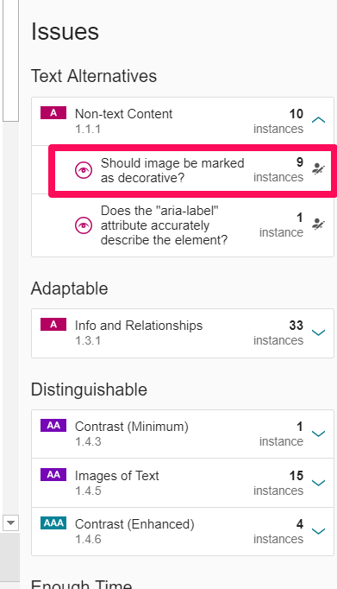
- The first part of the left panel will tell you what the problem is.
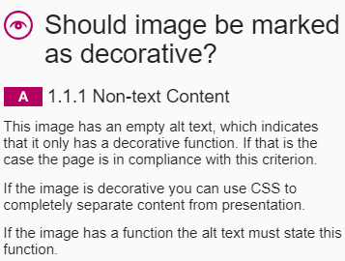
- The middle portion of the left pane explains each instance of the issue. Click the drop-down arrows to see the issue. To open Dev Tools to view code snippet, press Ctrl + Shift + I
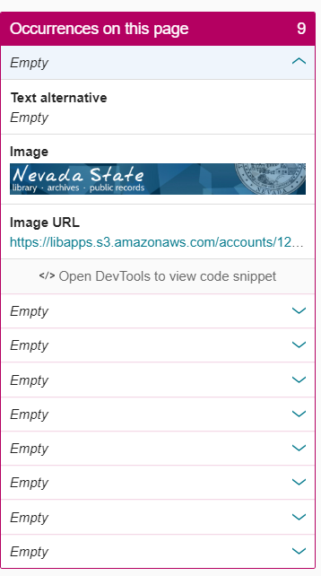
- Scroll to the bottom of the page to the How do I meet this criteria section to find techniques to fix the issue.
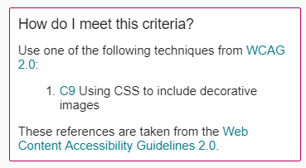

- Click on the solutions to find one that corrects the issue.

- Repeat Steps 4 – 8 for each issue identified.

- Repeat steps 1-8 for each webpage within your site.

Resources

- http://ada.nv.gov/CMS/CMS_Users/
- http://ada.nv.gov/Resources/ADA-Course-Resources/

