PDF Accessibility Issues
This tutorial has given examples of the most common errors encountered when remediating a PDF document. I have enclosed a sample PDF docent that is non-compliant and Instructions on how to make this document compliant. In the example the document was remediated using Adobe Acrobat XI Pro.
If document is a fillable form, STOP. Send to stateweb@admin.nv.gov and go to the next document.

How to Remediate a PDF Document in 23 steps:
- How to create a Document Title.
- Title Continued
- Setting PDF to Document Title.
- Setting the Language.
- Using the Action Wizard
- Using the Action Wizard Cont.
- Using the Action Wizard Cont.
- Using the Action Wizard Cont.
- Using the Action Wizard Cont.
- Locating Errors on document page.
- How to Tag Images.
- Adding Alternative Text.
- Unidentified content.
- How to Tag Text.
- How to Assign Headings.
- How to Tag Hyperlinks.
- How to Tag Hyperlinks Cont.
- Adding Text to Hyperlinks.
- Logical Reading Order.
- How to fix the Reading Order.
- Color Contrast.
- A compliant PDF Document.
Any further questions please refer to this QR code reader or this URL. http://ada.nv.gov/CMS/Remediation-Guides

How to Create a Document Title

Creating a Document Title
The first step in creating a compliant PDF is to give your document a title instead of a file name.
- Select “File”.
- Scroll down and select “Properties”.
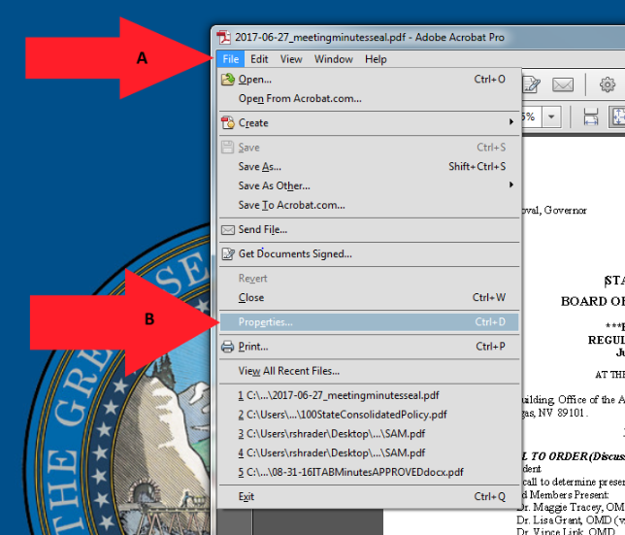

Title Continued

Creating a Title Cont.
Make sure to give the document a title. When a PDF document is saved it will be saved under a document file name and not a title.
- Select the “description” tab.
- Give a “Title” description to the document.
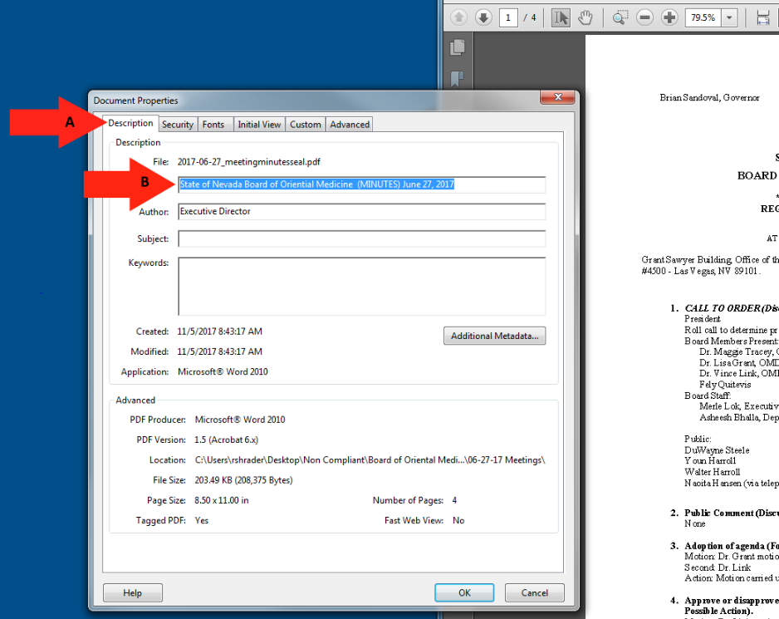

Setting PDF to Document Title

Changing File Name to Document Title
When adding a Title to you document, you must also change the Metadata from File Name to Document Title.
- Select the “Initial View” tab.
- Change the File Name to “Document Title.
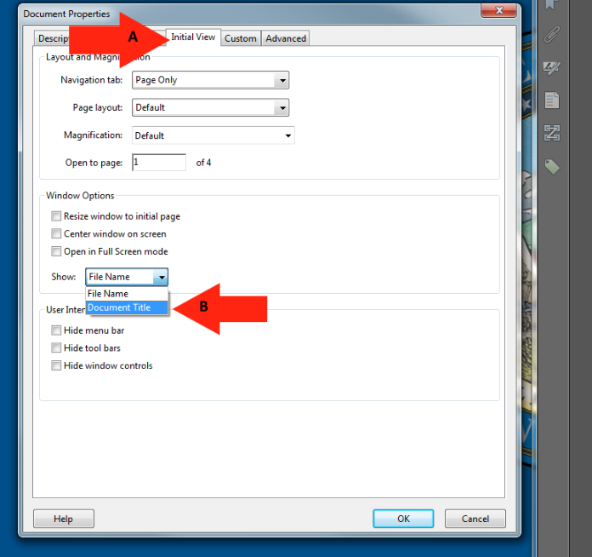

Setting the Language

Setting the Language in PDF
Screen reader technology will read the document to the user in the language set for the document. The steps to set the correct language in a PDF are:
- Select the “Advanced” tab.
- Choose the “Language” that you prefer you document to be set as.
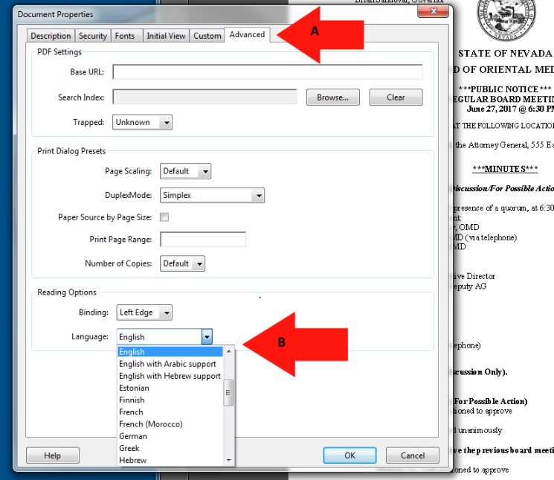

Using the Action Wizard

Making accessible documents with this tool.
The next step after giving a PDF document a title is to run the full check option to see what errors are in the document. This tool is used to give all images and tables the option to add Alt text as the scan runs.
- Select the “Action Wizard” option.
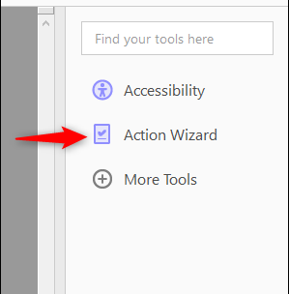
- Click on the “Make Accessible” option.
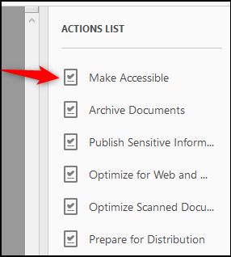

Using the Action Wizard Cont.

C. Click the “Start” option to run the accessible scan.
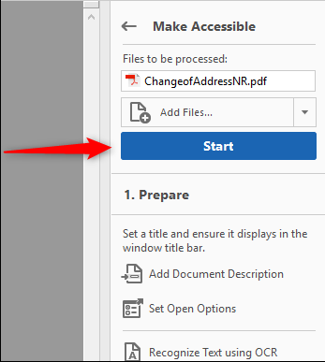

This space intentionally left blank.

Using the Action Wizard Cont.
Give the document a Title and click ok.
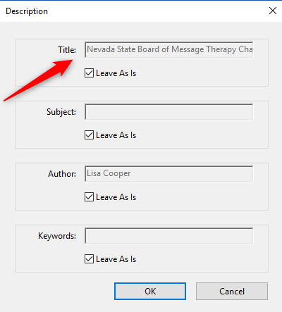

Set the language to English and click ok.
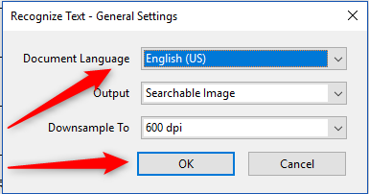

Using the Action Wizard Cont.
If this document is really a fillable form, STOP. Send to stateweb@admin.nv.gov and go to the next document. Otherwise, select No, Skip this Step.
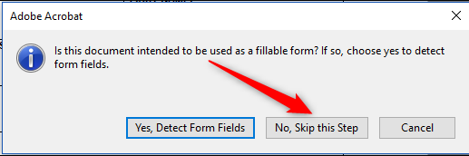
Make sure the language is set to English and click ok.
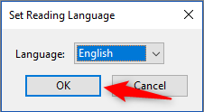
If your document has images or tables, Give them a description in each box and click save/close.
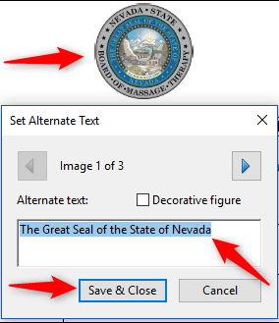

Using the Action Wizard Cont.

The “Accessibility Checker” will appear the recheck the document for any errors and you will select “Start Checking”.

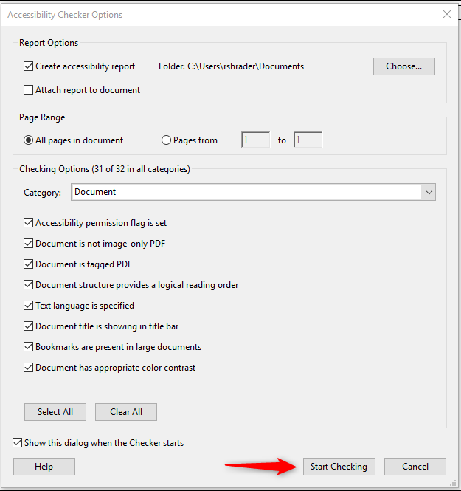

Locating Errors on document page

Finding all Errors on PDF page
Running the Action Wizard will give results of all errors found throughout the entire document. In order to make a document compliant, all errors must be corrected.
- Select the “Element”.
- The PDF error will highlight on the page when selecting the Element.
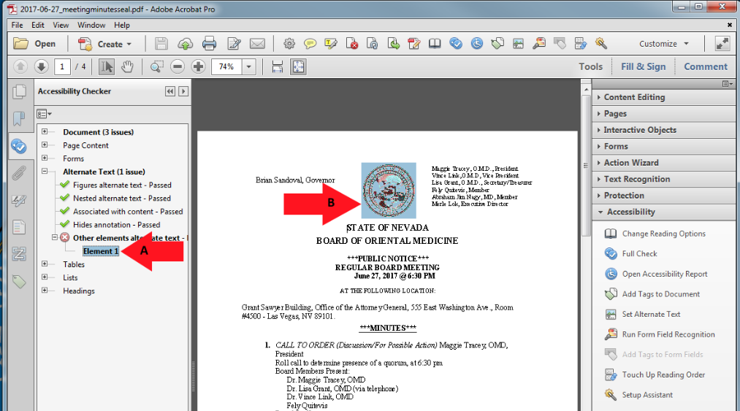

How to Tag Images

Tagging Images
All Images, Tables, and Unidentified content must be tagged in a PDF document to make it compliant. Screen reader technology will read an image and the image description is what is read back to the user.
- Select “Touch Up Reading Order”.
- Using the “Touch Up” tool, Enclose the Image until it is selected.
- Tag the Image as a “Figure”.
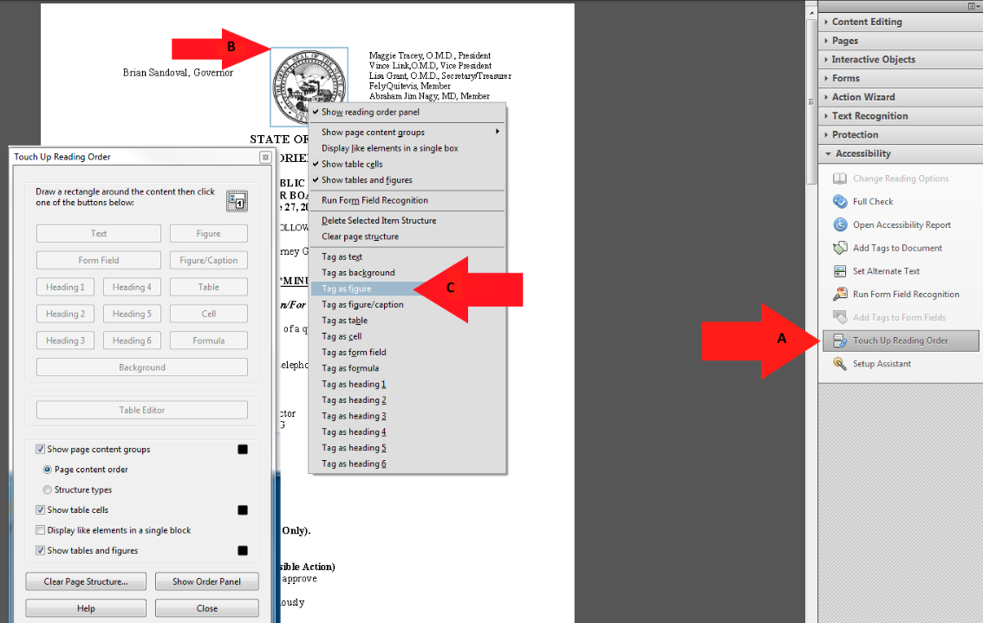

Adding Alternative Text

Alternative Text
Alternative text should be provided with all visual content: pictures, clip art, tables, shapes, groups, charts, embedded objects, ink, and videos.
- Right-click on “Figure”
- Select “Edit Alternate Text”.
- Add a description to the “Figure”.
- Select “OK” to save changes.
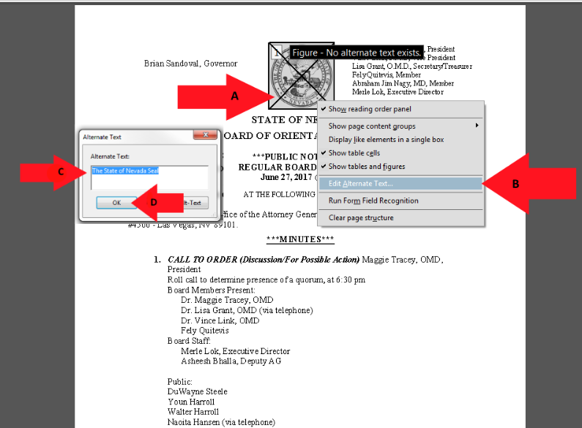

Unidentified Content

Removing Unidentified Content
The Accessibility checker will identify content in a PDF that needs to be tagged or removed from the document to become compliant. In this example the content is unidentified and needs to be removed.
- Select the “Element” to highlight the error on the page.
- Using the “Touch Up” tool, enclose the tagged content.
- Right-click and select “Delete Selected Item Structure.
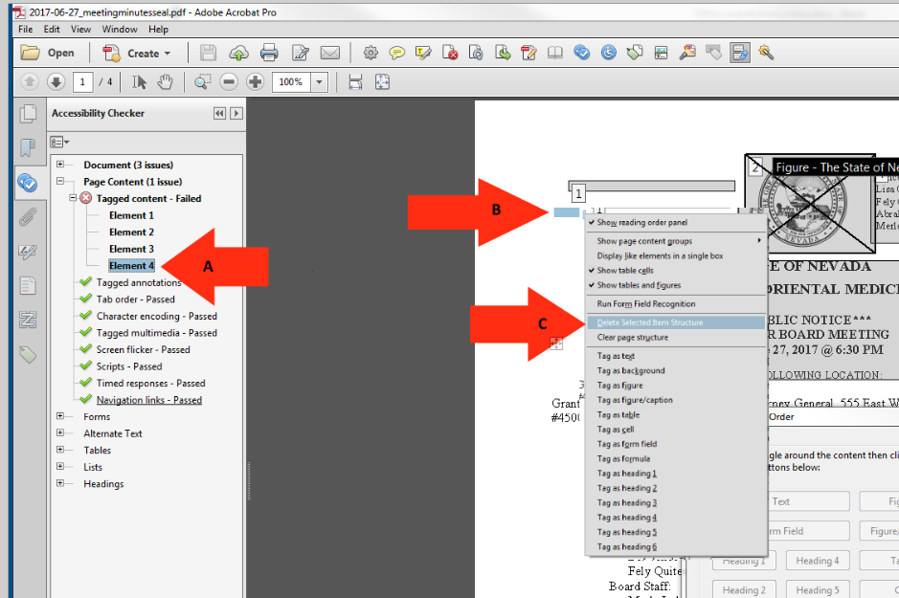

How to Tag Text

Tagging Text
In order for a screen reader to understand a document, all text on a page needs to be identified correctly to make it a better experience for the user.
- Select the “Touch Up Reading Order” tab.
- Enclose the text until it is completely highlighted.
- Choose text in the “Reading Order” panel.
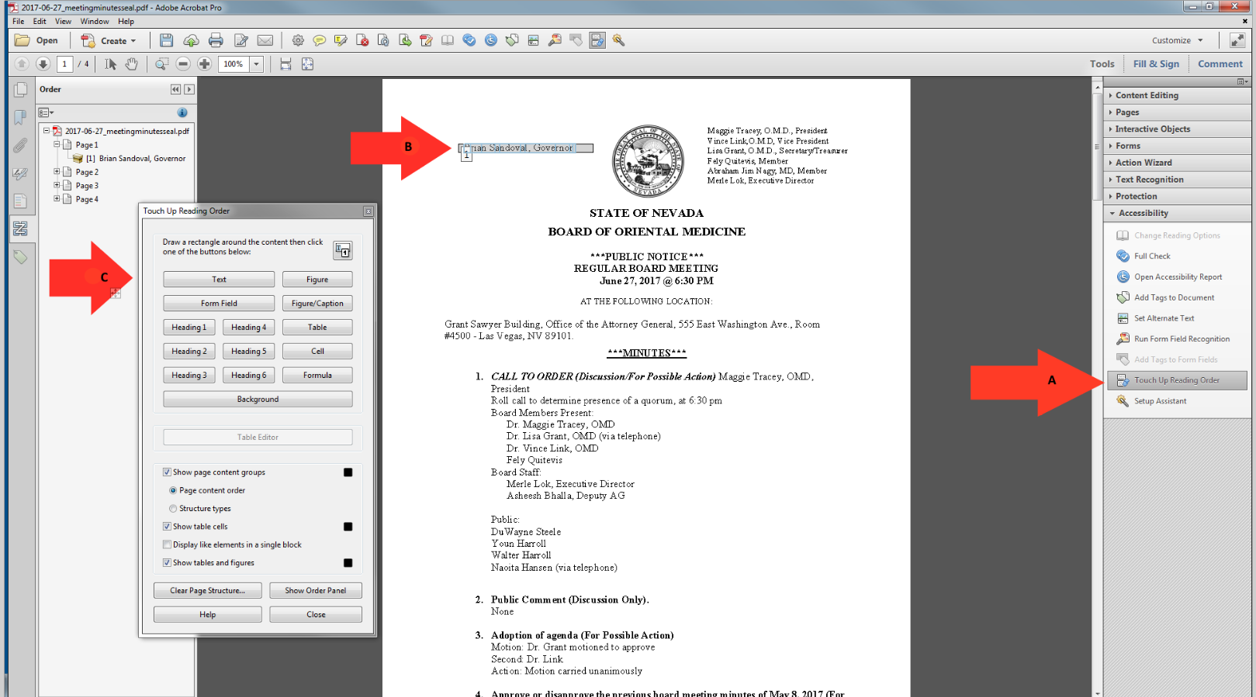

How to Assign Headings

Headings
Proper headings are used in a PDF document so a disabled user can navigate through a document with ease. It would be extremely difficult to find content in a document without headings and require them to read the entire document in order to find the piece of information that they were looking for.
- Select the “Touch Up Reading Order” tab.
- Enclose the text until it is completely highlighted.
- Choose the proper “Heading” in the touch up reading order panel.
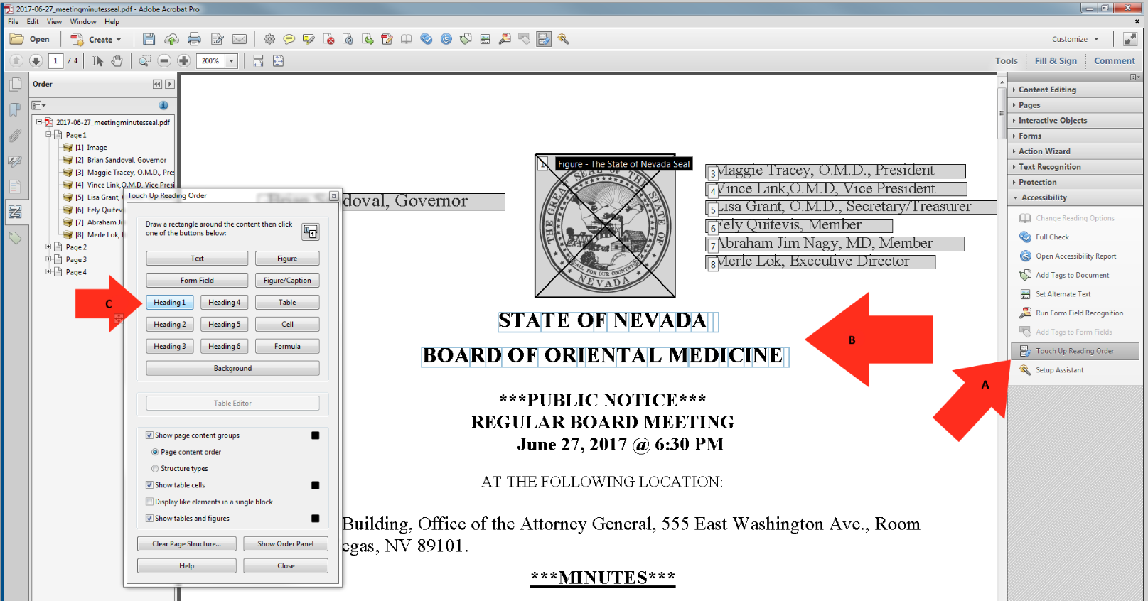

How to Tag Hyperlinks

Tagging Hyperlinks
All hyperlinks in a PDF will need to be identified in order to make the document ADA compliant. There are multiple steps in this process.
- Select the “Element” to find the hyperlink.
- The hyperlink will highlight on the PDF document.
- Right-click on the “Element” and choose “Show in Content Panel”.
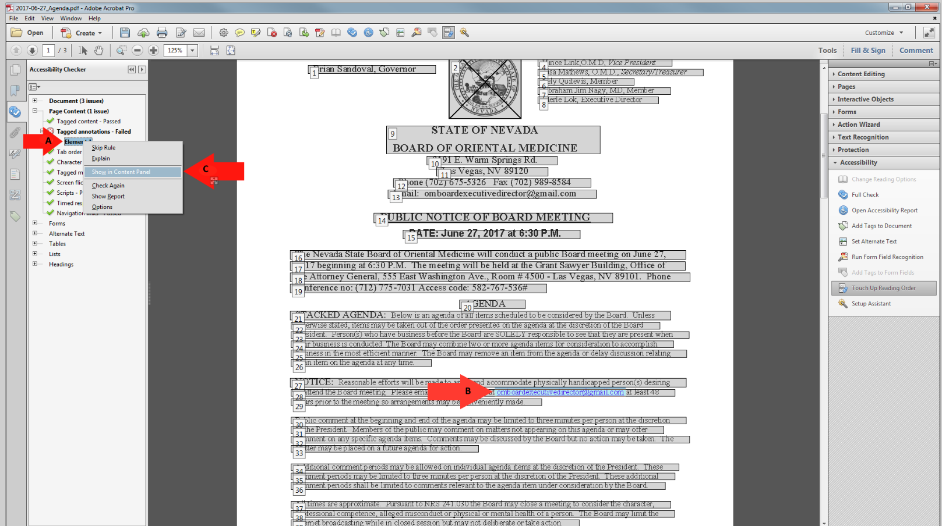

How to Tag Hyperlinks Cont.

Hyperlinks Continued
To find Unmarked Links in a PDF you have to search for them using the Find Element option.
- Right-click on “Link”.
- Select “Find” and it will open the “Find Element” search window.
- Highlight “Unmarked Links” option.
- Select “Find” to start the search.
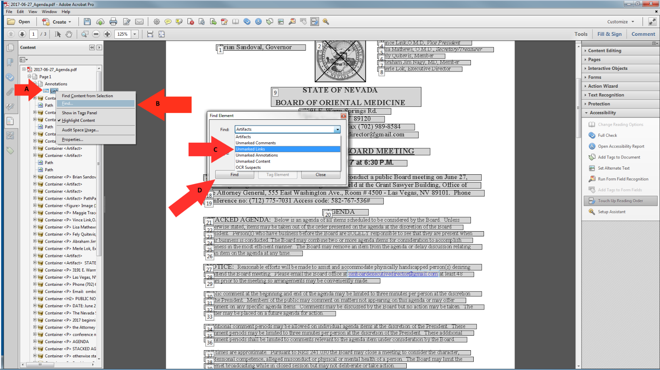

Adding text to Hyperlinks

Adding text to Unmarked Links
Adding text to hyperlinks in a PDF document will give users a better description of the link and the link will be read as the description instead of the URL.
- The location of the Hyperlink after the search has finished.
- Choose the “Tag Element” option.
- Give the Hyperlink a “Title”.
- Click “OK” to save changes.
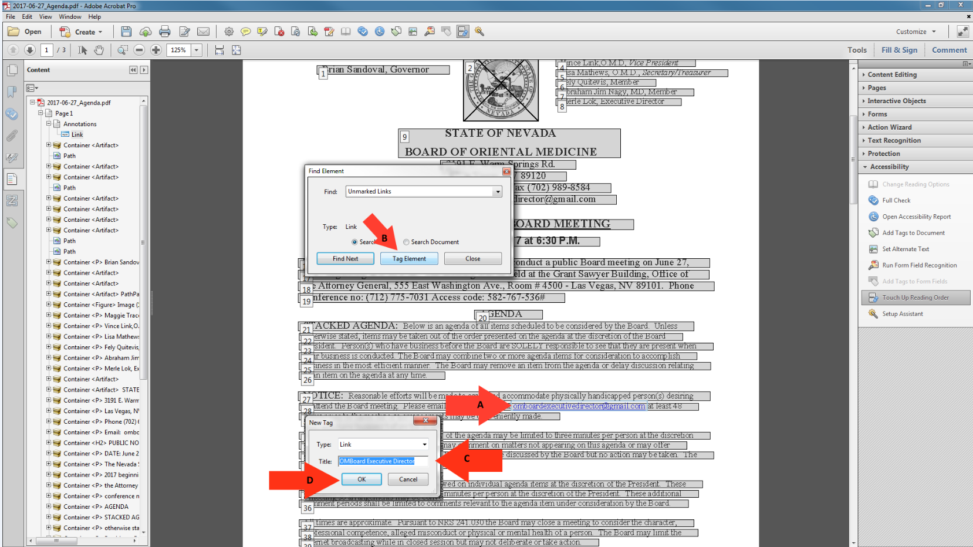

Logical Reading Order

Logical Reading Order
When reading a PDF document using screen reader technology, all text is read the same as it would be in a book. All document should be checked to have the document read in order.
- Select the “Order” tab.
- Start at the beginning of the document, page 1.
- This reading order is out of order.
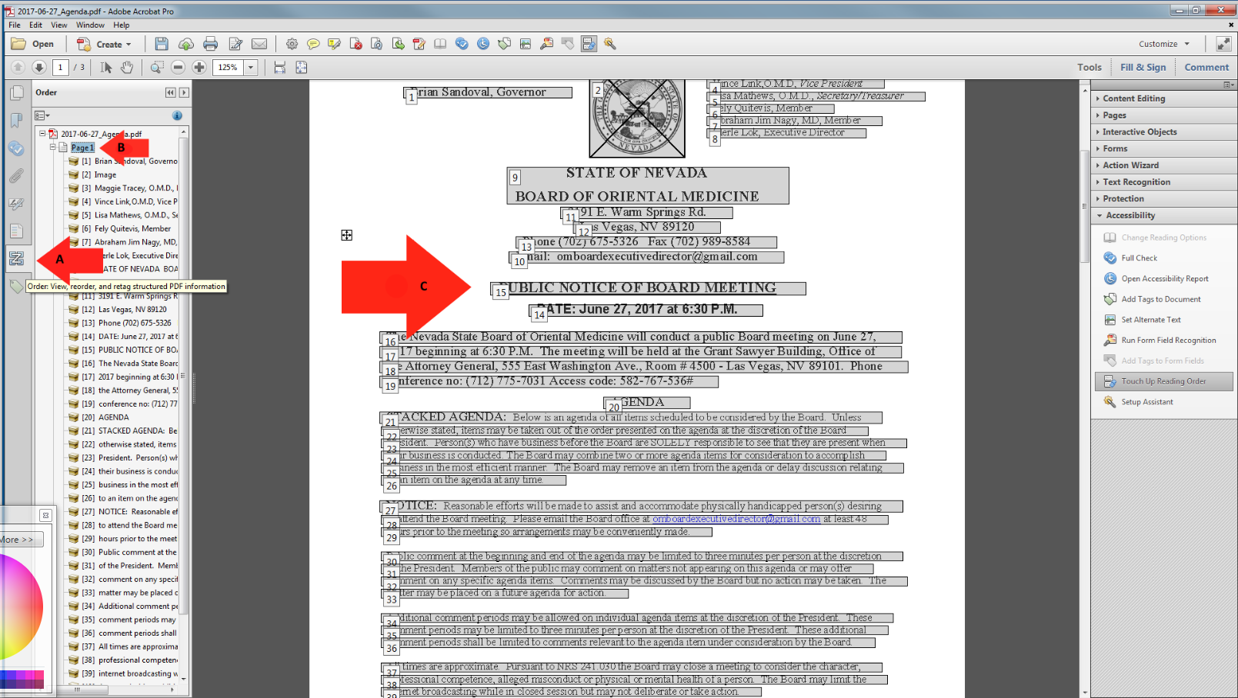

How to Fix the Reading Order

Reading Order Continued
The structure of the Reading Order can be changed during document remediation and here are the steps to fix the document and put it back into logical reading order.
- Select the text and move it up or down to put in the correct order.
- When you have moved the text, you will see the reading order in the document.
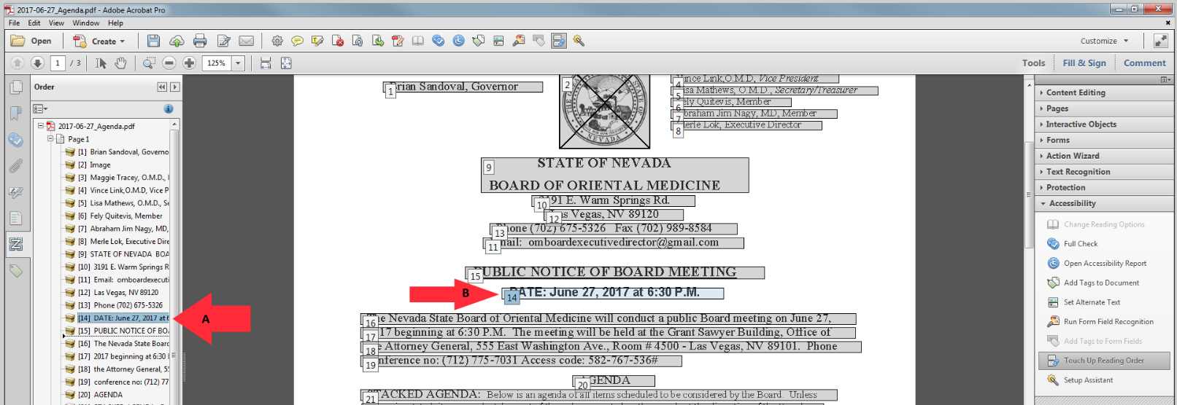

Color Contrast

Color Contrast
The color contrast will show up and can be ignored by manually passing it in the accessibility checker as this can be addressed in the source document and not in the PDF. The color of the text can only be fixed in the WORD version and not in the PDF version.
- Right-click on “Color Contrast”.
- Select “Pass” to fix the error manually. The color of the text can only be changed using the source document and is unable to be fixed in the PDF.
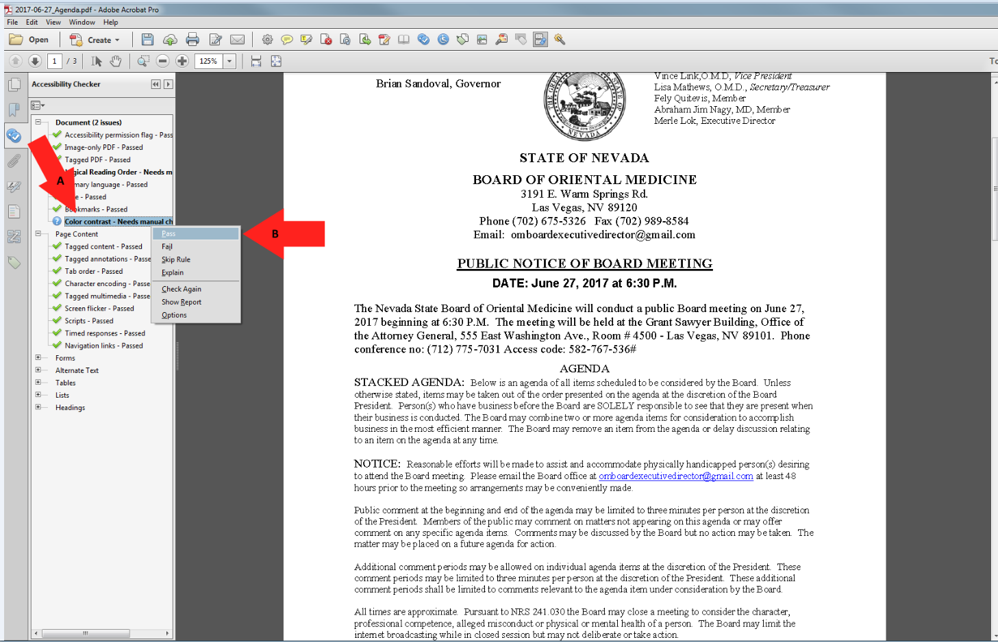

A Compliant PDF Document

An example of a Compliant PDF Document.
This is what a document should look like when all of the errors have been corrected.
- Re-run the “Full Check” option and the left pane will show the document results. There should be no errors and the entire document should have green checks in order to be compliant.
