Word Accessibility Issues

This tutorial has given examples of the most common errors encountered when creating a word document. I have enclosed a sample word document that is non-compliant and Instructions on how to make this document compliant. In this example the document was remediated using Microsoft Word 2013.

**To create an accessible word document, just create your document like you normally would and then use the remediation procedure below to resolve any issues.**

**How to Remediate a Word Document in 10 easy steps:**

1. How to Inspect a Document
2. How to Check for Issues
3. Alternative Text
4. Adding ALT Text to Images
5. Adding ALT to Tables
6. How to set a Table Header
7. Hyperlink Text
8. Adding ALT Text to a Hyperlink
9. How to fix Repeated Characters
10. Using Headings and Font Styles.

Any further questions please refer to this QR code reader or this URL.<http://ada.nv.gov/CMS/Remediation-Guides>

# Inspecting a Document

All documents should be checked for ADA compliance and this is how to check using Microsoft Word.

1. Select “File” in the top left of your document

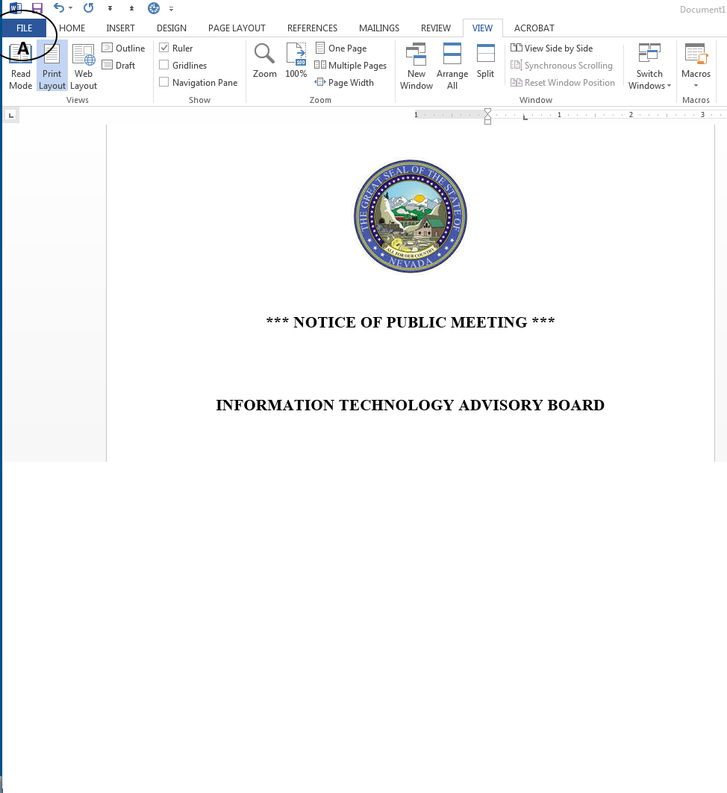

# Check for Issues

All documents can be checked for issues and the check accessibility will run a scan on documents. All errors will be listed for remediation.

1. Click on check for issues.
2. Select “check accessibility”.

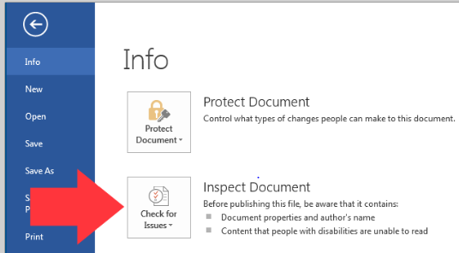

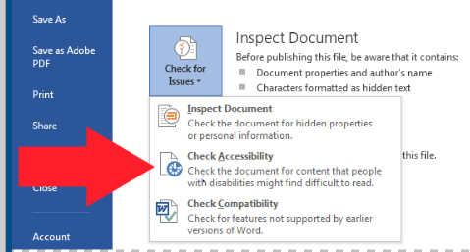

# Alternative Text

Alternative text should be provided with all visual content: pictures, clip art, SmartArt graphics, shapes, groups, charts, embedded objects, ink, and videos.

1. Right-click on photo.
2. Select “Format Picture”.

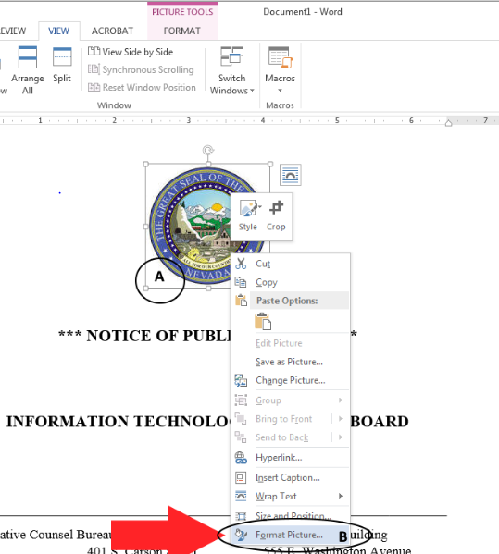

# Adding ATL Text cont.

Adding ALT text to each image in your document will give a description of your image and give a non-sighted user and better understanding of your document.

1. Select the “layout properties”.
2. Select “ALT Text”.
3. Add a title to the image.
4. Give a description of the image.

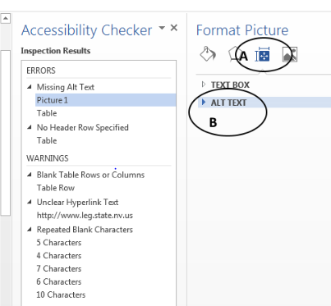

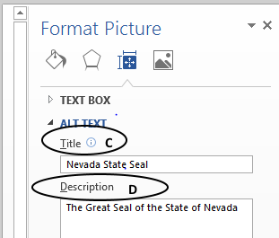

## Wrapping Text

When adding an image or graphic always set the wrapping style to “image or object not inline”. Text that wraps around an image or graphic often will confuse a screen reader, making it difficult for the user to understand.

In Word 2007 right-click the image and select ***Text Wrapping***, then choose ***inline with text.*** In later versions, right-click the image and select ***edit alt text.***

# Table Structure

Tables need ALT Text to give it a description. Tables must also be structured with a specified column header.

1. Right-click on the “Table options”.
2. Select “Table Options”.

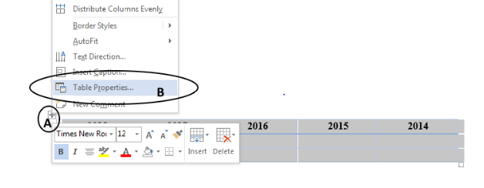

# Adding ATL text to Tables

Adding ALT text to each image in your document will give a description of your image and give a non-sighted user and better understanding of your document.

1. Select the “ALT text” tab.
2. Enter a descriptive title.
3. Give the table a brief description.
4. Select “OK”to save the changes.

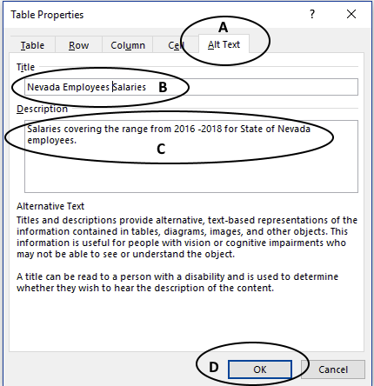

# Table Header

A Table requires a column header to identify the structure of a table for screen reader technologies.

1. Highlight the row or column of cells that you designate to be the header.
2. Select the “Layout” tab.
3. Select “Repeat Header Rows”.

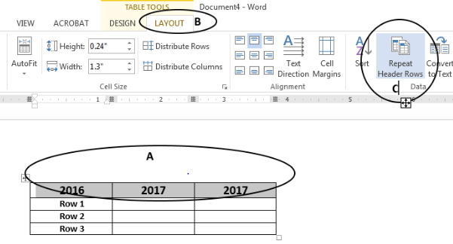

# Hyperlink Text

**Hyperlink text should provide a clear description of the link destination.** One of the ways a person who uses Assistive Technologies can navigate a document is by skipping from hyperlink to hyperlink, or they can also pull up a list of all the links in a document (Insert + F7). Since both of these methods of navigation do not include any of the surrounding text, the hyperlink text by itself needs to provide sufficient meaning.

For this reason, using phrases like, ‘Click Here’, or ‘Visit’ are not sufficient as they by themselves do not provide enough meaning.

1. Right-click on “Hyperlink”.
2. Select “Edit Hyperlink”.

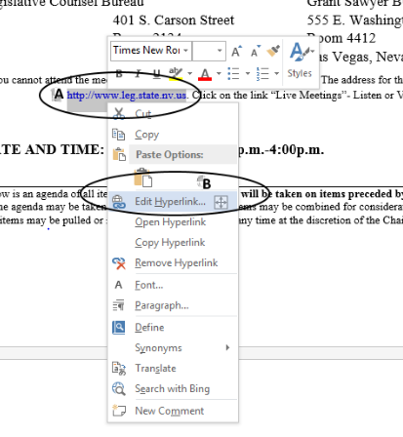

# Hyperlink Text cont.

1. Select the “screenTip” tab.
2. Give the Hyperlink a description.
3. Select “OK” in the “Set Hyperlink ScreenTip” dialog box and again in the “Edit Hyperlink” dialog box to save changes.

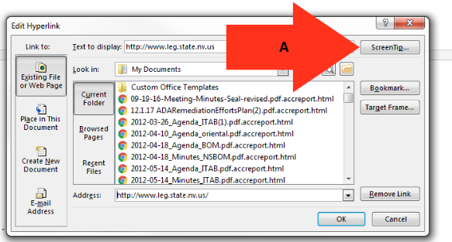

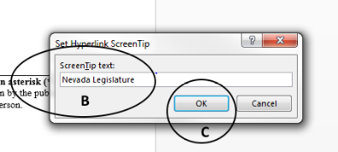

# Repeated Blank Characters

One of the most common errors that you will encounter in a word document is repeated blank characters. To fix this issue, follow these steps.

1. Place the cursor at the end of the sentence or paragraph.
2. Select this “Icon” and it will open paragraph settings.
3. Add the spacing that is preferred for your document.
4. Click “OK” to save your changes.

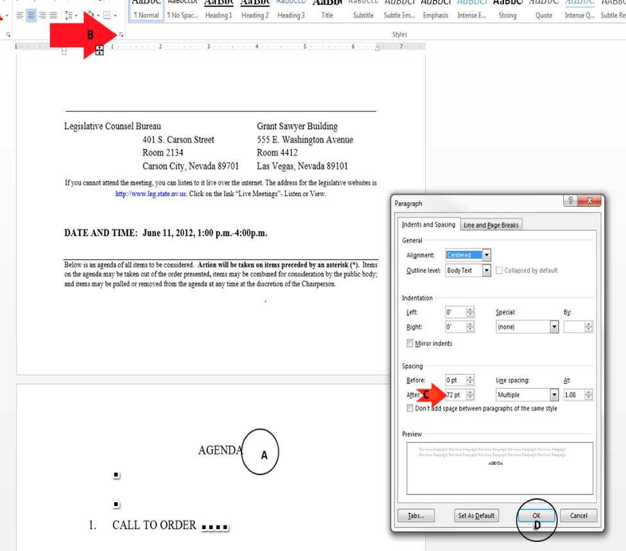

# Headings and Font Styles

The font styles **Arial** and **Verdana** are the most commonly recommended due to both their readability and availability across a variety of computer operating systems. Generally, sans-serif fonts work best as screens with low resolution make serif fonts more difficult to read.

No matter whether you choose Arial or Verdana, a minimum standard font size is 12 pixels.

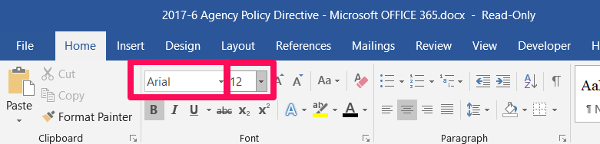

# Additional Resources

If your word document needs to include any of the following elements, please refer to the guide below:

## Document Headers

If creating letterhead or a document that needs a document header refer to   
[***Creating Document Headers guide***](http://ada.nv.gov/uploadedFiles/adanvgov/content/CMS/Word-CreateDocHeader-ADA-Instructions-inBrief.docx)

**Contrast-Ratio (Use Color Appropriately)**

If you need to add a hyperlink in your document refer to   
[***Word Documents – Use Color Appropriately*** ***guide***](http://ada.nv.gov/uploadedFiles/adanvgov/content/CMS/Word-CreateDocUseOfColor-ADA-Instructions.docx)

**Tables of Contents**

If you need to add a hyperlink in your document refer to   
[***Microsoft Word Accessible Table of Contents***](http://ada.nv.gov/uploadedFiles/adanvgov/content/CMS/Word-CreateDocHeader-ADA-Instructions-inBrief.docx%20http:/ada.nv.gov/uploadedFiles/adanvgov/content/CMS/Word-CreateDocTofC-ADA-Instructions.docx)