Purpose:
Americans with Disabilities Act
Department of Administration, Division of Information Technology Services (EITS)
The State of Nevada Department of Administration, Division of Information Technology Services (EITS) is committed to providing access to our electronic and information technology, including our web pages and PDFs in the State of Nevada’s Content Management System (CMS), for individuals with disabilities in accordance with the World Wide Web Consortium's (W3C's), Web Content Accessibility Guidelines (WCAG) 2.0 Levels A & AA, and the Web Accessibility Initiative Accessible Rich Internet Applications Suite (WAI-ARIA) 1.0 for web content.
The State of Nevada Department of Administration, Division of Information Technology Services (EITS), is working to ensure that State employees with disabilities, and members of the public with disabilities seeking information or services from us, have access to and use of information and data that is comparable to the access and use by State employees, or members of the public who are not individuals with disabilities, unless an undue burden would be imposed on us. To meet this commitment, we are in the process of re-designing our web pages to exceed the standards of the World Wide Web Consortium's (W3C's), Web Content Accessibility Guidelines (WCAG) 2.0 Levels A & AA, and the Web Accessibility Initiative Accessible Rich Internet Applications Suite (WAI-ARIA) 1.0 for web content.
If you have a disability and the format of any material on our State of Nevada’s Content Management System (CMS) web pages interferes with your ability to access the information, please click here, and the webmaster will refer your request to the appropriate Department component, and the component will respond to your request. To enable us to respond in a manner most helpful to you, please indicate the nature of the accessibility problem, the web address of the requested material, your preferred format in which you want to receive the material (electronic format (ASCII, etc.), standard print, large print, etc.), and your contact information.
Thank you for your patience while we re-design our site to better serve all constituents.
State of Nevada Website ADA Compliance
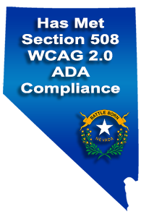The in compliance logo to the left will display in the footer of all State of Nevada’s Content Management Systems(CMS) websites that have been tested and met the Section 508 WCAG 2.0 Levels A & AA Compliance Standards
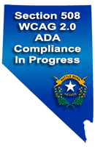The logo in-progress logo to the right will display in the footer of all State of Nevada Content Management System (CMS) Websites that are currently updating their site to meet the Section 508 WCAG 2.0 Levels A & AA Compliance Standards
Americans with Disabilities Act
Department of Human Resource management’s Equal Employment Opportunity Office (EEO)
The Division of Human Resource Management's Equal Employment Opportunity Office (EEO) coordinates the State's various ADA programs and resources, ensuring employees and citizens are referred to the right person. ADA is considered to be the first lawful affirmation for equal treatment of Americans with mental and physical disabilities, the ADA prohibits discrimination against people with disabilities in employment, government services, public accommodations, commercial facilities, education and other areas of society.
Citizens
Citizens with concerns regarding ADA issues related to government services, public accommodations, commercial facilities, and other areas can find various resources through the Department of Transportation or the Department of Administration's Public Works Division. Citizens who would like to file a complaint can do so by following the Department of Transportation or Public Works Division links or by submitting our online form and the EEO office will forward your complaint to the proper Agency for review. The Department of Transportation Complaint Form Department of Administration's Public Works Division Complaint Form File a Complaint Online.

Employees
Employees with concerns regarding ADA issues should contact their Agency Human Resource or Personnel representative, or can file a complaint online through NEATS, or by completing the Sexual Harassment or Discrimination Complaint form and forwarding the document to our office. Sexual Harassment or Discrimination Complaint form.

Contact
For information on the State of Nevada ADA Compliance please contact:
Tammy Smith – EEO Officer
100 North Stewart Street, Suite 200
Carson City, NV 89701
Phone: (775)-684-0104
Amy Taylor
EEO Administrator
appears on the top right of all State of Nevada’s Content Management System (CMS) websites, and links to the information listed above.

EITS Web team and History:
The State of Nevada Department of Administration, Division of Information Technology System (EITS) Enterprise Web team first started working on ADA compliance in 2001.
Governor Guinn’s created an Executive order requiring ADA compliance as well as a consistent look and feel (branding) for all state websites. One feature that was lacking on the current FrontPage websites was robust site navigation, so an enterprise version of AJMENU was purchased. Bobby, a free ADA compliant checking tool, was also selected to assist in making our state websites compliant. The Manager of the EITS web team conducted three group training classes for 60+ website coordinators at agencies that used our services so they could begin to assume editing responsibilities for their websites. During those training sessions, users were provided a prototype website built especially for each individual agency complete with new AJMENU navigation that were Section 508 compliance . A training website was also created that hosted instructions, templates, style guides and other tools to assist agencies in redesigning their existing content to meet the branding and ADA requirements mandated by the Governor. After the last class, agencies were given 30 days to make homepages compliant and 90 days for the entire sites to be ADA compliant with new branding. This goal was met, unfortunately without an ADA monitoring tool in place; the sites did not stay compliant very long.
In 2015, articles about ADA compliance started to circulate and we realized we needed to once again put our efforts on making the State of Nevada CMS ADA compliant. When doing our research, we realized how big an initiative it really was. We discovered a free ADA compliance tool, Wave, however the Wave had some limitations:
- It would only remediate one page at a time
- The tool identified and flagged issues, however, understanding how to fix them was another huge effort that made us realize we needed to learn a lot more if we wanted to continue
EITS Enterprise web team needed to become proficient in ADA remediation.
- We found Lynda.com and took many ADA training classes to understand what was needed to remediate not only HTML content, but all of the documents that resided in the websites
- We found Brett Silver, manager of Talking Books in Las Vegas
  - Brett was blind at birth
  - Brett offered to use JAWS to help us test the Smart forms and templates in our CMS environment
See Specific Testing Requests for Brett Silver for ADA Compliance Testing using Jaws (attached)
    - Other resources
  - Research of other 50 states
    - Collaborated with State of Michigan

EITS Enterprise web team then started to reconcile all of the information collected, and began to put a plan in place.
- List all components of ADA that needs to be addressed
  - State of Nevada CMS environment
  - CMS websites
    - Websites using our templates
    - Websites in our CMS environment that do not use our templates
  - CMS Templates
  - CMS Smart forms
- Researched ADA Compliance tools and found the Siteimprove tool to be the most comprehensive
  - Siteimprove
    - Recommended tool to Management but was not purchased because of funding
- Department of Justice, Office of Civil Rights cited the Department of Education (DOE) for not being ADA compliant
  - Met with DOE, and recommended Siteimprove to help them remediate their sites
    - DOE and EITS agreed to purchase the tool for DOE
  - EITS web team staff needed to take ADA classes to understand ADA remediation
    - EiTS web team also needed to get approval from OCR to train DOE Webmaster
  - EITS web team staff worked with the Department of Education and the Attorney for the Department of Education
    - Wrote documentation results for OCR, and answered OCR questions whenever needed
  - EITS web team staff continues to work with OCR and Siteimprove to assist in making DOE ADA compliant
Siteimprove Results: One year after remediation efforts
Website | Pages | A Issues | AA Issues | AAA Issues | PDF Issues
Governor’s office | 47 | 2 | ✔ | 2 | N/A
State of Nevada | 38 | 1 | ✔ | ✔ | N/A
Department of Education | 905 | 25 | 2 | 7 | 2,147
Bully Free Zone | 44 | ✔ | ✔ | ✔ | 27
Nevada Ready | 26 | 21 | 2 | 6 | 15
For Updated status of our Remediation Effort using Siteimprove
- Web team needed to write a Reconciliation plan
- Webteam needed to write an ADA training plan
- Put together a method of reporting the State of Nevada’s remediation Effort Status
For our Chronological Remediation efforts, see Attached.

Evaluation:
Purpose is to identify and evaluate everything about the State of Nevada CMS so we can begin to understand the scope of our ADA remediate efforts.
Evaluate the State of Nevada’s CMS environment and identify:
- Total # of valid websites in the State of Nevada CMS
- How many documents (forms, surveys, PDFs, Excel, Word, PowerPoint, Miscellaneous)?
- How many images?
- Status of remediation:
  - Meets Standards
  - In Progress
  - Not Started

Summary of the State of Nevada CMS Content, Files, Documents:
CMS Summary:
# of Websites | # of Pages | Forms &  Surveys | PDFs | Excel | Word | PPT | Images | Audio | Videos | Total
116 | 25,167 | 247 | 67,304 | 1,144 | 4,070 | 479 | 12,574 | 1,612 | 104 | 87,971
Detailed listing of all State of Nevada CMS websites (attached)

Evaluate the State of Nevada’s CMS environment and identify:
- Are the websites EITS supported or Agency supported Smart forms
  - Web team cannot remediate Agency supported sites ONLY as they are not using our Smart Forms
- Total # of Smart Forms
- Different types of Smart Forms being used
  - How many webpages are using each Smart Form?
- Does each Smart Form have an ADA complaint Smart form been created?
  - If not, Web team will build an ADA Smart Form

Reconciliation:

Reconcile that all smart forms being used have a remediated ADA Smart Form
Results: Number of Supported Smart Forms in the State of Nevada’s CMS (2016):
Original Smart Form | #pages | ADA Smart Forms | #pages | Status/Comments | Audited
Page Program | 5585 | Page-Program ADA |  | RENAME
 |  | ADA Page Program | 19
State: Page Program V3 | 3183
 |  | ADA State Program V4 | 502
Page | 2544
Press Releases | 1690 | ADA Press Release | 4
Web Event Smart Form | 1268
Links | 1142 | ADA Links | 10
Staff List | 849 | ADA Staff List | 8
Meetings & Agendas | 806 | ADA Meetings & Agendas | 41
 |  | ADA Meetings - Topic | 4
Documents | 636 | ADA Documents | 69
Proclamations |  | ADA Proclamations | 426
Page-FAQs | 387
Slides | 301 | ADA Slides | 24
Initiative Box | 236 | ADA Initiative
Press Release - PIO | 212 | ADA Press Release - PIO | 10
Carousel | 166 | ADA Carousel | 10
Site Setup | 183
Glossary | 115
Social Media Links | 79 | ADA Social Media | 83
Page Directory | 24
Service Catalog | 23
YouTube | 22
Countdown Clock | 14
AMBER Alert | 8
Agency directory | 7
EBlastV3 | 5
Eblast Template | 1
EBlast Newsletter | 2
ADA State: V3 List Serve4 | 4
Alert | 2
Flag Status | 3
For more details see attached report

ADA Training:

Available Training on State of Nevada ADA website (November 2017)
- ADA Remediation training 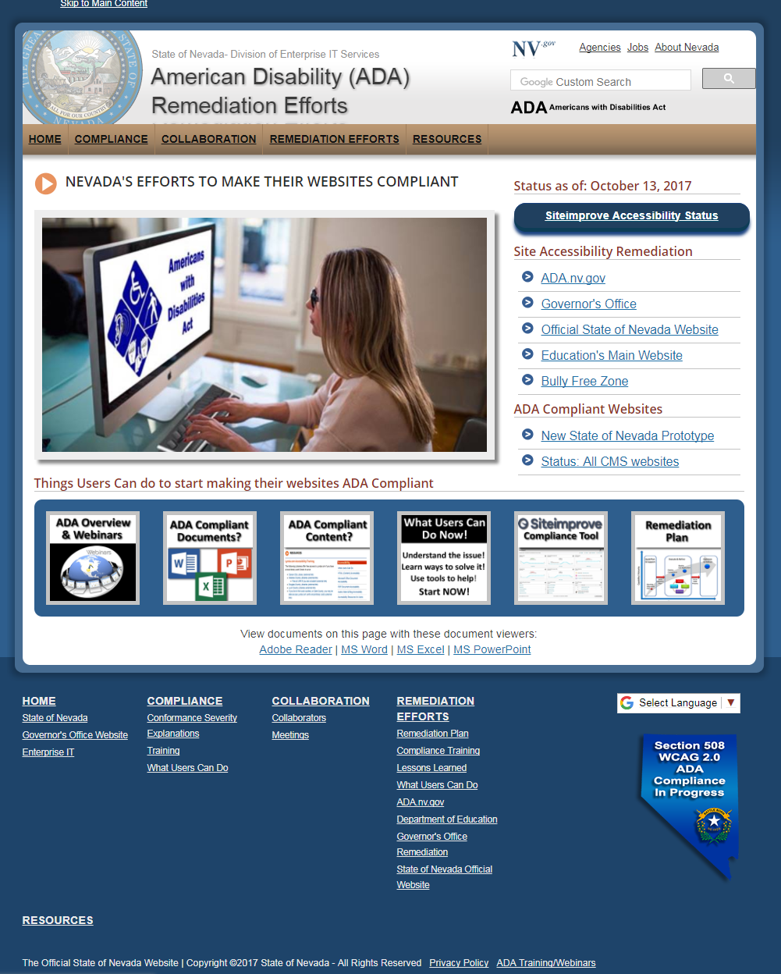

Build a training class in Moodle ELearn for State of Nevada CMS users on ADA:
- EITS Web team has put together the following training class syllabus to be added to the in Nevada ELearn (Moodle)
  - Design the ADA training course after the current State Security training
    - First time on-line training for State of Nevada CMS users, and then future refresher courses
    - Mandatory:
      - Everyone using the State of Nevada CMS is required
      - New Employees (part of onboarding)

MOODLE Training Class:
- Section 1 - Overview of ADA
  - What is ADA
  - What are the ADA requirements
  - EITS Web Team’s Chronological list of our Remediation efforts (see attached)
  - ADA Resources:
    - ADA Webinars - ADA Compliance Training
  - Quiz – one to three questions
- Section 2 – “Remove/delete it, or you have to Remediate it!”
- Recommend users review the content & documents in their websites and DELETE off garbage
- Recommend they only keep current & one previous year of data
  - Websites are NOT storage areas – Don’t use it to archive your information
  - Quiz – one to three questions
- Section 3 - Siteimprove tool
- What it is?
- Why we need to do it?
- How Siteimprove can help them identify ADA errors
- How Siteimprove will suggest possible solutions to correct their ADA errors
- What is required of them to start using the Siteimprove tool
  - Get access
  - Take the Siteimprove Training Course(s) & become Certified
  - How they can take advantage of their ADA Experts
- Resources (O/S class) – (see State CMS Evaluation – Webpages, Smart forms – Supported Smart Forms in CMS)
- Quiz- One to three questions

- Section 4 – How to remediate their content
- Discuss each current Smart form versus the new ADA Smart Form
- Differences between current & new ADA Smarts
- What they need to do to remediate the content
- Step by Step - Example of how to remediate our most used Smart forms
- Page Program V4
- Staff Listing
- Meetings
- Videos
- Resources
  - (see State CMS Evaluation – Webpages, Smart forms – Supported Smart Forms in CMS)
  - Each new ADA Smart form
    - will be available on the State of Nevada ADA website
    - Will have detailed Instructions how to remediate
- Quiz – one to three questions
- Section 5 - How to remediate their Documents
  - Steps on how to remediate Word
  - Steps on how to remediate Excel
  - Steps on how to remediate PowerPoint
  - Resources
    - Resources (O/S classes that are available – Training for ADA Documentation Remediation if the users feel they need more detail
- Section 6 – How to remediate their PDFs
  - To remediate PDFs, it is easier to go back to source (word, Excel, PowerPoint) and remediate them, and then create a new PDF
  - If you do not have the source for PDF
    - Steps you can follow
- Frequently Asked Questions
- Tips & Suggustions
- Final Exam (certificate)
  - Based on Quizes at end of each section
- Feedback/Survey

Outreach:
- Send Letter to Department heads about ADA requirements
  - EITS Administrator
- Use our CMSUSER listserv to communicate with our CMS content users
  - Listserv is generated by downloading current CMS users & populating the CMSUSER list
  - This ensures we have all CMS users
- ADA Presentations – one in the north and one in the south
  - Overview of ADA – PowerPoint Presentation
  - ADA Requirements
  - Overview of Siteimprove
  - Overview of our other tools and training available to them to help them remediate their websites
    - Lessons Learned
    - ADA website
    - ADA Training class for CMS users
  - North
    - Division of Enterprise Information Technology Services
      - CIO
      - Deputy Chief – David Haas
      - Chief- Suzie Block
      - Manager, Web Team – Linda DeSantis
      - Other EITS Web team staff
    - Department of Personnel
      - EEO – Tammy Smith
      - Department of Personnel – Peter Long
      - Assistive Technology
  - South
    - Division of Enterprise Information Technology Services
      - CIO
      - Deputy Chief – David Haas
      - Chief- Suzie Block
      - Manager, Web Team – Linda DeSantis
    - Department of Personnel
      - EEO – Tammy Smith
      - Department of Personnel – Peter Long
      - Assistive Technology
- Create a new website, ADA Website
  - Research other US State ADA websites
    - ADA Michigan
    - ADA Indiana
    - ADA California

  - Weekly progress Status report
    - Each website Status
      - A, AA, AAA
    - Progress (chart) or dashboard
    - Tips, tricks
    - Remediation Plan
  - List of all Recommended Training
    - Training for ADA Documentation Remediation
    - ADA Compliant Documents
    - ADA Compliant Content
    - Siteimprove Compliance tool
    - What users can do Now!

Attachments:
- Total Summary of Websites in CMS - Status
- Total Summary of Websites in CMS – Sorted by Department
- Detailed List of Websites in CMS – with each website listed under Department
- Brett Silver – Specific testing request for Brett Silver for ADA Compliance testing using JAWS-1/22/16
- Chronological EITS Remediation Efforts
- ADA Accessibility Training Checklist
- State of Nevada – American Disability (ADA) Remediation Efforts
- ADA Webinars – Outline of webinars
- Training for ADA Documentation Remediation

