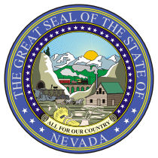

*** NOTICE OF PUBLIC MEETING ***

INFORMATION TECHNOLOGY ADVISORY BOARD
_____________________________________________________________________________________
LOCATIONS: Legislative Counsel Bureau Grant Sawyer Building
401 S. Carson Street 555 E. Washington Avenue
Room 2134 Room 4412
Carson City, Nevada 89701 Las Vegas, Nevada 89101
If you cannot attend the meeting, you can listen to it live over the internet. The address for the legislative websites is http://www.leg.state.nv.us. Click on the link “Live Meetings”- Listen or View.

DATE AND TIME: June 11, 2012, 1:00 p.m. – 4:00 p.m.

Below is an agenda of all items to be considered. Action will be taken on items preceded by an asterisk (*). Items on the agenda may be taken out of the order presented, items may be combined for consideration by the public body; and items may be pulled or removed from the agenda at any time at the discretion of the Chairperson.

AGENDA

1. CALL TO ORDER

2016 | 2017 | 2018
Row 1
Row 2
Row 3

