Siteimprove Quick Start Training Pre-Class Instructions

Pre-Class:
- Create a YouTube account or log in to an existing account to test.
NOTE: you need to be logged into a You Tube account to send comments or messages during the live stream.
- Your agency must have signed an SLA to receive a Siteimprove Account.

Live Stream Class:
- Roll call for all participants.
- If you do not have a YouTube account, you will not be able to leave comments. Please call the conference line at the end of the course so I can give you credit for the course.
- Go to the video settings and change resolution to 720p:
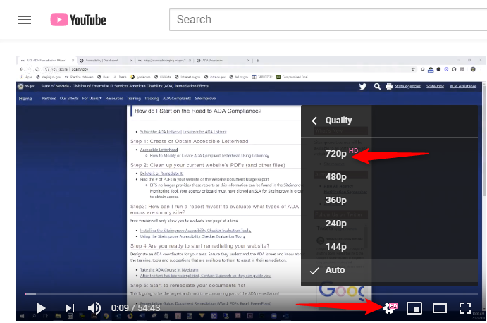

End of Class:
Please call at the end of class with the Conference Line 775-687-0999 Ext. 47310 for any questions about the course or to receive credit for the course if you do not have a You Tube account.
Did you Miss a Class?
If you did, please review the Siteimprove Quick Start Training page. There is a Quick Start Resource Guide, the full presentation as well as webinars available. http://adanew.staging.nv.gov/Training/SiteimproveClassMaterials/
Diana Estey – stateweb@admin.nv.gov (775) 684-7323

