How to convert an mp3 (audio file) to an mp4 (video file)
- Download HitFilm Express
  - Go to https://fxhome.com/express (If you already have HitFilm, go to step 2)
  - Create account and verify the account through e-mail
  - Download free version of HitFilm Express
  - Sign into new account and then restart software to activate license.
- Download the audio file you plan to transcribe.
- Open HitFilm Express
- Create new project by clicking on “New”
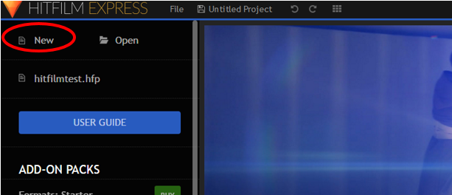
- Set Project Settings (Use example below)
  - Click “Start Editing”
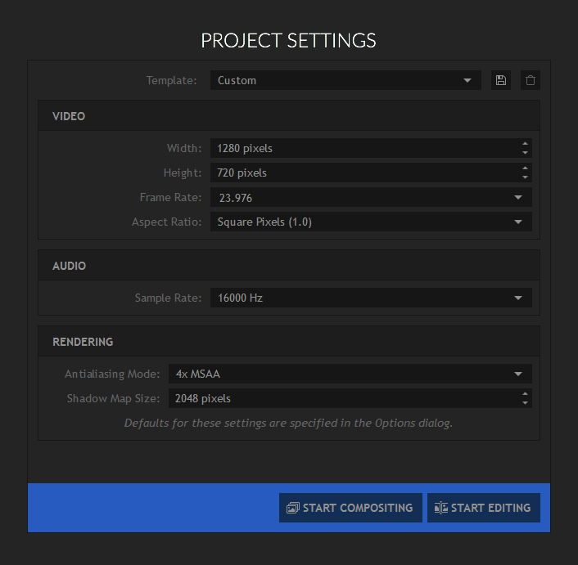
a.
- Import Media
  - Select your saved audio and picture file to import.
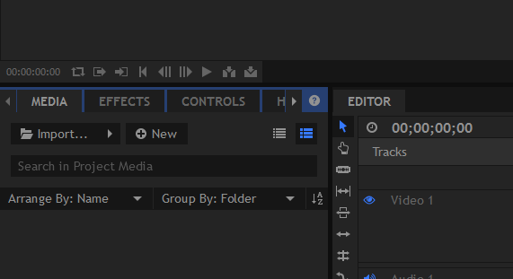

- Place audio and video on tracks.
- Drag and drop audio and video files from media section to the Upload area.
- Once the video file has finished downloading, place it into the video 1 area.
- Once the audio file has finished downloading, place it into the audio 1 area.
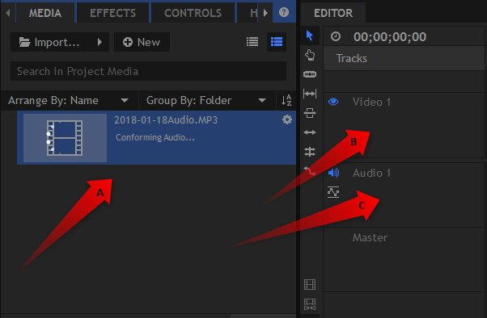
Import in process
- Check the timing on both the video and audio to match.
  - Slide the audio file and the length of the file will be
  - Slide the video file to match the length of the file
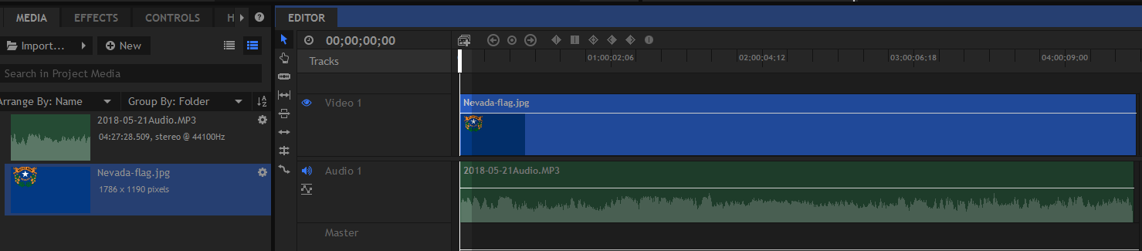
b .Click and stretch photo to match length of audio track
- Export video for uploading to YouTube.
  - Click on export film icon (top film icon)
  - Choose Go to Export and enter
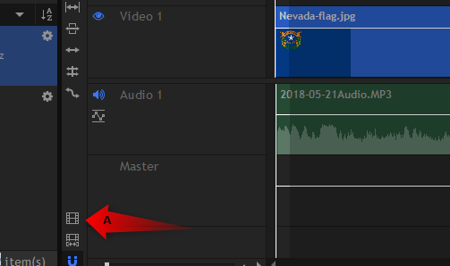
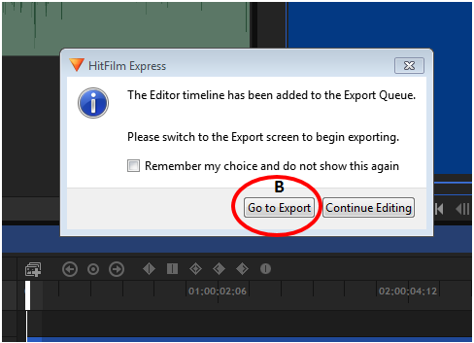

  - Verify YouTube preset is selected
  - Verify YouTube preset is selected on both pages
  - Start Exporting
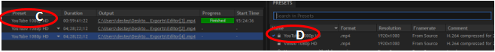 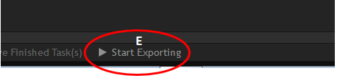
Note: HitFilm Express will automatically save all exports to a folder on your desktop. Folder name is HitFilm Express Exports. This is where you will find the video to upload to your YouTube channel for captioning.
