Installing the Siteimprove Accessibility Evaluation Tool
The Siteimprove Accessibility Checker must be installed in the Google Chrome browser and only checks a single page at a time.
- To install the tool, open a new Google Chrome browser window and type google chrome extensions in the search field and press enter or click this link to Add Chrome Extensions
- Click the link entitled Chrome Webstore – Extensions – Google
- Type Siteimprove into the search the store field and press enter
- Locate the Siteimprove Accessibility Checker and click the +ADD TO CHROME button to install the tool in the Chrome browser.
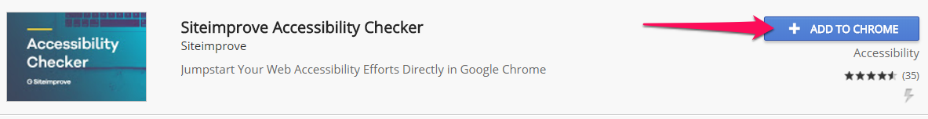
- then click the Add Extension button to confirm installation. This will add an icon to the browser bar and a message will pop up indicating the tool has been installed and you are ready to use the tool

