Windows 10 Photos
Convert an MP3 Audio file to an MP4 video file
and Caption it in YouTube

- Open Photos on a Windows 10 computer
- Import cover page
- Combine cover page with audio file
- Export file to desktop
- Upload to YouTube
- Caption

Photos
- Click the search icon on the start bar
- Enter the search criteria Photos in the search field
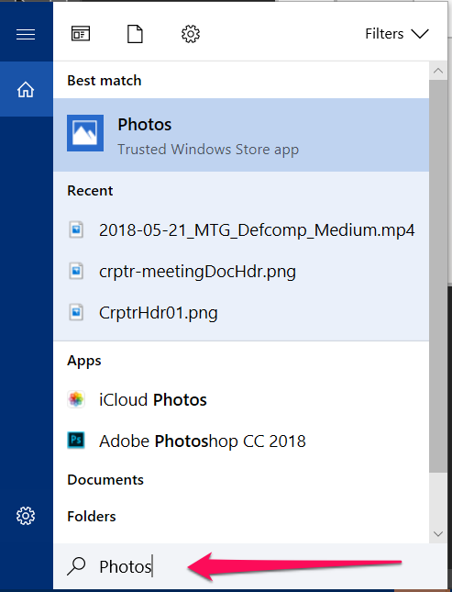
- click on the Photos App appears under Best Match when it appears
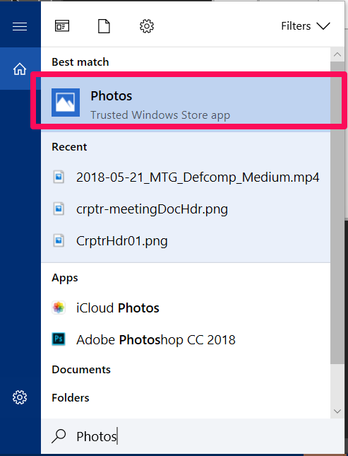

Import the Cover Page
- If you don’t see the image you want to use under collections or folders, click the IMPORT button
Navigate to the folder the file is in then click the Add this folder to Pictures button

Combine cover page with audio file
- Click the CREATE button and choose Custom video with music from the drop-down menu.
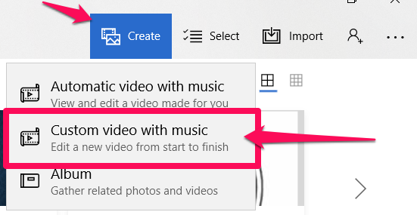
- Choose the cover page image by clicking on it to select it
- Click the CREATE button and wait while the video is being created.
- Name the video and click OK
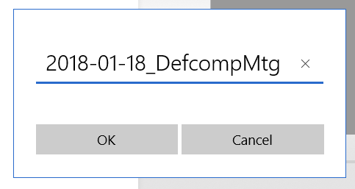
- Click and drag the image from the Project Library to the Storyboard
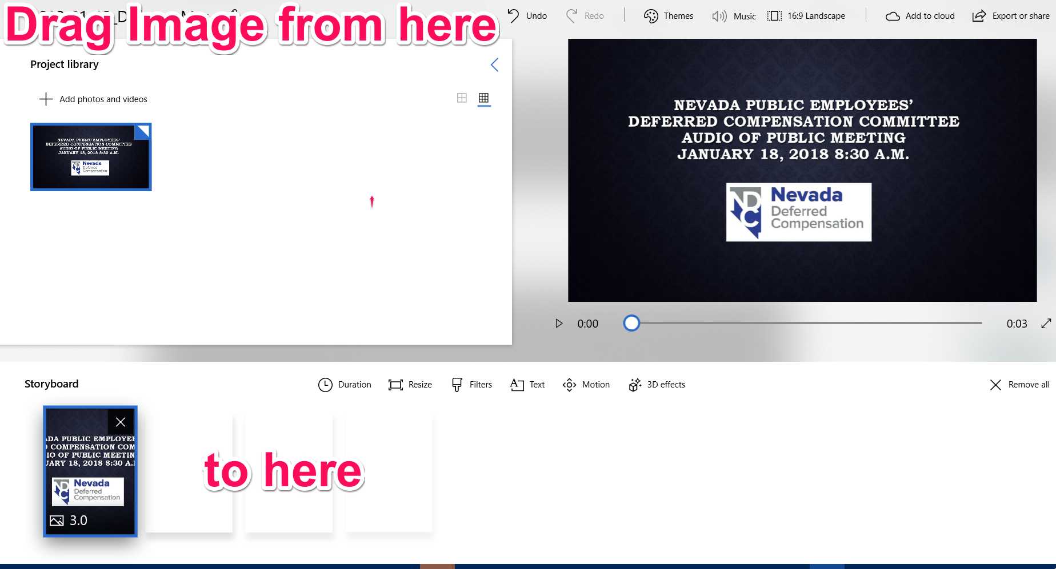
- Click the MUSIC button
- Click the Your Music
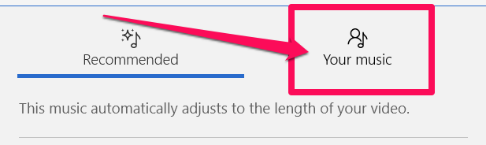
- Click the Select a music file button and navigate to the audio file you want to combine with the cover page. Select the file by clicking on it, then click the OPEN button.
- Click the DONE button
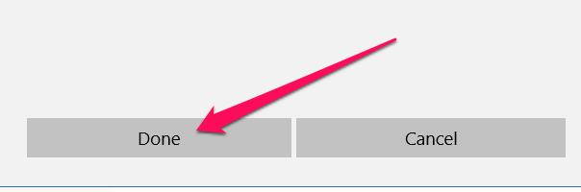

- Go to https://www.inchcalculator.com/convert/hour-to-second/ and enter the hours and minutes that make up the audio file you imported, then click the equal sign to make the conversion to seconds.
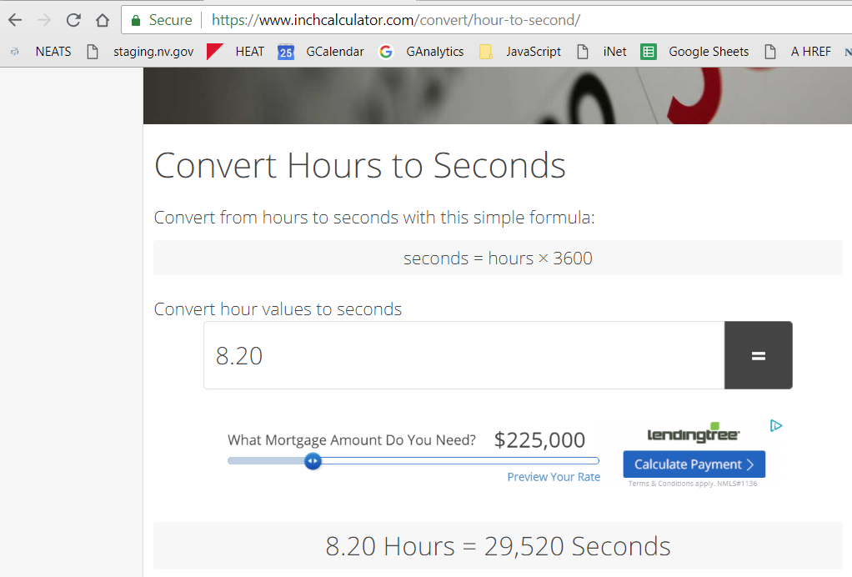
- Click the DURATION button and enter the number of seconds you want the video to be

Export file to desktop
- Click the Export or share button
- Click on BEST FOR SHARING ONLINE. It will create the video now. It will take a long time to complete.
- When it asks view the file in explorer say YES so you know where to locate the file.

Upload to YouTube
- Open your Agency or Board YouTube account by going tohttps://www.youtube.com/
- Click the Add button and choose Upload video
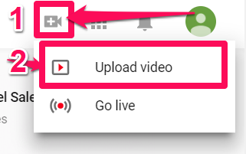
- Select the file you want to upload or drag and drop it to the upload location (the top left pane).
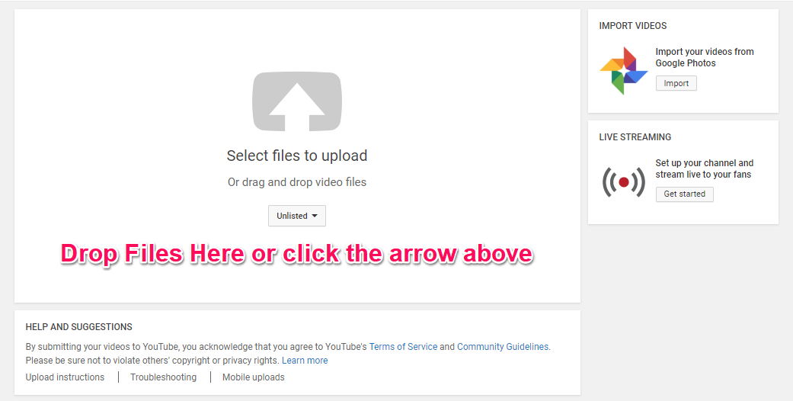
- While it is uploading enter the following information:
  - Replace the file name with a title
  - Add a description of the video
  - Add any tags
  - Change Unlisted to Public otherwise no one can see the video
  - Add it to a play list if you have more than one committee and want the videos organized by committee or category
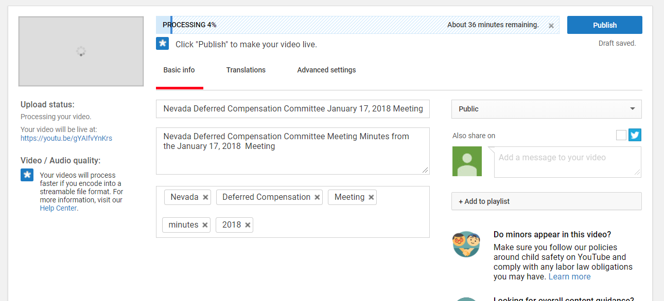
- Click the Publish button
- Copy the link it provides and save it as it is the link you will use on your website to link to the video. 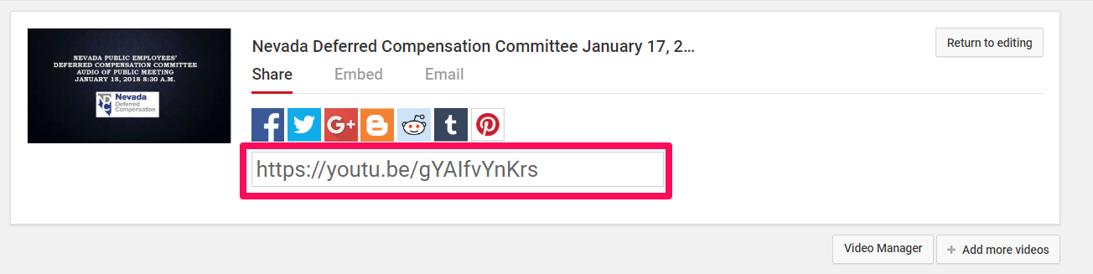

Caption
- To add a caption to the video, click the Video Manager button
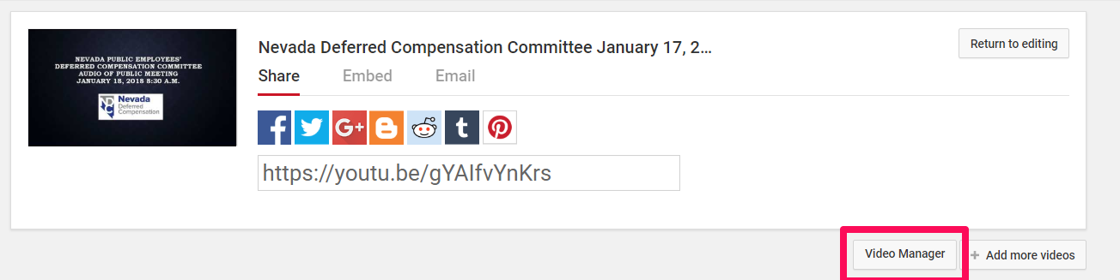
- Click on the icon for the video you wish to caption
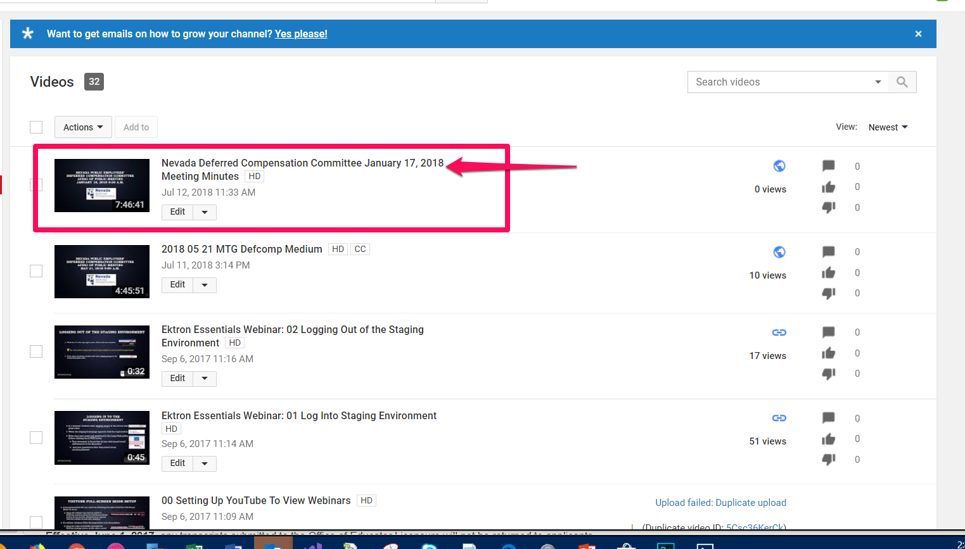
- Click the Subtitles/CC tab
- Click the Add new subtitles or cc button
- Choose English from the drop-down menu
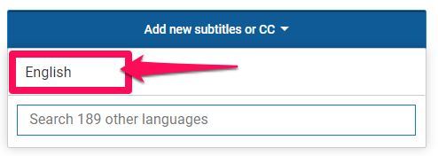
- Click the Transcribe and auto-sync button
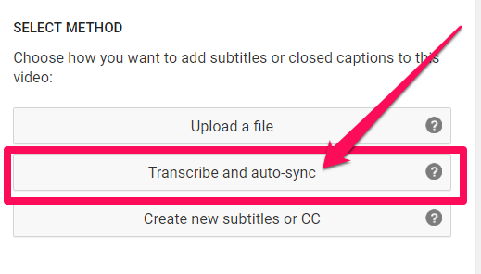
- Click the video to begin. Listen to the audio and begin transcribing what you hear. When you are typing it will pause the video if you have the pause video while typing check box checked.
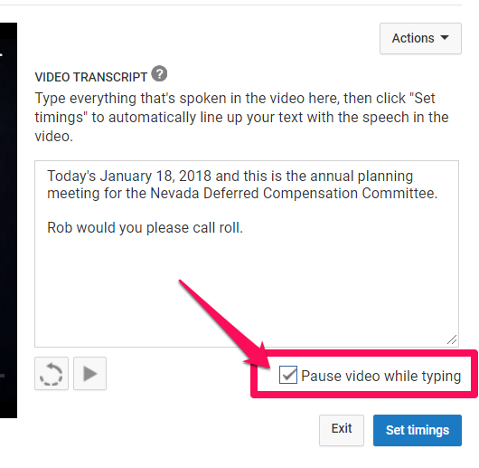
- Once you’ve finished transcribing all the audio, click the set timing button
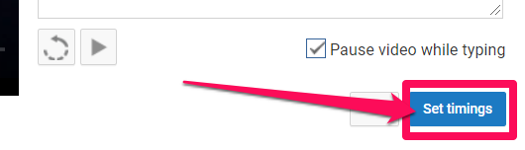
- It will take some time for the Subtitle timing to be set (this may take several hours). Once that is done, click the Publish button
NOTE: Closed Captioning “CC” must be selected on video to view subtitles after publishing. If you haven’t published you will not see any subtitles after clicking the CC (closed captioning) button.

