New and Redacted Material

New Material and Redacted content in document.
This procedure will help with remediating a document that contains newly added material and strikethrough content.
Tagging new material in a document, select first letter of new material and tag as a figure.
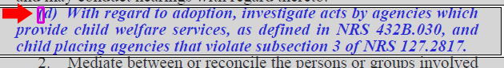
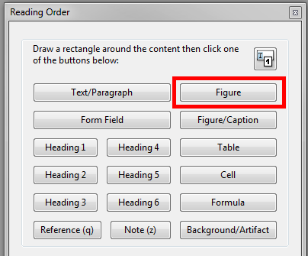
Once marked as a figure, right click on the figure, and select “Edit Alternative Text.”
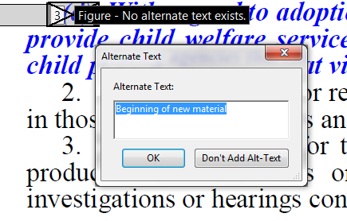
In the window of the edit alternative text, type “Beginning of new material” then click OK. At the end of the new material select the period and tag as a figure.
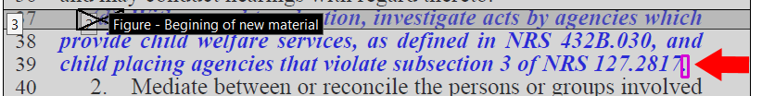
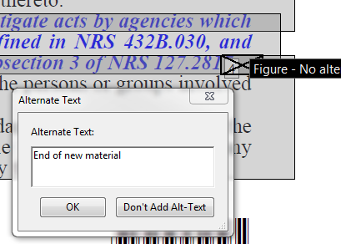
Right click on figure and select “Edit Alternative Text.” In the Alternate text window type “End of New Material,” and click ok.
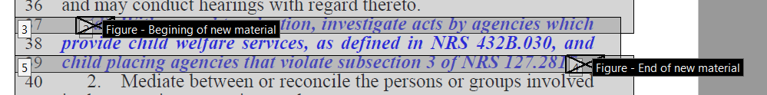
Now the new material is properly tagged and accessible.

Redacted Material

Just like with new material you will want to select the first letter or number of the redacted section.
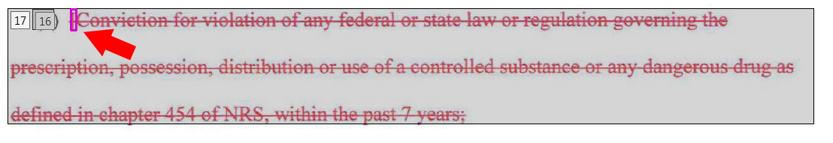
Once selected at start of redacted section tag it as figure.

Right click on the figure and select “Edit Alternative Text” and in the alternate text window type “Beginning of Proposed deletion.” Click OK.
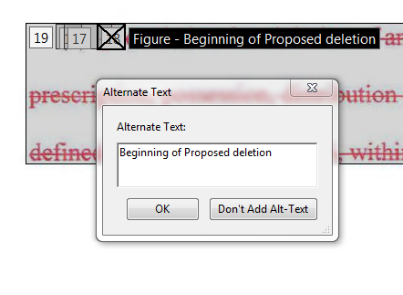
Select the last period or symbol of the section of the redacted material and tag as a figure.
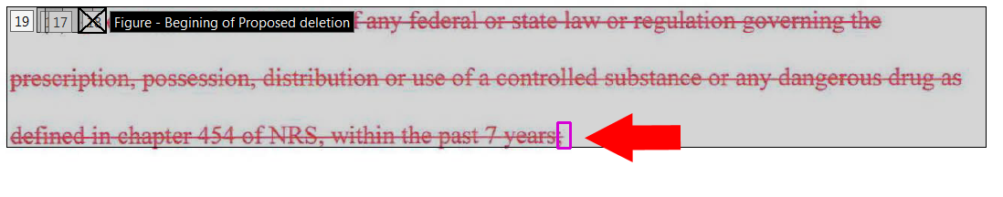
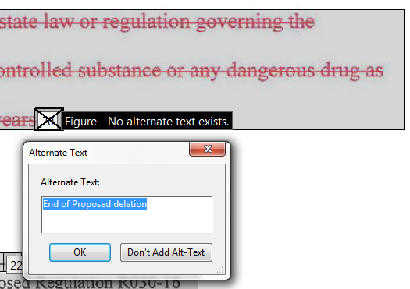
Right click on figure and select “Edit Alternative Text” and in alternate text window type “End of Proposed Deletion.” Click ok
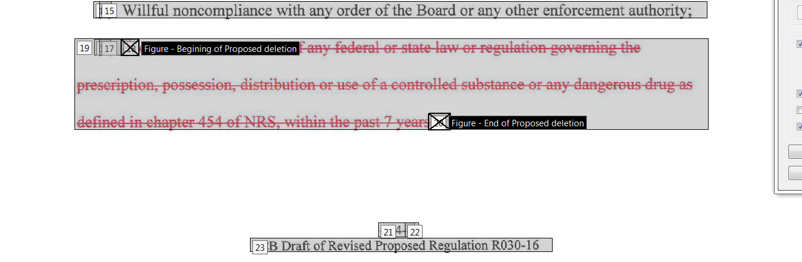

The redacted material is now properly tagged and accessible.

