**Build an ADA Accessible   
Word Document Header**

# Creating Document Headers

## Overview

If a document header like the one below is to be used it should be created as two separate sections.

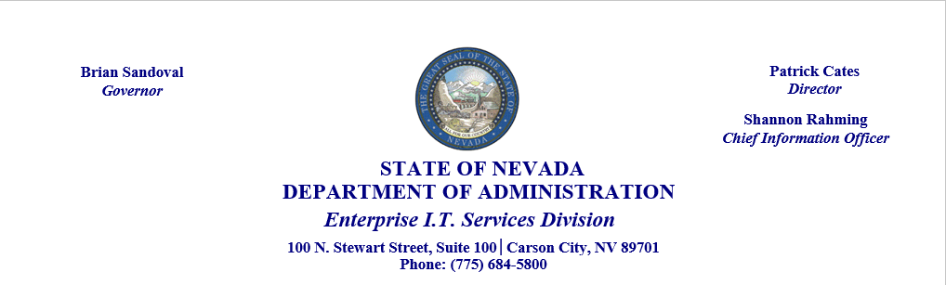

The first section will consist of just the Nevada State Seal with the names of the Governor and agency officers as shown below. The second section will include the address and contact information.

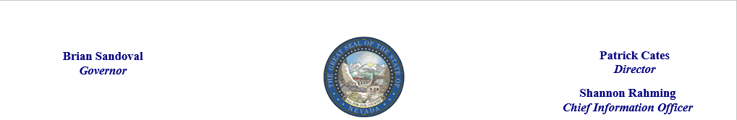

## Step 1 – Create document header section

Open the document header section (Insert Menu > Header).

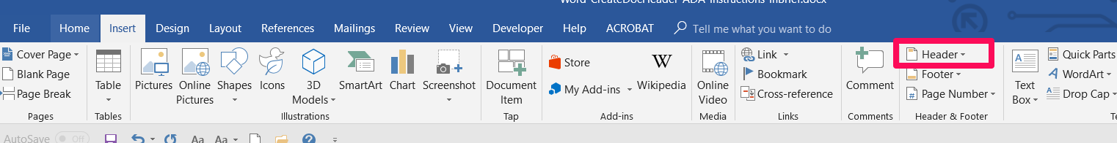

Use a text box to build each officer name and title.



Insert the image (Insert > pictures)

## Step 2

Once you’ve created the header take a screen shot of it. Follow the instructions below to take a screen shot

### Windows 10

In Windows 10 computers you can use the Snipping Tool. Click on the search icon Search Field at the bottom of the screen and enter the word ‘Snip’ in the search field to locate the Snipping tool. Click the icon to open the tool.



Click NEW to

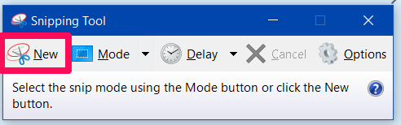

Click and drag to outline the document header to create the image. Save the image to your desktop.

### Windows 7

In Windows 7 computers you can use the Snipping Tool. Click on the Start Menu Windows 7 Start Menu at the bottom of the screen and enter the word ‘Snip’ in the ‘search programs and fields’ search box to locate the Snipping tool.  Click the icon to open the tool.

### 3rd Option

You can download and install a screen print software like [Screenpresso Free](https://www.screenpresso.com/) or another free screenshot software. There are many available in various browsers, including Google Chrome.

## Step 3

The second portion of the header appears below and should not be included in the image nor should it be placed in the document header. This information should be placed directly in the body of the document. ***A Text box should NOT be used to create this text.*** Use regular text and center it in the middle of the page as shown below or left justify the text.

**STATE OF NEVADA  
DEPARTMENT OF ADMINISTRATION  
*Enterprise I.T. Services Division*100 N. Stewart Street, Suite 100 | Carson City, NV 89701  
Phone: (775) 684-5800**[**http://it.nv.gov**](http://it.nv.gov)

When including a url such as [http://it.nv.gov](http://it.nv.gov/) make sure to right-click the link and choose edit hyperlink and click on **Screen Tip** to tell screen readers where the link will take the user. In this case, the Screen Tip tells the user they are going to “State of Nevada, Enterprise I.T. Services Division”.

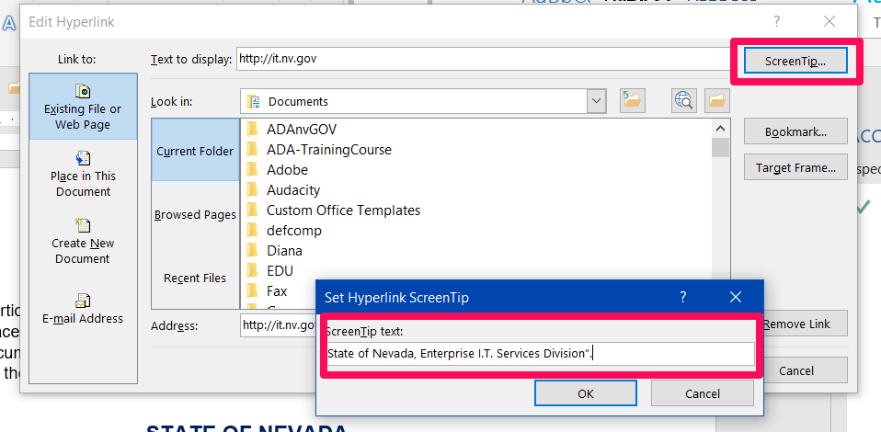

Then click OK to close the ScreenTip dialog box, and OK again to close the Edit Hyperlink dialog box.